CCNP ROUTING AND SWITCHING



Complete Networking Portfolio

Brennen Tse

10/25/2022

#### **TABLE OF CONTENTS:**

1. Resume
2. Configuring Windows Domain Controller, Active Directory, and Client
3. Configuring Group Policy Objects for User Security
4. Configuring RADIUS (AAA)
5. Configuring TACACS+(AAA)
6. Configuring Two Linux Distribution Desktops
7. Configuring PfSense
8. Configuring VRF Lite
9. Configuring eBGP Redistribution
10. Configuring iBGP Routing
11. Configuring EIGRP
12. Configuring OSPF Multi-Area
13. Configuring OSPF Single-Area
14. AWS EBS Instance
15. AWS EC2 Instance
16. AWS Load Balancing
17. Certifications



# Installing a Windows 2019 Server, Windows 10 Client, and Active Directory on VMs In Virtual Box:

By Brennen Tse

Go Back

Purpose:

Configure a Windows 2019 Server as a domain controller to create an Active Directory domain which would manage users and computers including a Windows 10 Client VM.

Background:

Windows 2019 Servers are the usual hardware for domain controllers and Active Directories Domain Services. Because I do not have physical equipment, I will have to settle with virtualization with virtual machines through VirtualBox. Although VMWare is more well known, that costs money, while VirtualBox does not.

Active Directory (AD) is a Microsoft proprietary database and directory service. In the AD, there exists information about the environment like what users or computers there are, their access levels, permissions, etc. Active Directories can contain hundreds of organizational units, which are basically smaller containers which can be managed by a single policy. An example might include an econ company has a tax division, so that tax division may be an organizational unit inside the larger company domain.

Active Directory Domain Services (AD DS) and its servers are the backbone of the AD framework. These servers with AD DS on them are called domain controllers. There are multiple of these DCs for redundancy.

There are three tiers in Active Directory, domains, trees and forests:

-Domains are management boundaries. Objects in a single domain can be stored in one database and managed as a whole with Group Policy Objects.

-Trees are collections of multiple domains. A group of trees is a forest.

-Forests are security boundaries, with objects in different forests prevented from interacting with each other unless there’s trust between them. An example of this could be different departments in a company. HR and finance may have trust between their forests, but finance and maintenance probably won’t.

AD Database:  
In the database, there is information about AD objects. Objects include users, computers, printers, folders, and applications. These objects can be organized through organizational units and users can be grouped. Every object has attributes. For example a user object can have a name, username and password, department, email address, ID, logon time, etc.

Table of Contents:

1. Virtual Box Installation
2. Creating Windows Server Domain Controller
3. Active Directory Installation
4. Creating Windows 10 Client VM
5. Problems
6. Conclusion

Prerequisites:

Download [Windows Server 2019](https://www.microsoft.com/en-us/evalcenter/download-windows-server-2019):

Download [VirtualBox](https://www.virtualbox.org/):

Download [Windows 10 ISO Image](https://www.microsoft.com/en-us/evalcenter/download-windows-10-enterprise)

# Virtual Box Installation:

|  |  |
| --- | --- |
| Download version 6.1.40  Just keep the defaults and click next until VirtualBox is installed. |  |
|  |  |
|  |  |
|  |  |

# Creating Windows Server Domain Controller:

|  |  |
| --- | --- |
| Click the blue button labeled New to create a new virtual machine. I will be creating a Windows 2019 server to use as a domain controller, so select accordingly. I allocated 2048 MB to memory and used a virtual hard disk. |  |
| I allocated 20 GB of file size, you need at least 12 GB for a windows server to function effectively. I selected VHD although you could choose either VDI or VMDK. |  |
| Deselect the floppy disk from the boot order and reorder so that the hard disk is on top with optical after. |  |
| I gave my server 2 of my CPUs, if you only have 1 you can select that. |  |
| Select the bridge adapter instead of NAT for Internet connection. |  |
| Locate the Windows Server 2019 ISO image you downloaded earlier and select it here. Press start. |  |
| Choose the language and select next. |  |
| Click install now, then select Windows Server Datacenter (Desktop Experience). |  |
| Read and accept the license terms. |  |
| I used the custom install since I will only be using this machine to run the domain controller for active directory. |  |
| Create a new partition by selecting new, this will serve as the primary drive. |  |
| Click next and windows will install. |  |
| Type in the username and password for the administrator account. Remember these for later, as they will be important for joining computers to the domain. |  |
| Login. |  |
| You’ve successfully installed a Windows 2019 Server on your VirtualBox VM. |  |
| You can check the specifics in the local server properties. |  |

# Installing Active Directory:

|  |  |
| --- | --- |
| From the server manager dashboard, you should see an icon where you should click “Add roles and features” |  |
| Read through and click next. |  |
| Select role based installation. | Select your windows server. |
| Select the Active Directory Domain Services roles as this is the main service for Active Directory and Group Object Policies. |  |
| Click through. | Click through, read if you want. |
| Select restart automatically, and confirm that all the necessary services are included. You can see GPM and ADDS there as well. |  |
| When the Domain Services finishes installing, you will see this warning pop-up in the upper right. Click on it to finish the domain controller configuration. |  |
| Add a new forest and select a domain name, I chose windows.local because it’s local. |  |
| Leaving the defaults alone should be fine for this, but remember the DSRM password. |  |
| Leave DNS delegation blank, we will configure DNS manually later. |  |
| Set the NetBIOS domain name, I set mine to WINDOWS, and you can always change it later. |  |
| Graphical user interface  Description automatically generated  Keep the defaults. | Keep the defaults. |
| Make sure that you have all prerequisite checks passed, and click Install. |  |

**Here’s the PowerShell script:**

# Windows PowerShell script for AD DS Deployment

Import-Module ADDSDeployment

Install-ADDSForest `

-CreateDnsDelegation:$false `

-DatabasePath "C:\Windows\NTDS" `

-DomainMode "WinThreshold" `

-DomainName "windows.local" `

-DomainNetbiosName "WINDOWS" `

-ForestMode "WinThreshold" `

-InstallDns:$true `

-LogPath "C:\Windows\NTDS" `

-NoRebootOnCompletion:$false `

-SysvolPath "C:\Windows\SYSVOL" `

-Force:$true

# Creating Windows 10 VM:

|  |  |
| --- | --- |
| Create a new VM by clicking the blue icon. I named my VM Windows 10 Client to denote it’s client status. Choose Windows 10, 2048MB of memory, and a virtual hard disk. |  |
| I also gave 20 GBs to this VM, although it likely doesn’t need that much as it’s not a server domain controller. Also you can choose what hard disk you need based on your needs. |  |
| Again make sure that the floppy disk is deselected in the boot order and hard disk is on top. |  |
| Select 2 CPUs if possible, if not, 1 is fine. |  |
| In this instance, I went to the settings and storage for the Windows 10 VM before I started it and added the Windows 10 ISO image medium by clicking the hard drive icon. Click choose and it should be attached. |  |
| Choose the bridged adapter, and select wireless for connectivity. |  |
| Confirm the details on the right. Then click the green start arrow. |  |
| Select the language and next. |  |
| Click Install Now. |  |
| Accept the license terms and continue. |  |
| I’ll still choose custom install because this PC will just be used to test group policy and security for the local domain. |  |
| Again, create another partition for Windows by clicking new that will serve as the primary drive. |  |
| (WARNING: NEVER DO THIS OUTSIDE PRODUCTION NETWORKS)  I turned off the firewall for the Windows Server so that the new Windows PC can more easily connect to the domain. Once it’s connected, I’ll reenable it. |  |
| Wait for the installation to finish. |  |
| Choose the keyboard. |  |
| I skipped signing in, instead using domain join instead. |  |
| Name the PC. |  |
| Give a password to the Client account. |  |
| Deselect all these privacy settings. |  |
| DNS:  Go into your ethernet properties for your Windows 10 client. Select obtain IP address automatically, but make sure that the preferred DNS server is the SAME IP Address as the Domain Controller. |   In this case it was 192.168.1.116. |
| Before the computer can join the domain, remote connection must be allowed. Click apply once it’s clicked. |  |
| From the system properties in the control panel, make sure you select member of _ domain to join the domain. In my case, it was windows.local. I also renamed my computer for easier identification. |  |
| Remember from earlier your login information for the main windows server? Enter that now. |  |
| Possible problem: Make sure client name and domain controller name are different. Also refresh because if you don’t, it won’t register the new name change. |  |
| Closer view. |  |
| If it’s successful, you should be greeted with this message. |  |
| To confirm, open the active directory and navigate to computers, and the computer should be there. If not simply search for it by name. |  |

# Problems:

Throughout this process, I encountered many problems. Mainly with the installation of VirtualBox and getting the VMs to run properly. The first major problem I encountered was that I had installed the wrong version of VirtualBox (7.0 instead of 6.1) and a lot of the old features that I need have been scrapped in the latest version. The second problem I encountered was after I tried starting the virtual machine. I was greeted by the errors: Not in a hypervisor partition (HVP=0) (VERR_NEM_NOT_AVAILABLE) and VT-x is disabled in the BIOS for all CPU modes (VERR_VMX_MSR_ALL_VMX_DISABLED). After some research I discovered that this error meant that virtualization was disabled on my machine and that I had to go into the BIOS to reenable it.

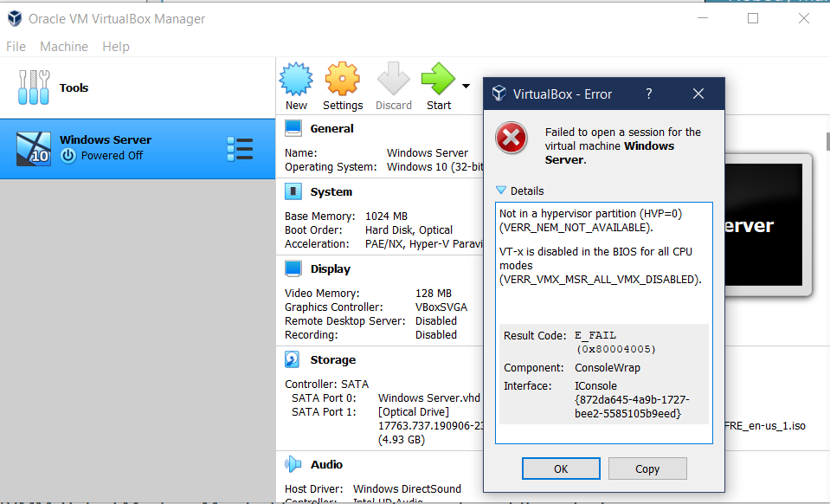

Enabling Virtualization:

|  |  |
| --- | --- |
| My computer, the Legion Y7000P-1060 has a weird boot quirk that doesn’t use the keys, instead you have to press a button with a paper clip, after navigating through and enabling virtualization the error didn’t appear anymore. By shutting down my laptop and pressing this button, it booted into the BIOS menu. |  |
| You can see here is the BIOS screen, I then navigated to configuration. |  |
| In configuration, I located Intel Virtual Technology. Virtual technology = virtualization for Intel. |  |
| I enabled the Intel Virtual Technology option. |  |
| Saved my changes, which partly resolve the problem. |  |

The next error I encountered was one of misconfiguration of the Microsoft Server VM. When I tried starting the VM again, it gave me an error stating that “This 64-bit application couldn’t load because your PC doesn’t have a 64-bit processor”. I knew this couldn’t be a problem with my hardware because my computer had like 12 cores and way more than enough processing power since it was made to be a gaming PC. I then got to thinking, and hypothesized that maybe when I created this VM when virtualization was still disabled, it got allocated a really small amount of processing power because the rest of it was locked if virtualization was disabled. Based on that hunch, I decided to delete this VM and create a new one. Immediately I discovered that there were new options available to me including a Windows Server 2019 option that wasn’t there before. When I chose that and started the new VM, I was able to start it up without a problem.

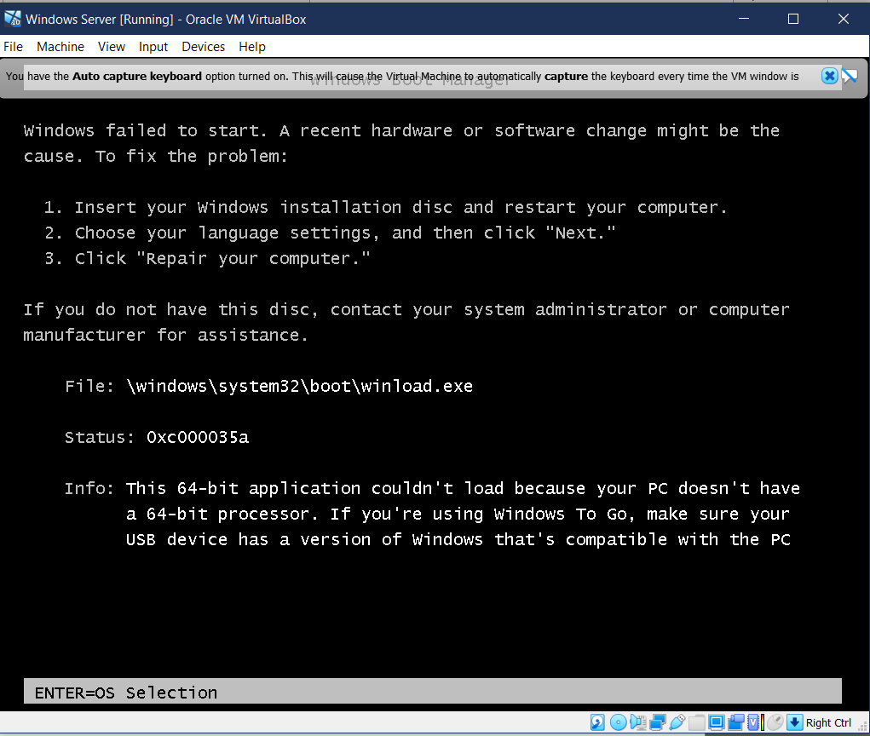

The final configuration error I encountered had to do with disk space. Because I also you this PC as storage for my photography, there was very little space, like less than 4 GB when I started. So I decided to only allocate 4 GB. However, I soon learned that this was way too little space for a Windows Server to run on, and it gave me the respective error of partition is too small. When I created a 20 GB partition instead once I had moved a lot of photos and deleted a ton of apps, the error resolved itself, and I was able to create the server.

Also note, I ran into trouble when I tried to join the domain as I was using the credential for my local PC, not the credentials of the Domain Controller which are required. Once I fixed that I was able to join without a problem.

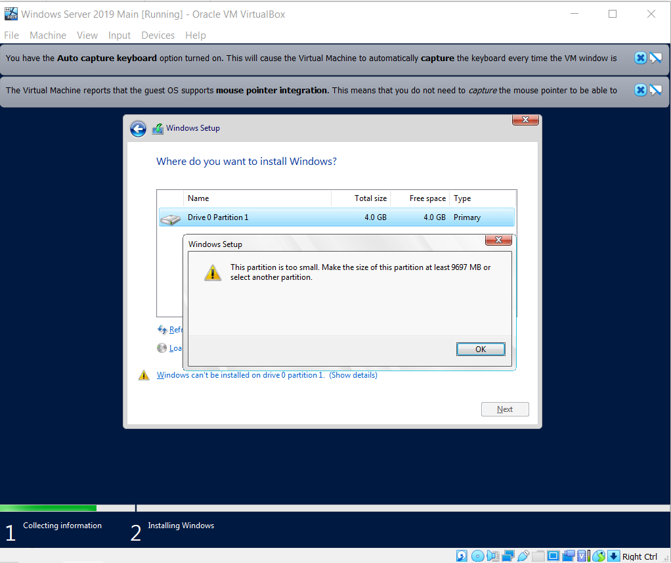

# Conclusion:

Installing a Windows Machine to be a domain controller on a VM is a very effective and efficient way of testing Active directory and group policy objects in a testing environment, where you can work out the problems and bugs in production instead of after the mass implementation rolls out. Active Directory is a crucial part in any organization’s management and efficiency. Knowing how to keep them secure is a crucial part of cybersecurity which we will cover in more depth in our next lab about Group Policy Objects.

# GROUP POLICY OBJECTS

By Brennen Tse:

Go Back

**Purpose:**

Create Untitled School District’s Active Directory, separate students and teachers, and apply security policies uniformly to computers and users.

**Background:**

A Group Policy Object is a collection of virtual policy settings that is applied to a certain group of things like users or computers or organizations. GPOs are another tool to regulate settings for the Active Directory. These GPOs are all controlled from the Group Policy Management Console, where you can create different policies affecting security, software, maintenance, folders, settings and more.

The three types of GPOs are local, non-local and starter.

-**Local Group Policy Objects**: Local GPOs are policy settings that only apply to a local computer and the users who log in. These are policies usually applied on a case-by-case basis for special situations and access.

-**Non-local Group Policy Objects**: These are GPOs who apply to more than one Windows computer or user. This category applies to the majority of policies implemented on Active Directory’s organizational units or domains, as these objects can contain hundreds of computers and users.

-**Starter Group Policy Objects**: These GPOs are templates that can be used for quick deployment of policies and serve as a baseline for further expansion.

The most helpful aspect of Group Policy Objects in regard to cybersecurity is their ability to secure a network or organization through certain policies that can be implemented or rolled-back quickly. GPOs can uniformly implement security measures like disabling access to sensitive systems like Control Panel or Command Prompt (I go more into depth on these in the Security Section).

The main benefits of GPOs are its efficiency, ease of administration, enforcement of password policy like length or expiry time and centralization of folders.

The main drawbacks of GPOs include their sequential process which can increase login times, limited flexibility, no version or auditing control and difficult maintenance if documentation is limited.

**Table of Contents:**

1. Creating Active Directory Structure and Users
2. Creating Group Policy Objects (Computer)
3. Group Policy Objects (User Security Policy)
4. List of Security Policies with Description
5. Confirmation of Correct Policy Implementation
6. Problems
7. Conclusion

# Creating the School Organization Structure in Active Directory:

|  |  |
| --- | --- |
| In Active Directories, I created an example School District Organizational Unit. |  |
|  |  |
| Inside that OU, I created two further OU’s |  |
| These two organizational units are computers for the computer policy and members for teachers and students. I created the members OU so that those two child OU’s can inherit the group policies of the overall members. |  |
| Here you can see the two nested child OU’s of students and teachers. |  |
| Drag the Client PC that we added in the previous step into the new computers OU For the untitled School district. |  |
| I created a new user to use for this example. |  |
| Name can be whatever, I’m just using the system of last name first initial for the username system. |  |
| Give the user a temporary password, and to maintain security policy always check that user MUST change password at next logon for data privacy. |  |
| Check the details here to make sure they’re correct. |  |
| Drag George Burdell to the students section so that it can be part of the Untitled School District OU. |  |
| Here you can see some of the example students. |  |

# Group Policy Objects (Computer):

|  |  |
| --- | --- |
| Head back to server manager and click Group Policy Management |  |
| When you open Group Policy Management, navigate down forest, domains to windows.local and find the Untitled School district OU. |  |
|  |  |
| Create a GPO for the computers first |  |
| To edit the Group Policy, right click and press edit. |  |
| For an example computer group policy, I’m editing the power options by adding a new one that increases the battery threshold for low battery warning. // Create a power plan that changes the default % low battery level alert to 20% instead of 10% to give students more time to charge. |  |
| Right click to select new and select Power Plan. |  |
| I changed the battery % threshold from 10% for low battery level to 20% instead. |  |
| I then signed in on the Windows 10 Client with the new user account I created earlier to see if the changes have taken effect. |  |
| As per our earlier policy, the user has to change their password before signing in and we can see that here. |  |
| Create a new password. |  |
| Open the Run pop-up and run the command “gpupdate”, this will update the client’s policy to the latest Group Policy. |  |
| You can see that it’s been confirmed. |  |
| By going into the control panel to hardware and sound, we can confirm that there has been a new plan added to the Power options. If this Untitled School Battery Warning is selected, when the computer reaches 20%, it’ll send an alert. |  |



# Group Policy Objects (User Security Policies)

|  |  |
| --- | --- |
| Now that we’ve confirmed that we can edit the GPO for the Computer policies, I want to create a GPO for the member’s security. |  |
| I named the GPO Security. |  |
| Like as to edit all GPO’s, right click and select edit to be brought to the Management Editor. |  |
| Here in the Management Editor we can now implement the security policies. |  |

# Security Policies:

List of Policies:

1. Restrict Access to Control Panel
2. Prevent Windows Lan Manager Hash Storage
3. Command Prompt Access Control
4. Disable Forced System Restarts
5. Disallow Insertable Devices (CD’s, USBs)
6. Restrict Software Installation
7. Disable the Guest Account

# Moderate Access to the Control Panel

Description: Moderating access to the control panel is a vital security policy because the control panel is a large security vulnerability as it can control all aspects of your computer. Only authorized IT staff should be able to access and change settings.

|  |  |
| --- | --- |
| To access this setting, go to User Configuration > Policies > Administrative Temples > Control Panel and double click. |  |
| Click enabled and apply the setting to prohibit access. |  |

# Prevent Windows from storing Lan Manager Hash

Description: Hashes are where Windows stores user account passwords. There are two types of hashes, a LAN Manager (LM) has and a Windows NT hash for passwords, storing them in the Security Accounts Manager database. LM hashes are weak and exploitable so they shouldn’t be stored.

|  |  |
| --- | --- |
| To access this policy, go to Computer Configuration > Policies > Windows Settings > Local Policies > Security Options > Network Security Do not store LAN Manager hash |  |
| Enable this policy and click apply. |  |

# Restrict Access to the Command Prompt

The Command Prompt can run commands that give high-level access to users and may be used to evade and bypass other system restrictions. Therefore, it is critical that unauthorized users are prevented from accessing this vulnerability by disabling it. If an authorized user tries to input commands, they will be greeted with a message stating that there are restrictions on any actions.

|  |  |
| --- | --- |
| To access this command, go to User Configuration>Policies>Administrative Templates>System |  |
| Enable the “Prevent access to the command prompt” policy and click apply. |  |

# Disable Forced System Restarts:

Forced restarts occur for many reasons like security updates or software updates. However, users may not notice these warnings and be automatically restarted, losing important and valuable work that wasn’t saved. To prevent this, disable forced restart. This is more a QOL improvement then security.

|  |  |
| --- | --- |
| To access this policy, go to Computer Configuration>Policies>Administrative Templates>Windows Components>Windows Update>No auto-restart with logged on users |  |
|  |  |
| Enable this policy and click apply. |  |

# Disallow Removable Media (Drives, DVD, CD’s, and USB drives)

It is good practice for any organization with sensitive data to implement a security policy that disallows removable media from being inserted into any devices. These media drives can contain all sorts of malicious code and if plugged into the right terminal may infect the entire network.

|  |  |
| --- | --- |
| To enable this policy, go to User Configuration>Policies>Administrative Templates>System>Removable Storage Access> All Removeable Storage Classes Deny all access. Enable the policy then click apply. |  |

# Restrict Software Installations:

If software installations are not restricted, the user may install unwanted apps or compromised software that can infect your system. Although some can slip through the cracks, having a security policy that automatically prevents these installations is a best practice. If new software needs to be downloaded, that request can be forwarded through the IT department first.

|  |  |
| --- | --- |
| To access this policy, go to Computer Configuration>Policies>Administrative Templates>Windows Components>Windows Installer>Prohibit User Installs. |  |
|  |  |
| Enable the policy of Prohibit User Installs and click apply. |  |

# Disable Guest Account:

Having guest accounts enabled can easily compromise your data security as these accounts can access computers without passwords. Although these are disabled by default, it’s good to check anyways.

|  |  |
| --- | --- |
| To check this policy, go to Computer Configuration>Policies>Windows Settings>Local Policies>Security Options>Accounts:Guest account status Properties and confirm that it’s disabled. |  |

# Confirmation of Proper Implementation:

The two easiest ways to check that the group policy objects have been implemented correctly are trying to gain access to the disabled systems of the control panel and the command prompt. If we cannot access them, we know that it was successful.

|  |  |
| --- | --- |
| Login with a user account that has the GPO applied to it. Since George Burdell is a student, his account automatically inherits the GPO from the members OU that students is nested within. |  |
| When trying to access Command Prompt, we can confirm that it has been disabled. |  |
| Similarly when trying to open Control Panel, we receive an error message saying that the operation has been canceled due to restrictions. |  |
| And that’s it! We’re done for now. This is only 7 of thousands of policies that can be implemented depending on the need and use case. |  |

# Problems:

Unlike with the configuration of Active Directory, enabling and assigning group policy objects went pretty smoothly. The only problems I faced was some issues with signing on from some of the student’s accounts. The main reason for this problem was that the passwords were either mistyped or after the first login the password didn’t request a change, mainly because the prompt to do so was left blank on accident.

# Conclusion:

Group Policy Objects are a critical part of any organization’s domain control and Active Directory service, no matter how big or small it is. Because of the ease of use, efficiency and uniformity of the policies implemented by GPOs, they are a fast and secure way to configure the security policies on users, computers, organizations, and more. They help with organization, management, and quality of life, mainly for IT administrators. Its wide array of policy options means that basically every issue or vulnerability has a policy to rectify it.

CCNP ROUTING AND SWITCHING



LINUX

RADIUS AAA

Brennen Tse

10/11/2022

# Linux: AAA RADIUS

Go Back

**Table of Contents:**

1. Purpose
2. Background Information
3. Lab Summary
4. Network Diagram
5. Lab Commands
6. RADIUS Configuration
7. Confirmation
8. Show Run
9. Problems
10. Conclusion

# Purpose:

In this lab, students are to recognize the uses of AAA and configure the two of the main AAA protocols, open-source RADIUS and Cisco proprietary TACACS+. Students are to set up a VM server with either Windows or Linux Ubuntu OS’s. With either RADIUS or TACACS+ installed on the server, a Router should be able to establish remote authentication on the router to confirm user credentials with the server. In this report, I will be configuring RADIUS on the Linux VM.

# Background Information:

**Authentication, Authorization, Accounting**

Triple A, or Authentication, Authorization, and Accounting is a standard used to control access to network devices (authentication), how much permission they have (authorization) and allows for the creation of activity logs (accounting). The main benefit of AAA services is security. If you don’t use AAA, then authentication would have to be done locally on every individual device using shared usernames and passwords, creating exponential more chances for incidents, breaches and leaks of sensitive information. Also, local management is a large strain on the individual networks and using AAA is both more secure and efficient. The most popular services are RADIUS, TACACS+ and Diameter.

* *Authentication* provides a way to identify a user through both valid usernames and passwords before access and authentication is granted. When a user wants to remotely access a device, the device will compare the user’s credentials with those stored on the remote AAA server. If the credentials match on the AAA server, the user is granted access to the device. Otherwise, the device is denied.
* *Authorization* is the process of determining the level of permission a user has, namely, what they are permitted to access. After a user is authenticated, they may be authorized to view or edit certain sensitive files.
* *Accounting* logs the activity of a user during access, which may include the length of time spent, what they accessed, or changes they made. These statistics can be used by higher officials to determine billing, trend analysis, time management, and such.

**Linux:**

Like other operating systems including Windows and MacOS, Linux can run applications, but excels at server-based services, such as hosting RADIUS servers, since it is much more lightweight than other software. In computing, something “lightweight” refers to software designed to have a small memory footprint (RAM), low CPU, and low overall usage of system resources. Perfect for something like a server, but less user friendly (unfortunately). Users will typically navigate Linux through the command-line with less focus on graphical applications. There isn’t really a GUI for Linux so it’s more complicated than more user-friendly systems like Windows.

Since Linux is an open-source OS, where anyone can take the base code and manufacture it to their liking, there are many *distributions* designed for specific purposes. I used Ubuntu for my virtual machine although this project could be replicated with any distribution of Linux like Debian or others. Just make sure that the open-source code is safe to use and doesn’t contain any malicious code.

Virtual Box:

AAA Communication Process:

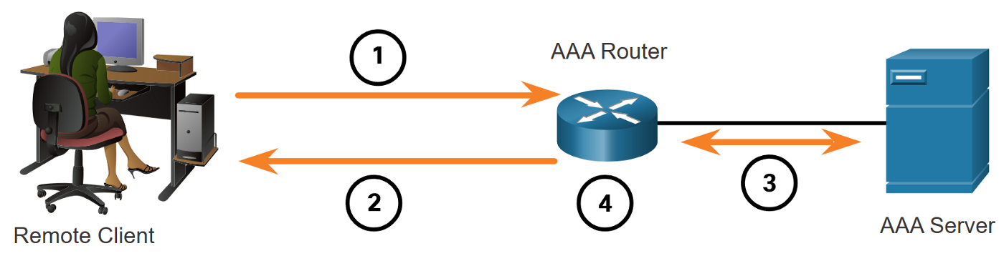

1. Remote client tries to login to router using PPP. In our case we use Putty.
2. AAA Router requests username and password.
3. Once username and password are given, AAA router sends these to AAA authentication server through either RADIUS or TACACS to check validity and authorization of user.
4. Once receiving this information, router either grants user access or denies access.

RADIUS vs TACACS:

Terminal Access Controller Access Control System (TACACS+) is used to communicate between the client and NAS server and is Cisco proprietary. Remote Access Dial-In User Service (RADIUS) is a protocol that is open standard used for the same purpose as TACACS+ but uses port 1812 and 1813. Both were designed for slightly different purposes can be used for the same roles, as RADIUS would ideally be used to authenticate and log remote users while TACACS+ is used for admin access to network devices like the router in this lab. TACACS+ is more reliable using TCP port 49 instead of RADIUS’s UPD ports 1812 and 1813, and provides more control of authorization of commands. TACACS+ is more secure as all packets in are encrypted while only passwords are in RADIUS. However, RADIUS is open standard meaning it can be used on devices other than Cisco ones. The authentication processes are the same between both protocols.

Differences:

TACACS+ separates each component of AAA, Authentication, Authorization and Accounting while RADIUS combines Authentication and Authorization, using port 1812 for them and 1813 for accounting. TACACS+ offers multiprotocol support and is used for device administration, while RADIUS is used for network access.

RADIUS PROTOCOLS:

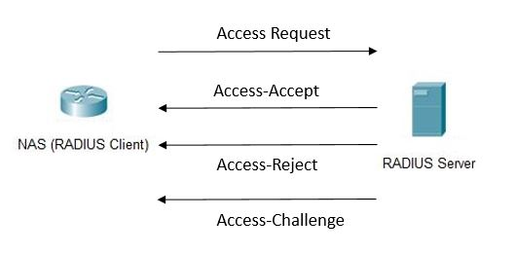

1.After the user request with credentials is received, the NAS sends an Access Request to the RADIUS server with the credentials.

2. The RADIUS server checks the validity of the credentials using PAP, CHAP or EAP. It either responds with Access-Accept, which means its valid, Access-Reject, which means its not, and Access-Challenge, which is request for more information like another password. Unfortunately, most of this information is sent unencrypted in cleartext, and the protocol of DIAMETER is planned to replace RADIUS as a more secure form of AAA.

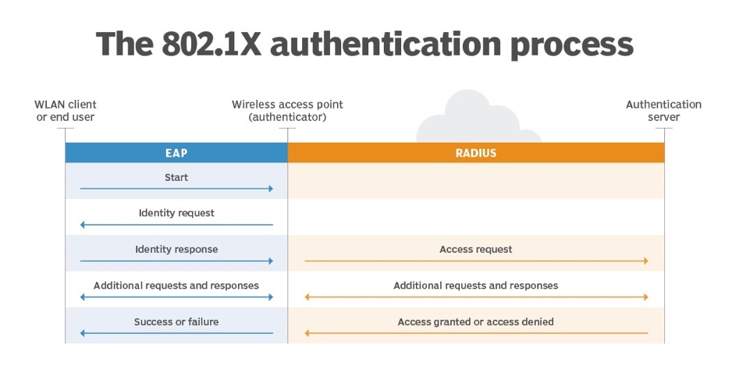

# Lab Summary:

A router which serves as the authentication client and NAS is connected to a PC hosting the VM with the either the TACACS+ or RADIUS server. Although these devices are physically connected through a single link, they logically represent separate devices. To confirm that the authentication protocols are working, a new user profile should be added to the authentication database and confirmed that it works. Incorrect logins should also be checked to make sure that the authentication isn’t set to allow all. For the RADIUS VM server we used Linux’s Ubuntu distribution 20.04 as the underlying OS and FreeRadius for the RADIUS software. When FreeRadius 3.0 is installed, you can configure the user and clients database in the “Users” and “Clients.conf” files using the NANO editor. You configure the username, password and shared secret (key). This key on the client file must be the same as the key on the NAS. The IP addresses should be in the same subnet and the VM should use the Bridged network adapter.

Upon successful client and server configuration, RADIUS should be fully functional. Attempting to access the router via either console or SSH (remote access), it prompts a login username and password. Any correct username and password pair is visible in the users file of the Linux server. The password to reach privileged EXEC mode is also configured there, under the username “$enab15$.” New users were added afterwards to prove that verification was from the server rather than a local configuration. Changes of configuration afterwards are documented as evidence of functionality. After all elements of configuration, the protocols are operational and AAA is in use.

# Network Diagram

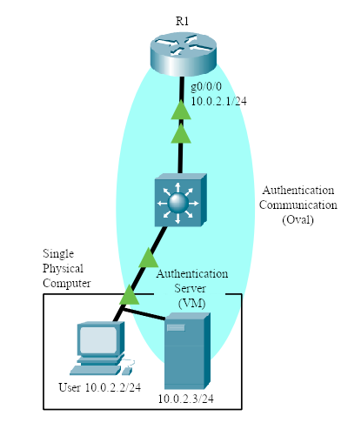

# LAB COMMANDS:

Router Commands:

Router(config)# **aaa new-model**

* Specifies AAA as the authentication method for VTY lines on the router

*To configure any AAA services, you must first define aaa new-model.*

// RADIUS Authentication

Router(config)# **aaa authentication attempts login [#]**

* Specifics the number of login attempts a user gets before the connection terminates

Router(config)# **aaa authentication banner `***message***`**

* Set a message for a user when they connect to the device

Router(config)# **aaa authentication fail-message `***message***`**

* Set a message if the user fails their credentials

Router(config)# **aaa authentication *login default group radius***

* Make the router verify login credentials with a radius server

Router(config)# **aaa authentication *enable default group radius***

* Make the router verify privilege exec mode credentials with a radius server

// Defining a RADIUS Server

Router(config)# **radius server [*name*]**

* Define a radius server

*The router will use the ip address of the radius server subsequently provided to verify credentials. This command can only be typed after* aaa new-model *has been declared.*

Router(config-radius-server)# **address ipv4 [*ip*] auth-port *1812* acct-port *1813***

* Define the *ip* of the radius server

Router(config-radius-server)# **key [*key*]**

* Define the *key* of the radius server

*The key on the router should match the key in the radius server’s configuration files.*

Linux command side:

**LS –** Lists folders and files in current directory.

**CD [*Folder name*] –** Enter new directory of new folder.

**Sudo su –** Enters super admin mode. “Sudo…” syntax for admin permissions is not necessary on future commands after first used.

**Sudo apt-get install FreeRadius {FreeRadius-utils} –** Installs FreeRadius. {As well as other FreeRadius utilities, optional.}

**Sudo apt policy FreeRadius –** Checks FreeRadius version. v3.0 was used for this lab.

**Service FreeRadius restart –** Restarts the FreeRadius service. Updates changes.

**FreeRadius -CX –** Checks FreeRadius operation and seeks errors in file configuration.

**Nano [*File name*]–** Using the default file editor called “nano,” opens and edits file contents.

**Client [*Client IP*] {**

**secret = [*Secret name*]**

**nastype = [*NAS type*]**

**shortname = [*Device-type*]**

**}**

Under “nano clients.conf,” the following creates the FreeRadius client. This set of commands determines its IP, shared secret key, NAS type, and a local nickname for the device. The key has to be exactly the SAME to the router-side configuration. NAS type of “cisco” and a shortname of “router” was used.

**[*username*] Cleartext-Password := “[*password*]”**

**Service-Type = NAS-prompt-user,**

**Cisco-AVpair = shell:priv-lvl=[*privilege number 1-15*]**

Under “nano users,” the following creates the FreeRadius user credentials. This set of commands can be repeated and is used to create a user on this server. These usernames and passwords are the ones the router will check with upon each login request.

**$enab15$ Cleartext-Password := “[*enable password*]”**

**Service-Type = NAS-prompt-user,**

**Cisco-AVpair = shell:priv-lvl=[*privilege number 1-15*]**

Creates password upon users’ requests for entering privileged mode.

Important Commands:

Cd /etc/freeradius/3.0/

Nano users

Service freeradius restart

Freeradius -CX

**Linux Radius AAA**

**Download Oracle VM VirtualBox Manager**

# CREATING THE LINUX RADIUS VM

|  |  |
| --- | --- |
| Click on the *new* icon to create a new Virtual Machine, select Linux and Ubuntu as the version, you should have a Linux machine image already downloaded to your computer. |  |
|  |  |
|  |  |
|  |  |

|  |  |
| --- | --- |
| Navigate to settings and change the network adapter from NAT to Bridged Adapter Ethernet. |  |
| Select the correct ubuntu start-up disk after clicking the start arrow. |  |
| Select Continue |  |
| Setup your profile. Remember the username and password as this will be important later. |  |
|  |  |
| Reboot the VM |  |

INSTALLING FreeRADIUS

|  |  |
| --- | --- |
| After rebooting, enter this command which gets and installs freeradius on the Linux Machine. |  |
| Check that freeradius is installed and has the correct version using the command *sudo apt policy freeradius* |  |
| Use the sudo su to gain root access and check the files using the cd /etc/freeradius/3.0/ ls command. |  |
| Install the nano editor using the command sudo apt install nano. Then enter the clients.conf file using the command nano clients.conf |  |
| When you are greeted with this text file, scroll down. |  |
| When you reach the end of the blue text, input the related user and user information into the file. |  |
| Enter the users file using nano user. Create the user profile with password and enable password. |  |
| Install net-tools and use the ifconfig command to check the ethernet addresses. |  |
| Enter the netplan file using NANO. |  |
| Enter the addressing information. |  |
| Enter these commands to save the static IP config and restart freeradius. |  |
|  |  |
| Do a radtest to confirm that a login would work. |  |
| If the router was configured correctly, you should have connectivity, see the configuration section for router configs. |  |
| The PC the VM is hosted on should also have this as the ethernet addressing. |  |

# Verification of Connection

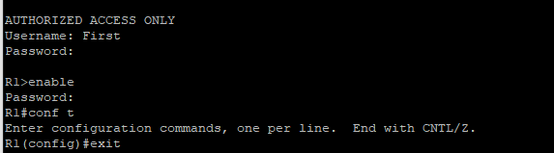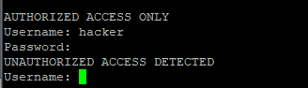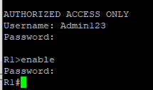

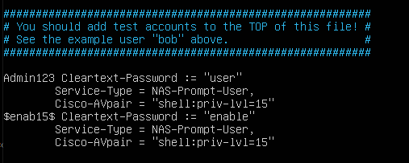

R1 RADIUS:

R1#**show run | include RADIUS**

aaa authentication login default group RADIUS enable

aaa authentication enable default group RADIUS enable

RADIUS server Linux1

R1#**show run | include aaa**

aaa new-model

aaa authentication banner ^CAUTHORIZED ACCESS ONLY^C

aaa authentication fail-message ^CUNAUTHORIZED ACCSS DETECTED^C

aaa authentication login default group RADIUS enable

aaa authentication enable default group RADIUS enable

aaa session-id common

# RADIUS ROUTER CONFIG

version 16.7

service timestamps debug datetime msec

service timestamps log datetime msec

platform qfp utilization monitor load 80

no platform punt-keepalive disable-kernel-core

!

hostname R1

!

boot-start-marker

boot-end-marker

!

!

vrf definition Mgmt-intf

!

address-family ipv4

exit-address-family

!

address-family ipv6

exit-address-family

!

!

aaa new-model

!

!

aaa authentication banner ^CAUTHORIZED ACCESS ONLY^C

aaa authentication fail-message ^CUNAUTHORIZED ACCESS DETECTED^C

aaa authentication login default group radius enable

aaa authentication enable default group radius enable

!

aaa session-id common

!

subscriber templating

vtp domain cisco

vtp mode transparent

!

multilink bundle-name authenticated

!

license udi pid ISR4321/K9 sn FDO220523GF

no license smart enable

diagnostic bootup level minimal

!

spanning-tree extend system-id

!

redundancy

mode none

!

interface GigabitEthernet0/0/0

ip address 10.0.2.1 255.255.255.0

negotiation auto

!

interface GigabitEthernet0/0/1

no ip address

shutdown

negotiation auto

!

interface Serial0/1/0

no ip address

shutdown

!

interface Serial0/1/1

no ip address

shutdown

!

interface GigabitEthernet0/2/0

no ip address

shutdown

negotiation auto

!

interface GigabitEthernet0/2/1

no ip address

shutdown

negotiation auto

!

interface GigabitEthernet0

vrf forwarding Mgmt-intf

no ip address

shutdown

negotiation auto

!

ip forward-protocol nd

ip http server

ip http authentication local

ip http secure-server

ip tftp source-interface GigabitEthernet0

!

radius server Linux1

address ipv4 10.0.2.3 auth-port 1812 acct-port 1813

timeout 2

retransmit 2

key secretkey

!

control-plane

!

line con 0

transport input none

stopbits 1

line aux 0

stopbits 1

line vty 0 4

!

wsma agent exec

!

wsma agent config

!

wsma agent filesys

!

wsma agent notify

!

End

# Problems for RADIUS and TACACS+

There were, expectedly, many problems during configuration, testing, and troubleshooting, especially those stemming from the inexperience of the new interfaces and outdated software. The one that would end up causing the greatest confusion is the necessity to restart the protocol service after making major changes, such as changing the shared secret key or an IP address. This caused many understanding conflicts as configurations do not update and apply instantaneously, making certain changes and configurations not display properly from a user device perspective. This interfered with expectations of certain commands and confused the general understanding of whether a command functioned or not. Ultimately, the “service FreeRadius restart” command for RADIUS and the “sc start/stop TACACS.net” for TACACS+ became go-to commands after any edit.

For FreeRadius v3 and Oracle VirtualBox, there were relatively small issues in regard to downloading the proper bootstrap version for USB integration. This was done to download operating disk images and .exe files for the virtual machine. The problem mainly stemmed from the inability to access files from the USB with TACACS+ and transfer it to the VM. After some troubleshooting, I discovered that VirtualBox as a default supports USB 2.0, instead of USB 3.0, which was needed to file share with the latest USB’s. After an extension pack was found, the problem was resolved. All versions and options are found on the Oracle VirtualBox website. Version 6.0 was used for this lab. An important configuration directed towards VirtualBox is the necessity to change the network adapter to a *bridged adapter*. This allows the virtual machine to share and connect their information via ethernet, where it would otherwise be isolated. This was the key solution to more than a couple pinging problems.

Other quicker issues relating to TACACS+ included the lack of permission to run TacTest commands, which could be fixed by using the *admin* command prompt, done by right-clicking the command prompt application. When TACACS+ needed to be restarted but the start command says that it is already running, stop the TACACS before trying to restart it. The wording for the commands must be very accurate, and even a slight mistype can lead to later bugs, as in some cases the interface will accept the incorrect command without notifying you. This led to a problem with my TACACS+ software in that the router was not connecting to the VM because the proper interface was still in its shutdown mode. With TACACS+ especially you needed to ensure that the right brackets were deleted to get the proper parts of the software working on the Windows Machine.

# Conclusion

This revealing lab was indisputably valuable in the new interfaces to be familiar with. As my first useful application with Linux and VirtualBox, I learned and navigated a wide array of commands, specifically those of Ubuntu Linux, Oracle VirtualBox, and Notepad++. In the foreign environment, it was an achievement to be able to understand and execute the protocols fully and functionally. AAA and other security protocol and frameworks like CIA are essential parts of today’s cybersecurity architecture, and continuing to improve and expand their use will lead to a more secure and safe world for all Internet users.

CCNP ROUTING AND SWITCHING



TACACS+ FOR WINDOWS VM

AAA

Brennen Tse

10/9/2022

# Windows: AAA TACACS+

Go Back

**Table of Contents:**

1. Purpose
2. Background Information
3. Lab Summary
4. Network Diagram
5. Lab Commands
6. TACACS+ Configuration
7. Confirmation
8. Show Run
9. Problems
10. Conclusion

# Purpose:

In this lab, students are to recognize the uses of AAA and configure the two main AAA protocols, open-source RADIUS and Cisco proprietary TACACS+. Students are to set up a VM server with either Windows or Linux Ubuntu OS’s. With either RADIUS or TACACS+ installed on the server, a Router should be able to establish remote authentication on the router to confirm user credentials with the server. Users should use SSH to secure login for administrative access into the router, and be prompted to enter login details which can be verified by the AAA server. In this report, I will be configuring TACACS+ on the Windows VM.

# Background Information:

AAA is the acronym for the security framework of Authentication, Authorization and Accounting for validating user login. This framework is usually used when users are accessing network infrastructure or resources remotely and to ensure added security. Levels of privilege and access can be assigned as well. Through authentication, you can control who is permitted to access certain resources. This is accomplished from comparing a user credentials with a database of valid users.

The advantages of using RADIUS or TACACS+ to remotely store user profiles is that since the user profiles are not stored locally, if someone was to gain unauthorized access to the router, the network security would not be compromised. Authorization dictates what network resources authenticated users can use, usually through privilege levels or access to certain commands. Finally, accounting is used to monitor and capture activity to use in monitoring network performance and user logins.

AAA clients can be a variety of several devices, mainly routers, switches and firewalls. In this lab we will focus on the router. These devices are known as a NAS, or Network Access Server, that serve as the device that users locally get AAA from, and the device in direct contact with the AAA server. Communication between the AAA server and the NAS is conducted through the authentication protocol, namely RADIUS and TACACS+.

AAA Communication Process:



1. Remote client tries to login to router using PPP. In our case we use Putty.
2. AAA Router requests username and password.
3. Once username and password are given, AAA router sends these to AAA authentication server through either RADIUS or TACACS+ to check validity and authorization of user.
4. Once receiving this information, router either grants user access or denies access.

RADIUS vs TACACS:

Terminal Access Controller Access Control System Plus (TACACS+) is used to communicate between the client and NAS server and is Cisco proprietary. Remote Access Dial-In User Service (RADIUS) is a protocol that is open standard used for the same purpose as TACACS+ but uses port 1812 and 1813. Both were designed for slightly different purposes can be used for the same roles, as RADIUS would ideally be used to authenticate and log remote users while TACACS+ is used for admin access to network devices like the router in this lab. TACACS+ is more reliable using TCP port 49 instead of RADIUS’s UPD ports 1812 and 1813, and also provides more control of authorization of commands. TACACS+ is more secure as all packets in are encrypted while only passwords are in RADIUS. However, RADIUS is open standard meaning it can be used on devices other than Cisco ones. The authentication processes are the same between both protocols.

Differences:

TACACS+ separates each component of AAA, Authentication, Authorization and Accounting while RADIUS combines Authentication and Authorization, using port 1812 for them and 1813 for accounting. TACACS+ offers multiprotocol support and is used for device administration, while RADIUS is used for network access.

**TACACS vs TACACS+**

So what’s the difference between TACACS and TACACS+?

-TACACS is the older version of TACACS+

-TACACS is open standard vs TACACS+

However, using TACACS is not recommended as TACAS does not:

-prompt for password change

-use of dynamic tokens

-support Kerberos secret key authentication

While TACACS+ has dynamic passwords, TFA, and audit functions. Both use TCP and Port 49.

**TACACS+ and its protocols:**

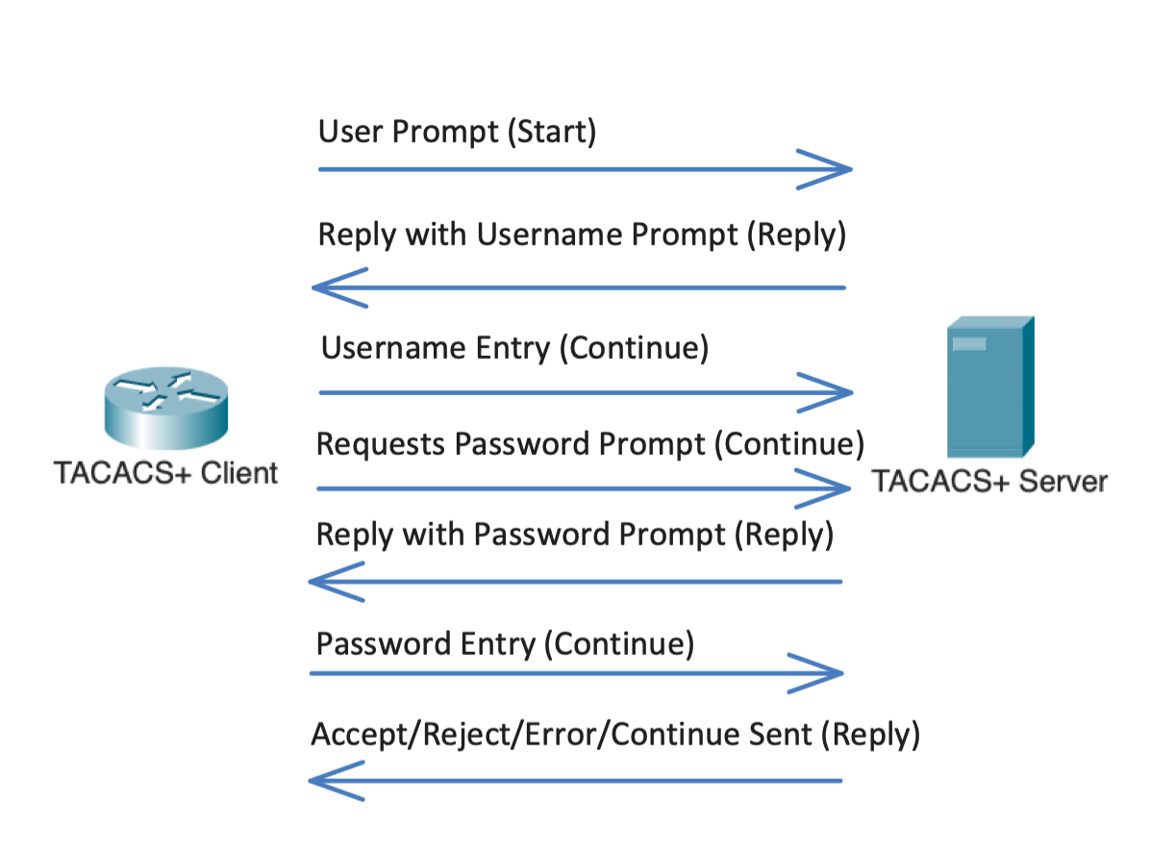

There are three different TACACS+ messages during the authentication process. Start (client -> server), Reply (server -> client) and Continue (client -> server).

1. When the TACACS+ client is connected to by a user using SSH or Telnet, a Start message is sent to the server with an authentication request.
2. The TACACS+ server sends a Reply message back with a prompt asking for a username.
3. Once a username is entered, the TACACS+ client sends a Continue message to the server.
4. The TACACS+ server send another Reply message back asking for a password.
5. Once a password is entered, the TACACS+ client sends another Continue message to the server.
6. The TACACS+ server will check the username against the password in its databases and once it’s either authenticated or rejected, one of four different reply messages can be sent: Either
7. Accept: Authentication is successful, authorization stage reached.
8. Reject: Authentication is unsuccessful.
9. Error: Authentication failed.
10. Continue: More information (MFA) is required to proceed and authenticate.

# Lab Summary:

A router which serves as the authentication client and NAS is connected to a PC hosting the VM with the TACACS+ server. Although these devices are physically connected through a single link, they logically represent separate devices. To confirm that the authentication protocols are working, a new user profile should be added to the authentication database and confirmed that it works. Incorrect logins should also be checked to make sure that the authentication isn’t set to allow all. For the TACACS+ VM server we used Window’s 2019 server and a download of the TACACS+ software.

For TACACS+, the server ran on the user computer itself rather than on a separate VM host, making the user device the both the remote client and TACACS+ host. The startup exe file was installed from the official TACACS website. Of the files downloaded after the wizard installation, “authentication,” “clients,” and “authorization” were edited for the goal of this lab. These files can be directly edited through a text editor, like Notepad++. User templates have already been made and by removing the comment tags, the text is rendered as readable code. There is also a pre-existing template for the clients. The corresponding information was filled in for all the files. This included IP addresses, usernames, passwords, and enable passwords.

From the installation wizard, a couple other useful features were installed. TacVerify looks for errors in the configuration, and admin command prompt can run TacTests that attempt to login with information without ever contacting the NAS. Restarting the service is also done on the command prompt.

Changes of configuration afterwards are documented as evidence of functionality. After all elements of configuration, the protocols are operational and AAA is in use.

# Network Diagram



# Router Commands:

Below are the minimum required commands to enable TACACS+ on whatever router you use, in our case it was a 4321. These should be executed in privilege exec:

aaa new-model

aaa authentication login default group tacacs+

aaa authentication enable default group tacacs+

tacacs server <Arbitrary Name>

address ipv4 <IP>

key <Server Key>

// TACACS+ Lab Commands Defined:

Router(config)# **aaa authentication *login default group tacacs+***

* Make the router verify login credentials with a tacacs server

Router(config)# **aaa authentication *enable default group tacacs+***

* Make the router verify privilege exec mode credentials with a tacacs server

Defining a TACACS Server

Router(config)# **tacacs server [*name*]**

* Define a tacacs server

*The router will use the ip of the tacacs server to verify credentials. You can only type this command after* aaa new-model *has been declared.*

Router(config-server-tacacs)# **address ipv4 [*ip*]**

* Defines the *ip address* of the tacacs server

Router(config-server-tacacs)# **key [*key*]**

* Define the *key* of the tacacs server

*The key on the router should match the key in the tacacs+ server’s configuration files.*

# TACACS+ Configuration with Windows Server:

|  |  |  |
| --- | --- | --- |
| Install and open VirtualBox. In Machine>New create a new machine. | |  |
| Name and select the version that matches the windows machine image you should have downloaded. In my case I used Windows 2019. | |  |
|  | |  |
|  | |  |
|  | |  |
| In the Virtual Machine go to settings>network>adapter 1 and change the NAT to Bridge Adapter (Ethernet). | |  |
| After the disk is created, launch the VM after clicking the green start arrow. Select the correct windows server image from the start-up disk. |  | |
| Click Install Now and navigate the language preferences. |  | |
| Choose either of the Standard versions. I chose the Desktop Experience. |  | |
| Click the Custom option, install Windows only. We only want an empty windows server for our TACACS+ VM. |  | |
| Select the available drive and complete the install. |  | |

DOWNLOADING and INSTALLING TACACS+

|  |  |
| --- | --- |
| Download the TACACS+ service from TACACS.net. In my case I put it on a USB and will download it from there. |  |
|  |  |
| Troubleshooting: If you are installing from a USB drive, go into the VM settings>USB and change the USB to version 3.0 instead of the default 1.1. |  |
| When the VM runs TACACS+, you will be given this prompt, click next. |  |
| Enter a key of your choosing and remember it. It will be important later. |  |
| Navigate to the TACACS.net folder and open Configuration. |  |
| Open the authentication xml document with Notepad and scroll down to the UserGroup section. Note: to enable the users remove the <!-- --!> from the section. Those were used to comment out certain parts. Changes the User Profiles as you see fit. |  |
| By default the permit will only allow *show.* commands, however you should remove the show command and leave it blank to allow all commands. |  |
| Change the local IP from the default. |  |

This IP Should match the ip address of the vm host machine. 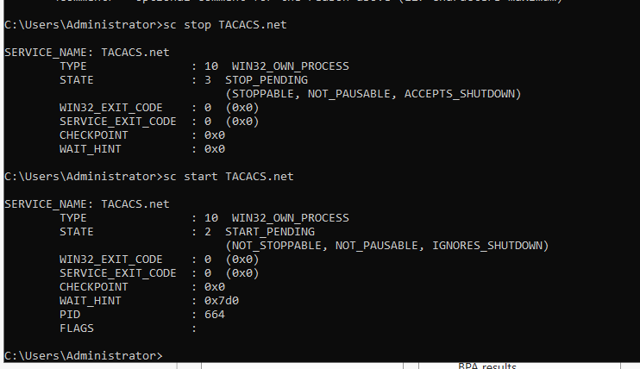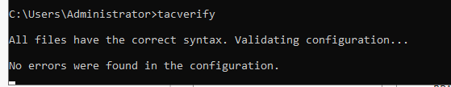

Remember to disable the firewall in this production environment.

More Show Commands:

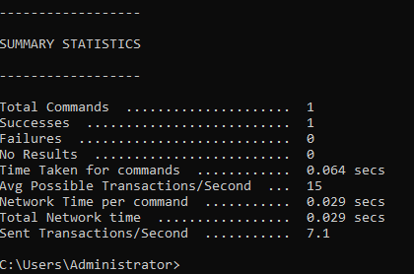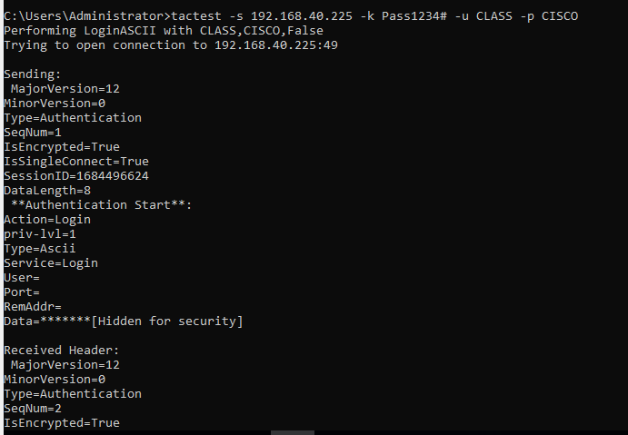

# Confirmation of Successful Authentication.

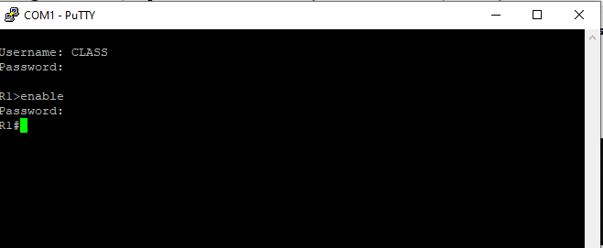

**Verification of Connection**

R1#**show run | include tacacs**

aaa authentication login default group tacacs+ enable

aaa authentication enable default group tacacs+ enable

tacacs server MAIN

R1#**show run | include aaa**

aaa new-model

aaa authentication login default group tacacs+ enable

aaa authentication enable default group tacacs+ enable

aaa session-id common

# ROUTER TACACS+ SHOW RUN:

version 16.7

service timestamps debug datetime msec

service timestamps log datetime msec

platform qfp utilization monitor load 80

no platform punt-keepalive disable-kernel-core

!

hostname R1

!

boot-start-marker

boot-end-marker

!

!

vrf definition Mgmt-intf

!

address-family ipv4

exit-address-family

!

address-family ipv6

exit-address-family

!

!

**aaa new-model**

**!**

**aaa authentication login default group tacacs+**

**aaa authentication enable default group tacacs+**

!

aaa session-id common

!

subscriber templating

vtp domain cisco

vtp mode transparent

!

multilink bundle-name authenticated

!

license udi pid ISR4321/K9 sn FDO220523GF

no license smart enable

diagnostic bootup level minimal

!

spanning-tree extend system-id

!

redundancy

mode none

!

**interface GigabitEthernet0/0/0**

**ip address 192.168.40.226 255.255.255.0**

negotiation auto

!

interface GigabitEthernet0/0/1

no ip address

shutdown

negotiation auto

!

interface Serial0/1/0

no ip address

shutdown

!

interface Serial0/1/1

no ip address

shutdown

!

interface GigabitEthernet0/2/0

no ip address

shutdown

negotiation auto

!

interface GigabitEthernet0/2/1

no ip address

shutdown

negotiation auto

!

interface GigabitEthernet0

vrf forwarding Mgmt-intf

no ip address

shutdown

negotiation auto

!

ip forward-protocol nd

ip http server

ip http authentication local

ip http secure-server

ip tftp source-interface GigabitEthernet0

!

**tacacs server <MAIN>**

**address ipv4 192.168.40.225**

**key Pass1234#**

**!**

control-plane

!

line con 0

transport input none

stopbits 1

line aux 0

stopbits 1

line vty 0 4

!

wsma agent exec

!

wsma agent config

!

wsma agent filesys

!

wsma agent notify

!

!

end

# Problems for RADIUS and TACACS+

There were, expectedly, many problems during configuration, testing, and troubleshooting, especially those stemming from the inexperience of the new interfaces and outdated software. The one that would end up causing the greatest confusion is the necessity to restart the protocol service after making major changes, such as changing the shared secret key or an IP address. This caused many understanding conflicts as configurations do not update and apply instantaneously, making certain changes and configurations not display properly from a user device perspective. This interfered with expectations of certain commands and confused the general understanding of whether a command functioned or not. Ultimately, the “service FreeRadius restart” command for RADIUS and the “sc start/stop TACACS.net” for TACACS+ became go-to commands after any edit.

For FreeRadius v3 and Oracle VirtualBox, there were relatively small issues in regard to downloading the proper bootstrap version for USB integration. This was done to download operating disk images and .exe files for the virtual machine. The problem mainly stemmed from the inability to access files from the USB with TACACS+ and transfer it to the VM. After some troubleshooting, I discovered that VirtualBox as a default supports USB 2.0, instead of USB 3.0, which was needed to file share with the latest USB’s. After an extension pack was found, the problem was resolved. All versions and options are found on the Oracle VirtualBox website. Version 6.0 was used for this lab. An important configuration directed towards VirtualBox is the necessity to change the network adapter to a *bridged adapter*. This allows the virtual machine to share and connect their information via ethernet, where it would otherwise be isolated. This was the key solution to more than a couple pinging problems.

Other quicker issues relating to TACACS+ included the lack of permission to run TacTest commands, which could be fixed by using the *admin* command prompt, done by right-clicking the command prompt application. When TACACS+ needed to be restarted but the start command says that it is already running, stop the TACACS before trying to restart it. The wording for the commands must be very accurate, and even a slight mistype can lead to later bugs, as in some cases the interface will accept the incorrect command without notifying you. This led to a problem with my TACACS+ software in that the router was not connecting to the VM because the proper interface was still in its shutdown mode. With TACACS+ especially you needed to ensure that the right brackets were deleted to get the proper parts of the software working on the Windows Machine.

# Conclusion

This revealing lab was indisputably valuable in the new interfaces to be familiar with. As my first useful application with Linux and VirtualBox, I learned and navigated a wide array of commands, specifically those of Ubuntu Linux, Oracle VirtualBox, and Notepad++. In the foreign environment, it was an achievement to be able to understand and execute the protocols fully and functionally. AAA and other security protocol and frameworks like CIA are essential parts of today’s cybersecurity architecture, and continuing to improve and expand their use will lead to a more secure and safe world for all Internet users.

# Linux Distribution Configurations

By Brennen Tse

Go Back

**Purpose:**

Configure 2 Linux distribution to later use with PfSense to connect to the internet.

**Background Information:**

Ubuntu and Debian/Linux Mint are two Linux distributions. Linux Mint is based on a Debian derivative and is becoming more popularity. The main reasons are that Linux mint is very similar with Windows desktop. Ubuntu Desktop is the older of the two and both are very usable, with Ubuntu having an interface closer to MacOS.

**Table of Contents:**

1. Installing Linux Mint
2. Installing Ubuntu
3. Problems
4. Conclusion

**Prerequisites:**

Download and install [VirtualBox](https://www.virtualbox.org/wiki/Downloads):

Download [Linux Mint](https://www.linuxmint.com/download.php):

Download [Ubuntu](https://launchpad.net/ubuntu/+cdmirrors):

# Installing Linux Mint:

|  |  |
| --- | --- |
| Create the VM instance:  Open VirtualBox and click the New VM icon (blue circle).  Enter in the VM’s name, what folder you want to store the VM files in, and the OS (Linux) and Linux version/distribution (Debian). You should select Debian because it’s similar enough to Linux Mint and Virtual Box doesn’t offer a Linux Mint version drop-down. |  |
| Graphical user interface, text, application, email  Description automatically generated  Configure the Linux Mint’s memory, I allocated 2048 MB. | Graphical user interface, text, application  Description automatically generated  Setup the hard disk, I used a virtual hard disk. |
| Graphical user interface, text, application  Description automatically generated  I left the hard disk file type as default of VDI, but if you have any plan to move this VM to another hypervisor you should choose VMDK. | Graphical user interface, text, application, email  Description automatically generated  Choose dynamically allocated. |
| After following the above steps like selecting memory size, creating a virtual hard disk, selecting the file type and storage, outline the maximum disk space the VM can take up, I set it to a default of 20 GB, but if your PC has less it can work with less. |  |
| Once you click create, this should be the screen that you’re brought to. Check all the settings to make sure they match what’s shown. Make sure that the network adapter is set to NAT if you require internet access. Then click the green start arrow to proceed. |  |
| After startup, VirtualBox prompts to choose the ISO image. Choose the Linux mint ISO you downloaded earlier and press start, then start Linux Mint if not prompted. |  |
| When you reach the live desktop, you should click the CD icon that says install Linux Mint, double click it to proceed. |  |
| Graphical user interface, application  Description automatically generated  Choose a language | Graphical user interface  Description automatically generated  And keyboard layout |
| If you plan to use multimedia, click install multimedia codec, since I’m only using this VM as a client of Pfsense I leave this unchecked and continue on. |  |
| Format the virtual hard drive by clicking on the Erase disk and install Linux Mint option. Continue with Install Now |  |
| Ignore the warning and continue. |  |
| Choose a time zone then click continue. |  |
| Set the VM’s username and password. |  |
| Click restart now to finish the installation. |  |
| When rebooting, you’ll be prompted to remove the installation medium then press Enter. The ISO file has already been removed after Linux mint was installed so you can press enter. | And that’s it, job complete for now. Now onto the Ubuntu client |

# Installing Ubuntu:

|  |  |
| --- | --- |
| Create the VM instance:  Open VirtualBox and click the New VM icon (blue circle).  Enter in the VM’s name, what folder you want to store the VM files in, and the OS (Linux) and Linux version/distribution (Ubuntu). |  |
| Graphical user interface, text, application, email  Description automatically generated  Allocate 2048 MB of memory to the VM. | Graphical user interface, text, application  Description automatically generated  Create a virtual hard disk. |
| Text  Description automatically generated  Use a dynamically allocated hard disk file. | Graphical user interface, text, application, email  Description automatically generated  I set the max size to 20 GB. |
| Click create and this should be what you see. At this point the network adapter should be set to Intel Nat for now as we have not created the Pfsense server, we will come back to this in the Pfsense configuration document. Click the green start arrow. |  |
| Locate the ubuntu start-up disk ISO you installed earlier and select it, then click start. |  |
| Install Ubuntu. |  |
| Once Ubuntu is at the installation screen, click the hard drive icon named Install Ubuntu 22.04 LTS. |  |
| Graphical user interface, application  Description automatically generated  Click on Install Ubuntu | Graphical user interface  Description automatically generated  Select the keyboard layout |
| If you wanted to use this Ubuntu VM as a full-blown desktop, then you need a normal installation with all the requisite software. However since I’m only using the web browser and Ubuntu terminal for the Pfsense configuration, I just need minimal installation.  Make sure downloading updates while installing Ubuntu is unchecked.  You can choose whether to leave install third-party software checked or unchecked based on your needs. |  |
| Format the virtual hard disk by clicking Erase disk and install Ubuntu. Then click Install now. |  |
| Select the time zone. |  |
| Specify login credentials for the account that you are going to use with this Ubuntu desktop. Write these down because if you forget them it’s a long and annoying process of resetting them.  The machine should now restart and once you login again you will be greeted by the Ubuntu desktop. |  |

# Problems:

Both Linux Mint and Ubuntu were very easy to install and straightforward to understand. The only problem I had was connectivity between the Linux Mint and Ubuntu through Pfsense in a later lab, but that was because Linux Mint wasn’t receiving the DHCP addresses.

# Conclusion:

Both Ubuntu and Linux Mint are capable and reliable Linux distributions. I couldn’t pick one over the other even if I tried. Linux based operating systems are open source and offer you a far greater level of control and customization than typical company OS’s like Windows or MacOs. In the next lab we will set-up a firewall with both of these distributions to hopefully provide more security.

# PfSense Firewall Router Network Configuration

**By Brennen Tse**

Go Back

**Purpose:**

Install PfSense to use as a firewall/router for two Linux desktops.   
**Background:**

PfSense is a version of the FreeBSD OS. The version we’re using today is open source and designed to be installed on a virtual machine to make a firewall and router for the network. Setting up PfSense is really easy with low hardware requirements. PfSense can follow either default or custom rules when it filters traffic separately. Whether it’s from the internal LAN or the Internet, you can use PfSense to set different rules and policies for each. It’s also flexible enough to be added upon with additional code to make it more useable. For example, you can include intrusion detection and prevention with PfSense (IPS/IDS).

Table of Contents:

1. Installing PfSense
2. Validating Configuration
3. PfSense GUI
4. Linux Mint Connectivity
5. Ubuntu Connectivity
6. Problems
7. Conclusion

**Prerequisites:**

Download [Pfsense](https://www.pfsense.org/download/)

Install Linux Mint or Ubuntu or Other Linux VM

# Installing PfSense:

|  |  |
| --- | --- |
| Name the pfSense VM and select BSD. |  |
| Assign 2048MB of memory | Create a virtual hard disk |
| Choose a hard disk file type, anyone works. | Graphical user interface, text, application  Description automatically generated  Dynamically allocate storage |
| Limit the data size to 20GB. |  |
| Set adapter 1 of the VM’s network to bridged adapter for wireless. |  |
| Set adapter 2 of the VM’s network to the internal PfSense-LAN. This is where the VM’s will connect to and be routed through PfSense. |  |
| Add the Pfsense ISO Image you downloaded earlier to the storage optical drive. |  |
| Rearrange the boot order so that hard disk is on top and floppy is not selected. |  |
| Once all these settings have been configured, click the green start arrow to start the VM. You will be greeted by this screen. Read and click accept. |  |
| Click Install to Install Pfsense. |  |
| Click Continue with default keymap. | Select the Auto ZFS partition. |
|  | Select the stripe as the Virtual Device. |
|  | Click yes to wipe the disk.   |
| Click No, then reboot. |  |
| Configuration Validation: Once the Pfsense firewall has been rebooted, it should automatically get an IP address. However this leads to both the WAN and the LAN being in the same network. To change that press 2. |  |
| After choosing 2, select the interface and press 2 again. Enter in the default gateway you want to use and press enter after you’ve chosen the subnet mask (/24) |  |
| Since this lab is not using IPV6, just ignore the following prompts. We will also need to configure a DHCP address, so press y, and enter the range of the client DHCP will use for addresses. |  |
| Now we can see that the LAN and WAN are in different networks which is what we want. |  |
| Can we reach the Internet though? To run a test I selected 7 and the general IP address of the internet (0.0.0.0) and you should be able to successfully reach and ping. |  |
| Now we go back to our Linux VM’s that we configured in the last lab. Change Linux mint’s network from intent to Pfsense-Lan to be inside the Pfsense LAN. |  |
|  |  |
| Do the same for the Ubuntu Desktop. |  |
| Verify IP Address: To verify the IP address, type in ip addr, which should display a DHCP assigned ip address within the selected range. |  |
| Access the pfSense GUI through https://10.1.1.1 |  |
| Use the general username and password of admin and admin to login to pfsense and start configuring. |  |
| Configure the default commands for Pfsense except for page 4, where you must ensure that the Block Private Networks remains unchecked to allow for network traffic and Internet connectivity on the local LAN. |  |
| Once you have finished setting up, reload the configuration to save your changes. |  |
| Test connectivity: The IP addresses should be from the DHCP server, and pinging the public IP address of 8.8.8.8 should work and be successful. |  |
| You can also browse the internet. |  |
|  |  |
| Ubuntu Connectivity Test: You can also check the Ubuntu Desktop as it too should have a DHCP address. If you ping the public IP it should go through. |  |
| To make doubly sure, you can do a traceroute command to see the path, and we can see that it goes through the PFSense firewall at pfsense.home.arpa. |  |
| You can also ping the Linux Mint VM from the Ubuntu Desktop too. |  |
| Since both are on the Internal LAN, the traffic is not routed through the Pfsense Internet interface. |  |
| We can also access google through Ubuntu desktop. |  |
| As one final check, we can see through the PFsense DHCP leases that both VM’s are online and working. |  |

# Problems:

The main problems I had with PfSense were with the DHCP server and connectivity. The DHCP server was originally not distributing IP addresses and I wasn’t sure what the problem was. I then discovered that the range for the IP addresses it was assigned was erroneous and prevented any addresses from being assigned. Second, the Linux Mint machine was using the wrong adapter instead of PfSense_Lan it was using the old one of Intnet which prevented pinging across.

# Conclusion:

PfSense is a strong candidate for those looking for a flexible and impressive alternative to physical routers and firewalls. With its ease of use, low hardware requirements and extensive firewall settings, any operator using virtual machines may want to consider using PfSense to strengthen their network.

CCNP ROUTING AND SWITCHING



Configuring

VRF Lite

B Brennen Tse . 4/19/2022

### Configuring VRF Lite

Go Back

**Purpose:**

The purpose of this lab is to configure VRF Lite on a single network to virtually separate traffic belonging to each VRF. Using OSPF and sub interfaces, traffic can be separated and pinging between the two networks is prevented.

**Background:**

Virtual Routing and Forwarding (VRF) is a technology that allows multiple routing table instances to exist in the same router, meaning that overlapping IP addresses can be used without conflicts. VRFs work at Layer 3 of the OSI model as network isolation/virtualization, helping separate network traffic between two different networks using the same hardware. Some of the advantages of using VRF are that it allows for multiple routes on one device, segmenting network paths, MPLS, multiple routing tables and multiple VPNs.

**VRFs vs VLANS**

VRFs and VLANS use essentially the same processes of virtualization. They do have different uses and work somewhat differently. Again we know that VRFs work on Layer 3 and help multiple VRs work on a single router or other hardware. VLANs work on Layer 2 and split ethernet networks, either for network security or performance and help eliminate constraints on the physical layout of the network.

**VRF vs VRF Lite**

There are two types of VRF, VRF and VRF Lite. VRF uses MPLS, which distributes route information across routers and helps it move traffic across service provider networks. VRF lite does not use MPLS, instead the route information is kept locally in routers routing and forwarding tables and can be shared through IGPs like OSPF. In this case we used VRF Lite because our LAN used the same devices and we needed separation between those networks.

**Lab Summary:**

When configuring VRF Lite for IPv4, I set up four 4321 Cisco Routers, with all routers connected to each other by a crossover cable and the end routers connected to two PCs respectively with a straight-through. For the routers, I used the network of 10.0.0.0/16 and 10.0.0.0/24 for the PCs. The Loopbacks were in the networks of 192.168.0.0/16. PC1 and 3 were Apple and PC2 and 4 were Facebook. Subinterfaces and encapsulation were designated as either 10 for apple of 11 for Facebook. We set up OSPF throughout all routers to exchange routing information. Show commands stated below were used to confirm that VFR was configured correctly and pinging was used to ensure VRF was doing its job.

Lab Commands:

show ip route vrf Facebook

**This command shows the VRF routing table for a specific VRF.**

show ip vrf int

**This command shows the interfaces using VRF and to which VRF they are assigned.**

ip vrf forwarding

**This command adds an interface from a VRF.**

ip vrf _

**This command creates the VRF instance and gives it a name.**

ip ospf _ vrf _

**This command splits the router into multiple virtual routers through VRF.**

Topology Diagram

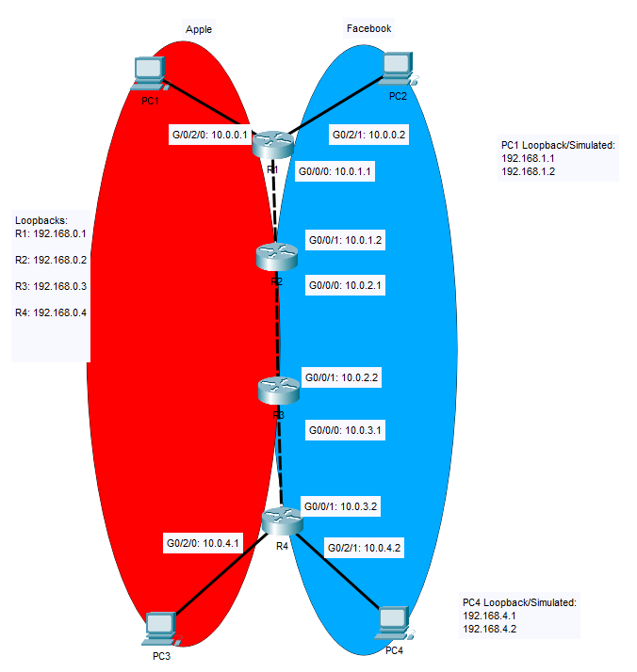

Addressing Table:

|  |  |  |  |
| --- | --- | --- | --- |
| **Devices** | **Interface** | **IP Address** | **Link-Local Addresses** |
| **R1** | **G0/0/0** | **10.0.1.1** | **192.168.0.1** |
| **G0/2/0** | **10.0.0.1** |
| **G0/2/1** | **10.0.0.2** |
| **R2** | **G0/0/0** | **10.0.2.1** | **192.168.0.2** |
| **G0/0/1** | **10.0.1.2** |
| **R3** | **G0/0/0** | **10.0.3.1** | **192.168.0.3** |
| **G0/0/1** | **10.0.2.1** |
| **R4** | **G0/0/1** | **10.0.3.2** | **192.168.0.4** |
| **G0/2/0** | **10.0.4.1** |
| **G0/2/1** | **10.0.4.2** |
| **PC1** | **NIC** | **10.0.0.1** | **192.168.1.1** |
| **PC2** | **NIC** | **10.0.0.2** | **192.168.1.2** |
| **PC3** | **NIC** | **10.0.0.3** | **192.168.4.1** |
| **PC4** | **NIC** | **10.0.0.4** | **192.168.4.2** |

**R1 Running Config**

Conclusion:

R1

hostname R1

!

boot-start-marker

boot-end-marker

!

!

vrf definition Mgmt-intf

!

address-family ipv4

exit-address-family

!

address-family ipv6

exit-address-family

!

!

no aaa new-model

!

ip vrf Apple

description Extranet

!

ip vrf Facebook

description Intranet

!

subscriber templating

ipv6 unicast-routing

!

!

multilink bundle-name authenticated

!

!

license udi pid ISR4321/K9 sn FDO220523GF

no license smart enable

diagnostic bootup level minimal

!

spanning-tree extend system-id

!

!

!

!

redundancy

mode none

!

interface Loopback0

ip address 192.168.100.1 255.255.255.255

ipv6 address 2001:DB8:ACAD:A::1/64

!

interface GigabitEthernet0/0/0

no ip address

negotiation auto

!

interface GigabitEthernet0/0/0.1

encapsulation dot1Q 10

ip vrf forwarding Apple

ip address 10.10.1.1 255.255.255.0

!

interface GigabitEthernet0/0/0.2

encapsulation dot1Q 11

ip vrf forwarding Facebook

ip address 10.11.1.1 255.255.255.0

!

interface GigabitEthernet0/0/1

no ip address

negotiation auto

!

interface Serial0/1/0

no ip address

shutdown

!

interface Serial0/1/1

no ip address

shutdown

!

interface GigabitEthernet0/2/0

ip vrf forwarding Apple

ip address 10.0.0.1 255.255.255.0

negotiation auto

!

interface GigabitEthernet0/2/1

ip vrf forwarding Facebook

ip address 192.168.0.2 255.255.255.0

negotiation auto

!

interface GigabitEthernet0

vrf forwarding Mgmt-intf

no ip address

shutdown

negotiation auto

!

router ospf 10 vrf Apple

router-id 1.1.1.10

network 10.0.0.0 0.0.0.255 area 0

network 10.10.1.0 0.0.0.255 area 0

!

router ospf 11 vrf Facebook

router-id 1.1.1.11

network 192.168.0.0 0.0.0.255 area 0

network 10.11.1.0 0.0.0.255 area 0

!

ip forward-protocol nd

ip http server

ip http authentication local

ip http secure-server

ip tftp source-interface GigabitEthernet0

ip route vrf Facebook 0.0.0.0 0.0.0.0 10.0.0.2

!

control-plane

!

!

line con 0

transport input none

stopbits 1

line aux 0

stopbits 1

line vty 0 4

login

!

wsma agent exec

!

wsma agent config

!

wsma agent filesys

!

wsma agent notify

!

!

end

**R1#show ip ospf neighbor**

Neighbor ID Pri State Dead Time Address Interface

2.2.2.11 1 FULL/DR 00:00:37 10.11.1.2 GigabitEthernet0/0/0.2

2.2.2.10 1 FULL/DR 00:00:30 10.10.1.2 GigabitEthernet0/0/0.1

**R1#show ip ospf int br**

Interface PID Area IP Address/Mask Cost State Nbrs F/C

Gi0/0/0.2 11 0 10.11.1.1/24 1 BDR 1/1

Gi0/2/1 11 0 192.168.0.2/24 1 DOWN 0/0

Gi0/0/0.1 10 0 10.10.1.1/24 1 BDR 1/1

Gi0/2/0 10 0 10.0.0.1/24 1 DR 0/0

**R1#show ip route vrf Facebook**

Routing Table: Facebook

Codes: L - local, C - connected, S - static, R - RIP, M - mobile, B - BGP

D - EIGRP, EX - EIGRP external, O - OSPF, IA - OSPF inter area

N1 - OSPF NSSA external type 1, N2 - OSPF NSSA external type 2

E1 - OSPF external type 1, E2 - OSPF external type 2

i - IS-IS, su - IS-IS summary, L1 - IS-IS level-1, L2 - IS-IS level-2

ia - IS-IS inter area, * - candidate default, U - per-user static route

o - ODR, P - periodic downloaded static route, H - NHRP, l - LISP

a - application route

+ - replicated route, % - next hop override, p - overrides from PfR

Gateway of last resort is not set

10.0.0.0/8 is variably subnetted, 4 subnets, 2 masks

C 10.11.1.0/24 is directly connected, GigabitEthernet0/0/0.2

L 10.11.1.1/32 is directly connected, GigabitEthernet0/0/0.2

O 10.11.2.0/24 [110/2] via 10.11.1.2, 00:02:58, GigabitEthernet0/0/0.2

O 10.11.3.0/24 [110/3] via 10.11.1.2, 00:02:58, GigabitEthernet0/0/0.2

192.168.11.0/32 is subnetted, 1 subnets

O 192.168.11.4 [110/4] via 10.11.1.2, 00:02:58, GigabitEthernet0/0/0.2

**R1#show ip route vrf Apple**

Routing Table: Apple

Codes: L - local, C - connected, S - static, R - RIP, M - mobile, B - BGP

D - EIGRP, EX - EIGRP external, O - OSPF, IA - OSPF inter area

N1 - OSPF NSSA external type 1, N2 - OSPF NSSA external type 2

E1 - OSPF external type 1, E2 - OSPF external type 2

i - IS-IS, su - IS-IS summary, L1 - IS-IS level-1, L2 - IS-IS level-2

ia - IS-IS inter area, * - candidate default, U - per-user static route

o - ODR, P - periodic downloaded static route, H - NHRP, l - LISP

a - application route

+ - replicated route, % - next hop override, p - overrides from PfR

Gateway of last resort is not set

10.0.0.0/8 is variably subnetted, 6 subnets, 2 masks

C 10.0.0.0/24 is directly connected, GigabitEthernet0/2/0

L 10.0.0.1/32 is directly connected, GigabitEthernet0/2/0

C 10.10.1.0/24 is directly connected, GigabitEthernet0/0/0.1

L 10.10.1.1/32 is directly connected, GigabitEthernet0/0/0.1

O 10.10.2.0/24 [110/2] via 10.10.1.2, 00:03:06, GigabitEthernet0/0/0.1

O 10.10.3.0/24 [110/3] via 10.10.1.2, 00:03:06, GigabitEthernet0/0/0.1

192.168.10.0/32 is subnetted, 1 subnets

O 192.168.10.4 [110/4] via 10.10.1.2, 00:03:06, GigabitEthernet0/0/0.1

**R1#show ip vrf int**

Interface IP-Address VRF Protocol

Gi0/0/0.1 10.10.1.1 Apple up

Gi0/2/0 10.0.0.1 Apple up

Gi0/0/0.2 10.11.1.1 Facebook up

Gi0/2/1 192.168.0.2 Facebook down

Gi0 unassigned Mgmt-intf down

**R1#show ip ospf int br**

Interface PID Area IP Address/Mask Cost State Nbrs F/C

Gi0/0/0.2 11 0 10.11.1.1/24 1 BDR 1/1

Gi0/2/1 11 0 192.168.0.2/24 1 DOWN 0/0

Gi0/0/0.1 10 0 10.10.1.1/24 1 BDR 1/1

Gi0/2/0 10 0 10.0.0.1/24 1 DR 0/0

R1#show ip route

Codes: L - local, C - connected, S - static, R - RIP, M - mobile, B - BGP

D - EIGRP, EX - EIGRP external, O - OSPF, IA - OSPF inter area

N1 - OSPF NSSA external type 1, N2 - OSPF NSSA external type 2

E1 - OSPF external type 1, E2 - OSPF external type 2

i - IS-IS, su - IS-IS summary, L1 - IS-IS level-1, L2 - IS-IS level-2

ia - IS-IS inter area, * - candidate default, U - per-user static route

o - ODR, P - periodic downloaded static route, H - NHRP, l - LISP

a - application route

+ - replicated route, % - next hop override, p - overrides from PfR

Gateway of last resort is not set

192.168.100.0/32 is subnetted, 1 subnets

C 192.168.100.1 is directly connected, Loopback0

R1#

**R2 Running Config**

Current configuration : 2165 bytes

!

! Last configuration change at 15:59:33 UTC Wed Mar 23 2022

!

version 15.5

service timestamps debug datetime msec

service timestamps log datetime msec

no platform punt-keepalive disable-kernel-core

!

hostname R2

!

boot-start-marker

boot-end-marker

!

!

vrf definition Mgmt-intf

!

address-family ipv4

exit-address-family

!

address-family ipv6

exit-address-family

!

!

no aaa new-model

!

ip vrf Apple

description Extranet

!

ip vrf Facebook

description Intranet

!

!

ipv6 unicast-routing

!

subscriber templating

multilink bundle-name authenticated

!

license udi pid ISR4321/K9 sn FDO214420HM

!

spanning-tree extend system-id

!

!

redundancy

mode none

!

!

vlan internal allocation policy ascending

!

interface Loopback0

ip address 192.168.0.2 255.255.255.255

ipv6 address 2001:DB8:ACAD:B::1/64

!

interface GigabitEthernet0/0/0

no ip address

negotiation auto

!

interface GigabitEthernet0/0/0.1

encapsulation dot1Q 10

ip vrf forwarding Apple

ip address 10.10.2.1 255.255.255.0

!

interface GigabitEthernet0/0/0.2

encapsulation dot1Q 11

ip vrf forwarding Facebook

ip address 10.11.2.1 255.255.255.0

!

interface GigabitEthernet0/0/1

no ip address

negotiation auto

!

interface GigabitEthernet0/0/1.1

encapsulation dot1Q 10

ip vrf forwarding Apple

ip address 10.10.1.2 255.255.255.0

!

interface GigabitEthernet0/0/1.2

encapsulation dot1Q 11

ip vrf forwarding Facebook

ip address 10.11.1.2 255.255.255.0

!

interface Serial0/1/0

no ip address

shutdown

!

interface Serial0/1/1

no ip address

shutdown

!

interface GigabitEthernet0

vrf forwarding Mgmt-intf

no ip address

shutdown

negotiation auto

!

interface Vlan1

no ip address

shutdown

!

router ospf 10 vrf Apple

router-id 2.2.2.10

network 10.10.1.0 0.0.0.255 area 0

network 10.10.2.0 0.0.0.255 area 0

!

router ospf 11 vrf Facebook

router-id 2.2.2.11

network 10.11.1.0 0.0.0.255 area 0

network 10.11.2.0 0.0.0.255 area 0

!

ip forward-protocol nd

no ip http server

no ip http secure-server

ip tftp source-interface GigabitEthernet0

control-plane

!

!

line con 0

stopbits 1

line aux 0

stopbits 1

line vty 0 4

login

!

!

end

**R2#show ip ospf neighbor**

Neighbor ID Pri State Dead Time Address Interface

3.3.3.11 1 FULL/DR 00:00:32 10.11.2.2 GigabitEthernet0/0/0.2

1.1.1.11 1 FULL/BDR 00:00:38 10.11.1.1 GigabitEthernet0/0/1.2

3.3.3.10 1 FULL/DR 00:00:38 10.10.2.2 GigabitEthernet0/0/0.1

1.1.1.10 1 FULL/BDR 00:00:38 10.10.1.1 GigabitEthernet0/0/1.1

R2#show ip ospf int br

Interface PID Area IP Address/Mask Cost State Nbrs F/C

Gi0/0/0.2 11 0 10.11.2.1/24 1 BDR 1/1

Gi0/0/1.2 11 0 10.11.1.2/24 1 DR 1/1

Gi0/0/0.1 10 0 10.10.2.1/24 1 BDR 1/1

Gi0/0/1.1 10 0 10.10.1.2/24 1 DR 1/1

**R2#show ip route vrf Facebook**

Routing Table: Facebook

Codes: L - local, C - connected, S - static, R - RIP, M - mobile, B - BGP

D - EIGRP, EX - EIGRP external, O - OSPF, IA - OSPF inter area

N1 - OSPF NSSA external type 1, N2 - OSPF NSSA external type 2

E1 - OSPF external type 1, E2 - OSPF external type 2

i - IS-IS, su - IS-IS summary, L1 - IS-IS level-1, L2 - IS-IS level-2

ia - IS-IS inter area, * - candidate default, U - per-user static route

o - ODR, P - periodic downloaded static route, H - NHRP, l - LISP

a - application route

+ - replicated route, % - next hop override, p - overrides from PfR

Gateway of last resort is not set

10.0.0.0/8 is variably subnetted, 5 subnets, 2 masks

C 10.11.1.0/24 is directly connected, GigabitEthernet0/0/1.2

L 10.11.1.2/32 is directly connected, GigabitEthernet0/0/1.2

C 10.11.2.0/24 is directly connected, GigabitEthernet0/0/0.2

L 10.11.2.1/32 is directly connected, GigabitEthernet0/0/0.2

O 10.11.3.0/24 [110/2] via 10.11.2.2, 00:33:12, GigabitEthernet0/0/0.2

192.168.11.0/32 is subnetted, 1 subnets

O 192.168.11.4 [110/3] via 10.11.2.2, 00:33:02, GigabitEthernet0/0/0.2

**R2#show ip route vrf Apple**

Routing Table: Apple

Codes: L - local, C - connected, S - static, R - RIP, M - mobile, B - BGP

D - EIGRP, EX - EIGRP external, O - OSPF, IA - OSPF inter area

N1 - OSPF NSSA external type 1, N2 - OSPF NSSA external type 2

E1 - OSPF external type 1, E2 - OSPF external type 2

i - IS-IS, su - IS-IS summary, L1 - IS-IS level-1, L2 - IS-IS level-2

ia - IS-IS inter area, * - candidate default, U - per-user static route

o - ODR, P - periodic downloaded static route, H - NHRP, l - LISP

a - application route

+ - replicated route, % - next hop override, p - overrides from PfR

Gateway of last resort is not set

10.0.0.0/8 is variably subnetted, 6 subnets, 2 masks

O 10.0.0.0/24 [110/2] via 10.10.1.1, 00:04:59, GigabitEthernet0/0/1.1

C 10.10.1.0/24 is directly connected, GigabitEthernet0/0/1.1

L 10.10.1.2/32 is directly connected, GigabitEthernet0/0/1.1

C 10.10.2.0/24 is directly connected, GigabitEthernet0/0/0.1

L 10.10.2.1/32 is directly connected, GigabitEthernet0/0/0.1

O 10.10.3.0/24 [110/2] via 10.10.2.2, 00:33:18, GigabitEthernet0/0/0.1

192.168.10.0/32 is subnetted, 1 subnets

O 192.168.10.4 [110/3] via 10.10.2.2, 00:33:08, GigabitEthernet0/0/0.1

**R2#show ip vrf int**

Interface IP-Address VRF Protocol

Gi0/0/0.1 10.10.2.1 Apple up

Gi0/0/1.1 10.10.1.2 Apple up

Gi0/0/0.2 10.11.2.1 Facebook up

Gi0/0/1.2 10.11.1.2 Facebook up

Gi0 unassigned Mgmt-intf down

**R2#show ip ospf int br**

Interface PID Area IP Address/Mask Cost State Nbrs F/C

Gi0/0/0.2 11 0 10.11.2.1/24 1 BDR 1/1

Gi0/0/1.2 11 0 10.11.1.2/24 1 DR 1/1

Gi0/0/0.1 10 0 10.10.2.1/24 1 BDR 1/1

Gi0/0/1.1 10 0 10.10.1.2/24 1 DR 1/1

**R2#show ip route**

Codes: L - local, C - connected, S - static, R - RIP, M - mobile, B - BGP

D - EIGRP, EX - EIGRP external, O - OSPF, IA - OSPF inter area

N1 - OSPF NSSA external type 1, N2 - OSPF NSSA external type 2

E1 - OSPF external type 1, E2 - OSPF external type 2

i - IS-IS, su - IS-IS summary, L1 - IS-IS level-1, L2 - IS-IS level-2

ia - IS-IS inter area, * - candidate default, U - per-user static route

o - ODR, P - periodic downloaded static route, H - NHRP, l - LISP

a - application route

+ - replicated route, % - next hop override, p - overrides from PfR

Gateway of last resort is not set

192.168.0.0/32 is subnetted, 1 subnets

C 192.168.0.2 is directly connected, Loopback0

**R3 Running Config**

version 15.5

service timestamps debug datetime msec

service timestamps log datetime msec

no platform punt-keepalive disable-kernel-core

!

hostname R3

!

boot-start-marker

boot-end-marker

!

!

vrf definition Mgmt-intf

!

address-family ipv4

exit-address-family

!

address-family ipv6

exit-address-family

!

!

no aaa new-model

!

ip vrf Apple

description Extranet

!

ip vrf Facebook

description Intranet

!

!

!

ipv6 unicast-routing

!

subscriber templating

multilink bundle-name authenticated

!

!

!

!

license udi pid ISR4321/K9 sn FDO214414DZ

!

spanning-tree extend system-id

!

!

redundancy

mode none

!

!

vlan internal allocation policy ascending

!

interface Loopback0

ip address 192.168.0.3 255.255.255.255

ipv6 address 2001:DB8:ACAD:C::1/64

!

interface GigabitEthernet0/0/0

no ip address

negotiation auto

!

interface GigabitEthernet0/0/0.1

encapsulation dot1Q 10

ip vrf forwarding Apple

ip address 10.10.3.1 255.255.255.0

!

interface GigabitEthernet0/0/0.2

encapsulation dot1Q 11

ip vrf forwarding Facebook

ip address 10.11.3.1 255.255.255.0

!

interface GigabitEthernet0/0/1

no ip address

negotiation auto

!

interface GigabitEthernet0/0/1.1

encapsulation dot1Q 10

ip vrf forwarding Apple

ip address 10.10.2.2 255.255.255.0

!

interface GigabitEthernet0/0/1.2

encapsulation dot1Q 11

ip vrf forwarding Facebook

ip address 10.11.2.2 255.255.255.0

!

interface Serial0/1/0

no ip address

shutdown

!

interface Serial0/1/1

no ip address

shutdown

!

interface GigabitEthernet0

vrf forwarding Mgmt-intf

no ip address

shutdown

negotiation auto

!

interface Vlan1

no ip address

shutdown

!

router ospf 10 vrf Apple

router-id 3.3.3.10

network 10.10.2.0 0.0.0.255 area 0

network 10.10.3.0 0.0.0.255 area 0

!

router ospf 11 vrf Facebook

router-id 3.3.3.11

network 10.11.2.0 0.0.0.255 area 0

network 10.11.3.0 0.0.0.255 area 0

!

ip forward-protocol nd

no ip http server

no ip http secure-server

ip tftp source-interface GigabitEthernet0

!

!

!

!

!

control-plane

!

!

line con 0

stopbits 1

line aux 0

stopbits 1

line vty 0 4

login

!

!

end

**R3#show ip ospf neighbor**

Neighbor ID Pri State Dead Time Address Interface

4.4.4.11 1 FULL/DR 00:00:34 10.11.3.2 GigabitEthernet0/0/0.2

2.2.2.11 1 FULL/BDR 00:00:30 10.11.2.1 GigabitEthernet0/0/1.2

4.4.4.10 1 FULL/DR 00:00:33 10.10.3.2 GigabitEthernet0/0/0.1

2.2.2.10 1 FULL/BDR 00:00:38 10.10.2.1 GigabitEthernet0/0/1.1

**R3#show ip ospf int br**

Interface PID Area IP Address/Mask Cost State Nbrs F/C

Gi0/0/0.2 11 0 10.11.3.1/24 1 BDR 1/1

Gi0/0/1.2 11 0 10.11.2.2/24 1 DR 1/1

Gi0/0/0.1 10 0 10.10.3.1/24 1 BDR 1/1

Gi0/0/1.1 10 0 10.10.2.2/24 1 DR 1/1

R3#show ip int br

Interface IP-Address OK? Method Status Protocol

GigabitEthernet0/0/0 unassigned YES unset up up

GigabitEthernet0/0/0.1 10.10.3.1 YES manual up up

GigabitEthernet0/0/0.2 10.11.3.1 YES manual up up

GigabitEthernet0/0/1 unassigned YES unset up up

GigabitEthernet0/0/1.1 10.10.2.2 YES manual up up

GigabitEthernet0/0/1.2 10.11.2.2 YES manual up up

Serial0/1/0 unassigned YES manual administratively down down

Serial0/1/1 unassigned YES manual administratively down down

GigabitEthernet0 unassigned YES unset administratively down down

Loopback0 192.168.0.3 YES manual up up

Vlan1 unassigned YES unset administratively down down

**R3#show ip route vrf Facebook**

Routing Table: Facebook

Codes: L - local, C - connected, S - static, R - RIP, M - mobile, B - BGP

D - EIGRP, EX - EIGRP external, O - OSPF, IA - OSPF inter area

N1 - OSPF NSSA external type 1, N2 - OSPF NSSA external type 2

E1 - OSPF external type 1, E2 - OSPF external type 2

i - IS-IS, su - IS-IS summary, L1 - IS-IS level-1, L2 - IS-IS level-2

ia - IS-IS inter area, * - candidate default, U - per-user static route

o - ODR, P - periodic downloaded static route, H - NHRP, l - LISP

a - application route

+ - replicated route, % - next hop override, p - overrides from PfR

Gateway of last resort is not set

10.0.0.0/8 is variably subnetted, 5 subnets, 2 masks

O 10.11.1.0/24 [110/2] via 10.11.2.1, 00:09:07, GigabitEthernet0/0/1.2

C 10.11.2.0/24 is directly connected, GigabitEthernet0/0/1.2

L 10.11.2.2/32 is directly connected, GigabitEthernet0/0/1.2

C 10.11.3.0/24 is directly connected, GigabitEthernet0/0/0.2

L 10.11.3.1/32 is directly connected, GigabitEthernet0/0/0.2

192.168.11.0/32 is subnetted, 1 subnets

O 192.168.11.4 [110/2] via 10.11.3.2, 00:34:44, GigabitEthernet0/0/0.2

**R3#show ip route vrf Apple**

Routing Table: Apple

Codes: L - local, C - connected, S - static, R - RIP, M - mobile, B - BGP

D - EIGRP, EX - EIGRP external, O - OSPF, IA - OSPF inter area

N1 - OSPF NSSA external type 1, N2 - OSPF NSSA external type 2

E1 - OSPF external type 1, E2 - OSPF external type 2

i - IS-IS, su - IS-IS summary, L1 - IS-IS level-1, L2 - IS-IS level-2

ia - IS-IS inter area, * - candidate default, U - per-user static route

o - ODR, P - periodic downloaded static route, H - NHRP, l - LISP

a - application route

+ - replicated route, % - next hop override, p - overrides from PfR

Gateway of last resort is not set

10.0.0.0/8 is variably subnetted, 6 subnets, 2 masks

O 10.0.0.0/24 [110/3] via 10.10.2.1, 00:06:32, GigabitEthernet0/0/1.1

O 10.10.1.0/24 [110/2] via 10.10.2.1, 00:09:13, GigabitEthernet0/0/1.1

C 10.10.2.0/24 is directly connected, GigabitEthernet0/0/1.1

L 10.10.2.2/32 is directly connected, GigabitEthernet0/0/1.1

C 10.10.3.0/24 is directly connected, GigabitEthernet0/0/0.1

L 10.10.3.1/32 is directly connected, GigabitEthernet0/0/0.1

192.168.10.0/32 is subnetted, 1 subnets

O 192.168.10.4 [110/2] via 10.10.3.2, 00:34:51, GigabitEthernet0/0/0.1

**R3#show ip vrf int**

Interface IP-Address VRF Protocol

Gi0/0/0.1 10.10.3.1 Apple up

Gi0/0/1.1 10.10.2.2 Apple up

Gi0/0/0.2 10.11.3.1 Facebook up

Gi0/0/1.2 10.11.2.2 Facebook up

Gi0 unassigned Mgmt-intf down

**R3#show ip ospf int br**

Interface PID Area IP Address/Mask Cost State Nbrs F/C

Gi0/0/0.2 11 0 10.11.3.1/24 1 BDR 1/1

Gi0/0/1.2 11 0 10.11.2.2/24 1 DR 1/1

Gi0/0/0.1 10 0 10.10.3.1/24 1 BDR 1/1

Gi0/0/1.1 10 0 10.10.2.2/24 1 DR 1/1

**R3#show ip route**

Codes: L - local, C - connected, S - static, R - RIP, M - mobile, B - BGP

D - EIGRP, EX - EIGRP external, O - OSPF, IA - OSPF inter area

N1 - OSPF NSSA external type 1, N2 - OSPF NSSA external type 2

E1 - OSPF external type 1, E2 - OSPF external type 2

i - IS-IS, su - IS-IS summary, L1 - IS-IS level-1, L2 - IS-IS level-2

ia - IS-IS inter area, * - candidate default, U - per-user static route

o - ODR, P - periodic downloaded static route, H - NHRP, l - LISP

a - application route

+ - replicated route, % - next hop override, p - overrides from PfR

Gateway of last resort is not set

192.168.0.0/32 is subnetted, 1 subnets

C 192.168.0.3 is directly connected, Loopback0

**R4 Running Config**

version 15.5

service timestamps debug datetime msec

service timestamps log datetime msec

no platform punt-keepalive disable-kernel-core

!

hostname R4

!

boot-start-marker

boot-end-marker

!

!

vrf definition Mgmt-intf

!

address-family ipv4

exit-address-family

!

address-family ipv6

exit-address-family

!

!

no aaa new-model

!

ip vrf Apple

description Extranet

!

ip vrf Facebook

description Intranet

!

!

!

!

!

!

ipv6 unicast-routing

subscriber templating

vtp domain cisco

vtp mode transparent

multilink bundle-name authenticated

!

!

!

!

license udi pid ISR4321/K9 sn FDO214417Q4

!

spanning-tree extend system-id

!

!

redundancy

mode none

!

!

vlan internal allocation policy ascending

!

interface Loopback1

ip vrf forwarding Apple

ip address 192.168.10.4 255.255.255.255

ipv6 address 2001:DB8:ACAD:D::1/64

!

interface Loopback2

ip vrf forwarding Facebook

ip address 192.168.11.4 255.255.255.255

!

interface GigabitEthernet0/0/0

no ip address

negotiation auto

!

interface GigabitEthernet0/0/1

no ip address

negotiation auto

!

interface GigabitEthernet0/0/1.1

encapsulation dot1Q 10

ip vrf forwarding Apple

ip address 10.10.3.2 255.255.255.0

!

interface GigabitEthernet0/0/1.2

encapsulation dot1Q 11

ip vrf forwarding Facebook

ip address 10.11.3.2 255.255.255.0

!

interface Serial0/1/0

no ip address

shutdown

!

interface Serial0/1/1

no ip address

shutdown

!

interface GigabitEthernet0

vrf forwarding Mgmt-intf

no ip address

shutdown

negotiation auto

!

interface Vlan1

no ip address

shutdown

!

router ospf 10 vrf Apple

router-id 4.4.4.10

network 10.10.3.0 0.0.0.255 area 0

network 192.168.10.4 0.0.0.0 area 0

!

router ospf 11 vrf Facebook

router-id 4.4.4.11

network 10.11.3.0 0.0.0.255 area 0

network 192.168.11.4 0.0.0.0 area 0

!

ip forward-protocol nd

no ip http server

no ip http secure-server

ip tftp source-interface GigabitEthernet0

control-plane

!

!

line con 0

stopbits 1

line aux 0

stopbits 1

line vty 0 4

login

!

!

end

**R4#show ip ospf neighbor**

Neighbor ID Pri State Dead Time Address Interface

3.3.3.11 1 FULL/BDR 00:00:31 10.11.3.1 GigabitEthernet0/0/1.2

3.3.3.10 1 FULL/BDR 00:00:39 10.10.3.1 GigabitEthernet0/0/1.1

**R4#show ip ospf int br**

Interface PID Area IP Address/Mask Cost State Nbrs F/C

Lo2 11 0 192.168.11.4/32 1 LOOP 0/0

Gi0/0/1.2 11 0 10.11.3.2/24 1 DR 1/1

Lo1 10 0 192.168.10.4/32 1 LOOP 0/0

Gi0/0/1.1 10 0 10.10.3.2/24 1 DR 1/1

**R4#show ip route vrf Facebook**

Routing Table: Facebook

Codes: L - local, C - connected, S - static, R - RIP, M - mobile, B - BGP

D - EIGRP, EX - EIGRP external, O - OSPF, IA - OSPF inter area

N1 - OSPF NSSA external type 1, N2 - OSPF NSSA external type 2

E1 - OSPF external type 1, E2 - OSPF external type 2

i - IS-IS, su - IS-IS summary, L1 - IS-IS level-1, L2 - IS-IS level-2

ia - IS-IS inter area, * - candidate default, U - per-user static route

o - ODR, P - periodic downloaded static route, H - NHRP, l - LISP

a - application route

+ - replicated route, % - next hop override, p - overrides from PfR

Gateway of last resort is not set

10.0.0.0/8 is variably subnetted, 4 subnets, 2 masks

O 10.11.1.0/24 [110/3] via 10.11.3.1, 00:10:47, GigabitEthernet0/0/1.2

O 10.11.2.0/24 [110/2] via 10.11.3.1, 00:36:24, GigabitEthernet0/0/1.2

C 10.11.3.0/24 is directly connected, GigabitEthernet0/0/1.2

L 10.11.3.2/32 is directly connected, GigabitEthernet0/0/1.2

192.168.11.0/32 is subnetted, 1 subnets

C 192.168.11.4 is directly connected, Loopback2

**R4#show ip route vrf Apple**

Routing Table: Apple

Codes: L - local, C - connected, S - static, R - RIP, M - mobile, B - BGP

D - EIGRP, EX - EIGRP external, O - OSPF, IA - OSPF inter area

N1 - OSPF NSSA external type 1, N2 - OSPF NSSA external type 2

E1 - OSPF external type 1, E2 - OSPF external type 2

i - IS-IS, su - IS-IS summary, L1 - IS-IS level-1, L2 - IS-IS level-2

ia - IS-IS inter area, * - candidate default, U - per-user static route

o - ODR, P - periodic downloaded static route, H - NHRP, l - LISP

a - application route

+ - replicated route, % - next hop override, p - overrides from PfR

Gateway of last resort is not set

10.0.0.0/8 is variably subnetted, 5 subnets, 2 masks

O 10.0.0.0/24 [110/4] via 10.10.3.1, 00:08:14, GigabitEthernet0/0/1.1

O 10.10.1.0/24 [110/3] via 10.10.3.1, 00:10:55, GigabitEthernet0/0/1.1

O 10.10.2.0/24 [110/2] via 10.10.3.1, 00:36:32, GigabitEthernet0/0/1.1

C 10.10.3.0/24 is directly connected, GigabitEthernet0/0/1.1

L 10.10.3.2/32 is directly connected, GigabitEthernet0/0/1.1

192.168.10.0/32 is subnetted, 1 subnets

C 192.168.10.4 is directly connected, Loopback1

**R4#show ip vrf int**

Interface IP-Address VRF Protocol

Lo1 192.168.10.4 Apple up

Gi0/0/1.1 10.10.3.2 Apple up

Lo2 192.168.11.4 Facebook up

Gi0/0/1.2 10.11.3.2 Facebook up

Gi0 unassigned Mgmt-intf down

**R4#show ip ospf int br**

Interface PID Area IP Address/Mask Cost State Nbrs F/C

Lo2 11 0 192.168.11.4/32 1 LOOP 0/0

Gi0/0/1.2 11 0 10.11.3.2/24 1 DR 1/1

Lo1 10 0 192.168.10.4/32 1 LOOP 0/0

Gi0/0/1.1 10 0 10.10.3.2/24 1 DR 1/1

**R4#show ip route**

Codes: L - local, C - connected, S - static, R - RIP, M - mobile, B - BGP

D - EIGRP, EX - EIGRP external, O - OSPF, IA - OSPF inter area

N1 - OSPF NSSA external type 1, N2 - OSPF NSSA external type 2

E1 - OSPF external type 1, E2 - OSPF external type 2

i - IS-IS, su - IS-IS summary, L1 - IS-IS level-1, L2 - IS-IS level-2

ia - IS-IS inter area, * - candidate default, U - per-user static route

o - ODR, P - periodic downloaded static route, H - NHRP, l - LISP

a - application route

+ - replicated route, % - next hop override, p - overrides from PfR

Gateway of last resort is not set

C:\Windows\system32>ping 192.168.10.4

Pinging 192.168.10.4 with 32 bytes of data:

Reply from 192.168.10.4: bytes=32 time<1ms TTL=252

Reply from 192.168.10.4: bytes=32 time<1ms TTL=252

Reply from 192.168.10.4: bytes=32 time<1ms TTL=252

Reply from 192.168.10.4: bytes=32 time<1ms TTL=252

Ping statistics for 192.168.10.4:

Packets: Sent = 4, Received = 4, Lost = 0 (0% loss),

Approximate round trip times in milli-seconds:

Minimum = 0ms, Maximum = 0ms, Average = 0ms

C:\Windows\system32>ping 192.168.11.4

Pinging 192.168.11.4 with 32 bytes of data:

Reply from 10.0.0.1: Destination host unreachable.

Reply from 10.0.0.1: Destination host unreachable.

Reply from 10.0.0.1: Destination host unreachable.

Reply from 10.0.0.1: Destination host unreachable.

Ping statistics for 192.168.11.4:

Packets: Sent = 4, Received = 4, Lost = 0 (0% loss),

C:\Windows\system32>ping 10.10.3.1

Pinging 10.10.3.1 with 32 bytes of data:

Reply from 10.10.3.1: bytes=32 time<1ms TTL=253

Reply from 10.10.3.1: bytes=32 time<1ms TTL=253

Reply from 10.10.3.1: bytes=32 time<1ms TTL=253

Reply from 10.10.3.1: bytes=32 time<1ms TTL=253

Ping statistics for 10.10.3.1:

Packets: Sent = 4, Received = 4, Lost = 0 (0% loss),

Approximate round trip times in milli-seconds:

Minimum = 0ms, Maximum = 0ms, Average = 0ms

C:\Windows\system32>ping 10.11.3.1

Pinging 10.11.3.1 with 32 bytes of data:

Reply from 10.0.0.1: Destination host unreachable.

Reply from 10.0.0.1: Destination host unreachable.

Reply from 10.0.0.1: Destination host unreachable.

Reply from 10.0.0.1: Destination host unreachable.

Ping statistics for 10.11.3.1:

Packets: Sent = 4, Received = 4, Lost = 0 (0% loss),

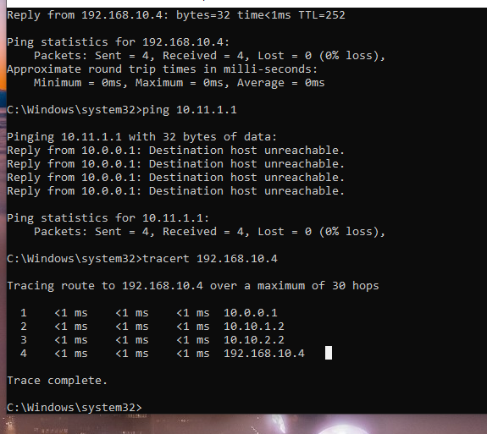

Problems:

We encountered several problems while configuring VRF-lite, some spawning from configuration errors. The first error I encountered was that only the VRF Apple .10 network for OSPF was showing up on R3. I issued show ip ospf interface and other requisite commands on R3 and R2. I noticed that there was no OSPF neighbor relationship between R2 and R3 on the G0/0/0 interface after running a show ip ospf neighbor command. Checking R3 again, I compared the running configs and discovered that not only was the encapsulation wrong on R3, but R4 was also wrong. I had put the encapsulation as 1 and 2 instead of 10 and 11. Also found out that VRF 11 was registered to Apple instead of Facebook on R4 after doing a show ip route vrf Facebook and seeing no entries for R4. Fixed some layer 1 problems as well, as I discovered that the PC couldn’t ping the routers because it was going through the WIFI instead of the ethernet and there was no default gateway set. I think the source of most of these problems was an incorrectly copied running-config.

Conclusion:

VRF and VRF Lite are integral technologies when more than one company is using the same physical infrastructure whether that be locally or across multiple ISPs. VRF allows for network traffic to be segmented into their respective VRFS with no way to contact or ping between them, ensuring network security. While this is not completely secure as there will always be ways to intercept data as they are running on the same links, it provides an added layer and is more cost efficient than buying more physical infrastructure.

CCNP ROUTING AND SWITCHING



Configuring

eBGP Redistribution

Brennen Tse

## Configuring eBGP Redistribution

Go Back

Purpose:

The purpose of this lab is to configure eBGP on the link between two different autonomous systems each with three routers, one running EIGRP and one running OSPF, configuring redistribution. Both would run with IPv4 and IPv6. Students will learn how to configure BGP and how to redistribute the routes through BGP.

**Background:**

**Dynamic Routing Protocol Classifications:**

The Internet basically consists of interconnected networks and autonomous systems. An autonomous system is a network or group of networks that are managed and administered by a single entity. There are two types of dynamic routing protocols, Interior Gateway Protocols (IGPs) or Exterior Gateway Protocols (EGPs). Interior Gateway Protocols, also known as intradomain routing protocols, are used within autonomous systems are routing protocols like OSPF or EIGRP that exchange routes within a single autonomous system. Not all IGPs are created equal as they use different algorithms to find paths and routes. Nevertheless, the main goal of IGPs is to use the most efficient routes depending on the metric. Some IGPs that I have used include EIGRP and OSPF, which use bandwidth and cost respectively.

Exterior Gateway Protocols, or interdomain routing protocols are used for routing between domains or autonomous systems. The main EGP protocol used on the Internet is BGP. BGP not only allows for routing between AS’s, but also can enforce many routing policies not possible through IGPs, and not just finding the best route. BGP then selects a single path that is the best path to a network based on these constraints. You can also load balance over BGP. However, in this lab we will only cover routing between AS.

**BGP Overview**

Border Gateway Protocol (BGP) is an EGP designed to exchange loop-free routes across the Internet between different autonomous systems. Routers which connect different autonomous systems are called border gateways hence the name Border Gateway Protocol. Because BGP is the main standard which routes are exchanged across the Internet, it is important for network administrators of organizations that have connections to ISPs or ISPs who interact with other service providers to know how BGP works. BGP uses path-vector routing, and this algorithm combines both distance-vector routing and loop detection. Each router must maintain a table storing distance and vector to remote networks. BGP uses many factors to make routing decisions, including paths, network policies, or rules set by administrators.

BGP neighbors or peers are established when two routers establish a BGP connection. These BGP sessions use TCP or Transmission Control Protocol. The two different types of BGP are Interior BGP (IBGP) and Exterior BGP (EBGP). IBGP is used with BGP peers that exchange routes within the same autonomous systems. EBGP is used with BGP peers that exchange routes between different autonomous systems. We will be using EBGP to redistribute EIGRP and OSPF routes between two autonomous systems

In order to start BGP routing, you need to assign an autonomous system number. For our lab, there are two BGP autonomous systems, one attached to the EIGRP side of the network and one attached to the OSPF side. The ASN uniquely identifies the BGP domain. Since we are routing between separate BGP autonomous systems, BGP will use eBGP or external BGP routes (AD of 20). In order to exchange routing information with neighbors or BGP “peers”, BGP does not do this automatically and you have to manually establish neighbor adjacencies through entering neighbor addresses. BGP is required to have a unique router id in order to establish connections with BGP peers.

**MPBGP**

Configured in an IPv4 network, BGP establishes sessions using IPv4 and BGP peers have IPv4 addresses. Advertised routes also include IPv4 addresses. Multiprotocol BGP was introduced to allow BGP to use other protocols like IPv6 unicast. To do this, address families are used. Address families help separate different families of addresses like IPv4 or IPv6 and allow for family specific configurations. Use the router address-family and neighbor address-family configuration modes to support multiprotocol BGP configurations. MP-BGP maintains separate RIBs for each configured address family, such as a unicast RIB and a multicast RIB for BGP.

**BGP Redistribution**

When using BGP, it is usually necessary to use IGP routes, so redistribution must be configured to both redistribute IGP routes into BGP and BGP routes into IGPs. BGP is also capable of redistributing IGPs into different IGPs between autonomous systems. The example we will use in this lab is EIGRP routes to OSPF routes. Do note that redistribution should be done with caution, as it is easy to end up accidentally distributing thousands of Internet routes into your IGP. To simplify this route redistribution, it is better to distribute a few summary routes using network statements. You can configure as many network statements as you need.

**Lab Summary:**

When configuring this BGP lab, I set up six 4321 Cisco Routers connected with copper crossover cables between their Gig 0/0/0 and 0/0/1 interfaces. Routers used the IPv4 network of 10.0.0.0 with a /30 subnet from 10.0.0.0-10.0.0.18. They also used the IPv6 network of 2001:db8:acad::/64. Loopback addresses are used in the place of LANs. Loopbacks have IPv4 addresses in the 192.168.0.0/16 network and are subnetted into /30s. They use IPv6 addresses in the 2001:db8:acad:0::1/64 network. I also configured OSPFv2 and OSPFv3 on three routers. I then configured EIGRP for IPv4 and IPv6 for the other three routers. I set loopback interfaces as passive interfaces. I configured BGP on the link between the EIGRP and OSPF autonomous systems, redistributing their routes. I also pinged all addresses in the network to ensure routes and BGP was working.

Lab Commands:

Router(config)#**router bgp *asn***

Definition: Enables BGP and assigns an autonomous system number.

Router(config-router)#**bgp router-id *RID***

Definition: Configures BGP router ID and uniquely identifies BGP router.

Router(config-router)#**neighbor *#* remote-as *ASN***

Definition: Identifies BGP peer using their IPv4 or IPv6 address and ASN.

Router(config-router)#**address-family ipv4/ipv6**

Definition: Enters neighbor address family configuration mode for ipv4 or ipv6.

Router(config-router-af)#**redistribute eigrp *ASN***

Definition: Command redistributes IPv4 or IPv6 EIGRP routes connected to router interface across BGP, and advertises them to peers.

Router(config-router-af)#**neighbor *IPV4#/IPV6* activate**

Definition: This command is used to notify other BGP peers which family-address they support.

Router(config-router-af)#**redistribute connected**

Definition: This command redistributes connected routes.

Router(config-router)#**redistribute bgp *ASN* metric *# # # # #***

Definition: Redistributes BGP routes over EIGRP network.

Router(config-router)#**redistribute bgp *ASN* metric *#***

Definition: Redistributes BGP routes over OSPF network.

Router#**show ip bgp**

Definition: Displays contents of BGP routing table.

Router#**show bgp ipv6 unicast**

Definition: Shows content of IPv6 BGP routing table.

Topology Diagram:

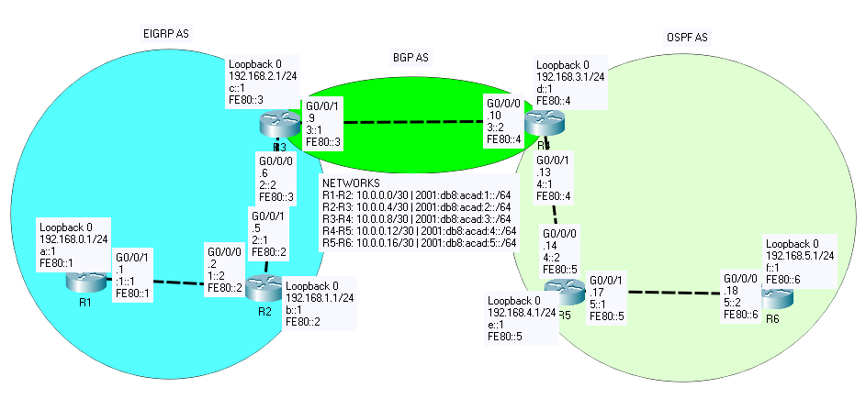

Addressing Table:

|  |  |  |  |  |
| --- | --- | --- | --- | --- |
| Device | Interface | IP Address | IPv6 Address | Link-Local Addresses |
| R1 | G 0/0/1 | 10.0.0.1/30 | 2001:db8:acad:1::1/64 | fe80::1 |
| Loopback 0 | 192.168.0.1/24 | 2001:db8:acad:a::1/64 | fe80::1 |
| R2 | G 0/0/0 | 10.0.0.2/30 | 2001:db8:acad:1::2/64 | fe80::2 |
| G 0/0/1 | 10.0.0.5/30 | 2001:db8:acad:2::1/64 | fe80::2 |
| Loopback 0 | 192.168.1.1/24 | 2001:db8:acad:b::1/64 | fe80::2 |
| R3 | G 0/0/0 | 10.0.0.6/30 | 2001:db8:acad:2::2/64 | fe80::3 |
| G 0/0/1 | 10.0.0.9/30 | 2001:db8:acad:3::1/64 | fe80::3 |
| Loopback 0 | 192.168.2.1/24 | 2001:db8:acad:c::1/64 | fe80::3 |
| R4 | G 0/0/0 | 10.0.0.10/30 | 2001:db8:acad:3::2/64 | fe80::4 |
| G 0/0/1 | 10.0.0.13/30 | 2001:db8:acad:4::1/64 | fe80::4 |
| Loopback 0 | 192.168.3.1/24 | 2001:db8:acad:d::1/64 | fe80::4 |
| R5 | G 0/0/0 | 10.0.0.14/30 | 2001:db8:acad:4::2/64 | fe80::5 |
| G 0/0/1 | 10.0.0.17/30 | 2001:db8:acad:5::1/64 | fe80::5 |
| Loopback 0 | 192.168.4.1/32 | 2001:db8:acad:e::1/64 | fe80::5 |
| R6 | G 0/0/0 | 10.0.0.18/32 | 2001:db8:acad:5::2/64 | fe80::6 |
| Loopback 0 | 192.168.5.1/32 | 2001:db8:acad:f::1/64 | fe80::6 |

Pings:

R1# ping 10.0.0.1

Type escape sequence to abort.

Sending 5, 100-byte ICMP Echos to 10.0.0.1, timeout is 2 seconds:

!!!!!

Success rate is 100 percent (5/5), round-trip min/avg/max = 1/1/1 ms

R1#ping 10.0.0.2

Type escape sequence to abort.

Sending 5, 100-byte ICMP Echos to 10.0.0.2, timeout is 2 seconds:

!!!!!

Success rate is 100 percent (5/5), round-trip min/avg/max = 1/1/1 ms

R1#ping 10.0.0.5

Type escape sequence to abort.

Sending 5, 100-byte ICMP Echos to 10.0.0.5, timeout is 2 seconds:

!!!!!

Success rate is 100 percent (5/5), round-trip min/avg/max = 1/1/1 ms

R1#ping 10.0.0.6

Type escape sequence to abort.

Sending 5, 100-byte ICMP Echos to 10.0.0.6, timeout is 2 seconds:

!!!!!

Success rate is 100 percent (5/5), round-trip min/avg/max = 1/1/1 ms

R1#ping 10.0.0.9

Type escape sequence to abort.

Sending 5, 100-byte ICMP Echos to 10.0.0.9, timeout is 2 seconds:

!!!!!

Success rate is 100 percent (5/5), round-trip min/avg/max = 1/1/1 ms

R1#ping 10.0.0.10

Type escape sequence to abort.

Sending 5, 100-byte ICMP Echos to 10.0.0.10, timeout is 2 seconds:

!!!!!

Success rate is 100 percent (5/5), round-trip min/avg/max = 1/1/1 ms

R1#ping 10.0.0.13

Type escape sequence to abort.

Sending 5, 100-byte ICMP Echos to 10.0.0.13, timeout is 2 seconds:

!!!!!

Success rate is 100 percent (5/5), round-trip min/avg/max = 1/1/1 ms

R1#ping 10.0.0.14

Type escape sequence to abort.

Sending 5, 100-byte ICMP Echos to 10.0.0.14, timeout is 2 seconds:

!!!!!

Success rate is 100 percent (5/5), round-trip min/avg/max = 1/1/1 ms

R1#ping 10.0.0.17

Type escape sequence to abort.

Sending 5, 100-byte ICMP Echos to 10.0.0.17, timeout is 2 seconds:

!!!!!

Success rate is 100 percent (5/5), round-trip min/avg/max = 1/1/1 ms

R1#ping 10.0.0.18

Type escape sequence to abort.

Sending 5, 100-byte ICMP Echos to 10.0.0.18, timeout is 2 seconds:

!!!!!

Success rate is 100 percent (5/5), round-trip min/avg/max = 1/1/1 ms

R1#ping 192.168.0.1

Type escape sequence to abort.

Sending 5, 100-byte ICMP Echos to 192.168.0.1, timeout is 2 seconds:

!!!!!

Success rate is 100 percent (5/5), round-trip min/avg/max = 1/1/1 ms

R1#ping 192.168.1.1

Type escape sequence to abort.

Sending 5, 100-byte ICMP Echos to 192.168.1.1, timeout is 2 seconds:

!!!!!

Success rate is 100 percent (5/5), round-trip min/avg/max = 1/1/1 ms

R1#ping 192.168.2.1

Type escape sequence to abort.

Sending 5, 100-byte ICMP Echos to 192.168.2.1, timeout is 2 seconds:

!!!!!

Success rate is 100 percent (5/5), round-trip min/avg/max = 1/1/1 ms

R1#ping 192.168.3.1

Type escape sequence to abort.

Sending 5, 100-byte ICMP Echos to 192.168.3.1, timeout is 2 seconds:

!!!!!

Success rate is 100 percent (5/5), round-trip min/avg/max = 1/1/1 ms

R1#ping 192.168.4.1

Type escape sequence to abort.

Sending 5, 100-byte ICMP Echos to 192.168.4.1, timeout is 2 seconds:

!!!!!

Success rate is 100 percent (5/5), round-trip min/avg/max = 1/1/1 ms

R1#ping 192.168.5.1

Type escape sequence to abort.

Sending 5, 100-byte ICMP Echos to 192.168.5.1, timeout is 2 seconds:

!!!!!

Success rate is 100 percent (5/5), round-trip min/avg/max = 1/1/2 ms

R1#ping 2001:db8:acad:1::1

Type escape sequence to abort.

Sending 5, 100-byte ICMP Echos to 2001:DB8:ACAD:1::1, timeout is 2 seconds:

!!!!!

Success rate is 100 percent (5/5), round-trip min/avg/max = 1/1/1 ms

R1#ping 2001:db8:acad:1::2

Type escape sequence to abort.

Sending 5, 100-byte ICMP Echos to 2001:DB8:ACAD:1::2, timeout is 2 seconds:

!!!!!

Success rate is 100 percent (5/5), round-trip min/avg/max = 1/4/18 ms

R1#ping 2001:db8:acad:2::1

Type escape sequence to abort.

Sending 5, 100-byte ICMP Echos to 2001:DB8:ACAD:2::1, timeout is 2 seconds:

!!!!!

Success rate is 100 percent (5/5), round-trip min/avg/max = 1/1/1 ms

R1#ping 2001:db8:acad:2::2

Type escape sequence to abort.

Sending 5, 100-byte ICMP Echos to 2001:DB8:ACAD:2::2, timeout is 2 seconds:

!!!!!

Success rate is 100 percent (5/5), round-trip min/avg/max = 1/2/7 ms

R1#ping 2001:db8:acad:3::1

Type escape sequence to abort.

Sending 5, 100-byte ICMP Echos to 2001:DB8:ACAD:3::1, timeout is 2 seconds:

!!!!!

Success rate is 100 percent (5/5), round-trip min/avg/max = 1/1/2 ms

R1#ping 2001:db8:acad:3::2

Type escape sequence to abort.

Sending 5, 100-byte ICMP Echos to 2001:DB8:ACAD:3::2, timeout is 2 seconds:

!!!!!

Success rate is 100 percent (5/5), round-trip min/avg/max = 1/1/1 ms

R1#ping 2001:db8:acad:4::1

Type escape sequence to abort.

Sending 5, 100-byte ICMP Echos to 2001:DB8:ACAD:4::1, timeout is 2 seconds:

!!!!!

Success rate is 100 percent (5/5), round-trip min/avg/max = 1/1/1 ms

R1#ping 2001:db8:acad:4::2

Type escape sequence to abort.

Sending 5, 100-byte ICMP Echos to 2001:DB8:ACAD:4::2, timeout is 2 seconds:

!!!!!

Success rate is 100 percent (5/5), round-trip min/avg/max = 3/6/15 ms

R1#ping 2001:db8:acad:5::1

Type escape sequence to abort.

Sending 5, 100-byte ICMP Echos to 2001:DB8:ACAD:5::1, timeout is 2 seconds:

!!!!!

Success rate is 100 percent (5/5), round-trip min/avg/max = 1/1/1 ms

R1#ping 2001:db8:acad:5::2

Type escape sequence to abort.

Sending 5, 100-byte ICMP Echos to 2001:DB8:ACAD:5::2, timeout is 2 seconds:

!!!!!

Success rate is 100 percent (5/5), round-trip min/avg/max = 1/1/1 ms

R1#ping 2001:db8:acad:a::1

Type escape sequence to abort.

Sending 5, 100-byte ICMP Echos to 2001:DB8:ACAD:A::1, timeout is 2 seconds:

!!!!!

Success rate is 100 percent (5/5), round-trip min/avg/max = 1/1/1 ms

R1#ping 2001:db8:acad:b::1

Type escape sequence to abort.

Sending 5, 100-byte ICMP Echos to 2001:DB8:ACAD:B::1, timeout is 2 seconds:

!!!!!

Success rate is 100 percent (5/5), round-trip min/avg/max = 1/1/1 ms

R1#ping 2001:db8:acad:c::1

Type escape sequence to abort.

Sending 5, 100-byte ICMP Echos to 2001:DB8:ACAD:C::1, timeout is 2 seconds:

!!!!!

Success rate is 100 percent (5/5), round-trip min/avg/max = 1/1/1 ms

R1#ping 2001:db8:acad:d::1

Type escape sequence to abort.

Sending 5, 100-byte ICMP Echos to 2001:DB8:ACAD:D::1, timeout is 2 seconds:

!!!!!

Success rate is 100 percent (5/5), round-trip min/avg/max = 1/1/1 ms

R1#ping 2001:db8:acad:e::1

Type escape sequence to abort.

Sending 5, 100-byte ICMP Echos to 2001:DB8:ACAD:E::1, timeout is 2 seconds:

!!!!!

Success rate is 100 percent (5/5), round-trip min/avg/max = 1/1/1 ms

R1#ping 2001:db8:acad:f::1

Type escape sequence to abort.

Sending 5, 100-byte ICMP Echos to 2001:DB8:ACAD:F::1, timeout is 2 seconds:

!!!!!

Success rate is 100 percent (5/5), round-trip min/avg/max = 1/1/2 ms

**Router 1 Config**

version 15.5

no service timestamps debug uptime

no service timestamps log uptime

no platform punt-keepalive disable-kernel-core

!

hostname R1

!

boot-start-marker

boot-end-marker

!

vrf definition Mgmt-intf

!

address-family ipv4

exit-address-family

!

address-family ipv6

exit-address-family

!

no aaa new-model

!

ipv6 unicast-routing

!

subscriber templating

multilink bundle-name authenticated

!

license udi pid ISR4321/K9 sn FDO21400XZX

!

spanning-tree mode pvst

spanning-tree extend system-id

!

redundancy

mode none

!

vlan internal allocation policy ascending

!

interface Loopback0

ip address 192.168.0.1 255.255.255.0

ipv6 address FE80::1 link-local

ipv6 address 2001:DB8:ACAD:A::1/64

ipv6 eigrp 10

!

interface GigabitEthernet0/0/0

no ip address

negotiation auto

!

interface GigabitEthernet0/0/1

ip address 10.0.0.1 255.255.255.252

negotiation auto

ipv6 address FE80::1 link-local

ipv6 address 2001:DB8:ACAD:1::1/64

ipv6 eigrp 10

!

interface Serial0/1/0

no ip address

shutdown

!

interface Serial0/1/1

no ip address

shutdown

!

interface GigabitEthernet0

vrf forwarding Mgmt-intf

no ip address

shutdown

negotiation auto

!

interface Vlan1

no ip address

shutdown

!

router eigrp 1

network 10.0.0.0 0.0.0.3

network 192.168.0.0

passive-interface Loopback0

eigrp router-id 1.1.1.1

!

ip forward-protocol nd

no ip http server

no ip http secure-server

ip tftp source-interface GigabitEthernet0

!

ipv6 router eigrp 10

passive-interface Loopback0

eigrp router-id 1.1.1.1

!

control-plane

!

line con 0

stopbits 1

line aux 0

stopbits 1

line vty 0 4

login

!

end

**R1#show ip route**

Codes: L - local, C - connected, S - static, R - RIP, M - mobile, B - BGP

D - EIGRP, EX - EIGRP external, O - OSPF, IA - OSPF inter area

N1 - OSPF NSSA external type 1, N2 - OSPF NSSA external type 2

E1 - OSPF external type 1, E2 - OSPF external type 2

i - IS-IS, su - IS-IS summary, L1 - IS-IS level-1, L2 - IS-IS level-2

ia - IS-IS inter area, * - candidate default, U - per-user static route

o - ODR, P - periodic downloaded static route, H - NHRP, l - LISP

a - application route

+ - replicated route, % - next hop override, p - overrides from PfR

Gateway of last resort is not set

10.0.0.0/8 is variably subnetted, 6 subnets, 2 masks

C 10.0.0.0/30 is directly connected, GigabitEthernet0/0/1

L 10.0.0.1/32 is directly connected, GigabitEthernet0/0/1

D 10.0.0.4/30 [90/3072] via 10.0.0.2, 01:09:15, GigabitEthernet0/0/1

D 10.0.0.8/30 [90/3328] via 10.0.0.2, 01:04:19, GigabitEthernet0/0/1

D EX 10.0.0.12/30

[170/2560768] via 10.0.0.2, 00:47:46, GigabitEthernet0/0/1

D EX 10.0.0.16/30

[170/2560768] via 10.0.0.2, 00:47:46, GigabitEthernet0/0/1

192.168.0.0/24 is variably subnetted, 2 subnets, 2 masks

C 192.168.0.0/24 is directly connected, Loopback0

L 192.168.0.1/32 is directly connected, Loopback0

D 192.168.1.0/24 [90/130816] via 10.0.0.2, 01:09:58, GigabitEthernet0/0/1

D 192.168.2.0/24 [90/131072] via 10.0.0.2, 01:09:13, GigabitEthernet0/0/1

D EX 192.168.3.0/24

[170/2560768] via 10.0.0.2, 00:47:46, GigabitEthernet0/0/1

192.168.4.0/32 is subnetted, 1 subnets

D EX 192.168.4.1

[170/2560768] via 10.0.0.2, 00:47:46, GigabitEthernet0/0/1

192.168.5.0/32 is subnetted, 1 subnets

D EX 192.168.5.1

[170/2560768] via 10.0.0.2, 00:47:46, GigabitEthernet0/0/1

**R1# show ipv6 route**

IPv6 Routing Table - default - 14 entries

Codes: C - Connected, L - Local, S - Static, U - Per-user Static route

B - BGP, R - RIP, I1 - ISIS L1, I2 - ISIS L2

IA - ISIS interarea, IS - ISIS summary, D - EIGRP, EX - EIGRP external

ND - ND Default, NDp - ND Prefix, DCE - Destination, NDr - Redirect

O - OSPF Intra, OI - OSPF Inter, OE1 - OSPF ext 1, OE2 - OSPF ext 2

ON1 - OSPF NSSA ext 1, ON2 - OSPF NSSA ext 2, a - Application

C 2001:DB8:ACAD:1::/64 [0/0]

via GigabitEthernet0/0/1, directly connected

L 2001:DB8:ACAD:1::1/128 [0/0]

via GigabitEthernet0/0/1, receive

D 2001:DB8:ACAD:2::/64 [90/3072]

via FE80::2, GigabitEthernet0/0/1

D 2001:DB8:ACAD:3::/64 [90/3328]

via FE80::2, GigabitEthernet0/0/1

EX 2001:DB8:ACAD:4::/64 [170/3328]

via FE80::2, GigabitEthernet0/0/1

EX 2001:DB8:ACAD:5::/64 [170/3328]

via FE80::2, GigabitEthernet0/0/1

C 2001:DB8:ACAD:A::/64 [0/0]

via Loopback0, directly connected

L 2001:DB8:ACAD:A::1/128 [0/0]

via Loopback0, receive

D 2001:DB8:ACAD:B::/64 [90/130816]

via FE80::2, GigabitEthernet0/0/1

D 2001:DB8:ACAD:C::/64 [90/131072]

via FE80::2, GigabitEthernet0/0/1

EX 2001:DB8:ACAD:D::/64 [170/3328]

via FE80::2, GigabitEthernet0/0/1

EX 2001:DB8:ACAD:E::1/128 [170/3328]

via FE80::2, GigabitEthernet0/0/1

EX 2001:DB8:ACAD:F::1/128 [170/3328]

via FE80::2, GigabitEthernet0/0/1

L FF00::/8 [0/0]

via Null0, receive

**R1# show ip protocol**

*** IP Routing is NSF aware ***

Routing Protocol is "application"

Sending updates every 0 seconds

Invalid after 0 seconds, hold down 0, flushed after 0

Outgoing update filter list for all interfaces is not set

Incoming update filter list for all interfaces is not set

Maximum path: 32

Routing for Networks:

Routing Information Sources:

Gateway Distance Last Update

Distance: (default is 4)

Routing Protocol is "eigrp 1"

Outgoing update filter list for all interfaces is not set

Incoming update filter list for all interfaces is not set

Default networks flagged in outgoing updates

Default networks accepted from incoming updates

Redistributing: ospf 1

EIGRP-IPv4 Protocol for AS(1)

Metric weight K1=1, K2=0, K3=1, K4=0, K5=0

Soft SIA disabled

NSF-aware route hold timer is 240

EIGRP NSF disabled

NSF signal timer is 20s

NSF converge timer is 120s

Router-ID: 1.1.1.1

Topology : 0 (base)

Active Timer: 3 min

Distance: internal 90 external 170

Maximum path: 4

Maximum hopcount 100

Maximum metric variance 1

Automatic Summarization: disabled

Maximum path: 4

Routing for Networks:

10.0.0.0/30

192.168.0.0

Passive Interface(s):

Loopback0

Routing Information Sources:

Gateway Distance Last Update

10.0.0.2 90 00:47:56

Distance: internal 90 external 170

**R1#show ipv6 protocol**

IPv6 Routing Protocol is "connected"

IPv6 Routing Protocol is "application"

IPv6 Routing Protocol is "ND"

IPv6 Routing Protocol is "eigrp 10"

EIGRP-IPv6 Protocol for AS(10)

Metric weight K1=1, K2=0, K3=1, K4=0, K5=0

Soft SIA disabled

NSF-aware route hold timer is 240

EIGRP NSF disabled

NSF signal timer is 20s

NSF converge timer is 120s

Router-ID: 1.1.1.1

Topology : 0 (base)

Active Timer: 3 min

Distance: internal 90 external 170

Maximum path: 16

Maximum hopcount 100

Maximum metric variance 1

Interfaces:

GigabitEthernet0/0/1

Loopback0 (passive)

Redistribution:

None

**Router 2 Config**

version 15.5

no service timestamps debug uptime

no service timestamps log uptime

no platform punt-keepalive disable-kernel-core

!

hostname R2

!

boot-start-marker

boot-end-marker

!

vrf definition Mgmt-intf

!

address-family ipv4

exit-address-family

!

address-family ipv6

exit-address-family

!

!

no aaa new-model

!

ipv6 unicast-routing

!

subscriber templating

multilink bundle-name authenticated

!

license udi pid ISR4321/K9 sn FDO21491FHX

!

spanning-tree mode pvst

spanning-tree extend system-id

!

redundancy

mode none

!

vlan internal allocation policy ascending

!

interface Loopback0

ip address 192.168.1.1 255.255.255.0

ipv6 address 2001:DB8:ACAD:B::1/64

ipv6 eigrp 10

!

interface GigabitEthernet0/0/0

ip address 10.0.0.2 255.255.255.252

negotiation auto

ipv6 address FE80::2 link-local

ipv6 address 2001:DB8:ACAD:1::2/64

ipv6 eigrp 10

!

interface GigabitEthernet0/0/1

ip address 10.0.0.5 255.255.255.252

negotiation auto

ipv6 address FE80::2 link-local

ipv6 address 2001:DB8:ACAD:2::1/64

ipv6 eigrp 10

!

interface Serial0/1/0

no ip address

shutdown

!

interface Serial0/1/1

no ip address

shutdown

!

interface GigabitEthernet0

vrf forwarding Mgmt-intf

no ip address

shutdown

negotiation auto

!

interface Vlan1

no ip address

shutdown

!

router eigrp 1

network 10.0.0.0 0.0.0.3

network 10.0.0.4 0.0.0.3

network 192.168.1.0

passive-interface Loopback0

eigrp router-id 2.2.2.2

!

ip forward-protocol nd

no ip http server

no ip http secure-server

ip tftp source-interface GigabitEthernet0

!

ipv6 router eigrp 10

passive-interface Loopback0

eigrp router-id 2.2.2.2

!

control-plane

!

line con 0

stopbits 1

line aux 0

stopbits 1

line vty 0 4

login

!

end

**R2#show ip route**

Codes: L - local, C - connected, S - static, R - RIP, M - mobile, B - BGP

D - EIGRP, EX - EIGRP external, O - OSPF, IA - OSPF inter area

N1 - OSPF NSSA external type 1, N2 - OSPF NSSA external type 2

E1 - OSPF external type 1, E2 - OSPF external type 2

i - IS-IS, su - IS-IS summary, L1 - IS-IS level-1, L2 - IS-IS level-2

ia - IS-IS inter area, * - candidate default, U - per-user static route

o - ODR, P - periodic downloaded static route, H - NHRP, l - LISP

a - application route

+ - replicated route, % - next hop override, p - overrides from PfR

Gateway of last resort is not set

10.0.0.0/8 is variably subnetted, 7 subnets, 2 masks

C 10.0.0.0/30 is directly connected, GigabitEthernet0/0/0

L 10.0.0.2/32 is directly connected, GigabitEthernet0/0/0

C 10.0.0.4/30 is directly connected, GigabitEthernet0/0/1

L 10.0.0.5/32 is directly connected, GigabitEthernet0/0/1

D 10.0.0.8/30 [90/3072] via 10.0.0.6, 01:05:55, GigabitEthernet0/0/1

D EX 10.0.0.12/30

[170/2560512] via 10.0.0.6, 00:49:22, GigabitEthernet0/0/1

D EX 10.0.0.16/30

[170/2560512] via 10.0.0.6, 00:49:22, GigabitEthernet0/0/1

D 192.168.0.0/24 [90/130816] via 10.0.0.1, 01:11:29, GigabitEthernet0/0/0

192.168.1.0/24 is variably subnetted, 2 subnets, 2 masks

C 192.168.1.0/24 is directly connected, Loopback0

L 192.168.1.1/32 is directly connected, Loopback0

D 192.168.2.0/24 [90/130816] via 10.0.0.6, 01:10:49, GigabitEthernet0/0/1

D EX 192.168.3.0/24

[170/2560512] via 10.0.0.6, 00:49:22, GigabitEthernet0/0/1

192.168.4.0/32 is subnetted, 1 subnets

D EX 192.168.4.1

[170/2560512] via 10.0.0.6, 00:49:22, GigabitEthernet0/0/1

192.168.5.0/32 is subnetted, 1 subnets

D EX 192.168.5.1

[170/2560512] via 10.0.0.6, 00:49:22, GigabitEthernet0/0/1

**R2# show ipv6 route**

IPv6 Routing Table - default - 15 entries

Codes: C - Connected, L - Local, S - Static, U - Per-user Static route

B - BGP, R - RIP, I1 - ISIS L1, I2 - ISIS L2

IA - ISIS interarea, IS - ISIS summary, D - EIGRP, EX - EIGRP external

ND - ND Default, NDp - ND Prefix, DCE - Destination, NDr - Redirect

O - OSPF Intra, OI - OSPF Inter, OE1 - OSPF ext 1, OE2 - OSPF ext 2

ON1 - OSPF NSSA ext 1, ON2 - OSPF NSSA ext 2, a - Application

C 2001:DB8:ACAD:1::/64 [0/0]

via GigabitEthernet0/0/0, directly connected

L 2001:DB8:ACAD:1::2/128 [0/0]

via GigabitEthernet0/0/0, receive

C 2001:DB8:ACAD:2::/64 [0/0]

via GigabitEthernet0/0/1, directly connected

L 2001:DB8:ACAD:2::1/128 [0/0]

via GigabitEthernet0/0/1, receive

D 2001:DB8:ACAD:3::/64 [90/3072]

via FE80::3, GigabitEthernet0/0/1

EX 2001:DB8:ACAD:4::/64 [170/3072]

via FE80::3, GigabitEthernet0/0/1

EX 2001:DB8:ACAD:5::/64 [170/3072]

via FE80::3, GigabitEthernet0/0/1

D 2001:DB8:ACAD:A::/64 [90/130816]

via FE80::1, GigabitEthernet0/0/0

C 2001:DB8:ACAD:B::/64 [0/0]

via Loopback0, directly connected

L 2001:DB8:ACAD:B::1/128 [0/0]

via Loopback0, receive

D 2001:DB8:ACAD:C::/64 [90/130816]

via FE80::3, GigabitEthernet0/0/1

EX 2001:DB8:ACAD:D::/64 [170/3072]

via FE80::3, GigabitEthernet0/0/1

EX 2001:DB8:ACAD:E::1/128 [170/3072]

via FE80::3, GigabitEthernet0/0/1

EX 2001:DB8:ACAD:F::1/128 [170/3072]

via FE80::3, GigabitEthernet0/0/1

L FF00::/8 [0/0]

via Null0, receive

**R2#show ip protocols**

*** IP Routing is NSF aware ***

Routing Protocol is "application"

Sending updates every 0 seconds

Invalid after 0 seconds, hold down 0, flushed after 0

Outgoing update filter list for all interfaces is not set

Incoming update filter list for all interfaces is not set

Maximum path: 32

Routing for Networks:

Routing Information Sources:

Gateway Distance Last Update

Distance: (default is 4)

Routing Protocol is "eigrp 1"

Outgoing update filter list for all interfaces is not set

Incoming update filter list for all interfaces is not set

Default networks flagged in outgoing updates

Default networks accepted from incoming updates

EIGRP-IPv4 Protocol for AS(1)

Metric weight K1=1, K2=0, K3=1, K4=0, K5=0

Soft SIA disabled

NSF-aware route hold timer is 240

EIGRP NSF disabled

NSF signal timer is 20s

NSF converge timer is 120s

Router-ID: 2.2.2.2

Topology : 0 (base)

Active Timer: 3 min

Distance: internal 90 external 170

Maximum path: 4

Maximum hopcount 100

Maximum metric variance 1

Automatic Summarization: disabled

Maximum path: 4

Routing for Networks:

10.0.0.0/30

10.0.0.4/30

192.168.1.0

Passive Interface(s):

Loopback0

Routing Information Sources:

Gateway Distance Last Update

10.0.0.1 90 00:49:31

10.0.0.6 90 00:49:31

Distance: internal 90 external 170

**R2#show ipv6 protocols**

IPv6 Routing Protocol is "connected"

IPv6 Routing Protocol is "application"

IPv6 Routing Protocol is "ND"

IPv6 Routing Protocol is "eigrp 10"

EIGRP-IPv6 Protocol for AS(10)

Metric weight K1=1, K2=0, K3=1, K4=0, K5=0

Soft SIA disabled

NSF-aware route hold timer is 240

EIGRP NSF disabled

NSF signal timer is 20s

NSF converge timer is 120s

Router-ID: 2.2.2.2

Topology : 0 (base)

Active Timer: 3 min

Distance: internal 90 external 170

Maximum path: 16

Maximum hopcount 100

Maximum metric variance 1

Interfaces:

GigabitEthernet0/0/0

GigabitEthernet0/0/1

Loopback0 (passive)

Redistribution:

None

**Router 3 Config**

version 15.5

no service timestamps debug uptime

no service timestamps log uptime

no platform punt-keepalive disable-kernel-core

!

hostname R3

!

boot-start-marker

boot-end-marker

!

vrf definition Mgmt-intf

!

address-family ipv4

exit-address-family

!

address-family ipv6

exit-address-family

!

no aaa new-model

!

ipv6 unicast-routing

!

subscriber templating

multilink bundle-name authenticated

!

license udi pid ISR4321/K9 sn FDO214421CU

!

spanning-tree mode pvst

spanning-tree extend system-id

!

redundancy

mode none

!

vlan internal allocation policy ascending

!

interface Loopback0

ip address 192.168.2.1 255.255.255.0

ipv6 address FE80::3 link-local

ipv6 address 2001:DB8:ACAD:C::1/64

ipv6 eigrp 10

!

interface GigabitEthernet0/0/0

ip address 10.0.0.6 255.255.255.252

negotiation auto

ipv6 address FE80::3 link-local

ipv6 address 2001:DB8:ACAD:2::2/64

ipv6 eigrp 10

!

interface GigabitEthernet0/0/1

ip address 10.0.0.9 255.255.255.252

negotiation auto

ipv6 address FE80::3 link-local

ipv6 address 2001:DB8:ACAD:3::1/64

ipv6 eigrp 10

!

interface Serial0/1/0

no ip address

shutdown

!

interface Serial0/1/1

no ip address

shutdown

!

interface GigabitEthernet0

vrf forwarding Mgmt-intf

no ip address

shutdown

negotiation auto

!

interface Vlan1

no ip address

shutdown

!

router eigrp 1

network 10.0.0.4 0.0.0.3

network 10.0.0.8 0.0.0.3

network 192.168.2.0

passive-interface Loopback0

redistribute bgp 200 metric 10000 1 255 1 1500

eigrp router-id 3.3.3.3

!

router bgp 200

bgp router-id 3.3.3.3

bgp log-neighbor-changes

neighbor 10.0.0.10 remote-as 100

neighbor 2001:DB8:ACAD:3::2 remote-as 100

!

address-family ipv4

redistribute eigrp 1

neighbor 10.0.0.10 activate

exit-address-family

!

address-family ipv6

redistribute eigrp 10

redistribute connected

neighbor 2001:DB8:ACAD:3::2 activate

exit-address-family

!

ip forward-protocol nd

no ip http server

no ip http secure-server

ip tftp source-interface GigabitEthernet0

!

ipv6 router eigrp 10

no shut

passive-interface Loopback0

eigrp router-id 3.3.3.3

redistribute bgp 200 metric 1000000 1 255 1 1500

!

control-plane

!

line con 0

stopbits 1

line aux 0

stopbits 1

line vty 0 4

login

!

end

**R3#show ip route**

Codes: L - local, C - connected, S - static, R - RIP, M - mobile, B - BGP

D - EIGRP, EX - EIGRP external, O - OSPF, IA - OSPF inter area

N1 - OSPF NSSA external type 1, N2 - OSPF NSSA external type 2

E1 - OSPF external type 1, E2 - OSPF external type 2

i - IS-IS, su - IS-IS summary, L1 - IS-IS level-1, L2 - IS-IS level-2

ia - IS-IS inter area, * - candidate default, U - per-user static route

o - ODR, P - periodic downloaded static route, H - NHRP, l - LISP

a - application route

+ - replicated route, % - next hop override, p - overrides from PfR

Gateway of last resort is not set

10.0.0.0/8 is variably subnetted, 7 subnets, 2 masks

D 10.0.0.0/30 [90/3072] via 10.0.0.5, 00:53:54, GigabitEthernet0/0/0

C 10.0.0.4/30 is directly connected, GigabitEthernet0/0/0

L 10.0.0.6/32 is directly connected, GigabitEthernet0/0/0

C 10.0.0.8/30 is directly connected, GigabitEthernet0/0/1

L 10.0.0.9/32 is directly connected, GigabitEthernet0/0/1

B 10.0.0.12/30 [20/0] via 10.0.0.10, 00:49:00

B 10.0.0.16/30 [20/2] via 10.0.0.10, 00:48:10

D 192.168.0.0/24 [90/131072] via 10.0.0.5, 00:53:54, GigabitEthernet0/0/0

D 192.168.1.0/24 [90/130816] via 10.0.0.5, 00:53:54, GigabitEthernet0/0/0

192.168.2.0/24 is variably subnetted, 2 subnets, 2 masks

C 192.168.2.0/24 is directly connected, Loopback0

L 192.168.2.1/32 is directly connected, Loopback0

B 192.168.3.0/24 [20/0] via 10.0.0.10, 00:49:00

192.168.4.0/32 is subnetted, 1 subnets

B 192.168.4.1 [20/2] via 10.0.0.10, 00:48:10

192.168.5.0/32 is subnetted, 1 subnets

B 192.168.5.1 [20/3] via 10.0.0.10, 00:48:10

**R3# show ipv6 route**

IPv6 Routing Table - default - 15 entries

Codes: C - Connected, L - Local, S - Static, U - Per-user Static route

B - BGP, R - RIP, I1 - ISIS L1, I2 - ISIS L2

IA - ISIS interarea, IS - ISIS summary, D - EIGRP, EX - EIGRP external

ND - ND Default, NDp - ND Prefix, DCE - Destination, NDr - Redirect

O - OSPF Intra, OI - OSPF Inter, OE1 - OSPF ext 1, OE2 - OSPF ext 2

ON1 - OSPF NSSA ext 1, ON2 - OSPF NSSA ext 2, a - Application

D 2001:DB8:ACAD:1::/64 [90/3072]

via FE80::2, GigabitEthernet0/0/0

C 2001:DB8:ACAD:2::/64 [0/0]

via GigabitEthernet0/0/0, directly connected

L 2001:DB8:ACAD:2::2/128 [0/0]

via GigabitEthernet0/0/0, receive

C 2001:DB8:ACAD:3::/64 [0/0]

via GigabitEthernet0/0/1, directly connected

L 2001:DB8:ACAD:3::1/128 [0/0]

via GigabitEthernet0/0/1, receive

B 2001:DB8:ACAD:4::/64 [20/0]

via FE80::4, GigabitEthernet0/0/1

B 2001:DB8:ACAD:5::/64 [20/2]

via FE80::4, GigabitEthernet0/0/1

D 2001:DB8:ACAD:A::/64 [90/131072]

via FE80::2, GigabitEthernet0/0/0

D 2001:DB8:ACAD:B::/64 [90/130816]

via FE80::2, GigabitEthernet0/0/0

C 2001:DB8:ACAD:C::/64 [0/0]

via Loopback0, directly connected

L 2001:DB8:ACAD:C::1/128 [0/0]

**R3# show ip protocol**

*** IP Routing is NSF aware ***

Routing Protocol is "application"

Sending updates every 0 seconds

Invalid after 0 seconds, hold down 0, flushed after 0

Outgoing update filter list for all interfaces is not set

Incoming update filter list for all interfaces is not set

Maximum path: 32

Routing for Networks:

Routing Information Sources:

Gateway Distance Last Update

Distance: (default is 4)

Routing Protocol is "eigrp 1"

Outgoing update filter list for all interfaces is not set

Incoming update filter list for all interfaces is not set

Default networks flagged in outgoing updates

Default networks accepted from incoming updates

Redistributing: bgp 200, ospf 1

EIGRP-IPv4 Protocol for AS(1)

Metric weight K1=1, K2=0, K3=1, K4=0, K5=0

Soft SIA disabled

NSF-aware route hold timer is 240

EIGRP NSF disabled

NSF signal timer is 20s

NSF converge timer is 120s

Router-ID: 3.3.3.3

Topology : 0 (base)

Active Timer: 3 min

Distance: internal 90 external 170

Maximum path: 4

Maximum hopcount 100

Maximum metric variance 1

Automatic Summarization: disabled

Maximum path: 4

Routing for Networks:

10.0.0.4/30

10.0.0.8/30

192.168.2.0

Passive Interface(s):

Loopback0

Routing Information Sources:

Gateway Distance Last Update

10.0.0.5 90 00:54:03

Distance: internal 90 external 170

Routing Protocol is "bgp 200"

Outgoing update filter list for all interfaces is not set

Incoming update filter list for all interfaces is not set

IGP synchronization is disabled

Automatic route summarization is disabled

Redistributing: eigrp 1

Neighbor(s):

Address FiltIn FiltOut DistIn DistOut Weight RouteMap

10.0.0.10

Maximum path: 1

Routing Information Sources:

Gateway Distance Last Update

10.0.0.10 20 00:48:21

Distance: external 20 internal 200 local 200

**R3# show ipv6 protocol**

IPv6 Routing Protocol is "connected"

IPv6 Routing Protocol is "application"

IPv6 Routing Protocol is "ND"

IPv6 Routing Protocol is "bgp 200"

IGP synchronization is disabled

Redistribution:

Redistributing protocol connected

Redistributing protocol eigrp 10

Neighbor(s):

Address FiltIn FiltOut Weight RoutemapIn RoutemapOut

2001:DB8:ACAD:3::2

IPv6 Routing Protocol is "eigrp 10"

EIGRP-IPv6 Protocol for AS(10)

Metric weight K1=1, K2=0, K3=1, K4=0, K5=0

Soft SIA disabled

NSF-aware route hold timer is 240

EIGRP NSF disabled

NSF signal timer is 20s

NSF converge timer is 120s

Router-ID: 3.3.3.3

Topology : 0 (base)

Active Timer: 3 min

Distance: internal 90 external 170

Maximum path: 16

Maximum hopcount 100

Maximum metric variance 1

Interfaces:

GigabitEthernet0/0/0

GigabitEthernet0/0/1

Loopback0 (passive)

Redistribution:

Redistributing protocol bgp 200 with metric 1000000 1 255 1 1500

**R3# show ip bgp**

BGP table version is 12, local router ID is 3.3.3.3

Status codes: s suppressed, d damped, h history, * valid, > best, i - internal,

r RIB-failure, S Stale, m multipath, b backup-path, f RT-Filter,

x best-external, a additional-path, c RIB-compressed,

Origin codes: i - IGP, e - EGP, ? - incomplete

RPKI validation codes: V valid, I invalid, N Not found

Network Next Hop Metric LocPrf Weight Path

*> 10.0.0.0/30 10.0.0.5 3072 32768 ?

*> 10.0.0.4/30 0.0.0.0 0 32768 ?

* 10.0.0.8/30 10.0.0.10 0 0 100 ?

*> 0.0.0.0 0 32768 ?

*> 10.0.0.12/30 10.0.0.10 0 0 100 ?

*> 10.0.0.16/30 10.0.0.10 2 0 100 ?

*> 192.168.0.0 10.0.0.5 131072 32768 ?

*> 192.168.1.0 10.0.0.5 130816 32768 ?

*> 192.168.2.0 0.0.0.0 0 32768 ?

*> 192.168.3.0 10.0.0.10 0 0 100 ?

*> 192.168.4.1/32 10.0.0.10 2 0 100 ?

*> 192.168.5.1/32 10.0.0.10 3 0 100 ?

**R3# show bgp ipv6 unicast**

BGP table version is 31, local router ID is 3.3.3.3

Status codes: s suppressed, d damped, h history, * valid, > best, i - internal,

r RIB-failure, S Stale, m multipath, b backup-path, f RT-Filter,

x best-external, a additional-path, c RIB-compressed,

Origin codes: i - IGP, e - EGP, ? - incomplete

RPKI validation codes: V valid, I invalid, N Not found

Network Next Hop Metric LocPrf Weight Path

*> 2001:DB8:ACAD:1::/64

FE80::2 3072 32768 ?

*> 2001:DB8:ACAD:2::/64

:: 0 32768 ?

* 2001:DB8:ACAD:3::/64

2001:DB8:ACAD:3::2

0 0 100 ?

*> :: 0 32768 ?

*> 2001:DB8:ACAD:4::/64

2001:DB8:ACAD:3::2

0 0 100 ?

*> 2001:DB8:ACAD:5::/64

2001:DB8:ACAD:3::2

2 0 100 ?

Network Next Hop Metric LocPrf Weight Path

*> 2001:DB8:ACAD:A::/64

FE80::2 131072 32768 ?

*> 2001:DB8:ACAD:B::/64

FE80::2 130816 32768 ?

*> 2001:DB8:ACAD:C::/64

:: 0 32768 ?

*> 2001:DB8:ACAD:D::/64

2001:DB8:ACAD:3::2

0 0 100 ?

*> 2001:DB8:ACAD:E::1/128

2001:DB8:ACAD:3::2

1 0 100 ?

*> 2001:DB8:ACAD:F::1/128

2001:DB8:ACAD:3::2

2 0 100 ?

**Router 4 Config**

version 15.5

no service timestamps debug uptime

no service timestamps log uptime

no platform punt-keepalive disable-kernel-core

!

hostname R4

!

boot-start-marker

boot-end-marker

!

vrf definition Mgmt-intf

!

address-family ipv4

exit-address-family

!

address-family ipv6

exit-address-family

!

no aaa new-model

!

ipv6 unicast-routing

!

subscriber templating

multilink bundle-name authenticated

!

license udi pid ISR4321/K9 sn FDO214420G3

!

spanning-tree mode pvst

spanning-tree extend system-id

!

redundancy

mode none

!

vlan internal allocation policy ascending

!

interface Loopback0

ip address 192.168.3.1 255.255.255.0

ipv6 address FE80::4 link-local

ipv6 address 2001:DB8:ACAD:D::1/64

ipv6 ospf 10 area 0

!

interface GigabitEthernet0/0/0

ip address 10.0.0.10 255.255.255.252

negotiation auto

ipv6 address FE80::4 link-local

ipv6 address 2001:DB8:ACAD:3::2/64

ipv6 ospf 10 area 0

!

interface GigabitEthernet0/0/1

ip address 10.0.0.13 255.255.255.252

negotiation auto

ipv6 address FE80::4 link-local

ipv6 address 2001:DB8:ACAD:4::1/64

ipv6 ospf 10 area 0

!

interface Serial0/1/0

no ip address

shutdown

!

interface Serial0/1/1

no ip address

shutdown

!

interface GigabitEthernet0

vrf forwarding Mgmt-intf

no ip address

shutdown

negotiation auto

!

interface Vlan1

no ip address

shutdown

!

router ospf 1

router-id 4.4.4.4

passive-interface Loopback0

redistribute bgp 100 metric 100000

network 10.0.0.8 0.0.0.3 area 0

network 10.0.0.12 0.0.0.3 area 0

network 192.168.3.0 0.0.0.255 area 0

!

router bgp 100

bgp router-id 4.4.4.4

bgp log-neighbor-changes

neighbor 10.0.0.9 remote-as 200

neighbor 2001:DB8:ACAD:3::1 remote-as 200

!

address-family ipv4

redistribute ospf 1

neighbor 10.0.0.9 activate

exit-address-family

!

address-family ipv6

redistribute ospf 10

redistribute connected

neighbor 2001:DB8:ACAD:3::1 activate

exit-address-family

!

ip forward-protocol nd

no ip http server

no ip http secure-server

ip tftp source-interface GigabitEthernet0

!

ipv6 router ospf 10

router-id 4.4.4.4

passive-interface Loopback0

redistribute bgp 100 metric 1000000

!

control-plane

!

line con 0

stopbits 1

line aux 0

stopbits 1

line vty 0 4

login

!

end

**R4#show ip route**

Codes: L - local, C - connected, S - static, R - RIP, M - mobile, B - BGP

D - EIGRP, EX - EIGRP external, O - OSPF, IA - OSPF inter area

N1 - OSPF NSSA external type 1, N2 - OSPF NSSA external type 2

E1 - OSPF external type 1, E2 - OSPF external type 2

i - IS-IS, su - IS-IS summary, L1 - IS-IS level-1, L2 - IS-IS level-2

ia - IS-IS inter area, * - candidate default, U - per-user static route

o - ODR, P - periodic downloaded static route, H - NHRP, l - LISP

a - application route

+ - replicated route, % - next hop override, p - overrides from PfR

Gateway of last resort is not set

10.0.0.0/8 is variably subnetted, 7 subnets, 2 masks

B 10.0.0.0/30 [20/3072] via 10.0.0.9, 00:47:30

B 10.0.0.4/30 [20/0] via 10.0.0.9, 00:47:30

C 10.0.0.8/30 is directly connected, GigabitEthernet0/0/0

L 10.0.0.10/32 is directly connected, GigabitEthernet0/0/0

C 10.0.0.12/30 is directly connected, GigabitEthernet0/0/1

L 10.0.0.13/32 is directly connected, GigabitEthernet0/0/1

O 10.0.0.16/30 [110/2] via 10.0.0.14, 00:46:41, GigabitEthernet0/0/1

B 192.168.0.0/24 [20/131072] via 10.0.0.9, 00:47:30

B 192.168.1.0/24 [20/130816] via 10.0.0.9, 00:47:30

B 192.168.2.0/24 [20/0] via 10.0.0.9, 00:47:30

192.168.3.0/24 is variably subnetted, 2 subnets, 2 masks

C 192.168.3.0/24 is directly connected, Loopback0

L 192.168.3.1/32 is directly connected, Loopback0

192.168.4.0/32 is subnetted, 1 subnets

O 192.168.4.1 [110/2] via 10.0.0.14, 00:46:41, GigabitEthernet0/0/1

192.168.5.0/32 is subnetted, 1 subnets

O 192.168.5.1 [110/3] via 10.0.0.14, 00:46:41, GigabitEthernet0/0/1

**R4# show ipv6 route**

IPv6 Routing Table - default - 15 entries

Codes: C - Connected, L - Local, S - Static, U - Per-user Static route

B - BGP, R - RIP, I1 - ISIS L1, I2 - ISIS L2

IA - ISIS interarea, IS - ISIS summary, D - EIGRP, EX - EIGRP external

ND - ND Default, NDp - ND Prefix, DCE - Destination, NDr - Redirect

O - OSPF Intra, OI - OSPF Inter, OE1 - OSPF ext 1, OE2 - OSPF ext 2

ON1 - OSPF NSSA ext 1, ON2 - OSPF NSSA ext 2, a - Application

B 2001:DB8:ACAD:1::/64 [20/3072]

via FE80::3, GigabitEthernet0/0/0

B 2001:DB8:ACAD:2::/64 [20/0]

via FE80::3, GigabitEthernet0/0/0

C 2001:DB8:ACAD:3::/64 [0/0]

via GigabitEthernet0/0/0, directly connected

L 2001:DB8:ACAD:3::2/128 [0/0]

via GigabitEthernet0/0/0, receive

C 2001:DB8:ACAD:4::/64 [0/0]

via GigabitEthernet0/0/1, directly connected

L 2001:DB8:ACAD:4::1/128 [0/0]

via GigabitEthernet0/0/1, receive

O 2001:DB8:ACAD:5::/64 [110/2]

via FE80::5, GigabitEthernet0/0/1

B 2001:DB8:ACAD:A::/64 [20/131072]

via FE80::3, GigabitEthernet0/0/0

B 2001:DB8:ACAD:B::/64 [20/130816]

via FE80::3, GigabitEthernet0/0/0

B 2001:DB8:ACAD:C::/64 [20/0]

via FE80::3, GigabitEthernet0/0/0

C 2001:DB8:ACAD:D::/64 [0/0]

via Loopback0, directly connected

L 2001:DB8:ACAD:D::1/128 [0/0]

via Loopback0, receive

O 2001:DB8:ACAD:E::1/128 [110/1]

via FE80::5, GigabitEthernet0/0/1

O 2001:DB8:ACAD:F::1/128 [110/2]

via FE80::5, GigabitEthernet0/0/1

L FF00::/8 [0/0]

via Null0, receive

**R4# show ip protocol**

*** IP Routing is NSF aware ***

Routing Protocol is "application"

Sending updates every 0 seconds

Invalid after 0 seconds, hold down 0, flushed after 0

Outgoing update filter list for all interfaces is not set

Incoming update filter list for all interfaces is not set

Maximum path: 32

Routing for Networks:

Routing Information Sources:

Gateway Distance Last Update

Distance: (default is 4)

Routing Protocol is "ospf 1"

Outgoing update filter list for all interfaces is not set

Incoming update filter list for all interfaces is not set

Router ID 4.4.4.4

It is an autonomous system boundary router

Redistributing External Routes from,

bgp 100 with metric mapped to 100000, includes subnets in redistribution

Number of areas in this router is 1. 1 normal 0 stub 0 nssa

Maximum path: 4

Routing for Networks:

10.0.0.8 0.0.0.3 area 0

10.0.0.12 0.0.0.3 area 0

192.168.3.0 0.0.0.255 area 0

Passive Interface(s):

Loopback0

Routing Information Sources:

Gateway Distance Last Update

5.5.5.5 110 00:46:48

6.6.6.6 110 00:46:48

Distance: (default is 110)

Routing Protocol is "bgp 100"

Outgoing update filter list for all interfaces is not set

Incoming update filter list for all interfaces is not set

IGP synchronization is disabled

Automatic route summarization is disabled

Redistributing: ospf 1 (internal)

Neighbor(s):

Address FiltIn FiltOut DistIn DistOut Weight RouteMap

10.0.0.9

Maximum path: 1

Routing Information Sources:

Gateway Distance Last Update

10.0.0.9 20 00:47:37

Distance: external 20 internal 200 local 200

Routing Protocol is "eigrp 1"

Outgoing update filter list for all interfaces is not set

Incoming update filter list for all interfaces is not set

Default networks flagged in outgoing updates

Default networks accepted from incoming updates

EIGRP-IPv4 Protocol for AS(1)

Metric weight K1=1, K2=0, K3=1, K4=0, K5=0

Soft SIA disabled

NSF-aware route hold timer is 240

EIGRP NSF disabled

NSF signal timer is 20s

NSF converge timer is 120s

Router-ID: 192.168.3.1

Topology : 0 (base)

Active Timer: 3 min

Distance: internal 90 external 170

Maximum path: 4

Maximum hopcount 100

Maximum metric variance 1

Automatic Summarization: disabled

Maximum path: 4

Routing for Networks:

Routing Information Sources:

Gateway Distance Last Update

Distance: internal 90 external 170

**R4# show ipv6 protocol**

IPv6 Routing Protocol is "connected"

IPv6 Routing Protocol is "application"

IPv6 Routing Protocol is "ND"

IPv6 Routing Protocol is "ospf 10"

Router ID 4.4.4.4

Autonomous system boundary router

Number of areas: 1 normal, 0 stub, 0 nssa

Interfaces (Area 0):

Loopback0

GigabitEthernet0/0/1

GigabitEthernet0/0/0

Redistribution:

Redistributing protocol bgp 100 with metric 1000000

IPv6 Routing Protocol is "bgp 100"

IGP synchronization is disabled

Redistribution:

Redistributing protocol connected

Redistributing protocol ospf 10 (internal)

Neighbor(s):

Address FiltIn FiltOut Weight RoutemapIn RoutemapOut

2001:DB8:ACAD:3::1

**R4# show ip bgp**

BGP table version is 12, local router ID is 4.4.4.4

Status codes: s suppressed, d damped, h history, * valid, > best, i - internal,

r RIB-failure, S Stale, m multipath, b backup-path, f RT-Filter,

x best-external, a additional-path, c RIB-compressed,

Origin codes: i - IGP, e - EGP, ? - incomplete

RPKI validation codes: V valid, I invalid, N Not found

Network Next Hop Metric LocPrf Weight Path

*> 10.0.0.0/30 10.0.0.9 3072 0 200 ?

*> 10.0.0.4/30 10.0.0.9 0 0 200 ?

* 10.0.0.8/30 10.0.0.9 0 0 200 ?

*> 0.0.0.0 0 32768 ?

*> 10.0.0.12/30 0.0.0.0 0 32768 ?

*> 10.0.0.16/30 10.0.0.14 2 32768 ?

*> 192.168.0.0 10.0.0.9 131072 0 200 ?

*> 192.168.1.0 10.0.0.9 130816 0 200 ?

*> 192.168.2.0 10.0.0.9 0 0 200 ?

*> 192.168.3.0 0.0.0.0 0 32768 ?

*> 192.168.4.1/32 10.0.0.14 2 32768 ?

*> 192.168.5.1/32 10.0.0.14 3 32768 ?

**R4# show bgp ipv6 unicast**

BGP table version is 20, local router ID is 4.4.4.4

Status codes: s suppressed, d damped, h history, * valid, > best, i - internal,

r RIB-failure, S Stale, m multipath, b backup-path, f RT-Filter,

x best-external, a additional-path, c RIB-compressed,

Origin codes: i - IGP, e - EGP, ? - incomplete

RPKI validation codes: V valid, I invalid, N Not found

Network Next Hop Metric LocPrf Weight Path

*> 2001:DB8:ACAD:1::/64

2001:DB8:ACAD:3::1

3072 0 200 ?

*> 2001:DB8:ACAD:2::/64

2001:DB8:ACAD:3::1

0 0 200 ?

* 2001:DB8:ACAD:3::/64

2001:DB8:ACAD:3::1

0 0 200 ?

*> :: 0 32768 ?

*> 2001:DB8:ACAD:4::/64

:: 0 32768 ?

*> 2001:DB8:ACAD:5::/64

FE80::5 2 32768 ?

Network Next Hop Metric LocPrf Weight Path

*> 2001:DB8:ACAD:A::/64

2001:DB8:ACAD:3::1

131072 0 200 ?

*> 2001:DB8:ACAD:B::/64

2001:DB8:ACAD:3::1

130816 0 200 ?

*> 2001:DB8:ACAD:C::/64

2001:DB8:ACAD:3::1

0 0 200 ?

*> 2001:DB8:ACAD:D::/64

:: 0 32768 ?

*> 2001:DB8:ACAD:E::1/128

FE80::5 1 32768 ?

*> 2001:DB8:ACAD:F::1/128

FE80::5 2 32768 ?

**Router 5 Config**

version 16.9

no service timestamps debug uptime

no service timestamps log uptime

platform qfp utilization monitor load 80

platform punt-keepalive disable-kernel-core

!

hostname R5

!

boot-start-marker

boot-end-marker

!

vrf definition Mgmt-intf

!

address-family ipv4

exit-address-family

!

address-family ipv6

exit-address-family

!

no aaa new-model

!

login on-success log

!

subscriber templating

ipv6 unicast-routing

multilink bundle-name authenticated

!

crypto pki trustpoint TP-self-signed-3458782570

enrollment selfsigned

subject-name cn=IOS-Self-Signed-Certificate-3458782570

revocation-check none

rsakeypair TP-self-signed-3458782570

!

crypto pki certificate chain TP-self-signed-3458782570

certificate self-signed 01

30820330 30820218 A0030201 02020101 300D0609 2A864886 F70D0101 05050030

31312F30 2D060355 04031326 494F532D 53656C66 2D536967 6E65642D 43657274

69666963 6174652D 33343538 37383235 3730301E 170D3231 31313034 31353038

35375A17 0D333030 31303130 30303030 305A3031 312F302D 06035504 03132649

4F532D53 656C662D 5369676E 65642D43 65727469 66696361 74652D33 34353837

38323537 30308201 22300D06 092A8648 86F70D01 01010500 0382010F 00308201

0A028201 0100A6B5 5097C9AC C37D341E C21241CF 409D4190 0F762B16 F0CB6032

864029E1 D20B2871 968745E7 DDC4D59C 41805B04 80ED3327 05AA59FE 4CEA3C95

646CFC06 81373924 65ABE69B B65998FD B385A171 C75E88B2 301BEDB6 92132D2C

7B1B28A7 7C10ABA6 BD441923 4F4DD1FD 0FFE1B43 EF5BA1E2 361092DE ADC5FF11

51F3638A CEFC470E A6F667FC 681C2D6F 1C8E0CF6 93DBADF5 4008A6FD FBA910FA

66937DF3 1A3A4000 B64D7319 D9B26421 E34E507E BA027D51 4510981F AE0E60B5

2AB1D2C4 A9700E4A 5A0FA7B8 DCAFB4EC 658A26F5 BAC0F181 02955BC5 A9496E40

5FE9F6C1 3C84165A 583FC836 A6F9D977 F55C1E23 68EA0E16 BF9BE296 911E2556

01C2A9B4 26670203 010001A3 53305130 0F060355 1D130101 FF040530 030101FF

301F0603 551D2304 18301680 1424DD9B CD20C65E 538483EE 08D7BFAB B0B87929

3B301D06 03551D0E 04160414 24DD9BCD 20C65E53 8483EE08 D7BFABB0 B879293B

300D0609 2A864886 F70D0101 05050003 82010100 22215972 023D34F5 8F028120

DF1A0AB8 CAB98D4D 55F78430 CBD01029 1A047ABA 42247872 B6C87D6D 89756C2D

E2AE4333 BED02A42 7449D6E8 7E6DB9E5 5309C8E6 11921214 646C6292 B9A8F7E3

FAEDB1B8 BCFD6236 715FDBD6 5F68B6CE 0DBDB893 754AE8A7 5DFC6A36 6059CEBA

2F4FE98D B82A6E25 B4CF13DC B471BE9F 19266551 2AC3EE8E 04EB459D 625D5A84

96BFA069 5142441B 3267CBE7 9F9166E2 466816E5 391D1A91 4BFD1D34 7A2704C3

BD6541D7 9599A31B 18C51C7E 85FDEA7E 9FFC44D6 402E2916 1E485577 7EB95BF8

29E44DBF 98E5C6FB DE21975A 51E54F21 AA83AD06 C63E6664 581EFED1 90B3892E

3815C6E9 A6DCF071 81385CBA 0016CAFC A10B43D9

quit

!

license udi pid ISR4321/K9 sn FLM240800D6

no license smart enable

diagnostic bootup level minimal

!

spanning-tree mode pvst

spanning-tree extend system-id

!

redundancy

mode none

!

interface Loopback0

ip address 192.168.4.1 255.255.255.0

ipv6 address FE80::5 link-local

ipv6 address 2001:DB8:ACAD:E::1/64

ipv6 ospf 10 area 0

!

interface GigabitEthernet0/0/0

ip address 10.0.0.14 255.255.255.252

negotiation auto

ipv6 address FE80::5 link-local

ipv6 address 2001:DB8:ACAD:4::2/64

ipv6 ospf 10 area 0

!

interface GigabitEthernet0/0/1

ip address 10.0.0.17 255.255.255.252

negotiation auto

ipv6 address FE80::5 link-local

ipv6 address 2001:DB8:ACAD:5::1/64

ipv6 ospf 10 area 0

!

interface GigabitEthernet0/1/0

no ip address

shutdown

negotiation auto

!

interface GigabitEthernet0/1/1

no ip address

shutdown

negotiation auto

!

interface GigabitEthernet0

vrf forwarding Mgmt-intf

no ip address

shutdown

negotiation auto

!

router ospf 1

router-id 5.5.5.5

passive-interface Loopback0

network 10.0.0.12 0.0.0.3 area 0

network 10.0.0.16 0.0.0.3 area 0

network 192.168.4.0 0.0.0.255 area 0

!

ip forward-protocol nd

ip http server

ip http authentication local

ip http secure-server

ip tftp source-interface GigabitEthernet0

!

ipv6 router ospf 10

router-id 5.5.5.5

passive-interface Loopback0

!

control-plane

!

line con 0

transport input none

stopbits 1

line aux 0

stopbits 1

line vty 0 4

login

!

end

**R5#show ip route**

Codes: L - local, C - connected, S - static, R - RIP, M - mobile, B - BGP

D - EIGRP, EX - EIGRP external, O - OSPF, IA - OSPF inter area

N1 - OSPF NSSA external type 1, N2 - OSPF NSSA external type 2

E1 - OSPF external type 1, E2 - OSPF external type 2

i - IS-IS, su - IS-IS summary, L1 - IS-IS level-1, L2 - IS-IS level-2

ia - IS-IS inter area, * - candidate default, U - per-user static route

o - ODR, P - periodic downloaded static route, H - NHRP, l - LISP

a - application route

+ - replicated route, % - next hop override, p - overrides from PfR

Gateway of last resort is not set

10.0.0.0/8 is variably subnetted, 7 subnets, 2 masks

O E2 10.0.0.0/30

[110/100000] via 10.0.0.13, 00:47:08, GigabitEthernet0/0/0

O E2 10.0.0.4/30

[110/100000] via 10.0.0.13, 00:47:08, GigabitEthernet0/0/0

O 10.0.0.8/30 [110/2] via 10.0.0.13, 01:06:03, GigabitEthernet0/0/0

C 10.0.0.12/30 is directly connected, GigabitEthernet0/0/0

L 10.0.0.14/32 is directly connected, GigabitEthernet0/0/0

C 10.0.0.16/30 is directly connected, GigabitEthernet0/0/1

L 10.0.0.17/32 is directly connected, GigabitEthernet0/0/1

O E2 192.168.0.0/24

[110/100000] via 10.0.0.13, 00:47:08, GigabitEthernet0/0/0

O E2 192.168.1.0/24

[110/100000] via 10.0.0.13, 00:47:08, GigabitEthernet0/0/0

O E2 192.168.2.0/24

[110/100000] via 10.0.0.13, 00:47:08, GigabitEthernet0/0/0

192.168.3.0/32 is subnetted, 1 subnets

O 192.168.3.1 [110/2] via 10.0.0.13, 01:06:03, GigabitEthernet0/0/0

192.168.4.0/24 is variably subnetted, 2 subnets, 2 masks

C 192.168.4.0/24 is directly connected, Loopback0

L 192.168.4.1/32 is directly connected, Loopback0

192.168.5.0/32 is subnetted, 1 subnets

O 192.168.5.1 [110/2] via 10.0.0.18, 01:08:27, GigabitEthernet0/0/1

**R5# show ipv6 route**

IPv6 Routing Table - default - 15 entries

Codes: C - Connected, L - Local, S - Static, U - Per-user Static route

B - BGP, R - RIP, I1 - ISIS L1, I2 - ISIS L2

IA - ISIS interarea, IS - ISIS summary, D - EIGRP, EX - EIGRP external

ND - ND Default, NDp - ND Prefix, DCE - Destination, NDr - Redirect

O - OSPF Intra, OI - OSPF Inter, OE1 - OSPF ext 1, OE2 - OSPF ext 2

ON1 - OSPF NSSA ext 1, ON2 - OSPF NSSA ext 2, a - Application

OE2 2001:DB8:ACAD:1::/64 [110/1000000]

via FE80::4, GigabitEthernet0/0/0

OE2 2001:DB8:ACAD:2::/64 [110/1000000]

via FE80::4, GigabitEthernet0/0/0

O 2001:DB8:ACAD:3::/64 [110/2]

via FE80::4, GigabitEthernet0/0/0

C 2001:DB8:ACAD:4::/64 [0/0]

via GigabitEthernet0/0/0, directly connected

L 2001:DB8:ACAD:4::2/128 [0/0]

via GigabitEthernet0/0/0, receive

C 2001:DB8:ACAD:5::/64 [0/0]

via GigabitEthernet0/0/1, directly connected

L 2001:DB8:ACAD:5::1/128 [0/0]

via GigabitEthernet0/0/1, receive

OE2 2001:DB8:ACAD:A::/64 [110/1000000]

via FE80::4, GigabitEthernet0/0/0

OE2 2001:DB8:ACAD:B::/64 [110/1000000]

via FE80::4, GigabitEthernet0/0/0

OE2 2001:DB8:ACAD:C::/64 [110/1000000]

via FE80::4, GigabitEthernet0/0/0

O 2001:DB8:ACAD:D::1/128 [110/1]

via FE80::4, GigabitEthernet0/0/0

C 2001:DB8:ACAD:E::/64 [0/0]

via Loopback0, directly connected

L 2001:DB8:ACAD:E::1/128 [0/0]

via Loopback0, receive

O 2001:DB8:ACAD:F::1/128 [110/1]

via FE80::6, GigabitEthernet0/0/1

L FF00::/8 [0/0]

via Null0, receive

**R5# show ip protocol**

*** IP Routing is NSF aware ***

Routing Protocol is "application"

Sending updates every 0 seconds

Invalid after 0 seconds, hold down 0, flushed after 0

Outgoing update filter list for all interfaces is not set

Incoming update filter list for all interfaces is not set

Maximum path: 32

Routing for Networks:

Routing Information Sources:

Gateway Distance Last Update

Distance: (default is 4)

Routing Protocol is "ospf 1"

Outgoing update filter list for all interfaces is not set

Incoming update filter list for all interfaces is not set

Router ID 5.5.5.5

Number of areas in this router is 1. 1 normal 0 stub 0 nssa

Maximum path: 4

Routing for Networks:

10.0.0.12 0.0.0.3 area 0

10.0.0.16 0.0.0.3 area 0

192.168.4.0 0.0.0.255 area 0

Passive Interface(s):

Loopback0

Routing Information Sources:

Gateway Distance Last Update

4.4.4.4 110 00:47:17

6.6.6.6 110 01:08:37

Distance: (default is 110)

**R5#show ipv6 protocols**

IPv6 Routing Protocol is "connected"

IPv6 Routing Protocol is "application"

IPv6 Routing Protocol is "ND"

IPv6 Routing Protocol is "ospf 10"

Router ID 5.5.5.5

Number of areas: 1 normal, 0 stub, 0 nssa

Interfaces (Area 0):

Loopback0

GigabitEthernet0/0/1

GigabitEthernet0/0/0

Redistribution:

None

**Router 6 Config**

version 16.9

no service timestamps debug uptime

no service timestamps log uptime

platform qfp utilization monitor load 80

no platform punt-keepalive disable-kernel-core

!

hostname R6

!

boot-start-marker

boot system flash bootflash:isr4300-universalk9.16.09.08.SPA.bin

boot-end-marker

!

vrf definition Mgmt-intf

!

address-family ipv4

exit-address-family

!

address-family ipv6

exit-address-family

!

no aaa new-model

!

ip dhcp pool webuidhcp

!

login on-success log

!

subscriber templating

ipv6 unicast-routing

multilink bundle-name authenticated

!

crypto pki trustpoint TP-self-signed-3632327409

enrollment selfsigned

subject-name cn=IOS-Self-Signed-Certificate-3632327409

revocation-check none

rsakeypair TP-self-signed-3632327409

!

crypto pki certificate chain TP-self-signed-3632327409

certificate self-signed 01

30820330 30820218 A0030201 02020101 300D0609 2A864886 F70D0101 05050030

31312F30 2D060355 04031326 494F532D 53656C66 2D536967 6E65642D 43657274

69666963 6174652D 33363332 33323734 3039301E 170D3231 30393233 31383137

35335A17 0D333030 31303130 30303030 305A3031 312F302D 06035504 03132649

4F532D53 656C662D 5369676E 65642D43 65727469 66696361 74652D33 36333233

32373430 39308201 22300D06 092A8648 86F70D01 01010500 0382010F 00308201

0A028201 0100B261 9DFBA6B6 8D617464 7C90FCC7 D914F91B F0DF4ED7 9AFB8CE2

BF1F41AC DB949268 AF8CD9BE 16EAB58A FB679418 C789105C DB05CB67 9249A66C

B4538875 218832E8 5DA23BA9 0F7DDC35 93C41E6C 0CF872EC 1710D94A C40141C1

20E54B85 66DF49BD 93F48563 ECB6934A 4811F2C8 468950D1 031CAB0B DF6987B7

12B77176 24B19411 5D6BCE70 B5B590CC C87C3CA7 C55A90E3 B6EDD138 5C63C9F1

06462C2C 254BBA4F 307D9121 1E7A867B 6DE2D1DE 0A28083B 2CFC55B8 4F40192A

86551DA1 7281AA09 70BA719F 0810F085 897C7BF4 1EA0AC26 9977C614 C4CD4B1F

0EA1E92F ED0F86E3 6F330E3F 618DDBEF FA156AB1 2C435CEC 42B0CB03 6C00E24D

DE169FF2 29090203 010001A3 53305130 0F060355 1D130101 FF040530 030101FF

301F0603 551D2304 18301680 1461F090 CFE5BD03 762D6BEA 47FA40B1 B7B50D84

B3301D06 03551D0E 04160414 61F090CF E5BD0376 2D6BEA47 FA40B1B7 B50D84B3

300D0609 2A864886 F70D0101 05050003 82010100 7AA1BE0B 2C741D8F 13F9D863

11C880F0 643DE7BD D32247FD 8A2EA77A 5B8ECACA 138BDD75 BC36D296 83B3EA0B

95C3B925 56304C8F B143BC75 EAF50D76 05BBE797 E8332934 BAA0E845 D3210A85

451A52F8 3F76538E C575EBBC 664DC1DB 879816F1 E185EE64 074CE44B A2A144D3

E241B1E6 3E8F5931 3381B01E CB014313 DEDC5150 10A6476B 63776933 A334B1A9

F0223A98 176997A3 8F77DA19 86DEB18C E2016B13 692442EC 35D05474 DB4147F9

0EF0B077 7B9B80CF 58D0F081 DDA781E5 248FF007 681FC687 5763966C DB6DF225

5DBF2C1F 9CB22504 85D554EC 7A0F84E2 E53FFDEF 7A837C8B 1BBD531E 1B014549

3049C732 9B1BD2A8 51C365CD E565AFF9 A7A67504

quit

!

license udi pid ISR4321/K9 sn FLM240607Q1

no license smart enable

diagnostic bootup level minimal

!

spanning-tree mode pvst

spanning-tree extend system-id

!

redundancy

mode none

!

interface Loopback0

ip address 192.168.5.1 255.255.255.0

ipv6 address FE80::6 link-local

ipv6 address 2001:DB8:ACAD:F::1/64

ipv6 ospf 10 area 0

!

interface GigabitEthernet0/0/0

ip address 10.0.0.18 255.255.255.252

negotiation auto

ipv6 address FE80::6 link-local

ipv6 address 2001:DB8:ACAD:5::2/64

ipv6 ospf 10 area 0

!

interface GigabitEthernet0/0/1

no ip address

negotiation auto

!

interface GigabitEthernet0/1/0

no ip address

negotiation auto

!

interface GigabitEthernet0/1/1

no ip address

negotiation auto

!

interface GigabitEthernet0

vrf forwarding Mgmt-intf

no ip address

shutdown

negotiation auto

!

router ospf 1

router-id 6.6.6.6

passive-interface Loopback0

network 10.0.0.16 0.0.0.3 area 0

network 192.168.5.0 0.0.0.255 area 0

!

ip forward-protocol nd

ip http server

ip http authentication local

ip http secure-server

ip tftp source-interface GigabitEthernet0

!

ipv6 router ospf 10

router-id 6.6.6.6

passive-interface Loopback0

!

control-plane

!

line con 0

transport input none

stopbits 1

line aux 0

stopbits 1

line vty 0 4

login

!

end

**R6# show ip route**

Codes: L - local, C - connected, S - static, R - RIP, M - mobile, B - BGP

D - EIGRP, EX - EIGRP external, O - OSPF, IA - OSPF inter area

N1 - OSPF NSSA external type 1, N2 - OSPF NSSA external type 2

E1 - OSPF external type 1, E2 - OSPF external type 2

i - IS-IS, su - IS-IS summary, L1 - IS-IS level-1, L2 - IS-IS level-2

ia - IS-IS inter area, * - candidate default, U - per-user static route

o - ODR, P - periodic downloaded static route, H - NHRP, l - LISP

a - application route

+ - replicated route, % - next hop override, p - overrides from PfR

Gateway of last resort is not set

10.0.0.0/8 is variably subnetted, 6 subnets, 2 masks

O E2 10.0.0.0/30

[110/100000] via 10.0.0.17, 00:48:11, GigabitEthernet0/0/0

O E2 10.0.0.4/30

[110/100000] via 10.0.0.17, 00:48:11, GigabitEthernet0/0/0

O 10.0.0.8/30 [110/3] via 10.0.0.17, 01:07:06, GigabitEthernet0/0/0

O 10.0.0.12/30 [110/2] via 10.0.0.17, 01:07:52, GigabitEthernet0/0/0

C 10.0.0.16/30 is directly connected, GigabitEthernet0/0/0

L 10.0.0.18/32 is directly connected, GigabitEthernet0/0/0

O E2 192.168.0.0/24

[110/100000] via 10.0.0.17, 00:48:11, GigabitEthernet0/0/0

O E2 192.168.1.0/24

[110/100000] via 10.0.0.17, 00:48:11, GigabitEthernet0/0/0

O E2 192.168.2.0/24

[110/100000] via 10.0.0.17, 00:48:11, GigabitEthernet0/0/0

192.168.3.0/32 is subnetted, 1 subnets

O 192.168.3.1 [110/3] via 10.0.0.17, 01:07:06, GigabitEthernet0/0/0

192.168.4.0/32 is subnetted, 1 subnets

O 192.168.4.1 [110/2] via 10.0.0.17, 01:09:30, GigabitEthernet0/0/0

192.168.5.0/24 is variably subnetted, 2 subnets, 2 masks

C 192.168.5.0/24 is directly connected, Loopback0

L 192.168.5.1/32 is directly connected, Loopback0

**R6# show ipv6 route**

IPv6 Routing Table - default - 14 entries

Codes: C - Connected, L - Local, S - Static, U - Per-user Static route

B - BGP, R - RIP, I1 - ISIS L1, I2 - ISIS L2

IA - ISIS interarea, IS - ISIS summary, D - EIGRP, EX - EIGRP external

ND - ND Default, NDp - ND Prefix, DCE - Destination, NDr - Redirect

O - OSPF Intra, OI - OSPF Inter, OE1 - OSPF ext 1, OE2 - OSPF ext 2

ON1 - OSPF NSSA ext 1, ON2 - OSPF NSSA ext 2, a - Application

OE2 2001:DB8:ACAD:1::/64 [110/1000000]

via FE80::5, GigabitEthernet0/0/0

OE2 2001:DB8:ACAD:2::/64 [110/1000000]

via FE80::5, GigabitEthernet0/0/0

O 2001:DB8:ACAD:3::/64 [110/3]

via FE80::5, GigabitEthernet0/0/0

O 2001:DB8:ACAD:4::/64 [110/2]

via FE80::5, GigabitEthernet0/0/0

C 2001:DB8:ACAD:5::/64 [0/0]

via GigabitEthernet0/0/0, directly connected

L 2001:DB8:ACAD:5::2/128 [0/0]

via GigabitEthernet0/0/0, receive

OE2 2001:DB8:ACAD:A::/64 [110/1000000]

via FE80::5, GigabitEthernet0/0/0

OE2 2001:DB8:ACAD:B::/64 [110/1000000]

via FE80::5, GigabitEthernet0/0/0

OE2 2001:DB8:ACAD:C::/64 [110/1000000]

via FE80::5, GigabitEthernet0/0/0

O 2001:DB8:ACAD:D::1/128 [110/2]

via FE80::5, GigabitEthernet0/0/0

O 2001:DB8:ACAD:E::1/128 [110/1]

via FE80::5, GigabitEthernet0/0/0

C 2001:DB8:ACAD:F::/64 [0/0]

via Loopback0, directly connected

L 2001:DB8:ACAD:F::1/128 [0/0]

via Loopback0, receive

L FF00::/8 [0/0]

via Null0, receive

**R6# show ip protocol**

*** IP Routing is NSF aware ***

Routing Protocol is "application"

Sending updates every 0 seconds

Invalid after 0 seconds, hold down 0, flushed after 0

Outgoing update filter list for all interfaces is not set

Incoming update filter list for all interfaces is not set

Maximum path: 32

Routing for Networks:

Routing Information Sources:

Gateway Distance Last Update

Distance: (default is 4)

Routing Protocol is "ospf 1"

Outgoing update filter list for all interfaces is not set

Incoming update filter list for all interfaces is not set

Router ID 6.6.6.6

Number of areas in this router is 1. 1 normal 0 stub 0 nssa

Maximum path: 4

Routing for Networks:

10.0.0.16 0.0.0.3 area 0

192.168.5.0 0.0.0.255 area 0

Passive Interface(s):

Loopback0

Routing Information Sources:

Gateway Distance Last Update

4.4.4.4 110 00:48:18

5.5.5.5 110 01:07:59

Distance: (default is 110)

**R6# show ipv6 protocol**

IPv6 Routing Protocol is "connected"

IPv6 Routing Protocol is "application"

IPv6 Routing Protocol is "ND"

IPv6 Routing Protocol is "ospf 10"

Router ID 6.6.6.6

Number of areas: 1 normal, 0 stub, 0 nssa

Interfaces (Area 0):

Loopback0

GigabitEthernet0/0/0

Redistribution:

None

**Problems and Troubleshooting:**

The OSPF and EIGRP routing was configured without any problems. The main issues I had was configuring BGP and the redistribution between BGP and the IGPs. First, BGP routes were not being put into the routing table. Second, BGP was not redistributing EIGRP or OSPF routes across the link. Third, BGP was not redistributing directly connected routes of the routers running BGP.

BGP Routes not visible:

After configuring the IP addressing schemes and enabling OSPF and EIGRP instances, I configured BGP on R3 and R4 using the router bgp asn command and assigned a router-id. I also specified the BGP peers and their remote-as and redistributed either ospf or eigrp in the address-families depending on which router I was on. When I entered the show ip route, I did not see any BGP routes. After researching online, I realized I had to use the neighbor IPV4/IPV6 address activate in order for BGP to start sharing routes. After configuring this, I was able to see BGP routes in the autonomous system I was in and the directly connected routes of the BGP router.

This meant that the routes past the BGP peer were still not visible and redistribution had not worked across the link. It appears you have to redistribute BGP in the EIGRP and OSPF instances as well so the routes across the entire network are visible and routable. I entered the redistribute bgp 100 metric 100000 for OSPF and redistribute bgp 200 metric 10000 1 255 1 1500 for EIGRP. After entering those commands, BGP routes propagated the routing table. However, I still was not able to see two directly connected Loopback addresses on the BGP peers. After consulting Cisco’s website, I discovered that a redistribute connected command was also needed to redistribute the directly connected routes and not just the network routes. After this, all BGP routes and interfaces seemed to be routable. When I started pinging, I discovered one final issue. The Loopback interface on R6 was not reachable nor was it in the routing table. When I checked the interface, I realized that I had accidentally entered in the wrong subnet for the interface so after I changed it all routers and networks. were reachable.

**Conclusion:**

Routing protocols are designed to solve certain problems. The problem of managing and exchanging huge volume of routes within and between autonomous systems is solved by BGP. The use of BGP as the main routing protocol for the Internet shows its scalability, performance and reliability. BGP can allow for both efficient routing and redistribution of IGPs. In our next lab, we will configure IBGP instead of just EBGP and learn how interior BGP works and how it differs from EBGP.

CCNP ROUTING AND SWITCHING



Configuring

iBGP Routing

Brennen Tse

# Configuring iBGP Routing

Go Back

**Purpose:**

The purpose of this lab is to configure IBGP on an internal network for IPv4 and IPv6, allowing EBGP configurations for two border networks to be preserved through IBGP.IGBP will run overtop of EIGRP, and EBGP will be used to redistribute routes from OSPF border networks into the internal EIGRP network. Students will learn how to configure IBGP and run two routing protocols simultaneously.

**Background:**

While IGBP is not as widely used as EBGP, it still serves an important purpose in many networks on the internet. IBGP is an interior routing protocol, but not in the traditional sense. Unlike OSPF or EIGRP, IBGP does not use its own routes, instead they provide a way to route EBGP route advertisements overtop of traditional IGP protocols like OSPF. IBGP neighbors or peers do not have to be directly connected, although they do have to be configured through neighbor peer relationships. The commands neighbor and neighbor activate creates this full mesh. IBGP also supports multi-hop connections so as long as there is a path to the router and they are within the same AS they can be IBGP neighbors. IBGP helps provide more information to internal routers and retains the BGP routes through IBGP instead of redistributing them through a routing protocol like EIGRP. If you don’t use synchronization, route recursion is a way to share route lookups. Using the destination network can help determine where the packet gets sent instead of the AS-path.

**Lab Summary:**

When configuring this IBGP lab, I set up seven 4321 Cisco Routers connected with copper crossover cables between their Gig 0/0/0 and 0/0/1 interfaces. Routers used the IPv4 network of 10.0.0.0 with a /30 subnet from 10.0.0-10.0.0.22. They also used the IPv6 network of 2001:db8:acad::/64. Loopback addresses are used in the place of LANs. Loopbacks have the IPv4 addresses in the 192.168.0.0/16 network and are subnetted into /30s. They use IPv6 addresses in the 2001:db8:acad:0::1/64 network. I also configured OSPFv2 and OSPFv3 router 1,2,6,7, EIGRP for router 3,4,5, EBGP for 2,3,5,6 and IBGP for 3,4,5. I set loopback interfaces as passive interfaces and pinged all addresses in the network to ensure routes and IBGP was working. To check that IBGP is working, consult page 25, 31, 45, and 47, the appropriate areas should be highlighted in red.

Lab Commands:

Router(config-router)#**neighbor # update-source #**

Definition: This command specifies that the router should use IBGP peers as the source address.

Router#**show ip bgp summary**

Definition: Displays the BGP path, prefix, and attribute information for all connections to BGP Neighbors.

Router#**show bgp ipv6 unicast summary**

Definition:

Router#**show ip bgp neighbors**

Definition: This command displays information about IPv4 BGP and TCP connections to neighbors. For BGP, this includes detailed neighbor attribute, capability, path, and prefix information. For TCP, this includes statistics related to BGP neighbor session establishment and maintenance.

Router#**show bgp ipv6 neighbors**

Definition: This command displays information about IPv6 BGP and TCP connections to neighbors. For BGP, this includes detailed neighbor attribute, capability, path, and prefix information. For TCP, this includes statistics related to BGP neighbor session establishment and maintenance.

Router#**show ip bgp**

Definition: This command displays the contents of the IPv4 BGP routing table, including prefixes, entries and other BGP entries.

Router#**show bgp ipv6**

Definition: This command displays the contents of the IPv6 BGP routing table, including prefixes, entries and other BGP entries.

Topology Diagram:

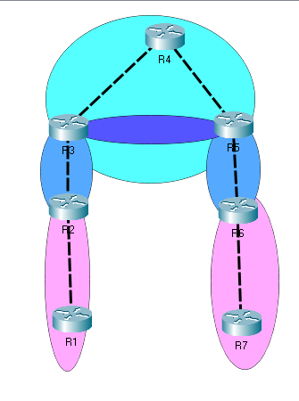

Blue: EBGP

Pink: OSPF

Dark Blue: IBGP

Light Blue: EIGRP

Addressing Table:

|  |  |  |  |  |
| --- | --- | --- | --- | --- |
| Device | Interface | IP Address | IPv6 Address | Link-Local Addresses |
| R1 | G 0/0/1 | 10.0.0.1/30 | 2001:db8:acad:1::1/64 | fe80::1 |
| Loopback 0 | 192.168.0.1/24 | 2001:db8:acad:a::1/64 | fe80::1 |
| R2 | G 0/0/0 | 10.0.0.2/30 | 2001:db8:acad:1::2/64 | fe80::2 |
| G 0/0/1 | 10.0.0.5/30 | 2001:db8:acad:2::1/64 | fe80::2 |
| Loopback 0 | 192.168.1.1/24 | 2001:db8:acad:b::1/64 | fe80::2 |
| R3 | G 0/0/0 | 10.0.0.6/30 | 2001:db8:acad:2::2/64 | fe80::3 |
| G 0/0/1 | 10.0.0.9/30 | 2001:db8:acad:3::1/64 | fe80::3 |
| Loopback 0 | 192.168.2.1/24 | 2001:db8:acad:c::1/64 | fe80::3 |
| R4 | G 0/0/0 | 10.0.0.10/30 | 2001:db8:acad:3::2/64 | fe80::4 |
| G 0/0/1 | 10.0.0.13/30 | 2001:db8:acad:4::1/64 | fe80::4 |
| Loopback 0 | 192.168.3.1/24 | 2001:db8:acad:d::1/64 | fe80::4 |
| R5 | G 0/0/0 | 10.0.0.14/30 | 2001:db8:acad:4::2/64 | fe80::5 |
| G 0/0/1 | 10.0.0.17/30 | 2001:db8:acad:5::1/64 | fe80::5 |
| Loopback 0 | 192.168.4.1/32 | 2001:db8:acad:e::1/64 | fe80::5 |
| R6 | G 0/0/0 | 10.0.0.18/30 | 2001:db8:acad:5::2/64 | fe80::6 |
| G 0/0/1 | 10.0.0.21/30 | 2001:db8:acad:6::1/64 | fe80::6 |
| Loopback 0 | 192.168.5.1/32 | 2001:db8:acad:f::1/64 | fe80::6 |
| R7 | G 0/0/0 | 10.0.0.22/30 | 2001:db8:acad:6::2/64 | fe80::7 |
| Loopback 0 | 192.168.6.1/32 | 2001:db8:acad:aa::1/64 | fe80::7 |

**Problems and Troubleshooting:**

The OSPF and EIGRP routing was configured without any problems. The main issues I had was configuring BGP and the redistribution between BGP and the IGPs. First, iBGP routes were not being put into the routing table. Second, iBGP was not redistributing EIGRP or OSPF routes across the link. Third, iBGP was not redistributing directly connected routes of the routers running BGP.

iBGP Routes not visible:

After configuring the IP addressing schemes and enabling OSPF and EIGRP instances, I configured BGP on R2, R3 and R5, R6 using the router bgp asn command and assigned a router-id. I also specified the BGP peers and their remote-as and redistributed either ospf or eigrp in the address-families depending on which router I was on. When I entered the show ip route, I did not see any BGP routes. After researching online, I realized I had to use the update the source loopback in order to start IBGP, and to get it to share BGP routes. After configuring this, I was able to see BGP routes in the autonomous system I was in and the directly connected routes of the BGP router.

When I started pinging, I discovered one final issue. The Loopback interface on R3 was not reachable nor was it in the routing table. When I checked the interface, I realized that I had accidentally entered in the wrong subnet for the interface so after I changed it all routers and networks. were reachable.

**Conclusion:**

While not as widely used, IBGP is still a critical part of major network infrastructures, allowing for configurations in BGP to be preserved while moving over parts of the network without BGP. Routing protocols are designed to solve certain problems. The problem of managing and exchanging huge volume of routes within and between autonomous systems is solved by BGP. The use of BGP as the main routing protocol for the Internet shows its scalability, performance and reliability. iBGP and eBGP can allow for both efficient routing and redistribution of IGPs.

Pings:

R7#ping 10.0.0.1

Type escape sequence to abort.

Sending 5, 100-byte ICMP Echos to 10.0.0.1, timeout is 2 seconds:

!!!!!

Success rate is 100 percent (5/5), round-trip min/avg/max = 1/1/1 ms

R7#ping 10.0.0.2

Type escape sequence to abort.

Sending 5, 100-byte ICMP Echos to 10.0.0.2, timeout is 2 seconds:

!!!!!

Success rate is 100 percent (5/5), round-trip min/avg/max = 1/1/1 ms

R7#ping 10.0.0.5

Type escape sequence to abort.

Sending 5, 100-byte ICMP Echos to 10.0.0.5, timeout is 2 seconds:

!!!!!

Success rate is 100 percent (5/5), round-trip min/avg/max = 1/1/1 ms

R7#ping 10.0.0.6

Type escape sequence to abort.

Sending 5, 100-byte ICMP Echos to 10.0.0.6, timeout is 2 seconds:

!!!!!

Success rate is 100 percent (5/5), round-trip min/avg/max = 1/1/1 ms

R7#ping 10.0.0.9

Type escape sequence to abort.

Sending 5, 100-byte ICMP Echos to 10.0.0.9, timeout is 2 seconds:

!!!!!

Success rate is 100 percent (5/5), round-trip min/avg/max = 1/1/1 ms

R7#ping 10.0.0.10

Type escape sequence to abort.

Sending 5, 100-byte ICMP Echos to 10.0.0.10, timeout is 2 seconds:

!!!!!

Success rate is 100 percent (5/5), round-trip min/avg/max = 1/1/1 ms

R7#ping 10.0.0.13

Type escape sequence to abort.

Sending 5, 100-byte ICMP Echos to 10.0.0.13, timeout is 2 seconds:

!!!!!

Success rate is 100 percent (5/5), round-trip min/avg/max = 1/1/1 ms

R7#ping 10.0.0.14

Type escape sequence to abort.

Sending 5, 100-byte ICMP Echos to 10.0.0.14, timeout is 2 seconds:

!!!!!

Success rate is 100 percent (5/5), round-trip min/avg/max = 1/1/1 ms

R7#ping 10.0.0.17

Type escape sequence to abort.

Sending 5, 100-byte ICMP Echos to 10.0.0.17, timeout is 2 seconds:

!!!!!

Success rate is 100 percent (5/5), round-trip min/avg/max = 1/1/1 ms

R7#ping 10.0.0.18

Type escape sequence to abort.

Sending 5, 100-byte ICMP Echos to 10.0.0.18, timeout is 2 seconds:

!!!!!

Success rate is 100 percent (5/5), round-trip min/avg/max = 1/1/1 ms

R7#ping 10.0.0.21

Type escape sequence to abort.

Sending 5, 100-byte ICMP Echos to 10.0.0.21, timeout is 2 seconds:

!!!!!

Success rate is 100 percent (5/5), round-trip min/avg/max = 1/1/1 ms

R7#ping 10.0.0.22

Type escape sequence to abort.

Sending 5, 100-byte ICMP Echos to 10.0.0.22, timeout is 2 seconds:

!!!!!

Success rate is 100 percent (5/5), round-trip min/avg/max = 1/1/1 ms

R7#ping 192.168.0.1

Type escape sequence to abort.

Sending 5, 100-byte ICMP Echos to 192.168.0.1, timeout is 2 seconds:

!!!!!

Success rate is 100 percent (5/5), round-trip min/avg/max = 1/1/1 ms

R7#ping 192.168.1.1

Type escape sequence to abort.

Sending 5, 100-byte ICMP Echos to 192.168.1.1, timeout is 2 seconds:

!!!!!

Success rate is 100 percent (5/5), round-trip min/avg/max = 1/1/1 ms

R7#ping 192.168.2.1

Type escape sequence to abort.

Sending 5, 100-byte ICMP Echos to 192.168.2.1, timeout is 2 seconds:

!!!!!

Success rate is 100 percent (5/5), round-trip min/avg/max = 1/1/1 ms

R7#ping 192.168.3.1

Type escape sequence to abort.

Sending 5, 100-byte ICMP Echos to 192.168.3.1, timeout is 2 seconds:

!!!!!

Success rate is 100 percent (5/5), round-trip min/avg/max = 1/1/1 ms

R7#ping 192.168.4.1

Type escape sequence to abort.

Sending 5, 100-byte ICMP Echos to 192.168.4.1, timeout is 2 seconds:

!!!!!

Success rate is 100 percent (5/5), round-trip min/avg/max = 1/1/1 ms

R7#ping 192.168.5.1

Type escape sequence to abort.

Sending 5, 100-byte ICMP Echos to 192.168.5.1, timeout is 2 seconds:

!!!!!

Success rate is 100 percent (5/5), round-trip min/avg/max = 1/1/1 ms

R7#ping 192.168.6.1

Type escape sequence to abort.

Sending 5, 100-byte ICMP Echos to 192.168.6.1, timeout is 2 seconds:

!!!!!

Success rate is 100 percent (5/5), round-trip min/avg/max = 1/1/1 ms

R7#ping 2001:db8:acad:1::1

Type escape sequence to abort.

Sending 5, 100-byte ICMP Echos to 2001:DB8:ACAD:1::1, timeout is 2 seconds:

!!!!!

Success rate is 100 percent (5/5), round-trip min/avg/max = 1/1/1 ms

R7#ping 2001:db8:acad:1::2

Type escape sequence to abort.

Sending 5, 100-byte ICMP Echos to 2001:DB8:ACAD:1::2, timeout is 2 seconds:

!!!!!

Success rate is 100 percent (5/5), round-trip min/avg/max = 1/1/1 ms

R7#ping 2001:db8:acad:2::1

Type escape sequence to abort.

Sending 5, 100-byte ICMP Echos to 2001:DB8:ACAD:2::1, timeout is 2 seconds:

!!!!!

Success rate is 100 percent (5/5), round-trip min/avg/max = 1/1/1 ms

R7#ping 2001:db8:acad:2::2

Type escape sequence to abort.

Sending 5, 100-byte ICMP Echos to 2001:DB8:ACAD:2::2, timeout is 2 seconds:

!!!!!

Success rate is 100 percent (5/5), round-trip min/avg/max = 1/1/1 ms

R7#ping 2001:db8:acad:3::1

Type escape sequence to abort.

Sending 5, 100-byte ICMP Echos to 2001:DB8:ACAD:3::1, timeout is 2 seconds:

!!!!!

Success rate is 100 percent (5/5), round-trip min/avg/max = 1/1/1 ms

R7#ping 2001:db8:acad:3::2

Type escape sequence to abort.

Sending 5, 100-byte ICMP Echos to 2001:DB8:ACAD:3::2, timeout is 2 seconds:

!!!!!

Success rate is 100 percent (5/5), round-trip min/avg/max = 1/1/1 ms

R7#ping 2001:db8:acad:4::1

Type escape sequence to abort.

Sending 5, 100-byte ICMP Echos to 2001:DB8:ACAD:4::1, timeout is 2 seconds:

!!!!!

Success rate is 100 percent (5/5), round-trip min/avg/max = 1/2/6 ms

R7#ping 2001:db8:acad:4::2

Type escape sequence to abort.

Sending 5, 100-byte ICMP Echos to 2001:DB8:ACAD:4::2, timeout is 2 seconds:

!!!!!

Success rate is 100 percent (5/5), round-trip min/avg/max = 1/1/1 ms

R7#ping 2001:db8:acad:5::1

Type escape sequence to abort.

Sending 5, 100-byte ICMP Echos to 2001:DB8:ACAD:5::1, timeout is 2 seconds:

!!!!!

Success rate is 100 percent (5/5), round-trip min/avg/max = 1/1/1 ms

R7#ping 2001:db8:acad:5::2

Type escape sequence to abort.

Sending 5, 100-byte ICMP Echos to 2001:DB8:ACAD:5::2, timeout is 2 seconds:

!!!!!

Success rate is 100 percent (5/5), round-trip min/avg/max = 1/1/1 ms

R7#ping 2001:db8:acad:6::1

Type escape sequence to abort.

Sending 5, 100-byte ICMP Echos to 2001:DB8:ACAD:6::1, timeout is 2 seconds:

!!!!!

Success rate is 100 percent (5/5), round-trip min/avg/max = 1/1/1 ms

R7#ping 2001:db8:acad:6::2

Type escape sequence to abort.

Sending 5, 100-byte ICMP Echos to 2001:DB8:ACAD:6::2, timeout is 2 seconds:

!!!!!

Success rate is 100 percent (5/5), round-trip min/avg/max = 1/1/1 ms

R7#ping 2001:db8:acad:a::1

Type escape sequence to abort.

Sending 5, 100-byte ICMP Echos to 2001:DB8:ACAD:A::1, timeout is 2 seconds:

!!!!!

Success rate is 100 percent (5/5), round-trip min/avg/max = 1/1/1 ms

R7#ping 2001:db8:acad:b::1

Type escape sequence to abort.

Sending 5, 100-byte ICMP Echos to 2001:DB8:ACAD:B::1, timeout is 2 seconds:

!!!!!

Success rate is 100 percent (5/5), round-trip min/avg/max = 1/1/2 ms

R7#ping 2001:db8:acad:c::1

Type escape sequence to abort.

Sending 5, 100-byte ICMP Echos to 2001:DB8:ACAD:C::1, timeout is 2 seconds:

!!!!!

Success rate is 100 percent (5/5), round-trip min/avg/max = 1/1/1 ms

R7#ping 2001:db8:acad:d::1

Type escape sequence to abort.

Sending 5, 100-byte ICMP Echos to 2001:DB8:ACAD:D::1, timeout is 2 seconds:

!!!!!

Success rate is 100 percent (5/5), round-trip min/avg/max = 1/1/1 ms

R7#ping 2001:db8:acad:f::1

Type escape sequence to abort.

Sending 5, 100-byte ICMP Echos to 2001:DB8:ACAD:F::1, timeout is 2 seconds:

!!!!!

Success rate is 100 percent (5/5), round-trip min/avg/max = 1/1/1 ms

R7#ping 2001:db8:acad:e::1

Type escape sequence to abort.

Sending 5, 100-byte ICMP Echos to 2001:DB8:ACAD:E::1, timeout is 2 seconds:

!!!!!

Success rate is 100 percent (5/5), round-trip min/avg/max = 1/1/1 ms

R7# ping 2001:db8:acad:aa::1

Type escape sequence to abort.

Sending 5, 100-byte ICMP Echos to 2001:DB8:ACAD:AA::1, timeout is 2 seconds:

!!!!!

Success rate is 100 percent (5/5), round-trip min/avg/max = 1/1/1 ms

Router 1 Config:

**Show Run:**

version 15.5

service timestamps debug datetime msec

service timestamps log datetime msec

no platform punt-keepalive disable-kernel-core

!

hostname R1

!

boot-start-marker

boot-end-marker

!

vrf definition Mgmt-intf

!

address-family ipv4

exit-address-family

!

address-family ipv6

exit-address-family

!

no aaa new-model

!

ipv6 unicast-routing

!

subscriber templating

multilink bundle-name authenticated

!

license udi pid ISR4321/K9 sn FDO214811ZM

!

spanning-tree extend system-id

!

redundancy

mode none

!

vlan internal allocation policy ascending

!

interface Loopback0

ip address 192.168.0.1 255.255.255.0

ipv6 address FE80::1 link-local

ipv6 address 2001:DB8:ACAD:A::1/64

ipv6 ospf 10 area 0

!

interface GigabitEthernet0/0/0

no ip address

negotiation auto

!

interface GigabitEthernet0/0/1

ip address 10.0.0.1 255.255.255.252

negotiation auto

ipv6 address FE80::1 link-local

ipv6 address 2001:DB8:ACAD:1::1/64

ipv6 ospf 10 area 0

!

interface Serial0/1/0

no ip address

shutdown

!

interface Serial0/1/1

no ip address

shutdown

!

interface GigabitEthernet0/2/0

no ip address

shutdown

negotiation auto

!

interface GigabitEthernet0/2/1

no ip address

shutdown

negotiation auto

!

interface GigabitEthernet0

vrf forwarding Mgmt-intf

no ip address

shutdown

negotiation auto

!

interface Vlan1

no ip address

shutdown

!

router ospf 1

router-id 1.1.1.1

passive-interface Loopback0

network 10.0.0.0 0.0.0.3 area 0

network 192.168.0.0 0.0.0.255 area 0

!

ip forward-protocol nd

no ip http server

no ip http secure-server

ip tftp source-interface GigabitEthernet0

!

!

ipv6 router ospf 10

router-id 1.1.1.1

passive-interface Loopback0

!

control-plane

!

line con 0

stopbits 1

line aux 0

stopbits 1

line vty 0 4

login

!

End

R1# show ip route

Codes: L - local, C - connected, S - static, R - RIP, M - mobile, B - BGP

D - EIGRP, EX - EIGRP external, O - OSPF, IA - OSPF inter area

N1 - OSPF NSSA external type 1, N2 - OSPF NSSA external type 2

E1 - OSPF external type 1, E2 - OSPF external type 2

i - IS-IS, su - IS-IS summary, L1 - IS-IS level-1, L2 - IS-IS level-2

ia - IS-IS inter area, * - candidate default, U - per-user static route

o - ODR, P - periodic downloaded static route, H - NHRP, l - LISP

a - application route

+ - replicated route, % - next hop override, p - overrides from PfR

Gateway of last resort is not set

10.0.0.0/8 is variably subnetted, 7 subnets, 2 masks

C 10.0.0.0/30 is directly connected, GigabitEthernet0/0/1

L 10.0.0.1/32 is directly connected, GigabitEthernet0/0/1

O 10.0.0.4/30 [110/2] via 10.0.0.2, 00:19:19, GigabitEthernet0/0/1

O E2 10.0.0.8/30

[110/10000000] via 10.0.0.2, 00:17:40, GigabitEthernet0/0/1

O E2 10.0.0.12/30

[110/10000000] via 10.0.0.2, 00:09:04, GigabitEthernet0/0/1

O E2 10.0.0.16/30

[110/10000000] via 10.0.0.2, 00:07:42, GigabitEthernet0/0/1

O E2 10.0.0.20/30

[110/10000000] via 10.0.0.2, 00:05:44, GigabitEthernet0/0/1

192.168.0.0/24 is variably subnetted, 2 subnets, 2 masks

C 192.168.0.0/24 is directly connected, Loopback0

L 192.168.0.1/32 is directly connected, Loopback0

192.168.1.0/32 is subnetted, 1 subnets

O 192.168.1.1 [110/2] via 10.0.0.2, 00:19:29, GigabitEthernet0/0/1

192.168.2.0/30 is subnetted, 1 subnets

O E2 192.168.2.0

[110/10000000] via 10.0.0.2, 00:18:14, GigabitEthernet0/0/1

192.168.3.0/30 is subnetted, 1 subnets

O E2 192.168.3.0

[110/10000000] via 10.0.0.2, 00:17:09, GigabitEthernet0/0/1

192.168.4.0/30 is subnetted, 1 subnets

O E2 192.168.4.0

[110/10000000] via 10.0.0.2, 00:08:33, GigabitEthernet0/0/1

192.168.5.0/30 is subnetted, 1 subnets

O E2 192.168.5.0

[110/10000000] via 10.0.0.2, 00:06:30, GigabitEthernet0/0/1

192.168.6.0/32 is subnetted, 1 subnets

O E2 192.168.6.1

[110/10000000] via 10.0.0.2, 00:04:59, GigabitEthernet0/0/1

R1#show ipv6 route

IPv6 Routing Table - default - 16 entries

Codes: C - Connected, L - Local, S - Static, U - Per-user Static route

B - BGP, R - RIP, I1 - ISIS L1, I2 - ISIS L2

IA - ISIS interarea, IS - ISIS summary, D - EIGRP, EX - EIGRP external

ND - ND Default, NDp - ND Prefix, DCE - Destination, NDr - Redirect

O - OSPF Intra, OI - OSPF Inter, OE1 - OSPF ext 1, OE2 - OSPF ext 2

ON1 - OSPF NSSA ext 1, ON2 - OSPF NSSA ext 2, a - Application

C 2001:DB8:ACAD:1::/64 [0/0]

via GigabitEthernet0/0/1, directly connected

L 2001:DB8:ACAD:1::1/128 [0/0]

via GigabitEthernet0/0/1, receive

O 2001:DB8:ACAD:2::/64 [110/2]

via FE80::2, GigabitEthernet0/0/1

OE2 2001:DB8:ACAD:3::/64 [110/10000000]

via FE80::2, GigabitEthernet0/0/1

OE2 2001:DB8:ACAD:4::/64 [110/10000000]

via FE80::2, GigabitEthernet0/0/1

OE2 2001:DB8:ACAD:5::/64 [110/10000000]

via FE80::2, GigabitEthernet0/0/1

OE2 2001:DB8:ACAD:6::/64 [110/10000000]

via FE80::2, GigabitEthernet0/0/1

C 2001:DB8:ACAD:A::/64 [0/0]

via Loopback0, directly connected

L 2001:DB8:ACAD:A::1/128 [0/0]

via Loopback0, receive

O 2001:DB8:ACAD:B::1/128 [110/1]

via FE80::2, GigabitEthernet0/0/1

OE2 2001:DB8:ACAD:C::/64 [110/10000000]

via FE80::2, GigabitEthernet0/0/1

OE2 2001:DB8:ACAD:D::/64 [110/10000000]

via FE80::2, GigabitEthernet0/0/1

OE2 2001:DB8:ACAD:E::/64 [110/10000000]

via FE80::2, GigabitEthernet0/0/1

OE2 2001:DB8:ACAD:F::/64 [110/10000000]

via FE80::2, GigabitEthernet0/0/1

OE2 2001:DB8:ACAD:AA::1/128 [110/10000000]

via FE80::2, GigabitEthernet0/0/1

L FF00::/8 [0/0]

via Null0, receive

R1# show ip ospf neighbor

Neighbor ID Pri State Dead Time Address Interface

2.2.2.2 1 FULL/DR 00:00:36 10.0.0.2 GigabitEthernet0/0/1

R1# show ip ospf

Routing Process "ospf 1" with ID 1.1.1.1

Start time: 02:44:16.715, Time elapsed: 00:21:36.848

Supports only single TOS(TOS0) routes

Supports opaque LSA

Supports Link-local Signaling (LLS)

Supports area transit capability

Supports NSSA (compatible with RFC 3101)

Supports Database Exchange Summary List Optimization (RFC 5243)

Event-log enabled, Maximum number of events: 1000, Mode: cyclic

Router is not originating router-LSAs with maximum metric

Initial SPF schedule delay 5000 msecs

Minimum hold time between two consecutive SPFs 10000 msecs

Maximum wait time between two consecutive SPFs 10000 msecs

Incremental-SPF disabled

Minimum LSA interval 5 secs

Minimum LSA arrival 1000 msecs

LSA group pacing timer 240 secs

Interface flood pacing timer 33 msecs

Retransmission pacing timer 66 msecs

EXCHANGE/LOADING adjacency limit: initial 300, process maximum 300

Number of external LSA 9. Checksum Sum 0x077160

Number of opaque AS LSA 0. Checksum Sum 0x000000

Number of DCbitless external and opaque AS LSA 0

Number of DoNotAge external and opaque AS LSA 0

Number of areas in this router is 1. 1 normal 0 stub 0 nssa

Number of areas transit capable is 0

External flood list length 0

IETF NSF helper support enabled

Cisco NSF helper support enabled

Reference bandwidth unit is 100 mbps

Area BACKBONE(0)

Number of interfaces in this area is 2 (1 loopback)

Area has no authentication

SPF algorithm last executed 00:19:36.831 ago

SPF algorithm executed 6 times

Area ranges are

Number of LSA 3. Checksum Sum 0x00DC40

Number of opaque link LSA 0. Checksum Sum 0x000000

Number of DCbitless LSA 0

Number of indication LSA 0

Number of DoNotAge LSA 0

Flood list length 0

R1# show ip ospf interface

Loopback0 is up, line protocol is up

Internet Address 192.168.0.1/24, Area 0, Attached via Network Statement

Process ID 1, Router ID 1.1.1.1, Network Type LOOPBACK, Cost: 1

Topology-MTID Cost Disabled Shutdown Topology Name

0 1 no no Base

Loopback interface is treated as a stub Host

GigabitEthernet0/0/1 is up, line protocol is up

Internet Address 10.0.0.1/30, Area 0, Attached via Network Statement

Process ID 1, Router ID 1.1.1.1, Network Type BROADCAST, Cost: 1

Topology-MTID Cost Disabled Shutdown Topology Name

0 1 no no Base

Transmit Delay is 1 sec, State BDR, Priority 1

Designated Router (ID) 2.2.2.2, Interface address 10.0.0.2

Backup Designated router (ID) 1.1.1.1, Interface address 10.0.0.1

Timer intervals configured, Hello 10, Dead 40, Wait 40, Retransmit 5

oob-resync timeout 40

Hello due in 00:00:05

Supports Link-local Signaling (LLS)

Cisco NSF helper support enabled

IETF NSF helper support enabled

Index 1/1/1, flood queue length 0

Next 0x0(0)/0x0(0)/0x0(0)

Last flood scan length is 1, maximum is 1

Last flood scan time is 0 msec, maximum is 0 msec

Neighbor Count is 1, Adjacent neighbor count is 1

Adjacent with neighbor 2.2.2.2 (Designated Router)

Suppress hello for 0 neighbor(s)

R1# show ip ospf border-routers

OSPF Router with ID (1.1.1.1) (Process ID 1)

Base Topology (MTID 0)

Internal Router Routing Table

Codes: i - Intra-area route, I - Inter-area route

i 2.2.2.2 [1] via 10.0.0.2, GigabitEthernet0/0/1, ASBR, Area 0, SPF 6

R1#show ipv6 ospf neighbor

OSPFv3 Router with ID (1.1.1.1) (Process ID 10)

Neighbor ID Pri State Dead Time Interface ID Interface

2.2.2.2 1 FULL/DR 00:00:35 6 GigabitEthernet0/0/1

R1#show ipv6 ospf interface

Loopback0 is up, line protocol is up

Link Local Address FE80::1, Interface ID 14

Area 0, Process ID 10, Instance ID 0, Router ID 1.1.1.1

Network Type LOOPBACK, Cost: 1

Loopback interface is treated as a stub Host

GigabitEthernet0/0/1 is up, line protocol is up

Link Local Address FE80::1, Interface ID 7

Area 0, Process ID 10, Instance ID 0, Router ID 1.1.1.1

Network Type BROADCAST, Cost: 1

Transmit Delay is 1 sec, State BDR, Priority 1

Designated Router (ID) 2.2.2.2, local address FE80::2

Backup Designated router (ID) 1.1.1.1, local address FE80::1

Timer intervals configured, Hello 10, Dead 40, Wait 40, Retransmit 5

Hello due in 00:00:05

Graceful restart helper support enabled

Index 1/2/2, flood queue length 0

Next 0x0(0)/0x0(0)/0x0(0)

Last flood scan length is 2, maximum is 2

Last flood scan time is 0 msec, maximum is 0 msec

Neighbor Count is 1, Adjacent neighbor count is 1

Adjacent with neighbor 2.2.2.2 (Designated Router)

Suppress hello for 0 neighbor(s)

R1#show ipv6 ospf border-routers

OSPFv3 Router with ID (1.1.1.1) (Process ID 10)

Codes: i - Intra-area route, I - Inter-area route

i 2.2.2.2 [1] via FE80::2, GigabitEthernet0/0/1, ASBR, Area 0, SPF 3

R1#show ip protocol

*** IP Routing is NSF aware ***

Routing Protocol is "application"

Sending updates every 0 seconds

Invalid after 0 seconds, hold down 0, flushed after 0

Outgoing update filter list for all interfaces is not set

Incoming update filter list for all interfaces is not set

Maximum path: 32

Routing for Networks:

Routing Information Sources:

Gateway Distance Last Update

Distance: (default is 4)

Routing Protocol is "ospf 1"

Outgoing update filter list for all interfaces is not set

Incoming update filter list for all interfaces is not set

Router ID 1.1.1.1

Number of areas in this router is 1. 1 normal 0 stub 0 nssa

Maximum path: 4

Routing for Networks:

10.0.0.0 0.0.0.3 area 0

192.168.0.0 0.0.0.255 area 0

Passive Interface(s):

Passive Interface(s):

Loopback0

Routing Information Sources:

Gateway Distance Last Update

2.2.2.2 110 00:05:58

Distance: (default is 110)

R1#show ipv6 protocol

IPv6 Routing Protocol is "connected"

IPv6 Routing Protocol is "application"

IPv6 Routing Protocol is "ND"

IPv6 Routing Protocol is "ospf 10"

Router ID 1.1.1.1

Number of areas: 1 normal, 0 stub, 0 nssa

Interfaces (Area 0):

Loopback0

GigabitEthernet0/0/1

Redistribution:

None

R2 Config:

R2#show run

Building configuration...

Current configuration : 2524 bytes

!

! Last configuration change at 18:37:08 UTC Wed Jan 5 2022

!

version 15.5

service timestamps debug datetime msec

service timestamps log datetime msec

no platform punt-keepalive disable-kernel-core

!

hostname R2

!

boot-start-marker

boot-end-marker

!

!

vrf definition Mgmt-intf

!

address-family ipv4

exit-address-family

!

address-family ipv6

exit-address-family

!

!

no aaa new-model

!

!

ipv6 unicast-routing

!

subscriber templating

multilink bundle-name authenticated

!

license udi pid ISR4321/K9 sn FDO214414TX

!

spanning-tree extend system-id

!

!

redundancy

mode none

!

!

vlan internal allocation policy ascending

!

interface Loopback0

ip address 192.168.1.1 255.255.255.252

ipv6 address FE80::2 link-local

ipv6 address 2001:DB8:ACAD:B::1/64

ipv6 ospf 10 area 0

!

interface GigabitEthernet0/0/0

ip address 10.0.0.2 255.255.255.252

negotiation auto

ipv6 address FE80::2 link-local

ipv6 address 2001:DB8:ACAD:1::2/64

ipv6 ospf 10 area 0

!

interface GigabitEthernet0/0/1

ip address 10.0.0.5 255.255.255.252

negotiation auto

ipv6 address FE80::2 link-local

ipv6 address 2001:DB8:ACAD:2::1/64

ipv6 ospf 10 area 0

!

interface Serial0/1/0

no ip address

shutdown

!

interface Serial0/1/1

no ip address

shutdown

!

interface GigabitEthernet0/2/0

no ip address

shutdown

negotiation auto

!

interface GigabitEthernet0/2/1

no ip address

shutdown

negotiation auto

!

interface GigabitEthernet0

vrf forwarding Mgmt-intf

no ip address

shutdown

negotiation auto

!

interface Vlan1

no ip address

shutdown

!

router ospf 1

router-id 2.2.2.2

redistribute bgp 100 metric 10000000 subnets

passive-interface Loopback0

network 10.0.0.0 0.0.0.3 area 0

network 10.0.0.4 0.0.0.3 area 0

network 192.168.1.0 0.0.0.255 area 0

!

router bgp 100

bgp router-id 2.2.2.2

bgp log-neighbor-changes

neighbor 10.0.0.6 remote-as 200

neighbor 2001:DB8:ACAD:2::2 remote-as 200

!

address-family ipv4

redistribute ospf 1

neighbor 10.0.0.6 activate

no neighbor 2001:DB8:ACAD:2::2 activate

exit-address-family

!

address-family ipv6

redistribute connected

redistribute ospf 10

neighbor 2001:DB8:ACAD:2::2 activate

exit-address-family

!

ip forward-protocol nd

no ip http server

no ip http secure-server

ip tftp source-interface GigabitEthernet0

!

!

ipv6 router ospf 10

router-id 2.2.2.2

passive-interface Loopback0

redistribute bgp 100 metric 10000000

!

!

!

!

control-plane

!

!

line con 0

stopbits 1

line aux 0

stopbits 1

line vty 0 4

login

!

!

end

R2# show ip route

Codes: L - local, C - connected, S - static, R - RIP, M - mobile, B - BGP

D - EIGRP, EX - EIGRP external, O - OSPF, IA - OSPF inter area

N1 - OSPF NSSA external type 1, N2 - OSPF NSSA external type 2

E1 - OSPF external type 1, E2 - OSPF external type 2

i - IS-IS, su - IS-IS summary, L1 - IS-IS level-1, L2 - IS-IS level-2

ia - IS-IS inter area, * - candidate default, U - per-user static route

o - ODR, P - periodic downloaded static route, H - NHRP, l - LISP

a - application route

+ - replicated route, % - next hop override, p - overrides from PfR

Gateway of last resort is not set

10.0.0.0/8 is variably subnetted, 8 subnets, 2 masks

C 10.0.0.0/30 is directly connected, GigabitEthernet0/0/0

L 10.0.0.2/32 is directly connected, GigabitEthernet0/0/0

C 10.0.0.4/30 is directly connected, GigabitEthernet0/0/1

L 10.0.0.5/32 is directly connected, GigabitEthernet0/0/1

B 10.0.0.8/30 [20/0] via 10.0.0.6, 00:20:19

B 10.0.0.12/30 [20/3072] via 10.0.0.6, 00:11:43

B 10.0.0.16/30 [20/3328] via 10.0.0.6, 00:10:21

B 10.0.0.20/30 [20/26368] via 10.0.0.6, 00:08:23

192.168.0.0/32 is subnetted, 1 subnets

O 192.168.0.1 [110/2] via 10.0.0.1, 00:22:07, GigabitEthernet0/0/0

192.168.1.0/24 is variably subnetted, 2 subnets, 2 masks

C 192.168.1.0/30 is directly connected, Loopback0

L 192.168.1.1/32 is directly connected, Loopback0

192.168.2.0/30 is subnetted, 1 subnets

B 192.168.2.0 [20/0] via 10.0.0.6, 00:20:53

192.168.3.0/30 is subnetted, 1 subnets

B 192.168.3.0 [20/130816] via 10.0.0.6, 00:19:48

192.168.4.0/30 is subnetted, 1 subnets

B 192.168.4.0 [20/131072] via 10.0.0.6, 00:11:12

192.168.5.0/30 is subnetted, 1 subnets

B 192.168.5.0 [20/26368] via 10.0.0.6, 00:09:09

192.168.6.0/32 is subnetted, 1 subnets

B 192.168.6.1 [20/26368] via 10.0.0.6, 00:07:38

R2#show ipv6 route

IPv6 Routing Table - default - 17 entries

Codes: C - Connected, L - Local, S - Static, U - Per-user Static route

B - BGP, R - RIP, I1 - ISIS L1, I2 - ISIS L2

IA - ISIS interarea, IS - ISIS summary, D - EIGRP, EX - EIGRP external

ND - ND Default, NDp - ND Prefix, DCE - Destination, NDr - Redirect

O - OSPF Intra, OI - OSPF Inter, OE1 - OSPF ext 1, OE2 - OSPF ext 2

ON1 - OSPF NSSA ext 1, ON2 - OSPF NSSA ext 2, a - Application

C 2001:DB8:ACAD:1::/64 [0/0]

via GigabitEthernet0/0/0, directly connected

L 2001:DB8:ACAD:1::2/128 [0/0]

via GigabitEthernet0/0/0, receive

C 2001:DB8:ACAD:2::/64 [0/0]

via GigabitEthernet0/0/1, directly connected

L 2001:DB8:ACAD:2::1/128 [0/0]

via GigabitEthernet0/0/1, receive

B 2001:DB8:ACAD:3::/64 [20/0]

via FE80::3, GigabitEthernet0/0/1

B 2001:DB8:ACAD:4::/64 [20/3072]

via FE80::3, GigabitEthernet0/0/1

B 2001:DB8:ACAD:5::/64 [20/3328]

via FE80::3, GigabitEthernet0/0/1

B 2001:DB8:ACAD:6::/64 [20/26368]

via FE80::3, GigabitEthernet0/0/1

O 2001:DB8:ACAD:A::1/128 [110/1]

via FE80::1, GigabitEthernet0/0/0

C 2001:DB8:ACAD:B::/64 [0/0]

via Loopback0, directly connected

L 2001:DB8:ACAD:B::1/128 [0/0]

via Loopback0, receive

B 2001:DB8:ACAD:C::/64 [20/0]

via FE80::3, GigabitEthernet0/0/1

B 2001:DB8:ACAD:D::/64 [20/130816]

via FE80::3, GigabitEthernet0/0/1

B 2001:DB8:ACAD:E::/64 [20/131072]

via FE80::3, GigabitEthernet0/0/1

B 2001:DB8:ACAD:F::/64 [20/26368]

via FE80::3, GigabitEthernet0/0/1

B 2001:DB8:ACAD:AA::1/128 [20/26368]

via FE80::3, GigabitEthernet0/0/1

L FF00::/8 [0/0]

via Null0, receive

R2# show ip bgp

BGP table version is 22, local router ID is 2.2.2.2

Status codes: s suppressed, d damped, h history, * valid, > best, i - internal,

r RIB-failure, S Stale, m multipath, b backup-path, f RT-Filter,

x best-external, a additional-path, c RIB-compressed,

Origin codes: i - IGP, e - EGP, ? - incomplete

RPKI validation codes: V valid, I invalid, N Not found

Network Next Hop Metric LocPrf Weight Path

*> 10.0.0.0/30 0.0.0.0 0 32768 ?

* 10.0.0.4/30 10.0.0.6 0 0 200 ?

*> 0.0.0.0 0 32768 ?

*> 10.0.0.8/30 10.0.0.6 0 0 200 ?

*> 10.0.0.12/30 10.0.0.6 3072 0 200 ?

*> 10.0.0.16/30 10.0.0.6 3328 0 200 ?

*> 10.0.0.20/30 10.0.0.6 26368 0 200 ?

*> 192.168.0.1/32 10.0.0.1 2 32768 ?

*> 192.168.1.0/30 0.0.0.0 0 32768 ?

*> 192.168.2.0/30 10.0.0.6 0 0 200 ?

*> 192.168.3.0/30 10.0.0.6 130816 0 200 ?

*> 192.168.4.0/30 10.0.0.6 131072 0 200 ?

*> 192.168.5.0/30 10.0.0.6 26368 0 200 ?

*> 192.168.6.1/32 10.0.0.6 26368 0 200 ?

R2#show bgp ipv6

BGP table version is 26, local router ID is 2.2.2.2

Status codes: s suppressed, d damped, h history, * valid, > best, i - internal,

r RIB-failure, S Stale, m multipath, b backup-path, f RT-Filter,

x best-external, a additional-path, c RIB-compressed,

Origin codes: i - IGP, e - EGP, ? - incomplete

RPKI validation codes: V valid, I invalid, N Not found

Network Next Hop Metric LocPrf Weight Path

*> 2001:DB8:ACAD:1::/64

:: 0 32768 ?

* 2001:DB8:ACAD:2::/64

2001:DB8:ACAD:2::2

0 0 200 ?

*> :: 0 32768 ?

*> 2001:DB8:ACAD:3::/64

2001:DB8:ACAD:2::2

0 0 200 ?

*> 2001:DB8:ACAD:4::/64

2001:DB8:ACAD:2::2

3072 0 200 ?

*> 2001:DB8:ACAD:5::/64

2001:DB8:ACAD:2::2

3328 0 200 ?

Network Next Hop Metric LocPrf Weight Path

*> 2001:DB8:ACAD:A::1/128

FE80::1 1 32768 ?

*> 2001:DB8:ACAD:B::/64

:: 0 32768 ?

*> 2001:DB8:ACAD:C::/64

2001:DB8:ACAD:2::2

0 0 200 ?

*> 2001:DB8:ACAD:D::/64

2001:DB8:ACAD:2::2

130816 0 200 ?

*> 2001:DB8:ACAD:E::/64

2001:DB8:ACAD:2::2

131072 0 200 ?

*> 2001:DB8:ACAD:AA::1/128

2001:DB8:ACAD:2::2

26368 0 200 ?

% NOTE: This command is deprecated. Please use 'show bgp ipv6 unicast'

R2#show bgp ipv6 unicast neighbors

BGP neighbor is 2001:DB8:ACAD:2::2, remote AS 200, external link

BGP version 4, remote router ID 3.3.3.3

BGP state = Established, up for 00:22:20

Last read 00:00:42, last write 00:00:31, hold time is 180, keepalive interval is 60 seconds

Neighbor sessions:

1 active, is not multisession capable (disabled)

Neighbor capabilities:

Route refresh: advertised and received(new)

Four-octets ASN Capability: advertised and received

Address family IPv6 Unicast: advertised and received

Enhanced Refresh Capability: advertised and received

Multisession Capability:

Stateful switchover support enabled: NO for session 1

Message statistics:

InQ depth is 0

OutQ depth is 0

Sent Rcvd

Opens: 1 1

Notifications: 0 0

Updates: 5 16

Keepalives: 25 19

Route Refresh: 0 0

Total: 31 36

Do log neighbor state changes (via global configuration)

Default minimum time between advertisement runs is 30 seconds

For address family: IPv6 Unicast

Session: 2001:DB8:ACAD:2::2

BGP table version 26, neighbor version 26/0

Output queue size : 0

Index 1, Advertise bit 0

1 update-group member

Slow-peer detection is disabled

Slow-peer split-update-group dynamic is disabled

Sent Rcvd

Prefix activity: ---- ----

Prefixes Current: 4 8 (Consumes 1152 bytes)

Prefixes Total: 8 14

Implicit Withdraw: 4 2

Explicit Withdraw: 0 4

Used as bestpath: n/a 7

Used as multipath: n/a 0

Outbound Inbound

Local Policy Denied Prefixes: -------- -------

Bestpath from this peer: 11 n/a

Total: 11 0

Number of NLRIs in the update sent: max 3, min 0

Last detected as dynamic slow peer: never

Dynamic slow peer recovered: never

Refresh Epoch: 1

Last Sent Refresh Start-of-rib: never

Last Sent Refresh End-of-rib: never

Last Received Refresh Start-of-rib: never

Last Received Refresh End-of-rib: never

Sent Rcvd

Refresh activity: ---- ----

Refresh Start-of-RIB 0 0

Refresh End-of-RIB 0 0

Address tracking is enabled, the RIB does have a route to 2001:DB8:ACAD:2::2

Connections established 1; dropped 0

Last reset never

External BGP neighbor configured for connected checks (single-hop no-disable-connected-check)

Interface associated: GigabitEthernet0/0/1 (peering address in same link)

Transport(tcp) path-mtu-discovery is enabled

Graceful-Restart is disabled

SSO is disabled

Connection state is ESTAB, I/O status: 1, unread input bytes: 0

Connection is ECN Disabled, Mininum incoming TTL 0, Outgoing TTL 1

Local host: 2001:DB8:ACAD:2::1, Local port: 34359

Foreign host: 2001:DB8:ACAD:2::2, Foreign port: 179

Connection tableid (VRF): 0

Maximum output segment queue size: 50

Enqueued packets for retransmit: 0, input: 0 mis-ordered: 0 (0 bytes)

Event Timers (current time is 0xACBC40):

Timer Starts Wakeups Next

Retrans 28 0 0x0

TimeWait 0 0 0x0

AckHold 35 30 0x0

SendWnd 0 0 0x0

KeepAlive 0 0 0x0

GiveUp 0 0 0x0

PmtuAger 525 524 0xACBD48

DeadWait 0 0 0x0

Linger 0 0 0x0

ProcessQ 0 0 0x0

iss: 399757082 snduna: 399758064 sndnxt: 399758064

irs: 1014810708 rcvnxt: 1014812409

sndwnd: 15403 scale: 0 maxrcvwnd: 16384

rcvwnd: 16132 scale: 0 delrcvwnd: 252

SRTT: 976 ms, RTTO: 1166 ms, RTV: 190 ms, KRTT: 0 ms

minRTT: 2 ms, maxRTT: 1000 ms, ACK hold: 200 ms

uptime: 1340998 ms, Sent idletime: 31207 ms, Receive idletime: 31006 ms

Status Flags: active open

Option Flags: nagle, path mtu capable

IP Precedence value : 6

Datagrams (max data segment is 1440 bytes):

Rcvd: 63 (out of order: 0), with data: 35, total data bytes: 1700

Sent: 62 (retransmit: 0, fastretransmit: 0, partialack: 0, Second Congestion: 0), with data: 62, total data bytes: 3469

Packets received in fast path: 0, fast processed: 0, slow path: 0

fast lock acquisition failures: 0, slow path: 0

TCP Semaphore 0x7F32C5A81BA8 FREE

R2# show ip bgp summary

BGP router identifier 2.2.2.2, local AS number 100

BGP table version is 22, main routing table version 22

13 network entries using 3224 bytes of memory

14 path entries using 1680 bytes of memory

8/8 BGP path/bestpath attribute entries using 1984 bytes of memory

1 BGP AS-PATH entries using 24 bytes of memory

0 BGP route-map cache entries using 0 bytes of memory

0 BGP filter-list cache entries using 0 bytes of memory

BGP using 6912 total bytes of memory

BGP activity 30/6 prefixes, 36/10 paths, scan interval 60 secs

Neighbor V AS MsgRcvd MsgSent TblVer InQ OutQ Up/Down State/PfxRcd

10.0.0.6 4 200 34 30 22 0 0 00:22:40 10

R2#show bgp ipv6 unicast summary

BGP router identifier 2.2.2.2, local AS number 100

BGP table version is 26, main routing table version 26

11 network entries using 2992 bytes of memory

12 path entries using 1728 bytes of memory

8/8 BGP path/bestpath attribute entries using 1984 bytes of memory

1 BGP AS-PATH entries using 24 bytes of memory

0 BGP route-map cache entries using 0 bytes of memory

0 BGP filter-list cache entries using 0 bytes of memory

BGP using 6728 total bytes of memory

BGP activity 30/6 prefixes, 36/10 paths, scan interval 60 secs

Neighbor V AS MsgRcvd MsgSent TblVer InQ OutQ Up/Down State/PfxRcd

2001:DB8:ACAD:2::2

4 200 37 31 26 0 0 00:22:38 8

R2#show ip ospf neighbor

Neighbor ID Pri State Dead Time Address Interface

1.1.1.1 1 FULL/BDR 00:00:35 10.0.0.1 GigabitEthernet0/0/0

R2#show ip ospf

Routing Process "ospf 1" with ID 2.2.2.2

Start time: 02:45:07.103, Time elapsed: 00:23:58.656

Supports only single TOS(TOS0) routes

Supports opaque LSA

Supports Link-local Signaling (LLS)

Supports area transit capability

Supports NSSA (compatible with RFC 3101)

Supports Database Exchange Summary List Optimization (RFC 5243)

Event-log enabled, Maximum number of events: 1000, Mode: cyclic

It is an autonomous system boundary router

Redistributing External Routes from,

bgp 100 with metric mapped to 10000000, includes subnets in redistribution

Router is not originating router-LSAs with maximum metric

Initial SPF schedule delay 5000 msecs

Minimum hold time between two consecutive SPFs 10000 msecs

Maximum wait time between two consecutive SPFs 10000 msecs

Incremental-SPF disabled

Minimum LSA interval 5 secs

Minimum LSA arrival 1000 msecs

LSA group pacing timer 240 secs

Interface flood pacing timer 33 msecs

Retransmission pacing timer 66 msecs

EXCHANGE/LOADING adjacency limit: initial 300, process maximum 300

Number of external LSA 9. Checksum Sum 0x077160

Number of opaque AS LSA 0. Checksum Sum 0x000000

Number of DCbitless external and opaque AS LSA 0

Number of DoNotAge external and opaque AS LSA 0

Number of areas in this router is 1. 1 normal 0 stub 0 nssa

Number of areas transit capable is 0

External flood list length 0

IETF NSF helper support enabled

Cisco NSF helper support enabled

Reference bandwidth unit is 100 mbps

Area BACKBONE(0)

Number of interfaces in this area is 3 (1 loopback)

Area has no authentication

SPF algorithm last executed 00:22:48.757 ago

SPF algorithm executed 5 times

Area ranges are

Number of LSA 3. Checksum Sum 0x00DC40

Number of opaque link LSA 0. Checksum Sum 0x000000

Number of DCbitless LSA 0

Number of indication LSA 0

Number of DoNotAge LSA 0

Flood list length 0

R2#show ip ospf interface

Loopback0 is up, line protocol is up

Internet Address 192.168.1.1/30, Area 0, Attached via Network Statement

Process ID 1, Router ID 2.2.2.2, Network Type LOOPBACK, Cost: 1

Topology-MTID Cost Disabled Shutdown Topology Name

0 1 no no Base

Loopback interface is treated as a stub Host

GigabitEthernet0/0/1 is up, line protocol is up

Internet Address 10.0.0.5/30, Area 0, Attached via Network Statement

Process ID 1, Router ID 2.2.2.2, Network Type BROADCAST, Cost: 1

Topology-MTID Cost Disabled Shutdown Topology Name

0 1 no no Base

Transmit Delay is 1 sec, State DR, Priority 1

Designated Router (ID) 2.2.2.2, Interface address 10.0.0.5

No backup designated router on this network

Timer intervals configured, Hello 10, Dead 40, Wait 40, Retransmit 5

oob-resync timeout 40

Hello due in 00:00:03

Supports Link-local Signaling (LLS)

Cisco NSF helper support enabled

IETF NSF helper support enabled

Index 1/2/2, flood queue length 0

Next 0x0(0)/0x0(0)/0x0(0)

Last flood scan length is 0, maximum is 0

Last flood scan time is 0 msec, maximum is 0 msec

Neighbor Count is 0, Adjacent neighbor count is 0

Suppress hello for 0 neighbor(s)

GigabitEthernet0/0/0 is up, line protocol is up

Internet Address 10.0.0.2/30, Area 0, Attached via Network Statement

Process ID 1, Router ID 2.2.2.2, Network Type BROADCAST, Cost: 1

Topology-MTID Cost Disabled Shutdown Topology Name

0 1 no no Base

Transmit Delay is 1 sec, State DR, Priority 1

Designated Router (ID) 2.2.2.2, Interface address 10.0.0.2

Backup Designated router (ID) 1.1.1.1, Interface address 10.0.0.1

Timer intervals configured, Hello 10, Dead 40, Wait 40, Retransmit 5

oob-resync timeout 40

Hello due in 00:00:01

Supports Link-local Signaling (LLS)

Cisco NSF helper support enabled

IETF NSF helper support enabled

Index 1/1/1, flood queue length 0

Next 0x0(0)/0x0(0)/0x0(0)

Last flood scan length is 1, maximum is 3

Last flood scan time is 0 msec, maximum is 1 msec

Neighbor Count is 1, Adjacent neighbor count is 1

Adjacent with neighbor 1.1.1.1 (Backup Designated Router)

Suppress hello for 0 neighbor(s)

R2#show ip ospf border-routers

OSPF Router with ID (2.2.2.2) (Process ID 1)

Base Topology (MTID 0)

Internal Router Routing Table

Codes: i - Intra-area route, I - Inter-area route

R2#show ipv6 ospf interface

Loopback0 is up, line protocol is up

Link Local Address FE80::2, Interface ID 14

Area 0, Process ID 10, Instance ID 0, Router ID 2.2.2.2

Network Type LOOPBACK, Cost: 1

Loopback interface is treated as a stub Host

GigabitEthernet0/0/1 is up, line protocol is up

Link Local Address FE80::2, Interface ID 7

Area 0, Process ID 10, Instance ID 0, Router ID 2.2.2.2

Network Type BROADCAST, Cost: 1

Transmit Delay is 1 sec, State DR, Priority 1

Designated Router (ID) 2.2.2.2, local address FE80::2

No backup designated router on this network

Timer intervals configured, Hello 10, Dead 40, Wait 40, Retransmit 5

Hello due in 00:00:03

Graceful restart helper support enabled

Index 1/3/3, flood queue length 0

Next 0x0(0)/0x0(0)/0x0(0)

Last flood scan length is 0, maximum is 0

Last flood scan time is 0 msec, maximum is 0 msec

Neighbor Count is 0, Adjacent neighbor count is 0

Suppress hello for 0 neighbor(s)

GigabitEthernet0/0/0 is up, line protocol is up

Link Local Address FE80::2, Interface ID 6

Area 0, Process ID 10, Instance ID 0, Router ID 2.2.2.2

Network Type BROADCAST, Cost: 1

Transmit Delay is 1 sec, State DR, Priority 1

Designated Router (ID) 2.2.2.2, local address FE80::2

Backup Designated router (ID) 1.1.1.1, local address FE80::1

Timer intervals configured, Hello 10, Dead 40, Wait 40, Retransmit 5

Hello due in 00:00:08

Graceful restart helper support enabled

Index 1/2/2, flood queue length 0

Next 0x0(0)/0x0(0)/0x0(0)

Last flood scan length is 1, maximum is 6

Last flood scan time is 0 msec, maximum is 1 msec

Neighbor Count is 1, Adjacent neighbor count is 1

Adjacent with neighbor 1.1.1.1 (Backup Designated Router)

Suppress hello for 0 neighbor(s)

R2#show ipv6 ospf neighbor

OSPFv3 Router with ID (2.2.2.2) (Process ID 10)

Neighbor ID Pri State Dead Time Interface ID Interface

1.1.1.1 1 FULL/BDR 00:00:39 7 GigabitEthernet0/0/0

R2#show ipv6 ospf border-router

OSPFv3 Router with ID (2.2.2.2) (Process ID 10)

Codes: i - Intra-area route, I - Inter-area route

R2#show ip prot

*** IP Routing is NSF aware ***

Routing Protocol is "application"

Sending updates every 0 seconds

Invalid after 0 seconds, hold down 0, flushed after 0

Outgoing update filter list for all interfaces is not set

Incoming update filter list for all interfaces is not set

Maximum path: 32

Routing for Networks:

Routing Information Sources:

Gateway Distance Last Update

Distance: (default is 4)

Routing Protocol is "ospf 1"

Outgoing update filter list for all interfaces is not set

Incoming update filter list for all interfaces is not set

Router ID 2.2.2.2

It is an autonomous system boundary router

Redistributing External Routes from,

bgp 100 with metric mapped to 10000000, includes subnets in redistribution

Number of areas in this router is 1. 1 normal 0 stub 0 nssa

Maximum path: 4

Routing for Networks:

10.0.0.0 0.0.0.3 area 0

10.0.0.4 0.0.0.3 area 0

192.168.1.0 0.0.0.255 area 0

Passive Interface(s):

Loopback0

Routing Information Sources:

Gateway Distance Last Update

1.1.1.1 110 00:23:38

Distance: (default is 110)

Routing Protocol is "bgp 100"

Outgoing update filter list for all interfaces is not set

Incoming update filter list for all interfaces is not set

IGP synchronization is disabled

Automatic route summarization is disabled

Redistributing: ospf 1 (internal)

Neighbor(s):

Address FiltIn FiltOut DistIn DistOut Weight RouteMap

10.0.0.6

Maximum path: 1

Routing Information Sources:

Gateway Distance Last Update

Gateway Distance Last Update

10.0.0.6 20 00:09:11

Distance: external 20 internal 200 local 200

R2#show ipv6 prot

IPv6 Routing Protocol is "connected"

IPv6 Routing Protocol is "application"

IPv6 Routing Protocol is "ND"

IPv6 Routing Protocol is "ospf 10"

Router ID 2.2.2.2

Autonomous system boundary router

Number of areas: 1 normal, 0 stub, 0 nssa

Interfaces (Area 0):

Loopback0

GigabitEthernet0/0/1

GigabitEthernet0/0/0

Redistribution:

Redistributing protocol bgp 100 with metric 10000000

IPv6 Routing Protocol is "bgp 100"

IGP synchronization is disabled

Redistribution:

Redistributing protocol connected

Redistributing protocol ospf 10 (internal)

Neighbor(s):

Address FiltIn FiltOut Weight RoutemapIn RoutemapOut

2001:DB8:ACAD:2::2

R2#show ip bgp neighbor

BGP neighbor is 10.0.0.6, remote AS 200, external link

BGP version 4, remote router ID 3.3.3.3

BGP state = Established, up for 00:30:53

Last read 00:00:56, last write 00:00:15, hold time is 180, keepalive interval is 60 seconds

Neighbor sessions:

1 active, is not multisession capable (disabled)

Neighbor capabilities:

Route refresh: advertised and received(new)

Four-octets ASN Capability: advertised and received

Address family IPv4 Unicast: advertised and received

Enhanced Refresh Capability: advertised and received

Multisession Capability:

Stateful switchover support enabled: NO for session 1

Message statistics:

InQ depth is 0

OutQ depth is 0

Sent Rcvd

Opens: 1 1

Notifications: 0 0

Updates: 3 17

Keepalives: 35 25

Route Refresh: 0 0

Total: 39 43

Do log neighbor state changes (via global configuration)

Default minimum time between advertisement runs is 30 seconds

For address family: IPv4 Unicast

Session: 10.0.0.6

BGP table version 22, neighbor version 22/0

Output queue size : 0

Index 1, Advertise bit 0

1 update-group member

Slow-peer detection is disabled

Slow-peer split-update-group dynamic is disabled

Sent Rcvd

Prefix activity: ---- ----

Prefixes Current: 4 10 (Consumes 1200 bytes)

Prefixes Total: 4 14

Implicit Withdraw: 0 0

Explicit Withdraw: 0 4

Used as bestpath: n/a 9

Used as multipath: n/a 0

Outbound Inbound

Local Policy Denied Prefixes: -------- -------

Bestpath from this peer: 13 n/a

Total: 13 0

Number of NLRIs in the update sent: max 3, min 0

Last detected as dynamic slow peer: never

Dynamic slow peer recovered: never

Refresh Epoch: 1

Last Sent Refresh Start-of-rib: never

Last Sent Refresh End-of-rib: never

Last Received Refresh Start-of-rib: never

Last Received Refresh End-of-rib: never

Sent Rcvd

Refresh activity: ---- ----

Refresh Start-of-RIB 0 0

Refresh End-of-RIB 0 0

Address tracking is enabled, the RIB does have a route to 10.0.0.6

Connections established 1; dropped 0

Last reset never

External BGP neighbor configured for connected checks (single-hop no-disable-connected-check)

Interface associated: GigabitEthernet0/0/1 (peering address in same link)

Transport(tcp) path-mtu-discovery is enabled

Graceful-Restart is disabled

SSO is disabled

Connection state is ESTAB, I/O status: 1, unread input bytes: 0

Connection is ECN Disabled, Mininum incoming TTL 0, Outgoing TTL 1

Local host: 10.0.0.5, Local port: 16694

Foreign host: 10.0.0.6, Foreign port: 179

Connection tableid (VRF): 0

Maximum output segment queue size: 50

Enqueued packets for retransmit: 0, input: 0 mis-ordered: 0 (0 bytes)

Event Timers (current time is 0xB46FD4):

Timer Starts Wakeups Next

Retrans 39 1 0x0

TimeWait 0 0 0x0

AckHold 42 39 0x0

SendWnd 0 0 0x0

KeepAlive 0 0 0x0

GiveUp 0 0 0x0

PmtuAger 980 979 0xB47024

DeadWait 0 0 0x0

Linger 0 0 0x0

ProcessQ 0 0 0x0

iss: 3641403094 snduna: 3641403960 sndnxt: 3641403960

irs: 2108471956 rcvnxt: 2108473321

sndwnd: 15519 scale: 0 maxrcvwnd: 16384

rcvwnd: 15020 scale: 0 delrcvwnd: 1364

SRTT: 993 ms, RTTO: 1052 ms, RTV: 59 ms, KRTT: 0 ms

minRTT: 2 ms, maxRTT: 1000 ms, ACK hold: 200 ms

uptime: 1855962 ms, Sent idletime: 15697 ms, Receive idletime: 15496 ms

Status Flags: active open

Option Flags: nagle, path mtu capable

IP Precedence value : 6

Datagrams (max data segment is 1460 bytes):

Rcvd: 80 (out of order: 0), with data: 42, total data bytes: 1364

Sent: 79 (retransmit: 1, fastretransmit: 0, partialack: 0, Second Congestion: 0), with data: 37, total data bytes: 865

Packets received in fast path: 0, fast processed: 0, slow path: 0

fast lock acquisition failures: 0, slow path: 0

TCP Semaphore 0x7F32C5A81AE8 FREE

Router 3 Config:

R3#show run

Building configuration...

Current configuration : 2656 bytes

!

! Last configuration change at 18:30:51 UTC Wed Jan 5 2022

!

version 15.5

service timestamps debug datetime msec

service timestamps log datetime msec

no platform punt-keepalive disable-kernel-core

!

hostname R3

!

boot-start-marker

boot-end-marker

!

!

vrf definition Mgmt-intf

!

address-family ipv4

exit-address-family

!

address-family ipv6

exit-address-family

!

!

no aaa new-model

!

!

!

!

!

!

!

!

!

!

!

!

!

!

ipv6 unicast-routing

!

!

!

!

!

!

!

subscriber templating

multilink bundle-name authenticated

!

!

!

!

license udi pid ISR4321/K9 sn FDO214328EH

!

spanning-tree extend system-id

!

!

redundancy

mode none

!

!

vlan internal allocation policy ascending

!

!

!

!

!

!

interface Loopback0

ip address 192.168.2.1 255.255.255.252

ipv6 address FE80::3 link-local

ipv6 address 2001:DB8:ACAD:C::1/64

ipv6 eigrp 10

!

interface GigabitEthernet0/0/0

ip address 10.0.0.6 255.255.255.252

negotiation auto

ipv6 address FE80::3 link-local

ipv6 address 2001:DB8:ACAD:2::2/64

ipv6 eigrp 10

!

interface GigabitEthernet0/0/1

ip address 10.0.0.9 255.255.255.252

negotiation auto

ipv6 address FE80::3 link-local

ipv6 address 2001:DB8:ACAD:3::1/64

ipv6 eigrp 10

!

interface Serial0/1/0

no ip address

shutdown

!

interface Serial0/1/1

no ip address

shutdown

!

interface Service-Engine0/2/0

no ip address

shutdown

!

interface GigabitEthernet0

vrf forwarding Mgmt-intf

no ip address

shutdown

negotiation auto

!

interface Vlan1

no ip address

shutdown

!

!

router eigrp 1

network 10.0.0.4 0.0.0.3

network 10.0.0.8 0.0.0.3

network 192.168.2.0

redistribute bgp 200 metric 100000 1 255 1 1500

passive-interface Loopback0

eigrp router-id 3.3.3.3

!

router bgp 200

bgp router-id 3.3.3.3

bgp log-neighbor-changes

neighbor 10.0.0.5 remote-as 100

neighbor 10.0.0.14 remote-as 200

neighbor 10.0.0.14 update-source Loopback0

neighbor 2001:DB8:ACAD:2::1 remote-as 100

neighbor 2001:DB8:ACAD:4::2 remote-as 200

neighbor 2001:DB8:ACAD:4::2 update-source Loopback0

!

address-family ipv4

redistribute eigrp 1

neighbor 10.0.0.5 activate

neighbor 10.0.0.14 activate

no neighbor 2001:DB8:ACAD:2::1 activate

neighbor 2001:DB8:ACAD:4::2 activate

exit-address-family

!

address-family ipv6

redistribute connected

redistribute eigrp 10

neighbor 2001:DB8:ACAD:2::1 activate

exit-address-family

!

ip forward-protocol nd

no ip http server

no ip http secure-server

ip tftp source-interface GigabitEthernet0

!

!

ipv6 router eigrp 10

passive-interface Loopback0

eigrp router-id 3.3.3.3

redistribute bgp 200 metric 1000000 1 255 1 1500

!

!

!

!

control-plane

!

!

line con 0

stopbits 1

line aux 0

stopbits 1

line vty 0 4

login

!

!

end

R3# show ip route

Codes: L - local, C - connected, S - static, R - RIP, M - mobile, B - BGP

D - EIGRP, EX - EIGRP external, O - OSPF, IA - OSPF inter area

N1 - OSPF NSSA external type 1, N2 - OSPF NSSA external type 2

E1 - OSPF external type 1, E2 - OSPF external type 2

i - IS-IS, su - IS-IS summary, L1 - IS-IS level-1, L2 - IS-IS level-2

ia - IS-IS inter area, * - candidate default, U - per-user static route

o - ODR, P - periodic downloaded static route, H - NHRP, l - LISP

a - application route

+ - replicated route, % - next hop override, p - overrides from PfR

Gateway of last resort is not set

10.0.0.0/8 is variably subnetted, 8 subnets, 2 masks

B 10.0.0.0/30 [20/0] via 10.0.0.5, 00:26:44

C 10.0.0.4/30 is directly connected, GigabitEthernet0/0/0

L 10.0.0.6/32 is directly connected, GigabitEthernet0/0/0

C 10.0.0.8/30 is directly connected, GigabitEthernet0/0/1

L 10.0.0.9/32 is directly connected, GigabitEthernet0/0/1

D 10.0.0.12/30 [90/3072] via 10.0.0.10, 00:17:34, GigabitEthernet0/0/1

D 10.0.0.16/30 [90/3328] via 10.0.0.10, 00:16:12, GigabitEthernet0/0/1

D EX 10.0.0.20/30

[170/26368] via 10.0.0.10, 00:14:14, GigabitEthernet0/0/1

192.168.0.0/32 is subnetted, 1 subnets

B 192.168.0.1 [20/2] via 10.0.0.5, 00:26:44

192.168.1.0/30 is subnetted, 1 subnets

B 192.168.1.0 [20/0] via 10.0.0.5, 00:26:44

192.168.2.0/24 is variably subnetted, 2 subnets, 2 masks

C 192.168.2.0/30 is directly connected, Loopback0

L 192.168.2.1/32 is directly connected, Loopback0

192.168.3.0/30 is subnetted, 1 subnets

D 192.168.3.0 [90/130816] via 10.0.0.10, 00:26:04, GigabitEthernet0/0/1

192.168.4.0/30 is subnetted, 1 subnets

D 192.168.4.0 [90/131072] via 10.0.0.10, 00:17:29, GigabitEthernet0/0/1

192.168.5.0/30 is subnetted, 1 subnets

D EX 192.168.5.0 [170/26368] via 10.0.0.10, 00:15:00, GigabitEthernet0/0/1

192.168.6.0/32 is subnetted, 1 subnets

D EX 192.168.6.1 [170/26368] via 10.0.0.10, 00:13:30, GigabitEthernet0/0/1

R3>show ipv6 route

IPv6 Routing Table - default - 17 entries

Codes: C - Connected, L - Local, S - Static, U - Per-user Static route

B - BGP, R - RIP, I1 - ISIS L1, I2 - ISIS L2

IA - ISIS interarea, IS - ISIS summary, D - EIGRP, EX - EIGRP external

ND - ND Default, NDp - ND Prefix, DCE - Destination, NDr - Redirect

O - OSPF Intra, OI - OSPF Inter, OE1 - OSPF ext 1, OE2 - OSPF ext 2

ON1 - OSPF NSSA ext 1, ON2 - OSPF NSSA ext 2, a - Application

B 2001:DB8:ACAD:1::/64 [20/0]

via FE80::2, GigabitEthernet0/0/0

C 2001:DB8:ACAD:2::/64 [0/0]

via GigabitEthernet0/0/0, directly connected

L 2001:DB8:ACAD:2::2/128 [0/0]

via GigabitEthernet0/0/0, receive

C 2001:DB8:ACAD:3::/64 [0/0]

via GigabitEthernet0/0/1, directly connected

L 2001:DB8:ACAD:3::1/128 [0/0]

via GigabitEthernet0/0/1, receive

D 2001:DB8:ACAD:4::/64 [90/3072]

via FE80::4, GigabitEthernet0/0/1

D 2001:DB8:ACAD:5::/64 [90/3328]

via FE80::4, GigabitEthernet0/0/1

EX 2001:DB8:ACAD:6::/64 [170/26368]

via FE80::4, GigabitEthernet0/0/1

B 2001:DB8:ACAD:A::1/128 [20/1]

via FE80::2, GigabitEthernet0/0/0

B 2001:DB8:ACAD:B::/64 [20/0]

via FE80::2, GigabitEthernet0/0/0

C 2001:DB8:ACAD:C::/64 [0/0]

via Loopback0, directly connected

L 2001:DB8:ACAD:C::1/128 [0/0]

via Loopback0, receive

D 2001:DB8:ACAD:D::/64 [90/130816]

via FE80::4, GigabitEthernet0/0/1

D 2001:DB8:ACAD:E::/64 [90/131072]

via FE80::4, GigabitEthernet0/0/1

EX 2001:DB8:ACAD:F::/64 [170/26368]

via FE80::4, GigabitEthernet0/0/1

EX 2001:DB8:ACAD:AA::1/128 [170/26368]

via FE80::4, GigabitEthernet0/0/1

L FF00::/8 [0/0]

via Null0, receive

R3#show ip bgp

BGP table version is 22, local router ID is 3.3.3.3

Status codes: s suppressed, d damped, h history, * valid, > best, i - internal,

r RIB-failure, S Stale, m multipath, b backup-path, f RT-Filter,

x best-external, a additional-path, c RIB-compressed,

Origin codes: i - IGP, e - EGP, ? - incomplete

RPKI validation codes: V valid, I invalid, N Not found

Network Next Hop Metric LocPrf Weight Path

*> 10.0.0.0/30 10.0.0.5 0 0 100 ?

* 10.0.0.4/30 10.0.0.5 0 0 100 ?

*> 0.0.0.0 0 32768 ?

*> 10.0.0.8/30 0.0.0.0 0 32768 ?

*>i 10.0.0.12/30 10.0.0.10 3072 32768 ?

*>i 10.0.0.16/30 10.0.0.10 3328 32768 ?

*>i 10.0.0.20/30 10.0.0.10 26368 32768 ?

*> 192.168.0.1/32 10.0.0.5 2 0 100 ?

*> 192.168.1.0/30 10.0.0.5 0 0 100 ?

*> 192.168.2.0/30 0.0.0.0 0 32768 ?

*>i 192.168.3.0/30 10.0.0.10 130816 32768 ?

*>i 192.168.4.0/30 10.0.0.10 131072 32768 ?

*>i 192.168.5.0/30 10.0.0.10 26368 32768 ?

*>i 192.168.6.1/32 10.0.0.10 26368 32768 ?

R3# show bgp ipv6

BGP table version is 25, local router ID is 3.3.3.3

Status codes: s suppressed, d damped, h history, * valid, > best, i - internal,

r RIB-failure, S Stale, m multipath, b backup-path, f RT-Filter,

x best-external, a additional-path, c RIB-compressed,

Origin codes: i - IGP, e - EGP, ? - incomplete

RPKI validation codes: V valid, I invalid, N Not found

Network Next Hop Metric LocPrf Weight Path

*> 2001:DB8:ACAD:1::/64

2001:DB8:ACAD:2::1

0 0 100 ?

* 2001:DB8:ACAD:2::/64

2001:DB8:ACAD:2::1

0 0 100 ?

*> :: 0 32768 ?

*> 2001:DB8:ACAD:3::/64

:: 0 32768 ?

*>i 2001:DB8:ACAD:4::/64

FE80::4 3072 32768 ?

*>i 2001:DB8:ACAD:5::/64

FE80::4 3328 32768 ?

*>i 2001:DB8:ACAD:6::/64

FE80::4 3650 32768 ?

*> 2001:DB8:ACAD:A::1/128

2001:DB8:ACAD:2::1

1 0 100 ?

*> 2001:DB8:ACAD:B::/64

2001:DB8:ACAD:2::1

0 0 100 ?

*> 2001:DB8:ACAD:C::/64

:: 0 32768 ?

*>i 2001:DB8:ACAD:D::/64

FE80::4 130816 32768 ?

*>i 2001:DB8:ACAD:E::/64

FE80::4 131072 32768 ?

*>i 2001:DB8:ACAD:F::/64

FE80::4 131251 32768 ?

*>i 2001:DB8:ACAD:AA::1/128

FE80::4 26368 32768 ?

% NOTE: This command is deprecated. Please use 'show bgp ipv6 unicast'

R3#show bgp ipv6 unicast neighbors

BGP neighbor is 2001:DB8:ACAD:2::1, remote AS 100, external link

BGP version 4, remote router ID 2.2.2.2

BGP state = Established, up for 00:28:12

Last read 00:00:09, last write 00:00:55, hold time is 180, keepalive interval is 60 seconds

Neighbor sessions:

1 active, is not multisession capable (disabled)

Neighbor capabilities:

Route refresh: advertised and received(new)

Four-octets ASN Capability: advertised and received

Address family IPv6 Unicast: advertised and received

Enhanced Refresh Capability: advertised and received

Multisession Capability:

Stateful switchover support enabled: NO for session 1

Message statistics:

InQ depth is 0

OutQ depth is 0

Sent Rcvd

Opens: 1 1

Notifications: 0 0

Updates: 16 5

Keepalives: 25 32

Route Refresh: 0 0

Total: 42 38

Do log neighbor state changes (via global configuration)

Default minimum time between advertisement runs is 30 seconds

For address family: IPv6 Unicast

Session: 2001:DB8:ACAD:2::1

BGP table version 25, neighbor version 25/0

Output queue size : 0

Index 1, Advertise bit 0

1 update-group member

Slow-peer detection is disabled

Slow-peer split-update-group dynamic is disabled

Sent Rcvd

Prefix activity: ---- ----

Prefixes Current: 8 4 (Consumes 576 bytes)

Prefixes Total: 14 8

Implicit Withdraw: 2 4

Explicit Withdraw: 4 0

Used as bestpath: n/a 3

Used as multipath: n/a 0

Outbound Inbound

Local Policy Denied Prefixes: -------- -------

Bestpath from this peer: 6 n/a

Total: 6 0

Number of NLRIs in the update sent: max 2, min 0

Last detected as dynamic slow peer: never

Dynamic slow peer recovered: never

Refresh Epoch: 1

Last Sent Refresh Start-of-rib: never

Last Sent Refresh End-of-rib: never

Last Received Refresh Start-of-rib: never

Last Received Refresh End-of-rib: never

Sent Rcvd

Refresh activity: ---- ----

Refresh Start-of-RIB 0 0

Refresh End-of-RIB 0 0

Address tracking is enabled, the RIB does have a route to 2001:DB8:ACAD:2::1

Connections established 1; dropped 0

Last reset never

External BGP neighbor configured for connected checks (single-hop no-disable-connected-check)

Interface associated: GigabitEthernet0/0/0 (peering address in same link)

Transport(tcp) path-mtu-discovery is enabled

Graceful-Restart is disabled

SSO is disabled

Connection state is ESTAB, I/O status: 1, unread input bytes: 0

Connection is ECN Disabled, Mininum incoming TTL 0, Outgoing TTL 1

Local host: 2001:DB8:ACAD:2::2, Local port: 179

Foreign host: 2001:DB8:ACAD:2::1, Foreign port: 34359

Connection tableid (VRF): 0

Maximum output segment queue size: 50

Enqueued packets for retransmit: 0, input: 0 mis-ordered: 0 (0 bytes)

Event Timers (current time is 0xB20C35):

Timer Starts Wakeups Next

Retrans 41 0 0x0

TimeWait 0 0 0x0

AckHold 34 32 0x0

SendWnd 0 0 0x0

KeepAlive 0 0 0x0

GiveUp 0 0 0x0

PmtuAger 0 0 0x0

DeadWait 0 0 0x0

Linger 0 0 0x0

ProcessQ 0 0 0x0

iss: 1014810708 snduna: 1014812523 sndnxt: 1014812523

irs: 399757082 rcvnxt: 399758197

sndwnd: 16018 scale: 0 maxrcvwnd: 16384

rcvwnd: 15270 scale: 0 delrcvwnd: 1114

SRTT: 996 ms, RTTO: 1031 ms, RTV: 35 ms, KRTT: 0 ms

minRTT: 1 ms, maxRTT: 1000 ms, ACK hold: 200 ms

uptime: 1692616 ms, Sent idletime: 8802 ms, Receive idletime: 9002 ms

Status Flags: passive open, gen tcbs

Option Flags: nagle, path mtu capable

IP Precedence value : 6

Datagrams (max data segment is 1440 bytes):

Rcvd: 75 (out of order: 0), with data: 35, total data bytes: 1114

Sent: 76 (retransmit: 0, fastretransmit: 0, partialack: 0, Second Congestion: 0), with data: 76, total data bytes: 4862

Packets received in fast path: 0, fast processed: 0, slow path: 0

fast lock acquisition failures: 0, slow path: 0

TCP Semaphore 0x7FE90517F540 FREE

R3# show ip bgp summary

BGP router identifier 3.3.3.3, local AS number 200

BGP table version is 22, main routing table version 22

13 network entries using 3224 bytes of memory

14 path entries using 1680 bytes of memory

8/8 BGP path/bestpath attribute entries using 1984 bytes of memory

1 BGP AS-PATH entries using 24 bytes of memory

0 BGP route-map cache entries using 0 bytes of memory

0 BGP filter-list cache entries using 0 bytes of memory

BGP using 6912 total bytes of memory

BGP activity 30/6 prefixes, 36/10 paths, scan interval 60 secs

Neighbor V AS MsgRcvd MsgSent TblVer InQ OutQ Up/Down State/PfxRcd

10.0.0.5 4 100 36 41 22 0 0 00:28:31 4

10.0.0.14 4 200 0 0 1 0 0 never Idle

2001:DB8:ACAD:4::2

4 200 0 0 1 0 0 never Idle

R3#show bgp ipv6 unicast summary

BGP router identifier 3.3.3.3, local AS number 200

BGP table version is 25, main routing table version 25

11 network entries using 2992 bytes of memory

12 path entries using 1728 bytes of memory

8/8 BGP path/bestpath attribute entries using 1984 bytes of memory

1 BGP AS-PATH entries using 24 bytes of memory

0 BGP route-map cache entries using 0 bytes of memory

0 BGP filter-list cache entries using 0 bytes of memory

BGP using 6728 total bytes of memory

BGP activity 30/6 prefixes, 36/10 paths, scan interval 60 secs

Neighbor V AS MsgRcvd MsgSent TblVer InQ OutQ Up/Down State/PfxRcd

2001:DB8:ACAD:2::1

4 100 38 43 25 0 0 00:28:35 4

R3#show ip eigrp neighbor

EIGRP-IPv4 Neighbors for AS(1)

H Address Interface Hold Uptime SRTT RTO Q Seq

(sec) (ms) Cnt Num

0 10.0.0.10 Gi0/0/1 11 00:27:09 1 100 0 26

R3#show ip eigrp interface

EIGRP-IPv4 Interfaces for AS(1)

Xmit Queue PeerQ Mean Pacing Time Multicast Pending

Interface Peers Un/Reliable Un/Reliable SRTT Un/Reliable Flow Timer Routes

Gi0/0/0 0 0/0 0/0 0 0/0 0 0

Gi0/0/1 1 0/0 0/0 1 0/0 50 0

R3#show ip eigrp border-routers

^

% Invalid input detected at '^' marker.

R3#show ip eigrp border-routers

^

% Invalid input detected at '^' marker.

R3#show ipv6 eigrp neighbor

EIGRP-IPv6 Neighbors for AS(10)

H Address Interface Hold Uptime SRTT RTO Q Seq

(sec) (ms) Cnt Num

0 Link-local address: Gi0/0/1 14 00:27:37 1 100 0 23

FE80::4

R3#show ipv6 interface

GigabitEthernet0/0/0 is up, line protocol is up

IPv6 is enabled, link-local address is FE80::3

No Virtual link-local address(es):

Global unicast address(es):

2001:DB8:ACAD:2::2, subnet is 2001:DB8:ACAD:2::/64

Joined group address(es):

FF02::1

FF02::2

FF02::A

FF02::1:FF00:2

FF02::1:FF00:3

MTU is 1500 bytes

ICMP error messages limited to one every 100 milliseconds

ICMP redirects are enabled

ICMP unreachables are sent

ND DAD is enabled, number of DAD attempts: 1

ND reachable time is 30000 milliseconds (using 30000)

ND advertised reachable time is 0 (unspecified)

ND advertised retransmit interval is 0 (unspecified)

ND router advertisements are sent every 200 seconds

ND router advertisements live for 1800 seconds

ND advertised default router preference is Medium

Hosts use stateless autoconfig for addresses.

GigabitEthernet0/0/1 is up, line protocol is up

IPv6 is enabled, link-local address is FE80::3

No Virtual link-local address(es):

Global unicast address(es):

2001:DB8:ACAD:3::1, subnet is 2001:DB8:ACAD:3::/64

Joined group address(es):

FF02::1

FF02::2

FF02::A

FF02::1:FF00:1

FF02::1:FF00:3

MTU is 1500 bytes

ICMP error messages limited to one every 100 milliseconds

ICMP redirects are enabled

ICMP unreachables are sent

ND DAD is enabled, number of DAD attempts: 1

ND reachable time is 30000 milliseconds (using 30000)

ND advertised reachable time is 0 (unspecified)

ND advertised retransmit interval is 0 (unspecified)

ND router advertisements are sent every 200 seconds

ND router advertisements live for 1800 seconds

ND advertised default router preference is Medium

Hosts use stateless autoconfig for addresses.

Loopback0 is up, line protocol is up

IPv6 is enabled, link-local address is FE80::3

No Virtual link-local address(es):

Global unicast address(es):

2001:DB8:ACAD:C::1, subnet is 2001:DB8:ACAD:C::/64

Joined group address(es):

FF02::1

FF02::2

FF02::A

FF02::1:FF00:1

FF02::1:FF00:3

MTU is 1514 bytes

ICMP error messages limited to one every 100 milliseconds

ICMP redirects are enabled

ICMP unreachables are sent

ND DAD is not supported

ND reachable time is 30000 milliseconds (using 30000)

ND advertised reachable time is 0 (unspecified)

ND advertised retransmit interval is 0 (unspecified)

ND router advertisements live for 1800 seconds

ND advertised default router preference is Medium

ND RAs are suppressed (periodic)

Hosts use stateless autoconfig for addresses.

R3# show ip prot

*** IP Routing is NSF aware ***

Routing Protocol is "application"

Sending updates every 0 seconds

Invalid after 0 seconds, hold down 0, flushed after 0

Outgoing update filter list for all interfaces is not set

Incoming update filter list for all interfaces is not set

Maximum path: 32

Routing for Networks:

Routing Information Sources:

Gateway Distance Last Update

Distance: (default is 4)

Routing Protocol is "eigrp 1"

Outgoing update filter list for all interfaces is not set

Incoming update filter list for all interfaces is not set

Default networks flagged in outgoing updates

Default networks accepted from incoming updates

Redistributing: bgp 200

EIGRP-IPv4 Protocol for AS(1)

Metric weight K1=1, K2=0, K3=1, K4=0, K5=0

Soft SIA disabled

NSF-aware route hold timer is 240

EIGRP NSF disabled

NSF signal timer is 20s

NSF converge timer is 120s

Router-ID: 3.3.3.3

Topology : 0 (base)

Active Timer: 3 min

Distance: internal 90 external 170

Maximum path: 4

Maximum hopcount 100

Maximum metric variance 1

Automatic Summarization: disabled

Maximum path: 4

Routing for Networks:

10.0.0.4/30

10.0.0.8/30

192.168.2.0

Passive Interface(s):

Loopback0

Routing Information Sources:

Gateway Distance Last Update

10.0.0.10 90 00:15:13

Distance: internal 90 external 170

Routing Protocol is "bgp 200"

Outgoing update filter list for all interfaces is not set

Incoming update filter list for all interfaces is not set

IGP synchronization is disabled

Automatic route summarization is disabled

Redistributing: eigrp 1

Neighbor(s):

Address FiltIn FiltOut DistIn DistOut Weight RouteMap

10.0.0.5

10.0.0.14

2001:DB8:ACAD:4::2

Maximum path: 1

Routing Information Sources:

Gateway Distance Last Update

10.0.0.5 20 00:28:29

Distance: external 20 internal 200 local 200

R3#show ipv6 prot

IPv6 Routing Protocol is "connected"

IPv6 Routing Protocol is "application"

IPv6 Routing Protocol is "ND"

IPv6 Routing Protocol is "bgp 200"

IGP synchronization is disabled

Redistribution:

Redistributing protocol connected

Redistributing protocol eigrp 10

Neighbor(s):

Address FiltIn FiltOut Weight RoutemapIn RoutemapOut

2001:DB8:ACAD:2::1

IPv6 Routing Protocol is "eigrp 10"

EIGRP-IPv6 Protocol for AS(10)

Metric weight K1=1, K2=0, K3=1, K4=0, K5=0

Soft SIA disabled

NSF-aware route hold timer is 240

EIGRP NSF disabled

NSF signal timer is 20s

NSF converge timer is 120s

Router-ID: 3.3.3.3

Topology : 0 (base)

Active Timer: 3 min

Distance: internal 90 external 170

Maximum path: 16

Maximum hopcount 100

Maximum metric variance 1

Interfaces:

GigabitEthernet0/0/0

GigabitEthernet0/0/1

Loopback0 (passive)

Redistribution:

Redistributing protocol bgp 200 with metric 1000000 1 255 1 1500

R3# show ip bgp neighbor

BGP neighbor is 10.0.0.5, remote AS 100, external link

BGP version 4, remote router ID 2.2.2.2

BGP state = Established, up for 00:30:02

Last read 00:00:19, last write 00:00:04, hold time is 180, keepalive interval is 60 seconds

Neighbor sessions:

1 active, is not multisession capable (disabled)

Neighbor capabilities:

Route refresh: advertised and received(new)

Four-octets ASN Capability: advertised and received

Address family IPv4 Unicast: advertised and received

Enhanced Refresh Capability: advertised and received

Multisession Capability:

Stateful switchover support enabled: NO for session 1

Message statistics:

InQ depth is 0

OutQ depth is 0

Sent Rcvd

Opens: 1 1

Notifications: 0 0

Updates: 17 3

Keepalives: 25 34

Route Refresh: 0 0

Total: 43 38

Do log neighbor state changes (via global configuration)

Default minimum time between advertisement runs is 30 seconds

For address family: IPv4 Unicast

Session: 10.0.0.5

BGP table version 22, neighbor version 22/0

Output queue size : 0

Index 1, Advertise bit 0

1 update-group member

Slow-peer detection is disabled

Slow-peer split-update-group dynamic is disabled

Sent Rcvd

Prefix activity: ---- ----

Prefixes Current: 10 4 (Consumes 480 bytes)

Prefixes Total: 14 4

Implicit Withdraw: 0 0

Explicit Withdraw: 4 0

Used as bestpath: n/a 3

Used as multipath: n/a 0

Outbound Inbound

Local Policy Denied Prefixes: -------- -------

Bestpath from this peer: 3 n/a

Total: 3 0

Number of NLRIs in the update sent: max 2, min 0

Last detected as dynamic slow peer: never

Dynamic slow peer recovered: never

Refresh Epoch: 1

Last Sent Refresh Start-of-rib: never

Last Sent Refresh End-of-rib: never

Last Received Refresh Start-of-rib: never

Last Received Refresh End-of-rib: never

Sent Rcvd

Refresh activity: ---- ----

Refresh Start-of-RIB 0 0

Refresh End-of-RIB 0 0

Address tracking is enabled, the RIB does have a route to 10.0.0.5

Connections established 1; dropped 0

Last reset never

External BGP neighbor configured for connected checks (single-hop no-disable-connected-check)

Interface associated: GigabitEthernet0/0/0 (peering address in same link)

Transport(tcp) path-mtu-discovery is enabled

Graceful-Restart is disabled

SSO is disabled

Connection state is ESTAB, I/O status: 1, unread input bytes: 0

Connection is ECN Disabled, Mininum incoming TTL 0, Outgoing TTL 1

Local host: 10.0.0.6, Local port: 179

Foreign host: 10.0.0.5, Foreign port: 16694

Connection tableid (VRF): 0

Maximum output segment queue size: 50

Enqueued packets for retransmit: 0, input: 0 mis-ordered: 0 (0 bytes)

Event Timers (current time is 0xB397E9):

Timer Starts Wakeups Next

Retrans 42 0 0x0

TimeWait 0 0 0x0

AckHold 36 35 0x0

SendWnd 0 0 0x0

KeepAlive 0 0 0x0

GiveUp 0 0 0x0

PmtuAger 0 0 0x0

DeadWait 0 0 0x0

Linger 0 0 0x0

ProcessQ 0 0 0x0

iss: 2108471956 snduna: 2108473321 sndnxt: 2108473321

irs: 3641403094 rcvnxt: 3641403941

sndwnd: 15020 scale: 0 maxrcvwnd: 16384

rcvwnd: 15538 scale: 0 delrcvwnd: 846

SRTT: 996 ms, RTTO: 1027 ms, RTV: 31 ms, KRTT: 0 ms

minRTT: 1 ms, maxRTT: 1000 ms, ACK hold: 200 ms

uptime: 1802164 ms, Sent idletime: 4921 ms, Receive idletime: 4719 ms

Status Flags: passive open, gen tcbs

Option Flags: nagle, path mtu capable

IP Precedence value : 6

Datagrams (max data segment is 1460 bytes):

Rcvd: 78 (out of order: 0), with data: 36, total data bytes: 846

Sent: 79 (retransmit: 0, fastretransmit: 0, partialack: 0, Second Congestion: 0), with data: 42, total data bytes: 1364

Packets received in fast path: 0, fast processed: 0, slow path: 0

fast lock acquisition failures: 0, slow path: 0

TCP Semaphore 0x7FE90517F600 FREE

BGP neighbor is 10.0.0.14, remote AS 200, **internal** link

BGP version 4, remote router ID 0.0.0.0

BGP state = Idle

Neighbor sessions:

0 active, is not multisession capable (disabled)

Stateful switchover support enabled: NO

Do log neighbor state changes (via global configuration)

Default minimum time between advertisement runs is 0 seconds

For address family: IPv4 Unicast

BGP table version 22, neighbor version 1/22

Output queue size : 0

Index 0, Advertise bit 0

Slow-peer detection is disabled

Slow-peer split-update-group dynamic is disabled

Sent Rcvd

Prefix activity: ---- ----

Prefixes Current: 0 0

Prefixes Total: 0 0

Implicit Withdraw: 0 0

Explicit Withdraw: 0 0

Used as bestpath: n/a 0

Used as multipath: n/a 0

Outbound Inbound

Local Policy Denied Prefixes: -------- -------

Total: 0 0

Number of NLRIs in the update sent: max 0, min 0

Last detected as dynamic slow peer: never

Dynamic slow peer recovered: never

Refresh Epoch: 1

Last Sent Refresh Start-of-rib: never

Last Sent Refresh End-of-rib: never

Last Received Refresh Start-of-rib: never

Last Received Refresh End-of-rib: never

Sent Rcvd

Refresh activity: ---- ----

Refresh Start-of-RIB 0 0

Refresh End-of-RIB 0 0

Address tracking is enabled, the RIB does have a route to 10.0.0.14

Connections established 0; dropped 0

Last reset never

Interface associated: (none) (peering address NOT in same link)

Transport(tcp) path-mtu-discovery is enabled

Graceful-Restart is disabled

SSO is disabled

No active TCP connection

BGP neighbor is 2001:DB8:ACAD:4::2, remote AS 200, internal link

BGP version 4, remote router ID 0.0.0.0

BGP state = Idle

Neighbor sessions:

0 active, is not multisession capable (disabled)

Stateful switchover support enabled: NO

Do log neighbor state changes (via global configuration)

Default minimum time between advertisement runs is 0 seconds

For address family: IPv4 Unicast

BGP table version 22, neighbor version 1/22

Output queue size : 0

Index 0, Advertise bit 0

Slow-peer detection is disabled

Slow-peer split-update-group dynamic is disabled

Sent Rcvd

Prefix activity: ---- ----

Prefixes Current: 0 0

Prefixes Total: 0 0

Implicit Withdraw: 0 0

Explicit Withdraw: 0 0

Used as bestpath: n/a 0

Used as multipath: n/a 0

Outbound Inbound

Local Policy Denied Prefixes: -------- -------

Total: 0 0

Number of NLRIs in the update sent: max 0, min 0

Last detected as dynamic slow peer: never

Dynamic slow peer recovered: never

Refresh Epoch: 1

Last Sent Refresh Start-of-rib: never

Last Sent Refresh End-of-rib: never

Last Received Refresh Start-of-rib: never

Last Received Refresh End-of-rib: never

Sent Rcvd

Refresh activity: ---- ----

Refresh Start-of-RIB 0 0

Refresh End-of-RIB 0 0

Address tracking is enabled, the RIB does have a route to 2001:DB8:ACAD:4::2

Connections established 0; dropped 0

Last reset never

Interface associated: (none) (peering address NOT in same link)

Transport(tcp) path-mtu-discovery is enabled

Graceful-Restart is disabled

SSO is disabled

No active TCP connection

R4 Config:

R4#show run

Building configuration...

Current configuration : 1998 bytes

!

! Last configuration change at 18:16:45 UTC Wed Jan 5 2022

!

version 15.5

service timestamps debug datetime msec

service timestamps log datetime msec

no platform punt-keepalive disable-kernel-core

!

hostname R4

!

boot-start-marker

boot-end-marker

!

!

vrf definition Mgmt-intf

!

address-family ipv4

exit-address-family

!

address-family ipv6

exit-address-family

!

!

no aaa new-model

!

!

!

!

!

!

!

!

!

!

!

!

!

!

ipv6 unicast-routing

!

!

!

!

!

!

!

subscriber templating

multilink bundle-name authenticated

!

!

!

!

license udi pid ISR4321/K9 sn FDO210907U3

!

spanning-tree extend system-id

!

!

redundancy

mode none

!

!

vlan internal allocation policy ascending

!

!

!

!

!

!

interface Loopback0

ip address 192.168.3.1 255.255.255.252

ipv6 address FE80::4 link-local

ipv6 address 2001:DB8:ACAD:D::1/64

ipv6 eigrp 10

!

interface GigabitEthernet0/0/0

ip address 10.0.0.10 255.255.255.252

negotiation auto

ipv6 address FE80::4 link-local

ipv6 address 2001:DB8:ACAD:3::2/64

ipv6 eigrp 10

!

interface GigabitEthernet0/0/1

ip address 10.0.0.13 255.255.255.252

negotiation auto

ipv6 address FE80::4 link-local

ipv6 address 2001:DB8:ACAD:4::1/64

ipv6 eigrp 10

!

interface Serial0/1/0

no ip address

shutdown

!

interface Serial0/1/1

no ip address

shutdown

!

interface GigabitEthernet0/2/0

no ip address

shutdown

negotiation auto

!

interface GigabitEthernet0/2/1

no ip address

shutdown

negotiation auto

!

interface GigabitEthernet0

vrf forwarding Mgmt-intf

no ip address

shutdown

negotiation auto

!

interface Vlan1

no ip address

shutdown

!

!

router eigrp 1

network 10.0.0.8 0.0.0.3

network 10.0.0.12 0.0.0.3

network 192.168.3.0

passive-interface Loopback0

eigrp router-id 4.4.4.4

!

ip forward-protocol nd

no ip http server

no ip http secure-server

ip tftp source-interface GigabitEthernet0

!

!

ipv6 router eigrp 10

passive-interface Loopback0

eigrp router-id 4.4.4.4

!

!

!

!

control-plane

!

!

line con 0

stopbits 1

line aux 0

stopbits 1

line vty 0 4

login

!

!

end

R4# show ip route

Codes: L - local, C - connected, S - static, R - RIP, M - mobile, B - BGP

D - EIGRP, EX - EIGRP external, O - OSPF, IA - OSPF inter area

N1 - OSPF NSSA external type 1, N2 - OSPF NSSA external type 2

E1 - OSPF external type 1, E2 - OSPF external type 2

i - IS-IS, su - IS-IS summary, L1 - IS-IS level-1, L2 - IS-IS level-2

ia - IS-IS inter area, * - candidate default, U - per-user static route

o - ODR, P - periodic downloaded static route, H - NHRP, l - LISP

a - application route

+ - replicated route, % - next hop override, p - overrides from PfR

Gateway of last resort is not set

10.0.0.0/8 is variably subnetted, 8 subnets, 2 masks

D EX 10.0.0.0/30 [170/26112] via 10.0.0.9, 00:30:06, GigabitEthernet0/0/0

D 10.0.0.4/30 [90/3072] via 10.0.0.9, 00:30:06, GigabitEthernet0/0/0

C 10.0.0.8/30 is directly connected, GigabitEthernet0/0/0

L 10.0.0.10/32 is directly connected, GigabitEthernet0/0/0

C 10.0.0.12/30 is directly connected, GigabitEthernet0/0/1

L 10.0.0.13/32 is directly connected, GigabitEthernet0/0/1

D 10.0.0.16/30 [90/3072] via 10.0.0.14, 00:20:11, GigabitEthernet0/0/1

D EX 10.0.0.20/30

[170/26112] via 10.0.0.14, 00:18:13, GigabitEthernet0/0/1

192.168.0.0/32 is subnetted, 1 subnets

D EX 192.168.0.1 [170/26112] via 10.0.0.9, 00:30:06, GigabitEthernet0/0/0

192.168.1.0/30 is subnetted, 1 subnets

D EX 192.168.1.0 [170/26112] via 10.0.0.9, 00:30:06, GigabitEthernet0/0/0

192.168.2.0/30 is subnetted, 1 subnets

D 192.168.2.0 [90/130816] via 10.0.0.9, 00:30:06, GigabitEthernet0/0/0

192.168.3.0/24 is variably subnetted, 2 subnets, 2 masks

C 192.168.3.0/30 is directly connected, Loopback0

L 192.168.3.1/32 is directly connected, Loopback0

192.168.4.0/30 is subnetted, 1 subnets

D 192.168.4.0 [90/130816] via 10.0.0.14, 00:21:27, GigabitEthernet0/0/1

192.168.5.0/30 is subnetted, 1 subnets

D EX 192.168.5.0 [170/26112] via 10.0.0.14, 00:18:59, GigabitEthernet0/0/1

192.168.6.0/32 is subnetted, 1 subnets

D EX 192.168.6.1 [170/26112] via 10.0.0.14, 00:17:28, GigabitEthernet0/0/1

R4#show ipv6 route

IPv6 Routing Table - default - 17 entries

Codes: C - Connected, L - Local, S - Static, U - Per-user Static route

B - BGP, R - RIP, I1 - ISIS L1, I2 - ISIS L2

IA - ISIS interarea, IS - ISIS summary, D - EIGRP, EX - EIGRP external

ND - ND Default, NDp - ND Prefix, DCE - Destination, NDr - Redirect

O - OSPF Intra, OI - OSPF Inter, OE1 - OSPF ext 1, OE2 - OSPF ext 2

ON1 - OSPF NSSA ext 1, ON2 - OSPF NSSA ext 2, a - Application

EX 2001:DB8:ACAD:1::/64 [170/3072]

via FE80::3, GigabitEthernet0/0/0

D 2001:DB8:ACAD:2::/64 [90/3072]

via FE80::3, GigabitEthernet0/0/0

C 2001:DB8:ACAD:3::/64 [0/0]

via GigabitEthernet0/0/0, directly connected

L 2001:DB8:ACAD:3::2/128 [0/0]

via GigabitEthernet0/0/0, receive

C 2001:DB8:ACAD:4::/64 [0/0]

via GigabitEthernet0/0/1, directly connected

L 2001:DB8:ACAD:4::1/128 [0/0]

via GigabitEthernet0/0/1, receive

D 2001:DB8:ACAD:5::/64 [90/3072]

via FE80::5, GigabitEthernet0/0/1

EX 2001:DB8:ACAD:6::/64 [170/26112]

via FE80::5, GigabitEthernet0/0/1

EX 2001:DB8:ACAD:A::1/128 [170/3072]

via FE80::3, GigabitEthernet0/0/0

EX 2001:DB8:ACAD:B::/64 [170/3072]

via FE80::3, GigabitEthernet0/0/0

D 2001:DB8:ACAD:C::/64 [90/130816]

via FE80::3, GigabitEthernet0/0/0

C 2001:DB8:ACAD:D::/64 [0/0]

via Loopback0, directly connected

L 2001:DB8:ACAD:D::1/128 [0/0]

via Loopback0, receive

D 2001:DB8:ACAD:E::/64 [90/130816]

via FE80::5, GigabitEthernet0/0/1

EX 2001:DB8:ACAD:F::/64 [170/26112]

via FE80::5, GigabitEthernet0/0/1

EX 2001:DB8:ACAD:AA::1/128 [170/26112]

via FE80::5, GigabitEthernet0/0/1

L FF00::/8 [0/0]

via Null0, receive

R4#show ip eigrp

% Incomplete command.

R4#show ip eigrp neighbors

EIGRP-IPv4 Neighbors for AS(1)

H Address Interface Hold Uptime SRTT RTO Q Seq

(sec) (ms) Cnt Num

1 10.0.0.14 Gi0/0/1 10 00:21:53 1 100 0 7

0 10.0.0.9 Gi0/0/0 14 00:30:28 1 100 0 16

R4#show ip eigrp interface

EIGRP-IPv4 Interfaces for AS(1)

Xmit Queue PeerQ Mean Pacing Time Multicast Pending

Interface Peers Un/Reliable Un/Reliable SRTT Un/Reliable Flow Timer Routes

Gi0/0/0 1 0/0 0/0 1 0/0 50 0

Gi0/0/1 1 0/0 0/0 1 0/0 50 0

R4# show ipv6 interface

GigabitEthernet0/0/0 is up, line protocol is up

IPv6 is enabled, link-local address is FE80::4

No Virtual link-local address(es):

Global unicast address(es):

2001:DB8:ACAD:3::2, subnet is 2001:DB8:ACAD:3::/64

Joined group address(es):

FF02::1

FF02::2

FF02::A

FF02::1:FF00:2

FF02::1:FF00:4

MTU is 1500 bytes

ICMP error messages limited to one every 100 milliseconds

ICMP redirects are enabled

ICMP unreachables are sent

ND DAD is enabled, number of DAD attempts: 1

ND reachable time is 30000 milliseconds (using 30000)

ND advertised reachable time is 0 (unspecified)

ND advertised retransmit interval is 0 (unspecified)

ND router advertisements are sent every 200 seconds

ND router advertisements live for 1800 seconds

ND advertised default router preference is Medium

Hosts use stateless autoconfig for addresses.

GigabitEthernet0/0/1 is up, line protocol is up

IPv6 is enabled, link-local address is FE80::4

No Virtual link-local address(es):

Global unicast address(es):

2001:DB8:ACAD:4::1, subnet is 2001:DB8:ACAD:4::/64

Joined group address(es):

FF02::1

FF02::2

FF02::A

FF02::1:FF00:1

FF02::1:FF00:4

MTU is 1500 bytes

ICMP error messages limited to one every 100 milliseconds

ICMP redirects are enabled

ICMP unreachables are sent

ND DAD is enabled, number of DAD attempts: 1

ND reachable time is 30000 milliseconds (using 30000)

ND advertised reachable time is 0 (unspecified)

ND advertised retransmit interval is 0 (unspecified)

ND router advertisements are sent every 200 seconds

ND router advertisements live for 1800 seconds

ND advertised default router preference is Medium

Hosts use stateless autoconfig for addresses.

Loopback0 is up, line protocol is up

IPv6 is enabled, link-local address is FE80::4

No Virtual link-local address(es):

Global unicast address(es):

2001:DB8:ACAD:D::1, subnet is 2001:DB8:ACAD:D::/64

Joined group address(es):

FF02::1

FF02::2

FF02::A

FF02::1:FF00:1

FF02::1:FF00:4

MTU is 1514 bytes

ICMP error messages limited to one every 100 milliseconds

ICMP redirects are enabled

ICMP unreachables are sent

ND DAD is not supported

ND reachable time is 30000 milliseconds (using 30000)

ND advertised reachable time is 0 (unspecified)

ND advertised retransmit interval is 0 (unspecified)

ND router advertisements live for 1800 seconds

ND advertised default router preference is Medium

ND RAs are suppressed (periodic)

Hosts use stateless autoconfig for addresses.

R4#show ipv6 eigrp neighbor

EIGRP-IPv6 Neighbors for AS(10)

H Address Interface Hold Uptime SRTT RTO Q Seq

(sec) (ms) Cnt Num

1 Link-local address: Gi0/0/1 12 00:22:16 1 100 0 5

FE80::5

0 Link-local address: Gi0/0/0 13 00:30:48 5 100 0 15

FE80::3

R4#show ipv6 eigrp border-routers

^

% Invalid input detected at '^' marker.

R4#show ip prot

*** IP Routing is NSF aware ***

Routing Protocol is "application"

Sending updates every 0 seconds

Invalid after 0 seconds, hold down 0, flushed after 0

Outgoing update filter list for all interfaces is not set

Incoming update filter list for all interfaces is not set

Maximum path: 32

Routing for Networks:

Routing Information Sources:

Gateway Distance Last Update

Distance: (default is 4)

Routing Protocol is "eigrp 1"

Outgoing update filter list for all interfaces is not set

Incoming update filter list for all interfaces is not set

Default networks flagged in outgoing updates

Default networks accepted from incoming updates

EIGRP-IPv4 Protocol for AS(1)

Metric weight K1=1, K2=0, K3=1, K4=0, K5=0

Soft SIA disabled

NSF-aware route hold timer is 240

EIGRP NSF disabled

NSF signal timer is 20s

NSF converge timer is 120s

Router-ID: 4.4.4.4

Topology : 0 (base)

Active Timer: 3 min

Distance: internal 90 external 170

Maximum path: 4

Maximum hopcount 100

Maximum metric variance 1

Automatic Summarization: disabled

Maximum path: 4

Routing for Networks:

10.0.0.8/30

10.0.0.12/30

192.168.3.0

Passive Interface(s):

Loopback0

Routing Information Sources:

Gateway Distance Last Update

10.0.0.9 90 00:18:20

10.0.0.14 90 00:18:20

Distance: internal 90 external 170

R4# show ipv6 prot

IPv6 Routing Protocol is "connected"

IPv6 Routing Protocol is "application"

IPv6 Routing Protocol is "ND"

IPv6 Routing Protocol is "eigrp 10"

EIGRP-IPv6 Protocol for AS(10)

Metric weight K1=1, K2=0, K3=1, K4=0, K5=0

Soft SIA disabled

NSF-aware route hold timer is 240

EIGRP NSF disabled

NSF signal timer is 20s

NSF converge timer is 120s

Router-ID: 4.4.4.4

Topology : 0 (base)

Active Timer: 3 min

Distance: internal 90 external 170

Maximum path: 16

Maximum hopcount 100

Maximum metric variance 1

Interfaces:

GigabitEthernet0/0/0

GigabitEthernet0/0/1

Loopback0 (passive)

Redistribution:

None

R5 Config:

R5#show run

Building configuration...

Current configuration : 2884 bytes

!

! Last configuration change at 18:41:41 UTC Wed Jan 5 2022

!

version 15.5

service timestamps debug datetime msec

service timestamps log datetime msec

platform punt-keepalive disable-kernel-core

!

hostname R5

!

boot-start-marker

boot-end-marker

!

!

vrf definition Mgmt-intf

!

address-family ipv4

exit-address-family

!

address-family ipv6

exit-address-family

!

!

no aaa new-model

!

!

!

!

!

!

!

!

!

!

!

!

!

!

login on-success log

ipv6 unicast-routing

!

!

!

!

!

!

!

subscriber templating

multilink bundle-name authenticated

!

!

!

crypto pki trustpoint TP-self-signed-3458782570

enrollment selfsigned

subject-name cn=IOS-Self-Signed-Certificate-3458782570

revocation-check none

rsakeypair TP-self-signed-3458782570

!

!

crypto pki certificate chain TP-self-signed-3458782570

license udi pid ISR4321/K9 sn FDO214421CH

!

spanning-tree extend system-id

!

!

redundancy

mode none

!

!

vlan internal allocation policy ascending

!

!

!

!

!

!

interface Loopback0

ip address 192.168.4.1 255.255.255.252

ipv6 address FE80::5 link-local

ipv6 address 2001:DB8:ACAD:E::1/64

ipv6 eigrp 10

!

interface GigabitEthernet0/0/0

ip address 10.0.0.14 255.255.255.252

negotiation auto

ipv6 address FE80::5 link-local

ipv6 address 2001:DB8:ACAD:4::2/64

ipv6 eigrp 10

!

interface GigabitEthernet0/0/1

ip address 10.0.0.17 255.255.255.252

negotiation auto

ipv6 address FE80::5 link-local

ipv6 address 2001:DB8:ACAD:5::1/64

ipv6 eigrp 10

!

interface Serial0/1/0

!

interface Serial0/1/1

!

interface Service-Engine0/2/0

no ip address

!

interface GigabitEthernet0

vrf forwarding Mgmt-intf

no ip address

shutdown

negotiation auto

!

interface Vlan1

no ip address

shutdown

!

!

router eigrp 1

network 10.0.0.12 0.0.0.3

network 10.0.0.16 0.0.0.3

network 192.168.4.0

redistribute bgp 200 metric 100000 1 255 1 1500

passive-interface Loopback0

eigrp router-id 5.5.5.5

!

router bgp 200

bgp router-id 5.5.5.5

bgp log-neighbor-changes

neighbor 10.0.0.9 remote-as 200

neighbor 10.0.0.9 update-source Loopback0

neighbor 10.0.0.18 remote-as 100

neighbor 2001:DB8:ACAD:3::1 remote-as 200

neighbor 2001:DB8:ACAD:3::1 update-source Loopback0

neighbor 2001:DB8:ACAD:5::2 remote-as 100

!

address-family ipv4

redistribute eigrp 1

neighbor 10.0.0.9 activate

neighbor 10.0.0.18 activate

neighbor 2001:DB8:ACAD:3::1 activate

no neighbor 2001:DB8:ACAD:5::2 activate

exit-address-family

!

address-family ipv6

redistribute connected

redistribute eigrp 10

neighbor 2001:DB8:ACAD:5::2 activate

exit-address-family

!

ip forward-protocol nd

ip http server

ip http authentication local

ip http secure-server

ip tftp source-interface GigabitEthernet0

!

!

ipv6 router eigrp 10

passive-interface Loopback0

eigrp router-id 5.5.5.5

redistribute bgp 200 metric 100000 1 255 1 1500

!

!

!

!

control-plane

!

!

line con 0

stopbits 1

line aux 0

stopbits 1

line vty 0 4

login

!

!

end

R5# show ip route

Codes: L - local, C - connected, S - static, R - RIP, M - mobile, B - BGP

D - EIGRP, EX - EIGRP external, O - OSPF, IA - OSPF inter area

N1 - OSPF NSSA external type 1, N2 - OSPF NSSA external type 2

E1 - OSPF external type 1, E2 - OSPF external type 2

i - IS-IS, su - IS-IS summary, L1 - IS-IS level-1, L2 - IS-IS level-2

ia - IS-IS inter area, * - candidate default, U - per-user static route

o - ODR, P - periodic downloaded static route, H - NHRP, l - LISP

a - application route

+ - replicated route, % - next hop override, p - overrides from PfR

Gateway of last resort is not set

10.0.0.0/8 is variably subnetted, 8 subnets, 2 masks

D EX 10.0.0.0/30 [170/26368] via 10.0.0.13, 00:56:14, GigabitEthernet0/0/0

D 10.0.0.4/30 [90/3328] via 10.0.0.13, 00:56:14, GigabitEthernet0/0/0

D 10.0.0.8/30 [90/3072] via 10.0.0.13, 00:56:14, GigabitEthernet0/0/0

C 10.0.0.12/30 is directly connected, GigabitEthernet0/0/0

L 10.0.0.14/32 is directly connected, GigabitEthernet0/0/0

C 10.0.0.16/30 is directly connected, GigabitEthernet0/0/1

L 10.0.0.17/32 is directly connected, GigabitEthernet0/0/1

B 10.0.0.20/30 [20/0] via 10.0.0.18, 00:52:57

192.168.0.0/32 is subnetted, 1 subnets

D EX 192.168.0.1 [170/26368] via 10.0.0.13, 00:56:14, GigabitEthernet0/0/0

192.168.1.0/30 is subnetted, 1 subnets

D EX 192.168.1.0 [170/26368] via 10.0.0.13, 00:56:14, GigabitEthernet0/0/0

192.168.2.0/30 is subnetted, 1 subnets

D 192.168.2.0 [90/131072] via 10.0.0.13, 00:56:14, GigabitEthernet0/0/0

192.168.3.0/30 is subnetted, 1 subnets

D 192.168.3.0 [90/130816] via 10.0.0.13, 00:56:14, GigabitEthernet0/0/0

192.168.4.0/24 is variably subnetted, 2 subnets, 2 masks

C 192.168.4.0/30 is directly connected, Loopback0

L 192.168.4.1/32 is directly connected, Loopback0

192.168.5.0/30 is subnetted, 1 subnets

B 192.168.5.0 [20/0] via 10.0.0.18, 00:53:42

192.168.6.0/32 is subnetted, 1 subnets

B 192.168.6.1 [20/2] via 10.0.0.18, 00:52:12

R5# show ipv6 route

IPv6 Routing Table - default - 17 entries

Codes: C - Connected, L - Local, S - Static, U - Per-user Static route

B - BGP, R - RIP, I1 - ISIS L1, I2 - ISIS L2

IA - ISIS interarea, IS - ISIS summary, D - EIGRP, EX - EIGRP external

ND - ND Default, NDp - ND Prefix, DCE - Destination, NDr - Redirect

O - OSPF Intra, OI - OSPF Inter, OE1 - OSPF ext 1, OE2 - OSPF ext 2

ON1 - OSPF NSSA ext 1, ON2 - OSPF NSSA ext 2, a - Application

EX 2001:DB8:ACAD:1::/64 [170/3328]

via FE80::4, GigabitEthernet0/0/0

D 2001:DB8:ACAD:2::/64 [90/3328]

via FE80::4, GigabitEthernet0/0/0

D 2001:DB8:ACAD:3::/64 [90/3072]

via FE80::4, GigabitEthernet0/0/0

C 2001:DB8:ACAD:4::/64 [0/0]

via GigabitEthernet0/0/0, directly connected

L 2001:DB8:ACAD:4::2/128 [0/0]

via GigabitEthernet0/0/0, receive

C 2001:DB8:ACAD:5::/64 [0/0]

via GigabitEthernet0/0/1, directly connected

L 2001:DB8:ACAD:5::1/128 [0/0]

via GigabitEthernet0/0/1, receive

B 2001:DB8:ACAD:6::/64 [20/0]

via FE80::6, GigabitEthernet0/0/1

EX 2001:DB8:ACAD:A::1/128 [170/3328]

via FE80::4, GigabitEthernet0/0/0

EX 2001:DB8:ACAD:B::/64 [170/3328]

via FE80::4, GigabitEthernet0/0/0

D 2001:DB8:ACAD:C::/64 [90/131072]

via FE80::4, GigabitEthernet0/0/0

D 2001:DB8:ACAD:D::/64 [90/130816]

via FE80::4, GigabitEthernet0/0/0

C 2001:DB8:ACAD:E::/64 [0/0]

via Loopback0, directly connected

L 2001:DB8:ACAD:E::1/128 [0/0]

via Loopback0, receive

B 2001:DB8:ACAD:F::/64 [20/0]

via FE80::6, GigabitEthernet0/0/1

B 2001:DB8:ACAD:AA::1/128 [20/1]

via FE80::6, GigabitEthernet0/0/1

L FF00::/8 [0/0]

via Null0, receive

R5#show ip bgp

BGP table version is 14, local router ID is 5.5.5.5

Status codes: s suppressed, d damped, h history, * valid, > best, i - internal,

r RIB-failure, S Stale, m multipath, b backup-path, f RT-Filter,

x best-external, a additional-path, c RIB-compressed,

Origin codes: i - IGP, e - EGP, ? - incomplete

RPKI validation codes: V valid, I invalid, N Not found

Network Next Hop Metric LocPrf Weight Path

*>i 10.0.0.0/30 10.0.0.13 26368 32768 ?

*>i 10.0.0.4/30 10.0.0.13 3328 32768 ?

*>i 10.0.0.8/30 10.0.0.13 3072 32768 ?

*> 10.0.0.12/30 0.0.0.0 0 32768 ?

* 10.0.0.16/30 10.0.0.18 0 0 100 ?

*> 0.0.0.0 0 32768 ?

*> 10.0.0.20/30 10.0.0.18 0 0 100 ?

*>i 192.168.0.1/32 10.0.0.13 26368 32768 ?

*>i 192.168.1.0/30 10.0.0.13 26368 32768 ?

*>i 192.168.2.0/30 10.0.0.13 131072 32768 ?

*>i 192.168.3.0/30 10.0.0.13 130816 32768 ?

*> 192.168.4.0/30 0.0.0.0 0 32768 ?

*> 192.168.5.0/30 10.0.0.18 0 0 100 ?

*> 192.168.6.1/32 10.0.0.18 2 0 100 ?

R5# show bgp ipv6

BGP table version is 39, local router ID is 5.5.5.5

Status codes: s suppressed, d damped, h history, * valid, > best, i - internal,

r RIB-failure, S Stale, m multipath, b backup-path, f RT-Filter,

x best-external, a additional-path, c RIB-compressed,

Origin codes: i - IGP, e - EGP, ? - incomplete

RPKI validation codes: V valid, I invalid, N Not found

Network Next Hop Metric LocPrf Weight Path

*>**i** 2001:DB8:ACAD:1::/64

FE80::4 3328 32768 ?

*>i 2001:DB8:ACAD:2::/64

FE80::4 3328 32768 ?

*>i 2001:DB8:ACAD:3::/64

FE80::4 3072 32768 ?

*> 2001:DB8:ACAD:4::/64

:: 0 32768 ?

* 2001:DB8:ACAD:5::/64

2001:DB8:ACAD:5::2

0 0 100 ?

*> :: 0 32768 ?

*> 2001:DB8:ACAD:6::/64

2001:DB8:ACAD:5::2

0 0 100 ?

Network Next Hop Metric LocPrf Weight Path

*>i 2001:DB8:ACAD:A::1/128

FE80::4 3328 32768 ?

*>i 2001:DB8:ACAD:B::/64

FE80::4 3328 32768 ?

*>i 2001:DB8:ACAD:C::/64

FE80::4 131072 32768 ?

*>i 2001:DB8:ACAD:D::/64

FE80::4 130816 32768 ?

*> 2001:DB8:ACAD:E::/64

:: 0 32768 ?

*> 2001:DB8:ACAD:F::/64

2001:DB8:ACAD:5::2

0 0 100 ?

*> 2001:DB8:ACAD:AA::1/128

2001:DB8:ACAD:5::2

1 0 100 ?

% NOTE: This command is deprecated. Please use 'show bgp ipv6 unicast'

R5#show ip bgp neighbors

BGP neighbor is 10.0.0.9, remote AS 200, **internal** link

BGP version 4, remote router ID 0.0.0.0

BGP state = Idle

Neighbor sessions:

0 active, is not multisession capable (disabled)

Stateful switchover support enabled: NO

Do log neighbor state changes (via global configuration)

Default minimum time between advertisement runs is 0 seconds

For address family: IPv4 Unicast

BGP table version 14, neighbor version 1/14

Output queue size : 0

Index 0, Advertise bit 0

Slow-peer detection is disabled

Slow-peer split-update-group dynamic is disabled

Sent Rcvd

Prefix activity: ---- ----

Prefixes Current: 0 0

Prefixes Total: 0 0

Implicit Withdraw: 0 0

Explicit Withdraw: 0 0

Used as bestpath: n/a 0

Used as multipath: n/a 0

Outbound Inbound

Local Policy Denied Prefixes: -------- -------

Total: 0 0

Number of NLRIs in the update sent: max 0, min 0

Last detected as dynamic slow peer: never

Dynamic slow peer recovered: never

Refresh Epoch: 1

Last Sent Refresh Start-of-rib: never

Last Sent Refresh End-of-rib: never

Last Received Refresh Start-of-rib: never

Last Received Refresh End-of-rib: never

Sent Rcvd

Refresh activity: ---- ----

Refresh Start-of-RIB 0 0

Refresh End-of-RIB 0 0

Address tracking is enabled, the RIB does have a route to 10.0.0.9

Connections established 0; dropped 0

Last reset never

Interface associated: (none) (peering address NOT in same link)

Transport(tcp) path-mtu-discovery is enabled

Graceful-Restart is disabled

SSO is disabled

No active TCP connection

BGP neighbor is 10.0.0.18, remote AS 100, external link

BGP version 4, remote router ID 6.6.6.6

BGP state = Established, up for 00:55:18

Last read 00:00:35, last write 00:00:39, hold time is 180, keepalive interval is 60 seconds

Neighbor sessions:

1 active, is not multisession capable (disabled)

Neighbor capabilities:

Route refresh: advertised and received(new)

Four-octets ASN Capability: advertised and received

Address family IPv4 Unicast: advertised and received

Enhanced Refresh Capability: advertised and received

Multisession Capability:

Stateful switchover support enabled: NO for session 1

Message statistics:

InQ depth is 0

OutQ depth is 0

Sent Rcvd

Opens: 1 1

Notifications: 0 0

Updates: 7 4

Keepalives: 61 60

Route Refresh: 0 0

Total: 69 65

Do log neighbor state changes (via global configuration)

Default minimum time between advertisement runs is 30 seconds

For address family: IPv4 Unicast

Session: 10.0.0.18

BGP table version 14, neighbor version 14/0

Output queue size : 0

Index 1, Advertise bit 0

1 update-group member

Slow-peer detection is disabled

Slow-peer split-update-group dynamic is disabled

Sent Rcvd

Prefix activity: ---- ----

Prefixes Current: 10 4 (Consumes 480 bytes)

Prefixes Total: 10 4

Implicit Withdraw: 0 0

Explicit Withdraw: 0 0

Used as bestpath: n/a 3

Used as multipath: n/a 0

Outbound Inbound

Local Policy Denied Prefixes: -------- -------

Bestpath from this peer: 3 n/a

Total: 3 0

Number of NLRIs in the update sent: max 3, min 0

Last detected as dynamic slow peer: never

Dynamic slow peer recovered: never

Refresh Epoch: 1

Last Sent Refresh Start-of-rib: never

Last Sent Refresh End-of-rib: never

Last Received Refresh Start-of-rib: never

Last Received Refresh End-of-rib: never

Sent Rcvd

Refresh activity: ---- ----

Refresh Start-of-RIB 0 0

Refresh End-of-RIB 0 0

Address tracking is enabled, the RIB does have a route to 10.0.0.18

Connections established 1; dropped 0

Last reset never

External BGP neighbor configured for connected checks (single-hop no-disable-connected-check)

Interface associated: GigabitEthernet0/0/1 (peering address in same link)

Transport(tcp) path-mtu-discovery is enabled

Graceful-Restart is disabled

SSO is disabled

Connection state is ESTAB, I/O status: 1, unread input bytes: 0

Connection is ECN Disabled, Mininum incoming TTL 0, Outgoing TTL 1

Local host: 10.0.0.17, Local port: 179

Foreign host: 10.0.0.18, Foreign port: 31695

Connection tableid (VRF): 0

Maximum output segment queue size: 50

Enqueued packets for retransmit: 0, input: 0 mis-ordered: 0 (0 bytes)

Event Timers (current time is 0x369C11):

Timer Starts Wakeups Next

Retrans 63 0 0x0

TimeWait 0 0 0x0

AckHold 64 63 0x0

SendWnd 0 0 0x0

KeepAlive 0 0 0x0

GiveUp 0 0 0x0

PmtuAger 0 0 0x0

DeadWait 0 0 0x0

Linger 0 0 0x0

ProcessQ 0 0 0x0

iss: 198311293 snduna: 198312883 sndnxt: 198312883

irs: 355780732 rcvnxt: 355782123

sndwnd: 16270 scale: 0 maxrcvwnd: 16384

rcvwnd: 14994 scale: 0 delrcvwnd: 1390

SRTT: 1000 ms, RTTO: 1003 ms, RTV: 3 ms, KRTT: 0 ms

minRTT: 1 ms, maxRTT: 1000 ms, ACK hold: 200 ms

uptime: 3318018 ms, Sent idletime: 35564 ms, Receive idletime: 35764 ms

Status Flags: passive open, gen tcbs

Option Flags: nagle, path mtu capable

IP Precedence value : 6

Datagrams (max data segment is 1460 bytes):

Rcvd: 128 (out of order: 0), with data: 64, total data bytes: 1390

Sent: 128 (retransmit: 0, fastretransmit: 0, partialack: 0, Second Congestion: 0), with data: 63, total data bytes: 1589

Packets received in fast path: 0, fast processed: 0, slow path: 0

fast lock acquisition failures: 0, slow path: 0

TCP Semaphore 0x7FE18AE09620 FREE

BGP neighbor is 2001:DB8:ACAD:3::1, remote AS 200, **internal** link

BGP version 4, remote router ID 0.0.0.0

BGP state = Idle

Neighbor sessions:

0 active, is not multisession capable (disabled)

Stateful switchover support enabled: NO

Do log neighbor state changes (via global configuration)

Default minimum time between advertisement runs is 0 seconds

For address family: IPv4 Unicast

BGP table version 14, neighbor version 1/14

Output queue size : 0

Index 0, Advertise bit 0

Slow-peer detection is disabled

Slow-peer split-update-group dynamic is disabled

Sent Rcvd

Prefix activity: ---- ----

Prefixes Current: 0 0

Prefixes Total: 0 0

Implicit Withdraw: 0 0

Explicit Withdraw: 0 0

Used as bestpath: n/a 0

Used as multipath: n/a 0

Outbound Inbound

Local Policy Denied Prefixes: -------- -------

Total: 0 0

Number of NLRIs in the update sent: max 0, min 0

Last detected as dynamic slow peer: never

Dynamic slow peer recovered: never

Refresh Epoch: 1

Last Sent Refresh Start-of-rib: never

Last Sent Refresh End-of-rib: never

Last Received Refresh Start-of-rib: never

Last Received Refresh End-of-rib: never

Sent Rcvd

Refresh activity: ---- ----

Refresh Start-of-RIB 0 0

Refresh End-of-RIB 0 0

Address tracking is enabled, the RIB does have a route to 2001:DB8:ACAD:3::1

Connections established 0; dropped 0

Last reset never

Interface associated: (none) (peering address NOT in same link)

Transport(tcp) path-mtu-discovery is enabled

Graceful-Restart is disabled

SSO is disabled

No active TCP connection

R5#$ show bgp ipv6 unicast neighbors

BGP neighbor is 2001:DB8:ACAD:5::2, remote AS 100, external link

BGP version 4, remote router ID 6.6.6.6

BGP state = Established, up for 00:55:33

Last read 00:00:03, last write 00:00:10, hold time is 180, keepalive interval is 60 seconds

Neighbor sessions:

1 active, is not multisession capable (disabled)

Neighbor capabilities:

Route refresh: advertised and received(new)

Four-octets ASN Capability: advertised and received

Address family IPv6 Unicast: advertised and received

Enhanced Refresh Capability: advertised and received

Multisession Capability:

Stateful switchover support enabled: NO for session 1

Message statistics:

InQ depth is 0

OutQ depth is 0

Sent Rcvd

Opens: 1 1

Notifications: 0 0

Updates: 17 5

Keepalives: 62 61

Route Refresh: 0 0

Total: 80 67

Do log neighbor state changes (via global configuration)

Default minimum time between advertisement runs is 30 seconds

For address family: IPv6 Unicast

Session: 2001:DB8:ACAD:5::2

BGP table version 39, neighbor version 39/0

Output queue size : 0

Index 1, Advertise bit 0

1 update-group member

Slow-peer detection is disabled

Slow-peer split-update-group dynamic is disabled

Sent Rcvd

Prefix activity: ---- ----

Prefixes Current: 10 4 (Consumes 576 bytes)

Prefixes Total: 31 8

Implicit Withdraw: 21 4

Explicit Withdraw: 0 0

Used as bestpath: n/a 3

Used as multipath: n/a 0

Outbound Inbound

Local Policy Denied Prefixes: -------- -------

Bestpath from this peer: 7 n/a

Total: 7 0

Number of NLRIs in the update sent: max 4, min 0

Last detected as dynamic slow peer: never

Dynamic slow peer recovered: never

Refresh Epoch: 1

Last Sent Refresh Start-of-rib: never

Last Sent Refresh End-of-rib: never

Last Received Refresh Start-of-rib: never

Last Received Refresh End-of-rib: never

Sent Rcvd

Refresh activity: ---- ----

Refresh Start-of-RIB 0 0

Refresh End-of-RIB 0 0

Address tracking is enabled, the RIB does have a route to 2001:DB8:ACAD:5::2

Connections established 1; dropped 0

Last reset never

External BGP neighbor configured for connected checks (single-hop no-disable-connected-check)

Interface associated: GigabitEthernet0/0/1 (peering address in same link)

Transport(tcp) path-mtu-discovery is enabled

Graceful-Restart is disabled

SSO is disabled

Connection state is ESTAB, I/O status: 1, unread input bytes: 0

Connection is ECN Disabled, Mininum incoming TTL 0, Outgoing TTL 1

Local host: 2001:DB8:ACAD:5::1, Local port: 24000

Foreign host: 2001:DB8:ACAD:5::2, Foreign port: 179

Connection tableid (VRF): 0

Maximum output segment queue size: 50

Enqueued packets for retransmit: 0, input: 0 mis-ordered: 0 (0 bytes)

Event Timers (current time is 0x36DCF2):

Timer Starts Wakeups Next

Retrans 67 0 0x0

TimeWait 0 0 0x0

AckHold 65 60 0x0

SendWnd 0 0 0x0

KeepAlive 0 0 0x0

GiveUp 0 0 0x0

PmtuAger 2460 2459 0x36DD51

DeadWait 0 0 0x0

Linger 0 0 0x0

ProcessQ 0 0 0x0

iss: 3944683959 snduna: 3944686855 sndnxt: 3944686855

irs: 2945266886 rcvnxt: 2945268552

sndwnd: 16384 scale: 0 maxrcvwnd: 16384

rcvwnd: 16251 scale: 0 delrcvwnd: 133

SRTT: 1000 ms, RTTO: 1003 ms, RTV: 3 ms, KRTT: 0 ms

minRTT: 1 ms, maxRTT: 1000 ms, ACK hold: 200 ms

uptime: 3333094 ms, Sent idletime: 3020 ms, Receive idletime: 3220 ms

Status Flags: active open

Option Flags: nagle, path mtu capable

IP Precedence value : 6

Datagrams (max data segment is 1440 bytes):

Rcvd: 133 (out of order: 0), with data: 66, total data bytes: 1665

Sent: 132 (retransmit: 0, fastretransmit: 0, partialack: 0, Second Congestion: 0), with data: 132, total data bytes: 8183

Packets received in fast path: 0, fast processed: 0, slow path: 0

fast lock acquisition failures: 0, slow path: 0

TCP Semaphore 0x7FE18AE096E0 FREE

R5# show ip eigrp neighbor

EIGRP-IPv4 Neighbors for AS(1)

H Address Interface Hold Uptime SRTT RTO Q Seq

(sec) (ms) Cnt Num

0 10.0.0.13 Gi0/0/0 12 00:57:10 1 100 0 25

R5#show ip eigrp interface

EIGRP-IPv4 Interfaces for AS(1)

Xmit Queue PeerQ Mean Pacing Time Multicast Pending

Interface Peers Un/Reliable Un/Reliable SRTT Un/Reliable Flow Timer Routes

Gi0/0/0 1 0/0 0/0 1 0/0 50 0

Gi0/0/1 0 0/0 0/0 0 0/0 0 0

R5#show ipv6 eigrp neighbor

EIGRP-IPv6 Neighbors for AS(10)

H Address Interface Hold Uptime SRTT RTO Q Seq

(sec) (ms) Cnt Num

0 Link-local address: Gi0/0/0 10 00:57:13 156 936 0 25

FE80::4

R5#show ip eigrp interface

EIGRP-IPv4 Interfaces for AS(1)

Xmit Queue PeerQ Mean Pacing Time Multicast Pending

Interface Peers Un/Reliable Un/Reliable SRTT Un/Reliable Flow Timer Routes

Gi0/0/0 1 0/0 0/0 1 0/0 50 0

Gi0/0/1 0 0/0 0/0 0 0/0 0 0

R5#show ip prot

*** IP Routing is NSF aware ***

Routing Protocol is "application"

Sending updates every 0 seconds

Invalid after 0 seconds, hold down 0, flushed after 0

Outgoing update filter list for all interfaces is not set

Incoming update filter list for all interfaces is not set

Maximum path: 32

Routing for Networks:

Routing Information Sources:

Gateway Distance Last Update

Distance: (default is 4)

Routing Protocol is "eigrp 1"

Outgoing update filter list for all interfaces is not set

Incoming update filter list for all interfaces is not set

Default networks flagged in outgoing updates

Default networks accepted from incoming updates

Redistributing: bgp 200

EIGRP-IPv4 Protocol for AS(1)

Metric weight K1=1, K2=0, K3=1, K4=0, K5=0

Soft SIA disabled

NSF-aware route hold timer is 240

R5#show ipv6 prot

IPv6 Routing Protocol is "connected"

IPv6 Routing Protocol is "application"

IPv6 Routing Protocol is "ND"

IPv6 Routing Protocol is "bgp 200"

IGP synchronization is disabled

Redistribution:

Redistributing protocol connected

Redistributing protocol eigrp 10

Neighbor(s):

Address FiltIn FiltOut Weight RoutemapIn RoutemapOut

2001:DB8:ACAD:5::2

IPv6 Routing Protocol is "eigrp 10"

EIGRP-IPv6 Protocol for AS(10)

Metric weight K1=1, K2=0, K3=1, K4=0, K5=0

Soft SIA disabled

NSF-aware route hold timer is 240

EIGRP NSF disabled

NSF signal timer is 20s

NSF converge timer is 120s

Router-ID: 5.5.5.5

Topology : 0 (base)

Active Timer: 3 min

Distance: internal 90 external 170

Maximum path: 16

Maximum hopcount 100

Maximum metric variance 1

Interfaces:

GigabitEthernet0/0/0

GigabitEthernet0/0/1

Loopback0 (passive)

Redistribution:

Redistributing protocol bgp 200 with metric 100000 1 255 1 1500

R6 Config:

R6#show run

Building configuration...

Current configuration : 2729 bytes

!

! Last configuration change at 19:22:03 UTC Wed Jan 5 2022

!

version 15.5

service timestamps debug datetime msec

service timestamps log datetime msec

no platform punt-keepalive disable-kernel-core

!

hostname R6

!

boot-start-marker

boot system flash bootflash:isr4300-universalk9.16.09.08.SPA.bin

boot-end-marker

!

!

vrf definition Mgmt-intf

!

address-family ipv4

exit-address-family

!

address-family ipv6

exit-address-family

!

!

no aaa new-model

!

!

!

!

!

!

!

!

!

!

!

!

ip dhcp pool webuidhcp

!

!

!

login on-success log

ipv6 unicast-routing

!

!

!

!

!

!

!

subscriber templating

multilink bundle-name authenticated

!

!

!

crypto pki trustpoint TP-self-signed-3632327409

enrollment selfsigned

subject-name cn=IOS-Self-Signed-Certificate-3632327409

revocation-check none

rsakeypair TP-self-signed-3632327409

!

!

crypto pki certificate chain TP-self-signed-3632327409

license udi pid ISR4321/K9 sn FDO214414VU

!

spanning-tree extend system-id

!

!

redundancy

mode none

!

!

vlan internal allocation policy ascending

!

!

!

!

!

!

interface Loopback0

ip address 192.168.5.1 255.255.255.252

ipv6 address FE80::6 link-local

ipv6 address 2001:DB8:ACAD:F::1/64

ipv6 ospf 10 area 1

!

interface GigabitEthernet0/0/0

ip address 10.0.0.18 255.255.255.252

negotiation auto

ipv6 address FE80::6 link-local

ipv6 address 2001:DB8:ACAD:5::2/64

ipv6 ospf 10 area 1

!

interface GigabitEthernet0/0/1

ip address 10.0.0.21 255.255.255.252

negotiation auto

ipv6 address FE80::6 link-local

ipv6 address 2001:DB8:ACAD:6::1/64

ipv6 ospf 10 area 1

!

interface Serial0/1/0

!

interface Serial0/1/1

!

interface GigabitEthernet0

vrf forwarding Mgmt-intf

no ip address

shutdown

negotiation auto

!

interface Vlan1

no ip address

shutdown

!

router ospf 1

router-id 6.6.6.6

redistribute bgp 100 metric 100000 subnets

passive-interface Loopback0

network 10.0.0.16 0.0.0.3 area 1

network 10.0.0.20 0.0.0.3 area 1

network 192.168.5.0 0.0.0.255 area 1

!

router bgp 100

bgp router-id 6.6.6.6

bgp log-neighbor-changes

neighbor 10.0.0.17 remote-as 200

neighbor 2001:DB8:ACAD:5::1 remote-as 200

!

address-family ipv4

redistribute connected

redistribute ospf 1

neighbor 10.0.0.17 activate

no neighbor 2001:DB8:ACAD:5::1 activate

exit-address-family

!

address-family ipv6

redistribute connected

redistribute ospf 10

neighbor 2001:DB8:ACAD:5::1 activate

exit-address-family

!

ip forward-protocol nd

ip http server

ip http authentication local

ip http secure-server

ip tftp source-interface GigabitEthernet0

!

!

ipv6 router ospf 10

router-id 6.6.6.6

passive-interface Loopback0

redistribute bgp 100 metric 1000000

!

!

!

!

control-plane

!

!

line con 0

stopbits 1

line aux 0

stopbits 1

line vty 0 4

login

!

!

end

R6# show ip route

Codes: L - local, C - connected, S - static, R - RIP, M - mobile, B - BGP

D - EIGRP, EX - EIGRP external, O - OSPF, IA - OSPF inter area

N1 - OSPF NSSA external type 1, N2 - OSPF NSSA external type 2

E1 - OSPF external type 1, E2 - OSPF external type 2

i - IS-IS, su - IS-IS summary, L1 - IS-IS level-1, L2 - IS-IS level-2

ia - IS-IS inter area, * - candidate default, U - per-user static route

o - ODR, P - periodic downloaded static route, H - NHRP, l - LISP

a - application route

+ - replicated route, % - next hop override, p - overrides from PfR

Gateway of last resort is not set

10.0.0.0/8 is variably subnetted, 8 subnets, 2 masks

B 10.0.0.0/30 [20/26368] via 10.0.0.17, 00:55:50

B 10.0.0.4/30 [20/3328] via 10.0.0.17, 00:55:50

B 10.0.0.8/30 [20/3072] via 10.0.0.17, 00:55:50

B 10.0.0.12/30 [20/0] via 10.0.0.17, 00:55:50

C 10.0.0.16/30 is directly connected, GigabitEthernet0/0/0

L 10.0.0.18/32 is directly connected, GigabitEthernet0/0/0

C 10.0.0.20/30 is directly connected, GigabitEthernet0/0/1

L 10.0.0.21/32 is directly connected, GigabitEthernet0/0/1

192.168.0.0/32 is subnetted, 1 subnets

B 192.168.0.1 [20/26368] via 10.0.0.17, 00:55:50

192.168.1.0/30 is subnetted, 1 subnets

B 192.168.1.0 [20/26368] via 10.0.0.17, 00:55:50

192.168.2.0/30 is subnetted, 1 subnets

B 192.168.2.0 [20/131072] via 10.0.0.17, 00:55:50

192.168.3.0/30 is subnetted, 1 subnets

B 192.168.3.0 [20/130816] via 10.0.0.17, 00:55:50

192.168.4.0/30 is subnetted, 1 subnets

B 192.168.4.0 [20/0] via 10.0.0.17, 00:55:50

192.168.5.0/24 is variably subnetted, 2 subnets, 2 masks

C 192.168.5.0/30 is directly connected, Loopback0

L 192.168.5.1/32 is directly connected, Loopback0

192.168.6.0/32 is subnetted, 1 subnets

O 192.168.6.1 [110/2] via 10.0.0.22, 00:54:20, GigabitEthernet0/0/1

R6# show ipv6 route

IPv6 Routing Table - default - 17 entries

Codes: C - Connected, L - Local, S - Static, U - Per-user Static route

B - BGP, R - RIP, I1 - ISIS L1, I2 - ISIS L2

IA - ISIS interarea, IS - ISIS summary, D - EIGRP, EX - EIGRP external

ND - ND Default, NDp - ND Prefix, DCE - Destination, NDr - Redirect

O - OSPF Intra, OI - OSPF Inter, OE1 - OSPF ext 1, OE2 - OSPF ext 2

ON1 - OSPF NSSA ext 1, ON2 - OSPF NSSA ext 2, a - Application

B 2001:DB8:ACAD:1::/64 [20/3328]

via FE80::5, GigabitEthernet0/0/0

B 2001:DB8:ACAD:2::/64 [20/3328]

via FE80::5, GigabitEthernet0/0/0

B 2001:DB8:ACAD:3::/64 [20/3072]

via FE80::5, GigabitEthernet0/0/0

B 2001:DB8:ACAD:4::/64 [20/0]

via FE80::5, GigabitEthernet0/0/0

C 2001:DB8:ACAD:5::/64 [0/0]

via GigabitEthernet0/0/0, directly connected

L 2001:DB8:ACAD:5::2/128 [0/0]

via GigabitEthernet0/0/0, receive

C 2001:DB8:ACAD:6::/64 [0/0]

via GigabitEthernet0/0/1, directly connected

L 2001:DB8:ACAD:6::1/128 [0/0]

via GigabitEthernet0/0/1, receive

B 2001:DB8:ACAD:A::1/128 [20/3328]

via FE80::5, GigabitEthernet0/0/0

B 2001:DB8:ACAD:B::/64 [20/3328]

via FE80::5, GigabitEthernet0/0/0

B 2001:DB8:ACAD:C::/64 [20/131072]

via FE80::5, GigabitEthernet0/0/0

B 2001:DB8:ACAD:D::/64 [20/130816]

via FE80::5, GigabitEthernet0/0/0

B 2001:DB8:ACAD:E::/64 [20/0]

via FE80::5, GigabitEthernet0/0/0

C 2001:DB8:ACAD:F::/64 [0/0]

via Loopback0, directly connected

L 2001:DB8:ACAD:F::1/128 [0/0]

via Loopback0, receive

O 2001:DB8:ACAD:AA::1/128 [110/1]

via FE80::7, GigabitEthernet0/0/1

L FF00::/8 [0/0]

via Null0, receive

R6# show ip bgp

BGP table version is 14, local router ID is 6.6.6.6

Status codes: s suppressed, d damped, h history, * valid, > best, i - internal,

r RIB-failure, S Stale, m multipath, b backup-path, f RT-Filter,

x best-external, a additional-path, c RIB-compressed,

Origin codes: i - IGP, e - EGP, ? - incomplete

RPKI validation codes: V valid, I invalid, N Not found

Network Next Hop Metric LocPrf Weight Path

*> 10.0.0.0/30 10.0.0.17 26368 0 200 ?

*> 10.0.0.4/30 10.0.0.17 3328 0 200 ?

*> 10.0.0.8/30 10.0.0.17 3072 0 200 ?

*> 10.0.0.12/30 10.0.0.17 0 0 200 ?

* 10.0.0.16/30 10.0.0.17 0 0 200 ?

*> 0.0.0.0 0 32768 ?

*> 10.0.0.20/30 0.0.0.0 0 32768 ?

*> 192.168.0.1/32 10.0.0.17 26368 0 200 ?

*> 192.168.1.0/30 10.0.0.17 26368 0 200 ?

*> 192.168.2.0/30 10.0.0.17 131072 0 200 ?

*> 192.168.3.0/30 10.0.0.17 130816 0 200 ?

*> 192.168.4.0/30 10.0.0.17 0 0 200 ?

*> 192.168.5.0/30 0.0.0.0 0 32768 ?

*> 192.168.6.1/32 10.0.0.22 2 32768 ?

R6#show bgp ipv7

^

% Invalid input detected at '^' marker.

R6#show bgp ipv6

BGP table version is 38, local router ID is 6.6.6.6

Status codes: s suppressed, d damped, h history, * valid, > best, i - internal,

r RIB-failure, S Stale, m multipath, b backup-path, f RT-Filter,

x best-external, a additional-path, c RIB-compressed,

Origin codes: i - IGP, e - EGP, ? - incomplete

RPKI validation codes: V valid, I invalid, N Not found

Network Next Hop Metric LocPrf Weight Path

*> 2001:DB8:ACAD:1::/64

2001:DB8:ACAD:5::1

3328 0 200 ?

*> 2001:DB8:ACAD:2::/64

2001:DB8:ACAD:5::1

3328 0 200 ?

*> 2001:DB8:ACAD:3::/64

2001:DB8:ACAD:5::1

3072 0 200 ?

*> 2001:DB8:ACAD:4::/64

2001:DB8:ACAD:5::1

0 0 200 ?

*> 2001:DB8:ACAD:5::/64

:: 0 32768 ?

* 2001:DB8:ACAD:5::1

Network Next Hop Metric LocPrf Weight Path

0 0 200 ?

*> 2001:DB8:ACAD:6::/64

:: 0 32768 ?

*> 2001:DB8:ACAD:A::1/128

2001:DB8:ACAD:5::1

3328 0 200 ?

*> 2001:DB8:ACAD:B::/64

2001:DB8:ACAD:5::1

3328 0 200 ?

*> 2001:DB8:ACAD:C::/64

2001:DB8:ACAD:5::1

131072 0 200 ?

*> 2001:DB8:ACAD:D::/64

2001:DB8:ACAD:5::1

130816 0 200 ?

*> 2001:DB8:ACAD:E::/64

2001:DB8:ACAD:5::1

0 0 200 ?

*> 2001:DB8:ACAD:F::/64

:: 0 32768 ?

*> 2001:DB8:ACAD:AA::1/128

FE80::7 1 32768 ?

Network Next Hop Metric LocPrf Weight Path

% NOTE: This command is deprecated. Please use 'show bgp ipv6 unicast'

R6# show ip bgp neighbors

BGP neighbor is 10.0.0.17, remote AS 200, external link

BGP version 4, remote router ID 5.5.5.5

BGP state = Established, up for 00:57:22

Last read 00:00:57, last write 00:00:42, hold time is 180, keepalive interval is 60 seconds

Neighbor sessions:

1 active, is not multisession capable (disabled)

Neighbor capabilities:

Route refresh: advertised and received(new)

Four-octets ASN Capability: advertised and received

Address family IPv4 Unicast: advertised and received

Enhanced Refresh Capability: advertised and received

Multisession Capability:

Stateful switchover support enabled: NO for session 1

Message statistics:

InQ depth is 0

OutQ depth is 0

Sent Rcvd

Opens: 1 1

Notifications: 0 0

Updates: 4 7

Keepalives: 62 63

Route Refresh: 0 0

Total: 67 71

Do log neighbor state changes (via global configuration)

Default minimum time between advertisement runs is 30 seconds

For address family: IPv4 Unicast

Session: 10.0.0.17

BGP table version 14, neighbor version 14/0

Output queue size : 0

Index 1, Advertise bit 0

1 update-group member

Slow-peer detection is disabled

Slow-peer split-update-group dynamic is disabled

Sent Rcvd

Prefix activity: ---- ----

Prefixes Current: 4 10 (Consumes 1200 bytes)

Prefixes Total: 4 10

Implicit Withdraw: 0 0

Explicit Withdraw: 0 0

Used as bestpath: n/a 9

Used as multipath: n/a 0

Outbound Inbound

Local Policy Denied Prefixes: -------- -------

Bestpath from this peer: 9 n/a

Total: 9 0

Number of NLRIs in the update sent: max 2, min 0

Last detected as dynamic slow peer: never

Dynamic slow peer recovered: never

Refresh Epoch: 1

Last Sent Refresh Start-of-rib: never

Last Sent Refresh End-of-rib: never

Last Received Refresh Start-of-rib: never

Last Received Refresh End-of-rib: never

Sent Rcvd

Refresh activity: ---- ----

Refresh Start-of-RIB 0 0

Refresh End-of-RIB 0 0

Address tracking is enabled, the RIB does have a route to 10.0.0.17

Connections established 1; dropped 0

Last reset never

External BGP neighbor configured for connected checks (single-hop no-disable-connected-check)

Interface associated: GigabitEthernet0/0/0 (peering address in same link)

Transport(tcp) path-mtu-discovery is enabled

Graceful-Restart is disabled

SSO is disabled

Connection state is ESTAB, I/O status: 1, unread input bytes: 0

Connection is ECN Disabled, Mininum incoming TTL 0, Outgoing TTL 1

Local host: 10.0.0.18, Local port: 31695

Foreign host: 10.0.0.17, Foreign port: 179

Connection tableid (VRF): 0

Maximum output segment queue size: 50

Enqueued packets for retransmit: 0, input: 0 mis-ordered: 0 (0 bytes)

Event Timers (current time is 0x38A904):

Timer Starts Wakeups Next

Retrans 68 1 0x0

TimeWait 0 0 0x0

AckHold 65 62 0x0

SendWnd 0 0 0x0

KeepAlive 0 0 0x0

GiveUp 0 0 0x0

PmtuAger 2557 2556 0x38A9A6

DeadWait 0 0 0x0

Linger 0 0 0x0

ProcessQ 0 0 0x0

iss: 355780732 snduna: 355782161 sndnxt: 355782161

irs: 198311293 rcvnxt: 198312921

sndwnd: 14956 scale: 0 maxrcvwnd: 16384

rcvwnd: 16232 scale: 0 delrcvwnd: 152

SRTT: 1000 ms, RTTO: 1003 ms, RTV: 3 ms, KRTT: 0 ms

minRTT: 1 ms, maxRTT: 1000 ms, ACK hold: 200 ms

uptime: 3444929 ms, Sent idletime: 42879 ms, Receive idletime: 42678 ms

Status Flags: active open

Option Flags: nagle, path mtu capable

IP Precedence value : 6

Datagrams (max data segment is 1460 bytes):

Rcvd: 132 (out of order: 0), with data: 65, total data bytes: 1627

Sent: 132 (retransmit: 1, fastretransmit: 0, partialack: 0, Second Congestion: 0), with data: 66, total data bytes: 1428

Packets received in fast path: 0, fast processed: 0, slow path: 0

fast lock acquisition failures: 0, slow path: 0

TCP Semaphore 0x7FF2BE8EBE48 FREE

R6#$ show bgp ipv6 unicast neighbors

BGP neighbor is 2001:DB8:ACAD:5::1, remote AS 200, external link

BGP version 4, remote router ID 5.5.5.5

BGP state = Established, up for 00:57:31

Last read 00:00:11, last write 00:00:20, hold time is 180, keepalive interval is 60 seconds

Neighbor sessions:

1 active, is not multisession capable (disabled)

Neighbor capabilities:

Route refresh: advertised and received(new)

Four-octets ASN Capability: advertised and received

Address family IPv6 Unicast: advertised and received

Enhanced Refresh Capability: advertised and received

Multisession Capability:

Stateful switchover support enabled: NO for session 1

Message statistics:

InQ depth is 0

OutQ depth is 0

Sent Rcvd

Opens: 1 1

Notifications: 0 0

Updates: 5 17

Keepalives: 63 64

Route Refresh: 0 0

Total: 69 82

Do log neighbor state changes (via global configuration)

Default minimum time between advertisement runs is 30 seconds

For address family: IPv6 Unicast

Session: 2001:DB8:ACAD:5::1

BGP table version 38, neighbor version 38/0

Output queue size : 0

Index 1, Advertise bit 0

1 update-group member

Slow-peer detection is disabled

Slow-peer split-update-group dynamic is disabled

Sent Rcvd

Prefix activity: ---- ----

Prefixes Current: 4 10 (Consumes 1440 bytes)

Prefixes Total: 8 31

Implicit Withdraw: 4 21

Explicit Withdraw: 0 0

Used as bestpath: n/a 9

Used as multipath: n/a 0

Outbound Inbound

Local Policy Denied Prefixes: -------- -------

Bestpath from this peer: 29 n/a

Total: 29 0

Number of NLRIs in the update sent: max 3, min 0

Last detected as dynamic slow peer: never

Dynamic slow peer recovered: never

Refresh Epoch: 1

Last Sent Refresh Start-of-rib: never

Last Sent Refresh End-of-rib: never

Last Received Refresh Start-of-rib: never

Last Received Refresh End-of-rib: never

Sent Rcvd

Refresh activity: ---- ----

Refresh Start-of-RIB 0 0

Refresh End-of-RIB 0 0

Address tracking is enabled, the RIB does have a route to 2001:DB8:ACAD:5::1

Connections established 1; dropped 0

Last reset never

External BGP neighbor configured for connected checks (single-hop no-disable-connected-check)

Interface associated: GigabitEthernet0/0/0 (peering address in same link)

Transport(tcp) path-mtu-discovery is enabled

Graceful-Restart is disabled

SSO is disabled

Connection state is ESTAB, I/O status: 1, unread input bytes: 0

Connection is ECN Disabled, Mininum incoming TTL 0, Outgoing TTL 1

Local host: 2001:DB8:ACAD:5::2, Local port: 179

Foreign host: 2001:DB8:ACAD:5::1, Foreign port: 24000

Connection tableid (VRF): 0

Maximum output segment queue size: 50

Enqueued packets for retransmit: 0, input: 0 mis-ordered: 0 (0 bytes)

Event Timers (current time is 0x38CF34):

Timer Starts Wakeups Next

Retrans 67 0 0x0

TimeWait 0 0 0x0

AckHold 68 64 0x0

SendWnd 0 0 0x0

KeepAlive 0 0 0x0

GiveUp 0 0 0x0

PmtuAger 0 0 0x0

DeadWait 0 0 0x0

Linger 0 0 0x0

ProcessQ 0 0 0x0

iss: 2945266886 snduna: 2945268590 sndnxt: 2945268590

irs: 3944683959 rcvnxt: 3944686893

sndwnd: 16213 scale: 0 maxrcvwnd: 16384

rcvwnd: 16346 scale: 0 delrcvwnd: 38

SRTT: 1000 ms, RTTO: 1003 ms, RTV: 3 ms, KRTT: 0 ms

minRTT: 1 ms, maxRTT: 1000 ms, ACK hold: 200 ms

uptime: 3451163 ms, Sent idletime: 11020 ms, Receive idletime: 11220 ms

Status Flags: passive open, gen tcbs

Option Flags: nagle, path mtu capable

IP Precedence value : 6

Datagrams (max data segment is 1440 bytes):

Rcvd: 136 (out of order: 0), with data: 69, total data bytes: 2933

Sent: 137 (retransmit: 0, fastretransmit: 0, partialack: 0, Second Congestion: 0), with data: 137, total data bytes: 7191

Packets received in fast path: 0, fast processed: 0, slow path: 0

fast lock acquisition failures: 0, slow path: 0

TCP Semaphore 0x7FF2BE8EBD88 FREE

R6#$ show ip bgp summary

BGP router identifier 6.6.6.6, local AS number 100

BGP table version is 14, main routing table version 14

13 network entries using 3224 bytes of memory

14 path entries using 1680 bytes of memory

8/8 BGP path/bestpath attribute entries using 1984 bytes of memory

1 BGP AS-PATH entries using 24 bytes of memory

0 BGP route-map cache entries using 0 bytes of memory

0 BGP filter-list cache entries using 0 bytes of memory

BGP using 6912 total bytes of memory

BGP activity 26/0 prefixes, 28/0 paths, scan interval 60 secs

Neighbor V AS MsgRcvd MsgSent TblVer InQ OutQ Up/Down State/PfxRcd

10.0.0.17 4 200 72 68 14 0 0 00:57:41 10

R6# show bgp ipv6 unicast summary

BGP router identifier 6.6.6.6, local AS number 100

BGP table version is 38, main routing table version 38

13 network entries using 3536 bytes of memory

14 path entries using 2016 bytes of memory

7/7 BGP path/bestpath attribute entries using 1736 bytes of memory

1 BGP AS-PATH entries using 24 bytes of memory

0 BGP route-map cache entries using 0 bytes of memory

0 BGP filter-list cache entries using 0 bytes of memory

BGP using 7312 total bytes of memory

BGP activity 26/0 prefixes, 28/0 paths, scan interval 60 secs

Neighbor V AS MsgRcvd MsgSent TblVer InQ OutQ Up/Down State/PfxRcd

2001:DB8:ACAD:5::1

4 200 82 69 38 0 0 00:57:47 10

R6#show ip ospf neighbor

Neighbor ID Pri State Dead Time Address Interface

7.7.7.7 1 FULL/DR 00:00:31 10.0.0.22 GigabitEthernet0/0/1

R6#show ip ospf

Routing Process "ospf 1" with ID 6.6.6.6

Start time: 00:03:44.756, Time elapsed: 00:58:41.520

Supports only single TOS(TOS0) routes

Supports opaque LSA

Supports Link-local Signaling (LLS)

Supports area transit capability

Supports NSSA (compatible with RFC 3101)

Supports Database Exchange Summary List Optimization (RFC 5243)

Event-log enabled, Maximum number of events: 1000, Mode: cyclic

It is an autonomous system boundary router

Redistributing External Routes from,

bgp 100 with metric mapped to 100000, includes subnets in redistribution

Router is not originating router-LSAs with maximum metric

Initial SPF schedule delay 5000 msecs

Minimum hold time between two consecutive SPFs 10000 msecs

Maximum wait time between two consecutive SPFs 10000 msecs

Incremental-SPF disabled

Minimum LSA interval 5 secs

Minimum LSA arrival 1000 msecs

LSA group pacing timer 240 secs

Interface flood pacing timer 33 msecs

Retransmission pacing timer 66 msecs

EXCHANGE/LOADING adjacency limit: initial 300, process maximum 300

Number of external LSA 9. Checksum Sum 0x02D7EF

Number of opaque AS LSA 0. Checksum Sum 0x000000

Number of DCbitless external and opaque AS LSA 0

Number of DoNotAge external and opaque AS LSA 0

Number of areas in this router is 1. 1 normal 0 stub 0 nssa

Number of areas transit capable is 0

External flood list length 0

IETF NSF helper support enabled

Cisco NSF helper support enabled

Reference bandwidth unit is 100 mbps

Area 1

Number of interfaces in this area is 3 (1 loopback)

Area has no authentication

SPF algorithm last executed 00:55:15.480 ago

SPF algorithm executed 4 times

Area ranges are

Number of LSA 3. Checksum Sum 0x021203

Number of opaque link LSA 0. Checksum Sum 0x000000

Number of DCbitless LSA 0

Number of indication LSA 0

Number of DoNotAge LSA 0

Flood list length 0

R6# show ip ospf interface

Loopback0 is up, line protocol is up

Internet Address 192.168.5.1/30, Area 1, Attached via Network Statement

Process ID 1, Router ID 6.6.6.6, Network Type LOOPBACK, Cost: 1

Topology-MTID Cost Disabled Shutdown Topology Name

0 1 no no Base

Loopback interface is treated as a stub Host

GigabitEthernet0/0/1 is up, line protocol is up

Internet Address 10.0.0.21/30, Area 1, Attached via Network Statement

Process ID 1, Router ID 6.6.6.6, Network Type BROADCAST, Cost: 1

Topology-MTID Cost Disabled Shutdown Topology Name

0 1 no no Base

Transmit Delay is 1 sec, State BDR, Priority 1

Designated Router (ID) 7.7.7.7, Interface address 10.0.0.22

Backup Designated router (ID) 6.6.6.6, Interface address 10.0.0.21

Timer intervals configured, Hello 10, Dead 40, Wait 40, Retransmit 5

oob-resync timeout 40

Hello due in 00:00:08

Supports Link-local Signaling (LLS)

Cisco NSF helper support enabled

IETF NSF helper support enabled

Index 1/2/2, flood queue length 0

Next 0x0(0)/0x0(0)/0x0(0)

Last flood scan length is 10, maximum is 10

Last flood scan time is 0 msec, maximum is 0 msec

Neighbor Count is 1, Adjacent neighbor count is 1

Adjacent with neighbor 7.7.7.7 (Designated Router)

Suppress hello for 0 neighbor(s)

GigabitEthernet0/0/0 is up, line protocol is up

Internet Address 10.0.0.18/30, Area 1, Attached via Network Statement

Process ID 1, Router ID 6.6.6.6, Network Type BROADCAST, Cost: 1

Topology-MTID Cost Disabled Shutdown Topology Name

0 1 no no Base

Transmit Delay is 1 sec, State DR, Priority 1

Designated Router (ID) 6.6.6.6, Interface address 10.0.0.18

No backup designated router on this network

Timer intervals configured, Hello 10, Dead 40, Wait 40, Retransmit 5

oob-resync timeout 40

Hello due in 00:00:08

Supports Link-local Signaling (LLS)

Cisco NSF helper support enabled

IETF NSF helper support enabled

Index 1/1/1, flood queue length 0

Next 0x0(0)/0x0(0)/0x0(0)

Last flood scan length is 0, maximum is 0

Last flood scan time is 0 msec, maximum is 0 msec

Neighbor Count is 0, Adjacent neighbor count is 0

Suppress hello for 0 neighbor(s)

R6#$ show ip ospf border-routers

OSPF Router with ID (6.6.6.6) (Process ID 1)

Base Topology (MTID 0)

Internal Router Routing Table

Codes: i - Intra-area route, I - Inter-area route

R6#show ipv6 ospf neighbor

OSPFv3 Router with ID (6.6.6.6) (Process ID 10)

Neighbor ID Pri State Dead Time Interface ID Interface

7.7.7.7 1 FULL/DR 00:00:39 6 GigabitEthernet0/0/1

R6# show ipv6 ospf

Routing Process "ospfv3 10" with ID 6.6.6.6

Supports NSSA (compatible with RFC 3101)

Supports Database Exchange Summary List Optimization (RFC 5243)

Event-log enabled, Maximum number of events: 1000, Mode: cyclic

It is an autonomous system boundary router

Redistributing External Routes from,

bgp 100 with metric 1000000

Router is not originating router-LSAs with maximum metric

Initial SPF schedule delay 5000 msecs

Minimum hold time between two consecutive SPFs 10000 msecs

Maximum wait time between two consecutive SPFs 10000 msecs

Minimum LSA interval 5 secs

Minimum LSA arrival 1000 msecs

LSA group pacing timer 240 secs

Interface flood pacing timer 33 msecs

Retransmission pacing timer 66 msecs

Retransmission limit dc 24 non-dc 24

EXCHANGE/LOADING adjacency limit: initial 300, process maximum 300

Number of external LSA 9. Checksum Sum 0x0397BD

Number of areas in this router is 1. 1 normal 0 stub 0 nssa

Graceful restart helper support enabled

Reference bandwidth unit is 100 mbps

RFC1583 compatibility enabled

Area 1

Number of interfaces in this area is 3

SPF algorithm executed 2 times

Number of LSA 9. Checksum Sum 0x03523B

Number of DCbitless LSA 0

Number of indication LSA 0

Number of DoNotAge LSA 0

Flood list length 0

R6# show ipv6 ospf interface

Loopback0 is up, line protocol is up

Link Local Address FE80::6, Interface ID 12

Area 1, Process ID 10, Instance ID 0, Router ID 6.6.6.6

Network Type LOOPBACK, Cost: 1

Loopback interface is treated as a stub Host

GigabitEthernet0/0/1 is up, line protocol is up

Link Local Address FE80::6, Interface ID 7

Area 1, Process ID 10, Instance ID 0, Router ID 6.6.6.6

Network Type BROADCAST, Cost: 1

Transmit Delay is 1 sec, State BDR, Priority 1

Designated Router (ID) 7.7.7.7, local address FE80::7

Backup Designated router (ID) 6.6.6.6, local address FE80::6

Timer intervals configured, Hello 10, Dead 40, Wait 40, Retransmit 5

Hello due in 00:00:09

Graceful restart helper support enabled

Index 1/3/3, flood queue length 0

Next 0x0(0)/0x0(0)/0x0(0)

Last flood scan length is 2, maximum is 10

Last flood scan time is 0 msec, maximum is 0 msec

Neighbor Count is 1, Adjacent neighbor count is 1

Adjacent with neighbor 7.7.7.7 (Designated Router)

Suppress hello for 0 neighbor(s)

GigabitEthernet0/0/0 is up, line protocol is up

Link Local Address FE80::6, Interface ID 6

Area 1, Process ID 10, Instance ID 0, Router ID 6.6.6.6

Network Type BROADCAST, Cost: 1

Transmit Delay is 1 sec, State DR, Priority 1

Designated Router (ID) 6.6.6.6, local address FE80::6

No backup designated router on this network

Timer intervals configured, Hello 10, Dead 40, Wait 40, Retransmit 5

Hello due in 00:00:08

Graceful restart helper support enabled

Index 1/2/2, flood queue length 0

Next 0x0(0)/0x0(0)/0x0(0)

Last flood scan length is 0, maximum is 0

Last flood scan time is 0 msec, maximum is 0 msec

Neighbor Count is 0, Adjacent neighbor count is 0

Suppress hello for 0 neighbor(s)

R6# show ipv6 ospf border-routers

OSPFv3 Router with ID (6.6.6.6) (Process ID 10)

Codes: i - Intra-area route, I - Inter-area route

R6# show ip prot

*** IP Routing is NSF aware ***

Routing Protocol is "application"

Sending updates every 0 seconds

Invalid after 0 seconds, hold down 0, flushed after 0

Outgoing update filter list for all interfaces is not set

Incoming update filter list for all interfaces is not set

Maximum path: 32

Routing for Networks:

Routing Information Sources:

Gateway Distance Last Update

Distance: (default is 4)

Routing Protocol is "ospf 1"

Outgoing update filter list for all interfaces is not set

Incoming update filter list for all interfaces is not set

Router ID 6.6.6.6

It is an autonomous system boundary router

Redistributing External Routes from,

bgp 100 with metric mapped to 100000, includes subnets in redistribution

Number of areas in this router is 1. 1 normal 0 stub 0 nssa

Maximum path: 4

Routing for Networks:

10.0.0.16 0.0.0.3 area 1

10.0.0.20 0.0.0.3 area 1

192.168.5.0 0.0.0.255 area 1

Passive Interface(s):

Loopback0

Routing Information Sources:

Gateway Distance Last Update

7.7.7.7 110 00:55:53

Distance: (default is 110)

Routing Protocol is "bgp 100"

Outgoing update filter list for all interfaces is not set

Incoming update filter list for all interfaces is not set

IGP synchronization is disabled

Automatic route summarization is disabled

Redistributing: connected, ospf 1 (internal)

Neighbor(s):

Address FiltIn FiltOut DistIn DistOut Weight RouteMap

10.0.0.17

Maximum path: 1

Routing Information Sources:

Gateway Distance Last Update

Gateway Distance Last Update

10.0.0.17 20 00:57:24

Distance: external 20 internal 200 local 200

R6# show ipv6 prot

IPv6 Routing Protocol is "connected"

IPv6 Routing Protocol is "application"

IPv6 Routing Protocol is "ND"

IPv6 Routing Protocol is "ospf 10"

Router ID 6.6.6.6

Autonomous system boundary router

Number of areas: 1 normal, 0 stub, 0 nssa

Interfaces (Area 1):

Loopback0

GigabitEthernet0/0/1

GigabitEthernet0/0/0

Redistribution:

Redistributing protocol bgp 100 with metric 1000000

IPv6 Routing Protocol is "bgp 100"

IGP synchronization is disabled

Redistribution:

Redistributing protocol connected

Redistributing protocol ospf 10 (internal)

Neighbor(s):

Address FiltIn FiltOut Weight RoutemapIn RoutemapOut

2001:DB8:ACAD:5::1

R6#

R7 Config:

R6#show run

Building configuration...

Current configuration : 1813 bytes

!

! Last configuration change at 18:34:57 UTC Wed Jan 5 2022

!

version 15.5

service timestamps debug datetime msec

service timestamps log datetime msec

no platform punt-keepalive disable-kernel-core

!

hostname R7

!

boot-start-marker

boot-end-marker

!

!

vrf definition Mgmt-intf

!

address-family ipv4

exit-address-family

!

address-family ipv6

exit-address-family

!

!

no aaa new-model

!

!

!

!

ipv6 unicast-routing

subscriber templating

multilink bundle-name authenticated

!

license udi pid ISR4321/K9 sn FDO21442167

!

spanning-tree extend system-id

!

!

redundancy

mode none

!

!

vlan internal allocation policy ascending

!

!

!

!

!

!

interface Loopback0

ip address 192.168.6.1 255.255.255.252

ipv6 address FE80::7 link-local

ipv6 address 2001:DB8:ACAD:AA::1/64

ipv6 ospf 10 area 1

!

interface GigabitEthernet0/0/0

ip address 10.0.0.22 255.255.255.252

negotiation auto

ipv6 address FE80::7 link-local

ipv6 address 2001:DB8:ACAD:6::2/64

ipv6 ospf 10 area 1

!

interface GigabitEthernet0/0/1

no ip address

shutdown

negotiation auto

ipv6 address FE80::7 link-local

ipv6 address 2001:DB8:ACAD:7::1/64

!

interface Serial0/1/0

no ip address

shutdown

!

interface Serial0/1/1

no ip address

shutdown

!

interface GigabitEthernet0

vrf forwarding Mgmt-intf

no ip address

shutdown

negotiation auto

!

interface Vlan1

no ip address

shutdown

!

router ospf 1

router-id 7.7.7.7

passive-interface Loopback0

network 10.0.0.20 0.0.0.3 area 1

network 192.168.6.0 0.0.0.255 area 1

!

ip forward-protocol nd

no ip http server

no ip http secure-server

ip tftp source-interface GigabitEthernet0

!

!

ipv6 router ospf 10

router-id 7.7.7.7

passive-interface Loopback0

!

!

!

!

control-plane

!

!

line con 0

stopbits 1

line aux 0

stopbits 1

line vty 0 4

login

!

!

end

R7#$ show ip route

Codes: L - local, C - connected, S - static, R - RIP, M - mobile, B - BGP

D - EIGRP, EX - EIGRP external, O - OSPF, IA - OSPF inter area

N1 - OSPF NSSA external type 1, N2 - OSPF NSSA external type 2

E1 - OSPF external type 1, E2 - OSPF external type 2

i - IS-IS, su - IS-IS summary, L1 - IS-IS level-1, L2 - IS-IS level-2

ia - IS-IS inter area, * - candidate default, U - per-user static route

o - ODR, P - periodic downloaded static route, H - NHRP, l - LISP

a - application route

+ - replicated route, % - next hop override, p - overrides from PfR

Gateway of last resort is not set

10.0.0.0/8 is variably subnetted, 7 subnets, 2 masks

O E2 10.0.0.0/30

[110/100000] via 10.0.0.21, 00:56:39, GigabitEthernet0/0/0

O E2 10.0.0.4/30

[110/100000] via 10.0.0.21, 00:56:39, GigabitEthernet0/0/0

O E2 10.0.0.8/30

[110/100000] via 10.0.0.21, 00:56:39, GigabitEthernet0/0/0

O E2 10.0.0.12/30

[110/100000] via 10.0.0.21, 00:56:39, GigabitEthernet0/0/0

O 10.0.0.16/30 [110/2] via 10.0.0.21, 00:56:39, GigabitEthernet0/0/0

C 10.0.0.20/30 is directly connected, GigabitEthernet0/0/0

L 10.0.0.22/32 is directly connected, GigabitEthernet0/0/0

192.168.0.0/32 is subnetted, 1 subnets

O E2 192.168.0.1

[110/100000] via 10.0.0.21, 00:56:39, GigabitEthernet0/0/0

192.168.1.0/30 is subnetted, 1 subnets

O E2 192.168.1.0

[110/100000] via 10.0.0.21, 00:56:39, GigabitEthernet0/0/0

192.168.2.0/30 is subnetted, 1 subnets

O E2 192.168.2.0

[110/100000] via 10.0.0.21, 00:56:39, GigabitEthernet0/0/0

192.168.3.0/30 is subnetted, 1 subnets

O E2 192.168.3.0

[110/100000] via 10.0.0.21, 00:56:39, GigabitEthernet0/0/0

192.168.4.0/30 is subnetted, 1 subnets

O E2 192.168.4.0

[110/100000] via 10.0.0.21, 00:56:39, GigabitEthernet0/0/0

192.168.5.0/32 is subnetted, 1 subnets

O 192.168.5.1 [110/2] via 10.0.0.21, 00:56:39, GigabitEthernet0/0/0

192.168.6.0/24 is variably subnetted, 2 subnets, 2 masks

C 192.168.6.0/30 is directly connected, Loopback0

L 192.168.6.1/32 is directly connected, Loopback0

R7# show ipv6 route

IPv6 Routing Table - default - 16 entries

Codes: C - Connected, L - Local, S - Static, U - Per-user Static route

B - BGP, R - RIP, I1 - ISIS L1, I2 - ISIS L2

IA - ISIS interarea, IS - ISIS summary, D - EIGRP, EX - EIGRP external

ND - ND Default, NDp - ND Prefix, DCE - Destination, NDr - Redirect

O - OSPF Intra, OI - OSPF Inter, OE1 - OSPF ext 1, OE2 - OSPF ext 2

ON1 - OSPF NSSA ext 1, ON2 - OSPF NSSA ext 2, a - Application

OE2 2001:DB8:ACAD:1::/64 [110/1000000]

via FE80::6, GigabitEthernet0/0/0

OE2 2001:DB8:ACAD:2::/64 [110/1000000]

via FE80::6, GigabitEthernet0/0/0

OE2 2001:DB8:ACAD:3::/64 [110/1000000]

via FE80::6, GigabitEthernet0/0/0

OE2 2001:DB8:ACAD:4::/64 [110/1000000]

via FE80::6, GigabitEthernet0/0/0

O 2001:DB8:ACAD:5::/64 [110/2]

via FE80::6, GigabitEthernet0/0/0

C 2001:DB8:ACAD:6::/64 [0/0]

via GigabitEthernet0/0/0, directly connected

L 2001:DB8:ACAD:6::2/128 [0/0]

via GigabitEthernet0/0/0, receive

OE2 2001:DB8:ACAD:A::1/128 [110/1000000]

via FE80::6, GigabitEthernet0/0/0

OE2 2001:DB8:ACAD:B::/64 [110/1000000]

via FE80::6, GigabitEthernet0/0/0

OE2 2001:DB8:ACAD:C::/64 [110/1000000]

via FE80::6, GigabitEthernet0/0/0

OE2 2001:DB8:ACAD:D::/64 [110/1000000]

via FE80::6, GigabitEthernet0/0/0

OE2 2001:DB8:ACAD:E::/64 [110/1000000]

via FE80::6, GigabitEthernet0/0/0

O 2001:DB8:ACAD:F::1/128 [110/1]

via FE80::6, GigabitEthernet0/0/0

C 2001:DB8:ACAD:AA::/64 [0/0]

via Loopback0, directly connected

L 2001:DB8:ACAD:AA::1/128 [0/0]

via Loopback0, receive

L FF00::/8 [0/0]

via Null0, receive

R7# show ip ospf

Routing Process "ospf 1" with ID 7.7.7.7

Start time: 00:07:32.548, Time elapsed: 00:57:50.290

Supports only single TOS(TOS0) routes

Supports opaque LSA

Supports Link-local Signaling (LLS)

Supports area transit capability

Supports NSSA (compatible with RFC 3101)

Supports Database Exchange Summary List Optimization (RFC 5243)

Event-log enabled, Maximum number of events: 1000, Mode: cyclic

Router is not originating router-LSAs with maximum metric

Initial SPF schedule delay 5000 msecs

Minimum hold time between two consecutive SPFs 10000 msecs

Maximum wait time between two consecutive SPFs 10000 msecs

Incremental-SPF disabled

Minimum LSA interval 5 secs

Minimum LSA arrival 1000 msecs

LSA group pacing timer 240 secs

Interface flood pacing timer 33 msecs

Retransmission pacing timer 66 msecs

EXCHANGE/LOADING adjacency limit: initial 300, process maximum 300

Number of external LSA 9. Checksum Sum 0x02D7EF

Number of opaque AS LSA 0. Checksum Sum 0x000000

Number of DCbitless external and opaque AS LSA 0

Number of DoNotAge external and opaque AS LSA 0

Number of areas in this router is 1. 1 normal 0 stub 0 nssa

Number of areas transit capable is 0

External flood list length 0

IETF NSF helper support enabled

Cisco NSF helper support enabled

Reference bandwidth unit is 100 mbps

Area 1

Number of interfaces in this area is 2 (1 loopback)

Area has no authentication

SPF algorithm last executed 00:56:47.856 ago

SPF algorithm executed 3 times

Area ranges are

Number of LSA 3. Checksum Sum 0x021203

Number of opaque link LSA 0. Checksum Sum 0x000000

Number of DCbitless LSA 0

Number of indication LSA 0

Number of DoNotAge LSA 0

Flood list length 0

R7# show ip ospf neighbor

Neighbor ID Pri State Dead Time Address Interface

6.6.6.6 1 FULL/BDR 00:00:33 10.0.0.21 GigabitEthernet0/0/0

R7# show ip ospf interface

Loopback0 is up, line protocol is up

Internet Address 192.168.6.1/30, Area 1, Attached via Network Statement

Process ID 1, Router ID 7.7.7.7, Network Type LOOPBACK, Cost: 1

Topology-MTID Cost Disabled Shutdown Topology Name

0 1 no no Base

Loopback interface is treated as a stub Host

GigabitEthernet0/0/0 is up, line protocol is up

Internet Address 10.0.0.22/30, Area 1, Attached via Network Statement

Process ID 1, Router ID 7.7.7.7, Network Type BROADCAST, Cost: 1

Topology-MTID Cost Disabled Shutdown Topology Name

0 1 no no Base

Transmit Delay is 1 sec, State DR, Priority 1

Designated Router (ID) 7.7.7.7, Interface address 10.0.0.22

Backup Designated router (ID) 6.6.6.6, Interface address 10.0.0.21

Timer intervals configured, Hello 10, Dead 40, Wait 40, Retransmit 5

oob-resync timeout 40

Hello due in 00:00:02

Supports Link-local Signaling (LLS)

Cisco NSF helper support enabled

IETF NSF helper support enabled

Index 1/1/1, flood queue length 0

Next 0x0(0)/0x0(0)/0x0(0)

Last flood scan length is 2, maximum is 3

Last flood scan time is 0 msec, maximum is 0 msec

Neighbor Count is 1, Adjacent neighbor count is 1

Adjacent with neighbor 6.6.6.6 (Backup Designated Router)

Suppress hello for 0 neighbor(s)

R7# show ip ospf border-rout

OSPF Router with ID (7.7.7.7) (Process ID 1)

Base Topology (MTID 0)

Internal Router Routing Table

Codes: i - Intra-area route, I - Inter-area route

i 6.6.6.6 [1] via 10.0.0.21, GigabitEthernet0/0/0, ASBR, Area 1, SPF 3

R7# show ipv6 ospf neighbor

OSPFv3 Router with ID (7.7.7.7) (Process ID 10)

Neighbor ID Pri State Dead Time Interface ID Interface

6.6.6.6 1 FULL/BDR 00:00:36 7 GigabitEthernet0/0/0

R7#show ipv6 ospf interface

Loopback0 is up, line protocol is up

Link Local Address FE80::7, Interface ID 12

Area 1, Process ID 10, Instance ID 0, Router ID 7.7.7.7

Network Type LOOPBACK, Cost: 1

Loopback interface is treated as a stub Host

GigabitEthernet0/0/0 is up, line protocol is up

Link Local Address FE80::7, Interface ID 6

Area 1, Process ID 10, Instance ID 0, Router ID 7.7.7.7

Network Type BROADCAST, Cost: 1

Transmit Delay is 1 sec, State DR, Priority 1

Designated Router (ID) 7.7.7.7, local address FE80::7

Backup Designated router (ID) 6.6.6.6, local address FE80::6

Timer intervals configured, Hello 10, Dead 40, Wait 40, Retransmit 5

Hello due in 00:00:02

Graceful restart helper support enabled

Index 1/2/2, flood queue length 0

Next 0x0(0)/0x0(0)/0x0(0)

Last flood scan length is 0, maximum is 5

Last flood scan time is 1 msec, maximum is 1 msec

Neighbor Count is 1, Adjacent neighbor count is 1

Adjacent with neighbor 6.6.6.6 (Backup Designated Router)

Suppress hello for 0 neighbor(s)

R7# show ipv6 ospf border-routers

OSPFv3 Router with ID (7.7.7.7) (Process ID 10)

Codes: i - Intra-area route, I - Inter-area route

i 6.6.6.6 [1] via FE80::6, GigabitEthernet0/0/0, ASBR, Area 1, SPF 3

R7#show ip prot

*** IP Routing is NSF aware ***

Routing Protocol is "application"

Sending updates every 0 seconds

Invalid after 0 seconds, hold down 0, flushed after 0

Outgoing update filter list for all interfaces is not set

Incoming update filter list for all interfaces is not set

Maximum path: 32

Routing for Networks:

Routing Information Sources:

Gateway Distance Last Update

Distance: (default is 4)

Routing Protocol is "ospf 1"

Outgoing update filter list for all interfaces is not set

Incoming update filter list for all interfaces is not set

Router ID 7.7.7.7

Number of areas in this router is 1. 1 normal 0 stub 0 nssa

Maximum path: 4

Routing for Networks:

10.0.0.20 0.0.0.3 area 1

192.168.6.0 0.0.0.255 area 1

Passive Interface(s):

Loopback0

Routing Information Sources:

Gateway Distance Last Update

6.6.6.6 110 00:57:23

Distance: (default is 110)

R7#show ipv6 prot

IPv6 Routing Protocol is "connected"

IPv6 Routing Protocol is "application"

IPv6 Routing Protocol is "ND"

IPv6 Routing Protocol is "ospf 10"

Router ID 7.7.7.7

Number of areas: 1 normal, 0 stub, 0 nssa

Interfaces (Area 1):

Loopback0

GigabitEthernet0/0/0

Redistribution:

None

|  |  |
| --- | --- |
|  |  |

CCNP ROUTING AND SWITCHING



Configuring

EIGRP

Brennen Tse

# Configuring EIGRP

Go Back

**Purpose**

The purpose of this lab is to configure EIGRP on six routers. Students will learn how to configure EIGRP for IPv4 and IPv6 on routers as well as load balancing across unequal cost-links and modifying metrics.

**Background:**

Enhanced Interior Gateway Routing Protocol (EIGRP) is an open standard protocol, however is not as supported by third party vendors as OSPF is. This protocol is an interior gateway protocol (IGP) which means it is used within a single autonomous system. EIGRP uses distance vector instead of “hop” count to calculate the best path, using the bandwidth, delay, load and reliability to create a formula that produces a metric for each link. These metrics are used to calculate the advertised distances as well as the feasible distances. The advertised distances is how far the neighbor router says the destination is and the feasible distances is how far it actually is factoring in the distances to the neighboring router as well.

Diffusing update algorithm (DUAL) uses these distances to ensure that route recaulculations do not result in loops. When DUAL recieves data from other routers, it calculates the primary and secondary routes (successor and feasible successor). The successor route usually has the lowest metric and the fesaibly successor has the second lowest. There can be multiple successor and feasible successors like in the case of load balancing. EIGRP is unique in that it can perform both equal and unequal cost load balancing. During equal cost load-balancing, two routes have the same metric and are both successors, causing EIGRP to send one packet across each link as it load-balances. However, during unequal cost load-balancing, because of DUAL, the link with the higher metric will be considered a feasible successor and not be entered into the routing table, leaving only the lower metric link as a successor. By using the variance command, paths with higher or lower metrics can be unequally load-balanced. Variance is a multiplier between 1 and 128. By default, that multiplier is 1 and only equal cost load-balancing will be possible. Variance tells the router to load-balance across routes with a metric less than the minimum metric multiplied by the variance number. To become a successor, the feasible successor must have a feasible distance less than the feasible distance of the current successor route times the variance. For example, if the successor’s feasible distance was 2621440, if you had a variance of 2, that distance would become 5242880. If the feasible successor (or the unequal cost link) had an advertised distance of less than 5242880 like 5200000, it would count as a successor route and EIGRP would unequally load-balance it proportionally.

Neighbor discovery/advertisement in EIGRP is started with a hello message which are sent every 5 seconds by default with a hold timer 3 times the hello interval. When a router recieves a hello message, certain requirements must be met. These requirements are that they must have the same Autonomous System number, be in the same subnet and have the same K values.The K values are an important part of determining the EIGRP metrics on routes. K values are numbers from 0-128 and influence the overall EIGRP cost metric. By default only delay and bandwidth metrics are used, with a K value of 1. In this lab, I enabled the use of reliability and load by setting the K values of those to 1 instead of 0. The metric weights can be seen in the show ip protocols section of the configs below.

**Lab Summary**

When configuring EIGRP for IPv4 and IPv6 I set up six 4321 Cisco Routers with two routers installed with a NIM-2T WAN Interface Card for serial connection. I used copper crossover cables to connect the routers to each other and two serial DCE connections to connect R3 with R4. Routers used the IPv4 network of 10.0.0.0 with a /30 subnet from 10.0.0.0-10.0.0.19. They also used the IPv6 network of 2001:db8:acad:0::1/64. Loopback addresses are used in the place of LANs. Loopbacks have IPv4 addresses in the 192.168.0.0/16 network and are subnetted into /30s. They use IPv6 addresses in the 2001:db8:acad:0::1/64 network. I configured EIGRP on all six routers using the commands listed below and set all loopback interfaces as passive-interfaces to ensure network security and efficiency. To enable unequal cost load-balancing, I set the Serial 0/1/1 links connecting S3 and S4 to a delay of 200 and bandwidth of 500. To allow for EIGRP to perform unequal cost load-balancing, I also changed the variance to 4 for IPv4 and 5 for IPv6. I then set the metric weights to enable the use of load and reliability in the metric calculations. Finally I pinged all addresses in the network and checked the ip route tables to make sure that unequal cost load-balancing was occuring and all destinations were reachable.

**Lab Commands:**

Router#**show ip eigrp neighbors**

Definition: Lists known neighbor and does not list neighbors for which some mismatched parameter is preventing a valid EIGRP neighbor relationship

Router#**show ip eigrp topology**

Definition: Lists all successor and feasible successor routes known to the router. It does not list all known topology details.

Router(config)#**router eigrp #**

Defintion: Used with network commands to enable EIGRP globally and on interfaces.

Router(config-router)#**eigrp router-id** #

Definition: This command sets the unique identifier identifying the router in the EIGRP domain.

Router(config)#**ipv6 router eigrp asn**

Defintion: Used with network commands to set EIGRP ASN number.

Router(config-router)#**no shutdown**

Definition: Prevents IPv6 EIGRP process from going offline.

Router(config-router)#**ipv6 eigrp router-id #**

Definition:Definition: This command sets the unique identifier identifying the router in the EIGRP domain.

Router(config)#**ipv6 eigrp #**

Defintion: Used to activate IPv6 EIGRP on interfaces and assigns it to an ASN

Router(config-if)#**bandwidth #**

Defintion: Used to increase or lower minimum bandwith on a link

Router(config-if)#**delay #**

Definition: Used to increase or lower the delay on a link (in tens of micoseconds).

Router(config-if)#**metric weight # # # # # #**

Definition: Changes the weights of the K value multipliers.

**Topology Diagram**

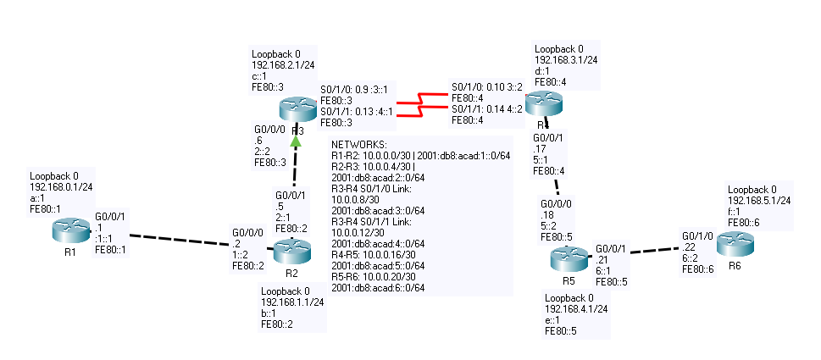

**Addressing Table**

|  |  |  |  |  |
| --- | --- | --- | --- | --- |
| Device | Interface | IP Address | IPv6 Address | Link-Local Addresses |
| R1 | G 0/0/1 | 10.0.0.1/30 | 2001:db8:acad:1::1/64 | fe80::1 |
| Loopback 0 | 192.168.0.1/24 | 2001:db8:acad:a::1/64 | fe80::1 |
| R2 | G 0/0/0 | 10.0.0.2/30 | 2001:db8:acad:1::2/64 | fe80::2 |
| G 0/0/1 | 10.0.0.5/30 | 2001:db8:acad:2::1/64 | fe80::2 |
| Loopback 0 | 192.168.1.1/24 | 2001:db8:acad:b::1/64 | fe80::2 |
| R3 | G 0/0/0 | 10.0.0.6/30 | 2001:db8:acad:2::264 | fe80::3 |
| S 0/1/0 | 10.0.0.9/30 | 2001:db8:acad:3::1/64 | fe80::3 |
| S 0/1/1 | 10.0.0.13/30 | 2001:db8:acad:4::1/64 | fe80::3 |
| Loopback 0 | 192.168.2.1/32 | 2001:db8:acad:c::1/64 | fe80::3 |
| R4 | G 0/0/1 | 10.0.0.17/30 | 2001:db8:acad:5::1/64 | fe80::4 |
| S 0/1/0 | 10.0.0.10/30 | 2001:db8:acad:3::2/64 | fe80::4 |
| S 0/1/1 | 10.0.0.14/30 | 2001:db8:acad:4::2/64 | fe80::4 |
| Loopback 0 | 192.168.3.1/32 | 2001:db8:acad:d::1/64 | fe80::4 |
| R5 | G 0/0/0 | 10.0.0.18/30 | 2001:db8:acad:5::2/64 | fe80::5 |
| G 0/0/1 | 10.0.0.21/30 | 2001:db8:acad:6::1/64 | fe80::5 |
| Loopback 0 | 192.168.4.1/32 | 2001:db8:acad:e::1/64 | fe80::5 |
| R6 | G 0/0/0 | 10.0.0.22/32 | 2001:db8:acad:6::2/64 | fe80::6 |
| Loopback 0 | 192.168.5.1/32 | 2001:db8:acad:f::1/64 | fe80::6 |

**PINGS:**

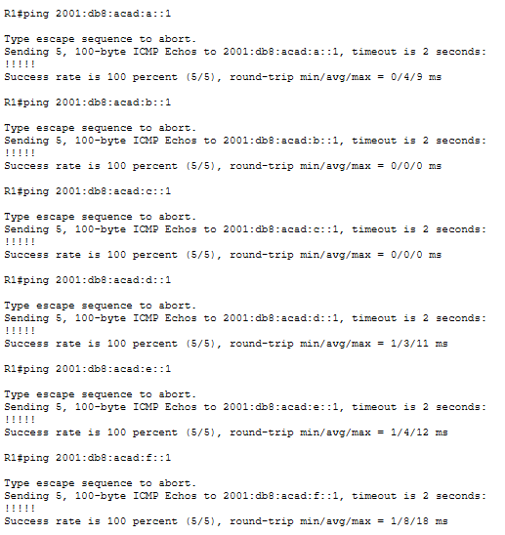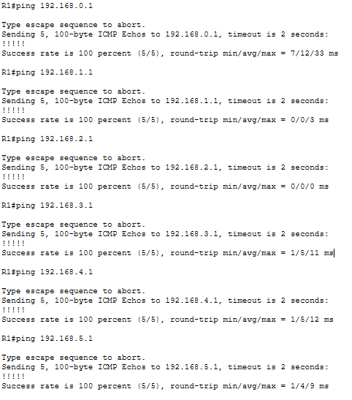

Router 1 Config:

R1#show run

Building configuration...

Current configuration : 1061 bytes

!

version 15.4

no service timestamps log datetime msec

no service timestamps debug datetime msec

no service password-encryption

!

hostname R1

!

ip cef

ipv6 unicast-routing

!

no ipv6 cef

!

spanning-tree mode pvst

interface Loopback0

ip address 192.168.0.1 255.255.255.0

ipv6 address FE80::1 link-local

ipv6 address 2001:DB8:ACAD:A::1/64

ipv6 eigrp 10

!

interface GigabitEthernet0/0/0

no ip address

duplex auto

speed auto

shutdown

!

interface GigabitEthernet0/0/1

ip address 10.0.0.1 255.255.255.252

duplex auto

speed auto

ipv6 address FE80::1 link-local

ipv6 address 2001:DB8:ACAD:1::1/64

ipv6 eigrp 10

!

interface Vlan1

no ip address

shutdown

!

router eigrp 1

eigrp router-id 1.1.1.1

passive-interface Loopback0

network 10.0.0.0 0.0.0.3

network 192.168.0.0

metric weights 0 1 1 1 1 0

!

ipv6 router eigrp 10

eigrp router-id 1.1.1.1

no shutdown

passive-interface Loopback0

!

ip classless

!

ip flow-export version 9

!

line con 0

!

line aux 0

!

line vty 0 4

login

end

R1#show ip route

Codes: L - local, C - connected, S - static, R - RIP, M - mobile, B - BGP

D - EIGRP, EX - EIGRP external, O - OSPF, IA - OSPF inter area

N1 - OSPF NSSA external type 1, N2 - OSPF NSSA external type 2

E1 - OSPF external type 1, E2 - OSPF external type 2, E - EGP

i - IS-IS, L1 - IS-IS level-1, L2 - IS-IS level-2, ia - IS-IS inter area

* - candidate default, U - per-user static route, o - ODR

P - periodic downloaded static route

Gateway of last resort is not set

10.0.0.0/8 is variably subnetted, 7 subnets, 2 masks

C 10.0.0.0/30 is directly connected, GigabitEthernet0/0/1

L 10.0.0.1/32 is directly connected, GigabitEthernet0/0/1

D 10.0.0.4/30 [90/3072] via 10.0.0.2, 01:28:27, GigabitEthernet0/0/1

D 10.0.0.8/30 [90/1665024] via 10.0.0.2, 01:28:25, GigabitEthernet0/0/1

D 10.0.0.12/30 [90/5191680] via 10.0.0.2, 01:28:25, GigabitEthernet0/0/1

D 10.0.0.16/30 [90/1665280] via 10.0.0.2, 01:28:25, GigabitEthernet0/0/1

D 10.0.0.20/30 [90/1665536] via 10.0.0.2, 01:28:25, GigabitEthernet0/0/1

192.168.0.0/24 is variably subnetted, 2 subnets, 2 masks

C 192.168.0.0/24 is directly connected, Loopback0

L 192.168.0.1/32 is directly connected, Loopback0

D 192.168.1.0/24 [90/130816] via 10.0.0.2, 01:28:27, GigabitEthernet0/0/1

R1#show ipv6 route

IPv6 Routing Table - 15 entries

Codes: C - Connected, L - Local, S - Static, R - RIP, B - BGP

U - Per-user Static route, M - MIPv6

I1 - ISIS L1, I2 - ISIS L2, IA - ISIS interarea, IS - ISIS summary

ND - ND Default, NDp - ND Prefix, DCE - Destination, NDr - Redirect

O - OSPF intra, OI - OSPF inter, OE1 - OSPF ext 1, OE2 - OSPF ext 2

ON1 - OSPF NSSA ext 1, ON2 - OSPF NSSA ext 2

D - EIGRP, EX - EIGRP external

C 2001:DB8:ACAD:1::/64 [0/0]

via GigabitEthernet0/0/1, directly connected

L 2001:DB8:ACAD:1::1/128 [0/0]

via GigabitEthernet0/0/1, receive

D 2001:DB8:ACAD:2::/64 [90/3072]

via FE80::2, GigabitEthernet0/0/1

D 2001:DB8:ACAD:3::/64 [90/1658624]

via FE80::2, GigabitEthernet0/0/1

D 2001:DB8:ACAD:4::/64 [90/5171712]

via FE80::2, GigabitEthernet0/0/1

D 2001:DB8:ACAD:5::/64 [90/1658880]

via FE80::2, GigabitEthernet0/0/1

D 2001:DB8:ACAD:6::/64 [90/1659136]

via FE80::2, GigabitEthernet0/0/1

R1#show ip protocols

Routing Protocol is "eigrp 1 "

Outgoing update filter list for all interfaces is not set

Incoming update filter list for all interfaces is not set

Default networks flagged in outgoing updates

Default networks accepted from incoming updates

EIGRP metric weight K1=1, K2=1, K3=1, K4=1, K5=0

EIGRP maximum hopcount 100

EIGRP maximum metric variance 1

Redistributing: eigrp 1

Automatic network summarization is not in effect

Maximum path: 4

Routing for Networks:

10.0.0.0/30

192.168.0.0

Passive Interface(s):

Loopback0

Routing Information Sources:

Gateway Distance Last Update

10.0.0.2 90 6654857

Distance: internal 90 external 170

R1#

R1#show ipv6 protocols

IPv6 Routing Protocol is "connected"

IPv6 Routing Protocol is "ND"

IPv6 Routing Protocol is "eigrp 10"

EIGRP metric weight K1=1, K2=0, K3=1, K4=0, K5=0

EIGRP maximum hopcount 100

EIGRP maximum metric variance 1

Interfaces:

Loopback0 (passive)

GigabitEthernet0/0/1

Redistributing: eigrp 10

Maximum path: 16

Distance: internal 90 external 170

R1#

R1#show ip eigrp neighbors

IP-EIGRP neighbors for process 1

H Address Interface Hold Uptime SRTT RTO Q Seq

(sec) (ms) Cnt Num

0 10.0.0.2 Gig0/0/1 11 01:28:26 40 1000 0 83

R1#

R1#show ipv6 eigrp neighbors

IPv6-EIGRP neighbors for process 10

H Address Interface Hold Uptime SRTT RTO Q Seq

(sec) (ms) Cnt Num

0 Link-local address: Gig0/0/1 12 01:28:26 40 1000 0 91

FE80::2

R1#

R1#show ip eigrp topology

IP-EIGRP Topology Table for AS 1/ID(1.1.1.1)

Codes: P - Passive, A - Active, U - Update, Q - Query, R - Reply,

r - Reply status

P 10.0.0.0/30, 1 successors, FD is 2816

via Connected, GigabitEthernet0/0/1

P 10.0.0.4/30, 1 successors, FD is 3072

via 10.0.0.2 (3072/2816), GigabitEthernet0/0/1

P 10.0.0.8/30, 1 successors, FD is 1665024

via 10.0.0.2 (1665024/1664768), GigabitEthernet0/0/1

P 10.0.0.12/30, 1 successors, FD is 5191680

via 10.0.0.2 (5191680/5191424), GigabitEthernet0/0/1

P 10.0.0.16/30, 1 successors, FD is 1665280

via 10.0.0.2 (1665280/1665024), GigabitEthernet0/0/1

P 10.0.0.20/30, 1 successors, FD is 1665536

via 10.0.0.2 (1665536/1665280), GigabitEthernet0/0/1

P 192.168.0.0/24, 1 successors, FD is 128256

via Connected, Loopback0

P 192.168.1.0/24, 1 successors, FD is 130816

via 10.0.0.2 (130816/128256), GigabitEthernet0/0/1

P 192.168.2.0/24, 1 successors, FD is 131072

R1#show ipv6 eigrp topology

IPv6-EIGRP Topology Table for AS 10/ID(1.1.1.1)

Codes: P - Passive, A - Active, U - Update, Q - Query, R - Reply,

r - Reply status

P 2001:DB8:ACAD:1::/64, 1 successors, FD is 2816

via Connected, GigabitEthernet0/0/1

P 2001:DB8:ACAD:2::/64, 1 successors, FD is 3072

via FE80::2 (3072/2816), GigabitEthernet0/0/1

P 2001:DB8:ACAD:3::/64, 1 successors, FD is 1658624

via FE80::2 (1658624/1658368), GigabitEthernet0/0/1

P 2001:DB8:ACAD:4::/64, 1 successors, FD is 5171712

via FE80::2 (5171712/5171456), GigabitEthernet0/0/1

P 2001:DB8:ACAD:5::/64, 1 successors, FD is 1658880

via FE80::2 (1658880/1658624), GigabitEthernet0/0/1

P 2001:DB8:ACAD:6::/64, 1 successors, FD is 1659136

via FE80::2 (1659136/1658880), GigabitEthernet0/0/1

P 2001:DB8:ACAD:A::/64, 1 successors, FD is 128256

via Connected, Loopback0

P 2001:DB8:ACAD:B::/64, 1 successors, FD is 130816

via FE80::2 (130816/128256), GigabitEthernet0/0/1

P 2001:DB8:ACAD:C::/64, 1 successors, FD is 131072

via FE80::2 (131072/130816), GigabitEthernet0/0/1

P 2001:DB8:ACAD:D::/64, 1 successors, FD is 1786624

via FE80::2 (1786624/1786368), GigabitEthernet0/0/1

P 2001:DB8:ACAD:E::/64, 1 successors, FD is 1786880

via FE80::2 (1786880/1786624), GigabitEthernet0/0/1

P 2001:DB8:ACAD:F::/64, 1 successors, FD is 1787136

via FE80::2 (1787136/1786880), GigabitEthernet0/0/1

Router 2 Config

R2#show run

Building configuration...

Current configuration : 1150 bytes

!

version 15.4

no service timestamps log datetime msec

no service timestamps debug datetime msec

no service password-encryption

!

hostname R2

!

ip cef

ipv6 unicast-routing

!

no ipv6 cef

!

spanning-tree mode pvst

interface Loopback0

ip address 192.168.1.1 255.255.255.0

ipv6 address 2001:DB8:ACAD:B::1/64

ipv6 eigrp 10

!

interface GigabitEthernet0/0/0

ip address 10.0.0.2 255.255.255.252

duplex auto

speed auto

ipv6 address FE80::2 link-local

ipv6 address 2001:DB8:ACAD:1::2/64

ipv6 eigrp 10

!

interface GigabitEthernet0/0/1

ip address 10.0.0.5 255.255.255.252

duplex auto

speed auto

ipv6 address FE80::2 link-local

ipv6 address 2001:DB8:ACAD:2::1/64

ipv6 eigrp 10

!

interface Vlan1

no ip address

shutdown

!

router eigrp 1

eigrp router-id 2.2.2.2

passive-interface Loopback0

network 10.0.0.0 0.0.0.3

network 192.168.1.0

network 10.0.0.4 0.0.0.3

metric weights 0 1 1 1 1 0

!

ipv6 router eigrp 10

eigrp router-id 2.2.2.2

no shutdown

passive-interface Loopback0

!

ip classless

!

ip flow-export version 9

line con 0

!

line aux 0

!

line vty 0 4

login

!

end

R2#show ip route

Codes: L - local, C - connected, S - static, R - RIP, M - mobile, B - BGP

D - EIGRP, EX - EIGRP external, O - OSPF, IA - OSPF inter area

N1 - OSPF NSSA external type 1, N2 - OSPF NSSA external type 2

E1 - OSPF external type 1, E2 - OSPF external type 2, E - EGP

i - IS-IS, L1 - IS-IS level-1, L2 - IS-IS level-2, ia - IS-IS inter area

* - candidate default, U - per-user static route, o - ODR

P - periodic downloaded static route

Gateway of last resort is not set

10.0.0.0/8 is variably subnetted, 8 subnets, 2 masks

C 10.0.0.0/30 is directly connected, GigabitEthernet0/0/0

L 10.0.0.2/32 is directly connected, GigabitEthernet0/0/0

C 10.0.0.4/30 is directly connected, GigabitEthernet0/0/1

L 10.0.0.5/32 is directly connected, GigabitEthernet0/0/1

D 10.0.0.8/30 [90/1664768] via 10.0.0.6, 01:35:35, GigabitEthernet0/0/1

D 10.0.0.12/30 [90/5191424] via 10.0.0.6, 01:35:35, GigabitEthernet0/0/1

D 10.0.0.16/30 [90/1665024] via 10.0.0.6, 01:35:34, GigabitEthernet0/0/1

D 10.0.0.20/30 [90/1665280] via 10.0.0.6, 01:35:34, GigabitEthernet0/0/1

D 192.168.0.0/24 [90/130816] via 10.0.0.1, 01:35:36, GigabitEthernet0/0/0

192.168.1.0/24 is variably subnetted, 2 subnets, 2 masks

C 192.168.1.0/24 is directly connected, Loopback0

R2#show ipv6 route

IPv6 Routing Table - 16 entries

Codes: C - Connected, L - Local, S - Static, R - RIP, B - BGP

U - Per-user Static route, M - MIPv6

I1 - ISIS L1, I2 - ISIS L2, IA - ISIS interarea, IS - ISIS summary

ND - ND Default, NDp - ND Prefix, DCE - Destination, NDr - Redirect

O - OSPF intra, OI - OSPF inter, OE1 - OSPF ext 1, OE2 - OSPF ext 2

ON1 - OSPF NSSA ext 1, ON2 - OSPF NSSA ext 2

D - EIGRP, EX - EIGRP external

C 2001:DB8:ACAD:1::/64 [0/0]

via GigabitEthernet0/0/0, directly connected

L 2001:DB8:ACAD:1::2/128 [0/0]

via GigabitEthernet0/0/0, receive

C 2001:DB8:ACAD:2::/64 [0/0]

via GigabitEthernet0/0/1, directly connected

L 2001:DB8:ACAD:2::1/128 [0/0]

via GigabitEthernet0/0/1, receive

D 2001:DB8:ACAD:3::/64 [90/1658368]

via FE80::3, GigabitEthernet0/0/1

D 2001:DB8:ACAD:4::/64 [90/5171456]

via FE80::3, GigabitEthernet0/0/1

D 2001:DB8:ACAD:5::/64 [90/1658624]

via FE80::3, GigabitEthernet0/0/1

R2#show ip protocols

Routing Protocol is "eigrp 1 "

Outgoing update filter list for all interfaces is not set

Incoming update filter list for all interfaces is not set

Default networks flagged in outgoing updates

Default networks accepted from incoming updates

**EIGRP metric weight K1=1, K2=1, K3=1, K4=1, K5=0**

EIGRP maximum hopcount 100

EIGRP maximum metric variance 1

Redistributing: eigrp 1

Automatic network summarization is not in effect

Maximum path: 4

Routing for Networks:

10.0.0.0/30

192.168.1.0

10.0.0.4/30

Passive Interface(s):

Loopback0

Routing Information Sources:

Gateway Distance Last Update

10.0.0.1 90 6654761

10.0.0.6 90 6655050

R2#show ipv6 protocols

IPv6 Routing Protocol is "connected"

IPv6 Routing Protocol is "ND"

IPv6 Routing Protocol is "eigrp 10"

EIGRP metric weight K1=1, K2=0, K3=1, K4=0, K5=0

EIGRP maximum hopcount 100

EIGRP maximum metric variance 1

Interfaces:

Loopback0 (passive)

GigabitEthernet0/0/0

GigabitEthernet0/0/1

Redistributing: eigrp 10

Maximum path: 16

Distance: internal 90 external 170

R2#

R2#show ip eigrp neighbors

IP-EIGRP neighbors for process 1

H Address Interface Hold Uptime SRTT RTO Q Seq

(sec) (ms) Cnt Num

0 10.0.0.1 Gig0/0/0 10 01:35:35 40 1000 0 76

1 10.0.0.6 Gig0/0/1 10 01:35:35 40 1000 0 83

R2#

R2#show ipv6 eigrp neighbors

IPv6-EIGRP neighbors for process 10

H Address Interface Hold Uptime SRTT RTO Q Seq

(sec) (ms) Cnt Num

0 Link-local address: Gig0/0/1 12 01:35:35 40 1000 0 103

FE80::3

1 Link-local address: Gig0/0/0 13 01:35:35 40 1000 0 77

FE80::1

R2#

R2#show ip eigrp topology

IP-EIGRP Topology Table for AS 1/ID(2.2.2.2)

Codes: P - Passive, A - Active, U - Update, Q - Query, R - Reply,

r - Reply status

P 10.0.0.0/30, 1 successors, FD is 2816

via Connected, GigabitEthernet0/0/0

P 10.0.0.4/30, 1 successors, FD is 2816

via Connected, GigabitEthernet0/0/1

P 10.0.0.8/30, 1 successors, FD is 1664768

via 10.0.0.6 (1664768/1664512), GigabitEthernet0/0/1

P 10.0.0.12/30, 1 successors, FD is 5191424

via 10.0.0.6 (5191424/5191168), GigabitEthernet0/0/1

P 10.0.0.16/30, 1 successors, FD is 1665024

via 10.0.0.6 (1665024/1664768), GigabitEthernet0/0/1

P 10.0.0.20/30, 1 successors, FD is 1665280

via 10.0.0.6 (1665280/1665024), GigabitEthernet0/0/1

P 192.168.0.0/24, 1 successors, FD is 130816

via 10.0.0.1 (130816/128256), GigabitEthernet0/0/0

P 192.168.1.0/24, 1 successors, FD is 128256

via Connected, Loopback0

P 192.168.2.0/24, 1 successors, FD is 130816

R2#show ipv6 eigrp topology

IPv6-EIGRP Topology Table for AS 10/ID(2.2.2.2)

Codes: P - Passive, A - Active, U - Update, Q - Query, R - Reply,

r - Reply status

P 2001:DB8:ACAD:1::/64, 1 successors, FD is 2816

via Connected, GigabitEthernet0/0/0

P 2001:DB8:ACAD:2::/64, 1 successors, FD is 2816

via Connected, GigabitEthernet0/0/1

P 2001:DB8:ACAD:3::/64, 1 successors, FD is 1658368

via FE80::3 (1658368/1658112), GigabitEthernet0/0/1

P 2001:DB8:ACAD:4::/64, 1 successors, FD is 5171456

via FE80::3 (5171456/5171200), GigabitEthernet0/0/1

P 2001:DB8:ACAD:5::/64, 1 successors, FD is 1658624

via FE80::3 (1658624/1658368), GigabitEthernet0/0/1

P 2001:DB8:ACAD:6::/64, 1 successors, FD is 1658880

via FE80::3 (1658880/1658624), GigabitEthernet0/0/1

P 2001:DB8:ACAD:A::/64, 1 successors, FD is 130816

via FE80::1 (130816/128256), GigabitEthernet0/0/0

P 2001:DB8:ACAD:B::/64, 1 successors, FD is 128256

via Connected, Loopback0

P 2001:DB8:ACAD:C::/64, 1 successors, FD is 130816

via FE80::3 (130816/128256), GigabitEthernet0/0/1

P 2001:DB8:ACAD:D::/64, 1 successors, FD is 1786368

via FE80::3 (1786368/1786112), GigabitEthernet0/0/1

P 2001:DB8:ACAD:E::/64, 1 successors, FD is 1786624

via FE80::3 (1786624/1786368), GigabitEthernet0/0/1

P 2001:DB8:ACAD:F::/64, 1 successors, FD is 1786880

via FE80::3 (1786880/1786624), GigabitEthernet0/0/1

Router 3 Config:

**Proof of unequal cost load-balancing shown in red:**

**R3#show ip route 10.0.0.20**

**Routing entry for 10.0.0.20/30**

**Known via "eigrp 1", distance 90, metric 1285787, type internal**

**Redistributing via eigrp 1**

**Last update from 10.0.0.14 on Serial0/1/1, 00:00:40 ago**

**Routing Descriptor Blocks:**

**10.0.0.14, from 10.0.0.14, 00:00:40 ago, via Serial0/1/1**

**Route metric is 5191790, traffic share count is 59**

**Total delay is 2020 microseconds, minimum bandwidth is 500 Kbit**

**Reliability 255/255, minimum MTU 1500 bytes**

**Loading 1/255, Hops 2**

**\* 10.0.0.10, from 10.0.0.10, 00:00:40 ago, via Serial0/1/0**

**Route metric is 1285787, traffic share count is 240**

**Total delay is 30 microseconds, minimum bandwidth is 2000 Kbit**

**Reliability 255/255, minimum MTU 1500 bytes**

**Loading 1/255, Hops 2**

**R3#show ip protocols**

**\*\*\* IP Routing is NSF aware \*\*\***

Routing Protocol is "application"

Sending updates every 0 seconds

Invalid after 0 seconds, hold down 0, flushed after 0

Outgoing update filter list for all interfaces is not set

Incoming update filter list for all interfaces is not set

Maximum path: 32

Routing for Networks:

Routing Information Sources:

Gateway Distance Last Update

Distance: (default is 4)

Routing Protocol is "eigrp 1"

Outgoing update filter list for all interfaces is not set

Incoming update filter list for all interfaces is not set

Default networks flagged in outgoing updates

Default networks accepted from incoming updates

EIGRP-IPv4 Protocol for AS(1)

**Metric weight K1=1, K2=1, K3=1, K4=1, K5=0**

Soft SIA disabled

NSF-aware route hold timer is 240

EIGRP NSF disabled

NSF signal timer is 20s

NSF converge timer is 120s

Router-ID: 3.3.3.3

Topology : 0 (base)

Active Timer: 3 min

Distance: internal 90 external 170

Maximum path: 4

Maximum hopcount 100

Maximum metric variance 5

Automatic Summarization: disabled

Maximum path: 4

Routing for Networks:

10.0.0.4/30

10.0.0.8/30

10.0.0.12/30

192.168.2.0

Passive Interface(s):

Loopback0

Routing Information Sources:

Gateway Distance Last Update

10.0.0.10 90 00:06:34

10.0.0.14 90 00:06:34

Gateway Distance Last Update

10.0.0.5 90 00:06:35

Distance: internal 90 external 170

R3#show ip eigrp topology

EIGRP-IPv4 Topology Table for AS(1)/ID(3.3.3.3)

Codes: P - Passive, A - Active, U - Update, Q - Query, R - Reply,

r - reply Status, s - sia Status

P 192.168.3.0/24, 2 successors, FD is 1413275

via 10.0.0.10 (1413275/128257), Serial0/1/0

via 10.0.0.14 (5319278/128257), Serial0/1/1

P 10.0.0.12/30, 1 successors, FD is 5191278

via Connected, Serial0/1/1

P 192.168.2.0/24, 1 successors, FD is 128257

via Connected, Loopback0

P 10.0.0.20/30, 2 successors, FD is 1285787

via 10.0.0.10 (1285787/3082), Serial0/1/0

via 10.0.0.14 (5191790/3082), Serial0/1/1

P 10.0.0.8/30, 1 successors, FD is 1285275

via Connected, Serial0/1/0

via 10.0.0.14 (5191534/1274995), Serial0/1/1

P 192.168.0.0/24, 1 successors, FD is 131082

via 10.0.0.5 (131082/130826), GigabitEthernet0/0/0

P 10.0.0.0/30, 1 successors, FD is 3082

via 10.0.0.5 (3082/2826), GigabitEthernet0/0/0

P 192.168.1.0/24, 1 successors, FD is 130826

via 10.0.0.5 (130826/128257), GigabitEthernet0/0/0

P 10.0.0.4/30, 1 successors, FD is 2826

via Connected, GigabitEthernet0/0/0

P 192.168.4.0/24, 2 successors, FD is 1413531

via 10.0.0.10 (1413531/130826), Serial0/1/0

via 10.0.0.14 (5319534/130826), Serial0/1/1

P 192.168.5.0/24, 2 successors, FD is 1413787

via 10.0.0.10 (1413787/131082), Serial0/1/0

via 10.0.0.14 (5319790/131082), Serial0/1/1

P 10.0.0.16/30, 2 successors, FD is 1285531

via 10.0.0.10 (1285531/2826), Serial0/1/0

via 10.0.0.14 (5191534/2826), Serial0/1/1

R3#show ipv6 eigrp topology

EIGRP-IPv6 Topology Table for AS(10)/ID(3.3.3.3)

Codes: P - Passive, A - Active, U - Update, Q - Query, R - Reply,

r - reply Status, s - sia Status

P 2001:DB8:ACAD:A::/64, 1 successors, FD is 131072

via FE80::2 (131072/130816), GigabitEthernet0/0/0

P 2001:DB8:ACAD:1::/64, 1 successors, FD is 3072

via FE80::2 (3072/2816), GigabitEthernet0/0/0

P 2001:DB8:ACAD:6::/64, 2 successors, FD is 1280768

via FE80::4 (5171712/3072), Serial0/1/1

via FE80::4 (1280768/3072), Serial0/1/0

P 2001:DB8:ACAD:C::/64, 1 successors, FD is 128256

via Connected, Loopback0

P 2001:DB8:ACAD:5::/64, 2 successors, FD is 1280512

via FE80::4 (5171456/2816), Serial0/1/1

via FE80::4 (1280512/2816), Serial0/1/0

P 2001:DB8:ACAD:F::/64, 2 successors, FD is 1408768

via FE80::4 (5299712/131072), Serial0/1/1

via FE80::4 (1408768/131072), Serial0/1/0

P 2001:DB8:ACAD:B::/64, 1 successors, FD is 130816

via FE80::2 (130816/128256), GigabitEthernet0/0/0

P 2001:DB8:ACAD:2::/64, 1 successors, FD is 2816

via Connected, GigabitEthernet0/0/0

P 2001:DB8:ACAD:D::/64, 2 successors, FD is 1408256

via FE80::4 (5299200/128256), Serial0/1/1

via FE80::4 (1408256/128256), Serial0/1/0

P 2001:DB8:ACAD:4::/64, 1 successors, FD is 5171200

via Connected, Serial0/1/1

P 2001:DB8:ACAD:3::/64, 1 successors, FD is 1280256

via Connected, Serial0/1/0

via FE80::4 (5171456/1270016), Serial0/1/1

via FE80::4 (1280512/1270016), Serial0/1/0

P 2001:DB8:ACAD:E::/64, 2 successors, FD is 1408512

via FE80::4 (5299456/130816), Serial0/1/1

via FE80::4 (1408512/130816), Serial0/1/0

R3#show ip route

Codes: L - local, C - connected, S - static, R - RIP, M - mobile, B - BGP

D - EIGRP, EX - EIGRP external, O - OSPF, IA - OSPF inter area

N1 - OSPF NSSA external type 1, N2 - OSPF NSSA external type 2

E1 - OSPF external type 1, E2 - OSPF external type 2

i - IS-IS, su - IS-IS summary, L1 - IS-IS level-1, L2 - IS-IS level-2

ia - IS-IS inter area, * - candidate default, U - per-user static route

o - ODR, P - periodic downloaded static route, H - NHRP, l - LISP

a - application route

+ - replicated route, % - next hop override, p - overrides from PfR

Gateway of last resort is not set

10.0.0.0/8 is variably subnetted, 9 subnets, 2 masks

D 10.0.0.0/30 [90/3082] via 10.0.0.5, 00:08:59, GigabitEthernet0/0/0

C 10.0.0.4/30 is directly connected, GigabitEthernet0/0/0

L 10.0.0.6/32 is directly connected, GigabitEthernet0/0/0

C 10.0.0.8/30 is directly connected, Serial0/1/0

L 10.0.0.9/32 is directly connected, Serial0/1/0

C 10.0.0.12/30 is directly connected, Serial0/1/1

L 10.0.0.13/32 is directly connected, Serial0/1/1

D 10.0.0.16/30 [90/5191534] via 10.0.0.14, 00:08:59, Serial0/1/1

[90/1285531] via 10.0.0.10, 00:08:59, Serial0/1/0

D 10.0.0.20/30 [90/5191790] via 10.0.0.14, 00:08:59, Serial0/1/1

[90/1285787] via 10.0.0.10, 00:08:59, Serial0/1/0

D 192.168.0.0/24 [90/131082] via 10.0.0.5, 00:08:59, GigabitEthernet0/0/0

D 192.168.1.0/24 [90/130826] via 10.0.0.5, 00:08:59, GigabitEthernet0/0/0

192.168.2.0/24 is variably subnetted, 2 subnets, 2 masks

C 192.168.2.0/24 is directly connected, Loopback0

L 192.168.2.1/32 is directly connected, Loopback0

D 192.168.3.0/24 [90/5319278] via 10.0.0.14, 00:08:59, Serial0/1/1

[90/1413275] via 10.0.0.10, 00:08:59, Serial0/1/0

D 192.168.4.0/24 [90/5319534] via 10.0.0.14, 00:08:59, Serial0/1/1

[90/1413531] via 10.0.0.10, 00:08:59, Serial0/1/0

D 192.168.5.0/24 [90/5319790] via 10.0.0.14, 00:08:59, Serial0/1/1

[90/1413787] via 10.0.0.10, 00:08:59, Serial0/1/0

R3#show ipv6 route

IPv6 Routing Table - default - 17 entries

Codes: C - Connected, L - Local, S - Static, U - Per-user Static route

B - BGP, R - RIP, I1 - ISIS L1, I2 - ISIS L2

IA - ISIS interarea, IS - ISIS summary, D - EIGRP, EX - EIGRP external

ND - ND Default, NDp - ND Prefix, DCE - Destination, NDr - Redirect

O - OSPF Intra, OI - OSPF Inter, OE1 - OSPF ext 1, OE2 - OSPF ext 2

ON1 - OSPF NSSA ext 1, ON2 - OSPF NSSA ext 2, a - Application

D 2001:DB8:ACAD:1::/64 [90/3072]

via FE80::2, GigabitEthernet0/0/0

C 2001:DB8:ACAD:2::/64 [0/0]

via GigabitEthernet0/0/0, directly connected

L 2001:DB8:ACAD:2::2/128 [0/0]

via GigabitEthernet0/0/0, receive

C 2001:DB8:ACAD:3::/64 [0/0]

via Serial0/1/0, directly connected

L 2001:DB8:ACAD:3::1/128 [0/0]

via Serial0/1/0, receive

C 2001:DB8:ACAD:4::/64 [0/0]

via Serial0/1/1, directly connected

L 2001:DB8:ACAD:4::1/128 [0/0]

via Serial0/1/1, receive

D 2001:DB8:ACAD:5::/64 [90/1280512]

via FE80::4, Serial0/1/0

via FE80::4, Serial0/1/1

D 2001:DB8:ACAD:6::/64 [90/1280768]

via FE80::4, Serial0/1/0

via FE80::4, Serial0/1/1

D 2001:DB8:ACAD:A::/64 [90/131072]

via FE80::2, GigabitEthernet0/0/0

D 2001:DB8:ACAD:B::/64 [90/130816]

via FE80::2, GigabitEthernet0/0/0

C 2001:DB8:ACAD:C::/64 [0/0]

via Loopback0, directly connected

L 2001:DB8:ACAD:C::1/128 [0/0]

via Loopback0, receive

D 2001:DB8:ACAD:D::/64 [90/1408256]

via FE80::4, Serial0/1/0

via FE80::4, Serial0/1/1

D 2001:DB8:ACAD:E::/64 [90/1408512]

via FE80::4, Serial0/1/0

via FE80::4, Serial0/1/1

D 2001:DB8:ACAD:F::/64 [90/1408768]

via FE80::4, Serial0/1/0

via FE80::4, Serial0/1/1

L FF00::/8 [0/0]

via Null0, receive

R3#show ip eigrp neighbor

EIGRP-IPv4 Neighbors for AS(1)

H Address Interface Hold Uptime SRTT RTO Q Seq

(sec) (ms) Cnt Num

2 10.0.0.14 Se0/1/1 14 00:09:50 3 294 0 50

1 10.0.0.10 Se0/1/0 13 00:09:50 1 100 0 49

0 10.0.0.5 Gi0/0/0 14 00:09:52 1 100 0 35

R3#show ipv6 eigrp neighbor

EIGRP-IPv6 Neighbors for AS(10)

H Address Interface Hold Uptime SRTT RTO Q Seq

(sec) (ms) Cnt Num

2 Link-local address: Se0/1/1 10 00:50:28 1 300 0 23

FE80::4

1 Link-local address: Se0/1/0 11 00:50:37 1 100 0 22

FE80::4

0 Link-local address: Gi0/0/0 14 00:51:34 1 100 0 30

FE80::2

Router 4 Config

**Proof of unequal cost load-balancing shown in red:**

**R4#show ip route 10.0.0.1**

**Routing entry for 10.0.0.0/30**

**Known via "eigrp 1", distance 90, metric 1665024, type internal**

**Redistributing via eigrp 1**

**Last update from 10.0.0.9 on Serial0/1/0, 00:07:21 ago**

**Routing Descriptor Blocks:**

**\* 10.0.0.9, from 10.0.0.9, 00:07:21 ago, via Serial0/1/0**

**Route metric is 1665024, traffic share count is 240**

**Total delay is 30 microseconds, minimum bandwidth is 1544 Kbit**

**Reliability 255/255, minimum MTU 1500 bytes**

**Loading 1/255, Hops 2**

**10.0.0.13, from 10.0.0.13, 00:07:21 ago, via Serial0/1/1**

**Route metric is 5191680, traffic share count is 59**

**Total delay is 2020 microseconds, minimum bandwidth is 500 Kbit**

**Reliability 255/255, minimum MTU 1500 bytes**

**Loading 1/255, Hops 2**

R4#show run

Building configuration...

Current configuration : 1510 bytes

!

version 15.4

no service timestamps log datetime msec

no service timestamps debug datetime msec

no service password-encryption

!

hostname R4

!

no ip cef

ipv6 unicast-routing

!

no ipv6 cef

!

spanning-tree mode pvst

!

interface Loopback0

ip address 192.168.3.1 255.255.255.0

ipv6 address FE80::4 link-local

ipv6 address 2001:DB8:ACAD:D::1/64

ipv6 eigrp 10

!

interface GigabitEthernet0/0/0

no ip address

duplex auto

speed auto

shutdown

!

interface GigabitEthernet0/0/1

ip address 10.0.0.17 255.255.255.252

duplex auto

speed auto

ipv6 address FE80::4 link-local

ipv6 address 2001:DB8:ACAD:5::1/64

ipv6 eigrp 10

!

interface Serial0/1/0

ip address 10.0.0.10 255.255.255.252

delay 1

ipv6 address FE80::4 link-local

ipv6 address 2001:DB8:ACAD:3::2/64

ipv6 eigrp 10

clock rate 2000000

!

interface Serial0/1/1

bandwidth 500

ip address 10.0.0.14 255.255.255.252

delay 200

ipv6 address FE80::4 link-local

ipv6 address 2001:DB8:ACAD:4::2/64

ipv6 eigrp 10

clock rate 2000000

!

interface Vlan1

no ip address

shutdown

!

router eigrp 1

eigrp router-id 4.4.4.4

variance 4

passive-interface Loopback0

network 10.0.0.16 0.0.0.3

network 10.0.0.12 0.0.0.3

network 10.0.0.8 0.0.0.3

network 192.168.3.0

metric weights 0 1 1 1 1 0

!

ipv6 router eigrp 10

eigrp router-id 4.4.4.4

variance 5

no shutdown

passive-interface Loopback0

!

ip classless

!

ip flow-export version 9

!

line con 0

!

line aux 0

!

line vty 0 4

login

!

End

R4#show ip route 10.0.0.0

Routing entry for 10.0.0.0/8, 9 known subnets

Attached (6 connections)

Variably subnetted with 2 masks

Redistributing via eigrp 1

D 10.0.0.0/30 [90/5191790] via 10.0.0.13, 00:11:42, Serial0/1/1

[90/1275507] via 10.0.0.9, 00:11:42, Serial0/1/0

D 10.0.0.4/30 [90/5191534] via 10.0.0.13, 00:11:42, Serial0/1/1

[90/1275251] via 10.0.0.9, 00:11:42, Serial0/1/0

C 10.0.0.8/30 is directly connected, Serial0/1/0

L 10.0.0.10/32 is directly connected, Serial0/1/0

C 10.0.0.12/30 is directly connected, Serial0/1/1

L 10.0.0.14/32 is directly connected, Serial0/1/1

C 10.0.0.16/30 is directly connected, GigabitEthernet0/0/1

L 10.0.0.17/32 is directly connected, GigabitEthernet0/0/1

D 10.0.0.20/30 [90/3082] via 10.0.0.18, 00:11:42, GigabitEthernet0/0/1

R4#show ip protocols

*** IP Routing is NSF aware ***

Routing Protocol is "application"

Sending updates every 0 seconds

Invalid after 0 seconds, hold down 0, flushed after 0

Outgoing update filter list for all interfaces is not set

Incoming update filter list for all interfaces is not set

Maximum path: 32

Routing for Networks:

Routing Information Sources:

Gateway Distance Last Update

Distance: (default is 4)

Routing Protocol is "eigrp 1"

Outgoing update filter list for all interfaces is not set

Incoming update filter list for all interfaces is not set

Default networks flagged in outgoing updates

Default networks accepted from incoming updates

EIGRP-IPv4 Protocol for AS(1)

**Metric weight K1=1, K2=1, K3=1, K4=1, K5=0**

Soft SIA disabled

NSF-aware route hold timer is 240

EIGRP NSF disabled

NSF signal timer is 20s

NSF converge timer is 120s

Router-ID: 4.4.4.4

Topology : 0 (base)

Active Timer: 3 min

Distance: internal 90 external 170

Maximum path: 4

Maximum hopcount 100

Maximum metric variance 5

Automatic Summarization: disabled

Maximum path: 4

Routing for Networks:

10.0.0.8/30

10.0.0.12/30

10.0.0.16/30

192.168.3.0

Passive Interface(s):

Loopback0

Routing Information Sources:

Gateway Distance Last Update

10.0.0.9 90 00:11:55

10.0.0.13 90 00:11:55

Gateway Distance Last Update

10.0.0.18 90 00:11:57

Distance: internal 90 external 170

R4#show ip eigrp top

EIGRP-IPv4 Topology Table for AS(1)/ID(4.4.4.4)

Codes: P - Passive, A - Active, U - Update, Q - Query, R - Reply,

r - reply Status, s - sia Status

P 192.168.3.0/24, 1 successors, FD is 128257

via Connected, Loopback0

P 10.0.0.12/30, 1 successors, FD is 5191278

via Connected, Serial0/1/1

P 192.168.2.0/24, 2 successors, FD is 1402995

via 10.0.0.9 (1402995/128257), Serial0/1/0

via 10.0.0.13 (5319278/128257), Serial0/1/1

P 10.0.0.20/30, 1 successors, FD is 3082

via 10.0.0.18 (3082/2826), GigabitEthernet0/0/1

P 10.0.0.8/30, 1 successors, FD is 1274995

via Connected, Serial0/1/0

P 192.168.0.0/24, 2 successors, FD is 1403507

via 10.0.0.9 (1403507/131082), Serial0/1/0

via 10.0.0.13 (5319790/131082), Serial0/1/1

P 10.0.0.0/30, 2 successors, FD is 1275507

via 10.0.0.9 (1275507/3082), Serial0/1/0

via 10.0.0.13 (5191790/3082), Serial0/1/1

P 192.168.1.0/24, 2 successors, FD is 1403251

via 10.0.0.9 (1403251/130826), Serial0/1/0

via 10.0.0.13 (5319534/130826), Serial0/1/1

P 10.0.0.4/30, 2 successors, FD is 1275251

via 10.0.0.9 (1275251/2826), Serial0/1/0

via 10.0.0.13 (5191534/2826), Serial0/1/1

P 192.168.4.0/24, 1 successors, FD is 130826

via 10.0.0.18 (130826/128257), GigabitEthernet0/0/1

P 192.168.5.0/24, 1 successors, FD is 131082

via 10.0.0.18 (131082/130826), GigabitEthernet0/0/1

P 10.0.0.16/30, 1 successors, FD is 2826

via Connected, GigabitEthernet0/0/1

R4#show ipv6 eigrp top

EIGRP-IPv6 Topology Table for AS(10)/ID(4.4.4.4)

Codes: P - Passive, A - Active, U - Update, Q - Query, R - Reply,

r - reply Status, s - sia Status

P 2001:DB8:ACAD:A::/64, 2 successors, FD is 1398528

via FE80::3 (5299712/131072), Serial0/1/1

via FE80::3 (1398528/131072), Serial0/1/0

P 2001:DB8:ACAD:1::/64, 2 successors, FD is 1270528

via FE80::3 (5171712/3072), Serial0/1/1

via FE80::3 (1270528/3072), Serial0/1/0

P 2001:DB8:ACAD:6::/64, 1 successors, FD is 3072

via FE80::5 (3072/2816), GigabitEthernet0/0/1

P 2001:DB8:ACAD:C::/64, 2 successors, FD is 1398016

via FE80::3 (5299200/128256), Serial0/1/1

via FE80::3 (1398016/128256), Serial0/1/0

P 2001:DB8:ACAD:5::/64, 1 successors, FD is 2816

via Connected, GigabitEthernet0/0/1

P 2001:DB8:ACAD:F::/64, 1 successors, FD is 131072

via FE80::5 (131072/130816), GigabitEthernet0/0/1

P 2001:DB8:ACAD:B::/64, 2 successors, FD is 1398272

via FE80::3 (5299456/130816), Serial0/1/1

via FE80::3 (1398272/130816), Serial0/1/0

P 2001:DB8:ACAD:2::/64, 2 successors, FD is 1270272

via FE80::3 (5171456/2816), Serial0/1/1

via FE80::3 (1270272/2816), Serial0/1/0

P 2001:DB8:ACAD:D::/64, 1 successors, FD is 128256

via Connected, Loopback0

P 2001:DB8:ACAD:4::/64, 1 successors, FD is 5171200

via Connected, Serial0/1/1

P 2001:DB8:ACAD:3::/64, 1 successors, FD is 1270016

via Connected, Serial0/1/0

P 2001:DB8:ACAD:E::/64, 1 successors, FD is 130816

via FE80::5 (130816/128256), GigabitEthernet0/0/1

R4#show ip route

Codes: L - local, C - connected, S - static, R - RIP, M - mobile, B - BGP

D - EIGRP, EX - EIGRP external, O - OSPF, IA - OSPF inter area

N1 - OSPF NSSA external type 1, N2 - OSPF NSSA external type 2

E1 - OSPF external type 1, E2 - OSPF external type 2

i - IS-IS, su - IS-IS summary, L1 - IS-IS level-1, L2 - IS-IS level-2

ia - IS-IS inter area, * - candidate default, U - per-user static route

o - ODR, P - periodic downloaded static route, H - NHRP, l - LISP

a - application route

+ - replicated route, % - next hop override, p - overrides from PfR

Gateway of last resort is not set

10.0.0.0/8 is variably subnetted, 9 subnets, 2 masks

D 10.0.0.0/30 [90/5191790] via 10.0.0.13, 00:12:57, Serial0/1/1

[90/1275507] via 10.0.0.9, 00:12:57, Serial0/1/0

D 10.0.0.4/30 [90/5191534] via 10.0.0.13, 00:12:57, Serial0/1/1

[90/1275251] via 10.0.0.9, 00:12:57, Serial0/1/0

C 10.0.0.8/30 is directly connected, Serial0/1/0

L 10.0.0.10/32 is directly connected, Serial0/1/0

C 10.0.0.12/30 is directly connected, Serial0/1/1

L 10.0.0.14/32 is directly connected, Serial0/1/1

C 10.0.0.16/30 is directly connected, GigabitEthernet0/0/1

L 10.0.0.17/32 is directly connected, GigabitEthernet0/0/1

D 10.0.0.20/30 [90/3082] via 10.0.0.18, 00:12:57, GigabitEthernet0/0/1

D 192.168.0.0/24 [90/5319790] via 10.0.0.13, 00:12:57, Serial0/1/1

[90/1403507] via 10.0.0.9, 00:12:57, Serial0/1/0

D 192.168.1.0/24 [90/5319534] via 10.0.0.13, 00:12:57, Serial0/1/1

[90/1403251] via 10.0.0.9, 00:12:57, Serial0/1/0

D 192.168.2.0/24 [90/5319278] via 10.0.0.13, 00:12:57, Serial0/1/1

[90/1402995] via 10.0.0.9, 00:12:57, Serial0/1/0

192.168.3.0/24 is variably subnetted, 2 subnets, 2 masks

C 192.168.3.0/24 is directly connected, Loopback0

L 192.168.3.1/32 is directly connected, Loopback0

D 192.168.4.0/24 [90/130826] via 10.0.0.18, 00:12:57, GigabitEthernet0/0/1

D 192.168.5.0/24 [90/131082] via 10.0.0.18, 00:12:57, GigabitEthernet0/0/1

R4#show ipv6 route

IPv6 Routing Table - default - 17 entries

Codes: C - Connected, L - Local, S - Static, U - Per-user Static route

B - BGP, R - RIP, I1 - ISIS L1, I2 - ISIS L2

IA - ISIS interarea, IS - ISIS summary, D - EIGRP, EX - EIGRP external

ND - ND Default, NDp - ND Prefix, DCE - Destination, NDr - Redirect

O - OSPF Intra, OI - OSPF Inter, OE1 - OSPF ext 1, OE2 - OSPF ext 2

ON1 - OSPF NSSA ext 1, ON2 - OSPF NSSA ext 2, a - Application

D 2001:DB8:ACAD:1::/64 [90/1270528]

via FE80::3, Serial0/1/0

via FE80::3, Serial0/1/1

D 2001:DB8:ACAD:2::/64 [90/1270272]

via FE80::3, Serial0/1/0

via FE80::3, Serial0/1/1

C 2001:DB8:ACAD:3::/64 [0/0]

via Serial0/1/0, directly connected

L 2001:DB8:ACAD:3::2/128 [0/0]

via Serial0/1/0, receive

C 2001:DB8:ACAD:4::/64 [0/0]

via Serial0/1/1, directly connected

L 2001:DB8:ACAD:4::2/128 [0/0]

via Serial0/1/1, receive

C 2001:DB8:ACAD:5::/64 [0/0]

via GigabitEthernet0/0/1, directly connected

L 2001:DB8:ACAD:5::1/128 [0/0]

via GigabitEthernet0/0/1, receive

D 2001:DB8:ACAD:6::/64 [90/3072]

via FE80::5, GigabitEthernet0/0/1

D 2001:DB8:ACAD:A::/64 [90/1398528]

via FE80::3, Serial0/1/0

via FE80::3, Serial0/1/1

D 2001:DB8:ACAD:B::/64 [90/1398272]

via FE80::3, Serial0/1/0

via FE80::3, Serial0/1/1

D 2001:DB8:ACAD:C::/64 [90/1398016]

via FE80::3, Serial0/1/0

via FE80::3, Serial0/1/1

C 2001:DB8:ACAD:D::/64 [0/0]

via Loopback0, directly connected

L 2001:DB8:ACAD:D::1/128 [0/0]

via Loopback0, receive

D 2001:DB8:ACAD:E::/64 [90/130816]

via FE80::5, GigabitEthernet0/0/1

D 2001:DB8:ACAD:F::/64 [90/131072]

via FE80::5, GigabitEthernet0/0/1

L FF00::/8 [0/0]

via Null0, receive

R4#show ip eigrp neighbor

EIGRP-IPv4 Neighbors for AS(1)

H Address Interface Hold Uptime SRTT RTO Q Seq

(sec) (ms) Cnt Num

2 10.0.0.13 Se0/1/1 12 00:13:25 5 294 0 60

1 10.0.0.9 Se0/1/0 13 00:13:25 1 100 0 62

0 10.0.0.18 Gi0/0/1 10 00:13:33 1 100 0 22

R4#show ipv6 eigrp neighbor

EIGRP-IPv6 Neighbors for AS(10)

H Address Interface Hold Uptime SRTT RTO Q Seq

(sec) (ms) Cnt Num

2 Link-local address: Gi0/0/1 12 00:49:23 654 3924 0 11

FE80::5

1 Link-local address: Se0/1/1 12 00:49:56 1 300 0 33

FE80::3

0 Link-local address: Se0/1/0 11 00:50:05 1 100 0 32

FE80::3

Router 5 Config

R5#show run

Building configuration...

Current configuration : 1154 bytes

!

version 15.4

no service timestamps log datetime msec

no service timestamps debug datetime msec

no service password-encryption

!

hostname R5

!

ip cef

ipv6 unicast-routing

!

no ipv6 cef

spanning-tree mode pvst

!

interface Loopback0

ip address 192.168.4.1 255.255.255.0

ipv6 address 2001:DB8:ACAD:E::1/64

ipv6 eigrp 10

!

interface GigabitEthernet0/0/0

ip address 10.0.0.18 255.255.255.252

duplex auto

speed auto

ipv6 address FE80::5 link-local

ipv6 address 2001:DB8:ACAD:5::2/64

ipv6 eigrp 10

!

interface GigabitEthernet0/0/1

ip address 10.0.0.21 255.255.255.252

duplex auto

speed auto

ipv6 address FE80::5 link-local

ipv6 address 2001:DB8:ACAD:6::1/64

ipv6 eigrp 10

!

interface Vlan1

no ip address

shutdown

!

router eigrp 1

eigrp router-id 5.5.5.5

passive-interface Loopback0

network 10.0.0.16 0.0.0.3

network 10.0.0.20 0.0.0.3

network 192.168.4.0

metric weights 0 1 1 1 1 0

!

ipv6 router eigrp 10

eigrp router-id 5.5.5.5

no shutdown

passive-interface Loopback0

!

ip classless

!

ip flow-export version 9

line con 0

!

line aux 0

!

line vty 0 4

login

!

!

!

end

R5#show ip route

Codes: L - local, C - connected, S - static, R - RIP, M - mobile, B - BGP

D - EIGRP, EX - EIGRP external, O - OSPF, IA - OSPF inter area

N1 - OSPF NSSA external type 1, N2 - OSPF NSSA external type 2

E1 - OSPF external type 1, E2 - OSPF external type 2, E - EGP

i - IS-IS, L1 - IS-IS level-1, L2 - IS-IS level-2, ia - IS-IS inter area

* - candidate default, U - per-user static route, o - ODR

P - periodic downloaded static route

Gateway of last resort is not set

10.0.0.0/8 is variably subnetted, 8 subnets, 2 masks

D 10.0.0.0/30 [90/1665280] via 10.0.0.17, 01:50:40, GigabitEthernet0/0/0

D 10.0.0.4/30 [90/1665024] via 10.0.0.17, 01:50:40, GigabitEthernet0/0/0

D 10.0.0.8/30 [90/1664768] via 10.0.0.17, 01:50:40, GigabitEthernet0/0/0

D 10.0.0.12/30 [90/5191424] via 10.0.0.17, 01:50:40, GigabitEthernet0/0/0

C 10.0.0.16/30 is directly connected, GigabitEthernet0/0/0

L 10.0.0.18/32 is directly connected, GigabitEthernet0/0/0

C 10.0.0.20/30 is directly connected, GigabitEthernet0/0/1

L 10.0.0.21/32 is directly connected, GigabitEthernet0/0/1

D 192.168.0.0/24 [90/1793280] via 10.0.0.17, 01:50:39, GigabitEthernet0/0/0

D 192.168.1.0/24 [90/1793024] via 10.0.0.17, 01:50:40, GigabitEthernet0/0/0

D 192.168.2.0/24 [90/1792768] via 10.0.0.17, 01:50:40, GigabitEthernet0/0/0

R5#show ipv6 route

IPv6 Routing Table - 16 entries

Codes: C - Connected, L - Local, S - Static, R - RIP, B - BGP

U - Per-user Static route, M - MIPv6

I1 - ISIS L1, I2 - ISIS L2, IA - ISIS interarea, IS - ISIS summary

ND - ND Default, NDp - ND Prefix, DCE - Destination, NDr - Redirect

O - OSPF intra, OI - OSPF inter, OE1 - OSPF ext 1, OE2 - OSPF ext 2

ON1 - OSPF NSSA ext 1, ON2 - OSPF NSSA ext 2

D - EIGRP, EX - EIGRP external

D 2001:DB8:ACAD:1::/64 [90/1658880]

via FE80::4, GigabitEthernet0/0/0

D 2001:DB8:ACAD:2::/64 [90/1658624]

via FE80::4, GigabitEthernet0/0/0

D 2001:DB8:ACAD:3::/64 [90/1658368]

via FE80::4, GigabitEthernet0/0/0

D 2001:DB8:ACAD:4::/64 [90/5171456]

via FE80::4, GigabitEthernet0/0/0

C 2001:DB8:ACAD:5::/64 [0/0]

via GigabitEthernet0/0/0, directly connected

L 2001:DB8:ACAD:5::2/128 [0/0]

via GigabitEthernet0/0/0, receive

C 2001:DB8:ACAD:6::/64 [0/0]

via GigabitEthernet0/0/1, directly connected

R5#show ip protocols

Routing Protocol is "eigrp 1 "

Outgoing update filter list for all interfaces is not set

Incoming update filter list for all interfaces is not set

Default networks flagged in outgoing updates

Default networks accepted from incoming updates

**EIGRP metric weight K1=1, K2=1, K3=1, K4=1, K5=0**

EIGRP maximum hopcount 100

EIGRP maximum metric variance 1

Redistributing: eigrp 1

Automatic network summarization is not in effect

Maximum path: 4

Routing for Networks:

10.0.0.16/30

10.0.0.20/30

192.168.4.0

Passive Interface(s):

Loopback0

Routing Information Sources:

Gateway Distance Last Update

10.0.0.22 90 6653907

10.0.0.17 90 6655083

R5#show ipv6 protocols

IPv6 Routing Protocol is "connected"

IPv6 Routing Protocol is "ND"

IPv6 Routing Protocol is "eigrp 10"

EIGRP metric weight K1=1, K2=0, K3=1, K4=0, K5=0

EIGRP maximum hopcount 100

EIGRP maximum metric variance 1

Interfaces:

Loopback0 (passive)

GigabitEthernet0/0/0

GigabitEthernet0/0/1

Redistributing: eigrp 10

Maximum path: 16

Distance: internal 90 external 170

R5#

R5#show ip eigrp neighbors

IP-EIGRP neighbors for process 1

H Address Interface Hold Uptime SRTT RTO Q Seq

(sec) (ms) Cnt Num

0 10.0.0.22 Gig0/0/1 13 01:50:42 40 1000 0 92

1 10.0.0.17 Gig0/0/0 10 01:50:41 40 1000 0 108

R5#

R5#show ipv6 eigrp neighbors

IPv6-EIGRP neighbors for process 10

H Address Interface Hold Uptime SRTT RTO Q Seq

(sec) (ms) Cnt Num

0 Link-local address: Gig0/0/1 13 01:50:41 40 1000 0 77

FE80::6

1 Link-local address: Gig0/0/0 10 01:50:41 40 1000 0 102

FE80::4

R5#

R5#show ip eigrp topology

IP-EIGRP Topology Table for AS 1/ID(5.5.5.5)

Codes: P - Passive, A - Active, U - Update, Q - Query, R - Reply,

r - Reply status

P 10.0.0.0/30, 1 successors, FD is 1665280

via 10.0.0.17 (1665280/1665024), GigabitEthernet0/0/0

P 10.0.0.4/30, 1 successors, FD is 1665024

via 10.0.0.17 (1665024/1664768), GigabitEthernet0/0/0

P 10.0.0.8/30, 1 successors, FD is 1664768

via 10.0.0.17 (1664768/1664512), GigabitEthernet0/0/0

P 10.0.0.12/30, 1 successors, FD is 5191424

via 10.0.0.17 (5191424/5191168), GigabitEthernet0/0/0

P 10.0.0.16/30, 1 successors, FD is 2816

via Connected, GigabitEthernet0/0/0

P 10.0.0.20/30, 1 successors, FD is 2816

via Connected, GigabitEthernet0/0/1

P 192.168.0.0/24, 1 successors, FD is 1793280

via 10.0.0.17 (1793280/1793024), GigabitEthernet0/0/0

P 192.168.1.0/24, 1 successors, FD is 1793024

via 10.0.0.17 (1793024/1792768), GigabitEthernet0/0/0

P 192.168.2.0/24, 1 successors, FD is 1792768

R5#show ipv6 eigrp topology

IPv6-EIGRP Topology Table for AS 10/ID(5.5.5.5)

Codes: P - Passive, A - Active, U - Update, Q - Query, R - Reply,

r - Reply status

P 2001:DB8:ACAD:1::/64, 1 successors, FD is 1658880

via FE80::4 (1658880/1658624), GigabitEthernet0/0/0

P 2001:DB8:ACAD:2::/64, 1 successors, FD is 1658624

via FE80::4 (1658624/1658368), GigabitEthernet0/0/0

P 2001:DB8:ACAD:3::/64, 1 successors, FD is 1658368

via FE80::4 (1658368/1658112), GigabitEthernet0/0/0

P 2001:DB8:ACAD:4::/64, 1 successors, FD is 5171456

via FE80::4 (5171456/5171200), GigabitEthernet0/0/0

P 2001:DB8:ACAD:5::/64, 1 successors, FD is 2816

via Connected, GigabitEthernet0/0/0

P 2001:DB8:ACAD:6::/64, 1 successors, FD is 2816

via Connected, GigabitEthernet0/0/1

P 2001:DB8:ACAD:A::/64, 1 successors, FD is 1786880

via FE80::4 (1786880/1786624), GigabitEthernet0/0/0

P 2001:DB8:ACAD:B::/64, 1 successors, FD is 1786624

via FE80::4 (1786624/1786368), GigabitEthernet0/0/0

P 2001:DB8:ACAD:C::/64, 1 successors, FD is 1786368

via FE80::4 (1786368/1786112), GigabitEthernet0/0/0

P 2001:DB8:ACAD:D::/64, 1 successors, FD is 130816

via FE80::4 (130816/128256), GigabitEthernet0/0/0

P 2001:DB8:ACAD:E::/64, 1 successors, FD is 128256

via Connected, Loopback0

P 2001:DB8:ACAD:F::/64, 1 successors, FD is 130816

via FE80::6 (130816/128256), GigabitEthernet0/0/1

Router 6 Config

R6#show run

Building configuration...

Current configuration : 1063 bytes

!

version 15.4

no service timestamps log datetime msec

no service timestamps debug datetime msec

no service password-encryption

!

hostname R6

ip cef

ipv6 unicast-routing

!

no ipv6 cef

!

spanning-tree mode pvst

interface Loopback0

ip address 192.168.5.1 255.255.255.0

ipv6 address FE80::6 link-local

ipv6 address 2001:DB8:ACAD:F::1/64

ipv6 eigrp 10

!

interface GigabitEthernet0/0/0

ip address 10.0.0.22 255.255.255.252

duplex auto

speed auto

ipv6 address FE80::6 link-local

ipv6 address 2001:DB8:ACAD:6::2/64

ipv6 eigrp 10

!

interface GigabitEthernet0/0/1

no ip address

duplex auto

speed auto

shutdown

!

interface Vlan1

no ip address

shutdown

!

router eigrp 1

eigrp router-id 6.6.6.6

passive-interface Loopback0

network 10.0.0.20 0.0.0.3

network 192.168.5.0

metric weights 0 1 1 1 1 0

!

ipv6 router eigrp 10

eigrp router-id 6.6.6.6

no shutdown

passive-interface Loopback0

!

ip classless

!

ip flow-export version 9

!

line con 0

!

line aux 0

!

line vty 0 4

login

!

End

R6#show ip route

Codes: L - local, C - connected, S - static, R - RIP, M - mobile, B - BGP

D - EIGRP, EX - EIGRP external, O - OSPF, IA - OSPF inter area

N1 - OSPF NSSA external type 1, N2 - OSPF NSSA external type 2

E1 - OSPF external type 1, E2 - OSPF external type 2, E - EGP

i - IS-IS, L1 - IS-IS level-1, L2 - IS-IS level-2, ia - IS-IS inter area

* - candidate default, U - per-user static route, o - ODR

P - periodic downloaded static route

Gateway of last resort is not set

10.0.0.0/8 is variably subnetted, 7 subnets, 2 masks

D 10.0.0.0/30 [90/1665536] via 10.0.0.21, 01:52:09, GigabitEthernet0/0/0

D 10.0.0.4/30 [90/1665280] via 10.0.0.21, 01:52:09, GigabitEthernet0/0/0

D 10.0.0.8/30 [90/1665024] via 10.0.0.21, 01:52:09, GigabitEthernet0/0/0

D 10.0.0.12/30 [90/5191680] via 10.0.0.21, 01:52:09, GigabitEthernet0/0/0

D 10.0.0.16/30 [90/3072] via 10.0.0.21, 01:52:11, GigabitEthernet0/0/0

C 10.0.0.20/30 is directly connected, GigabitEthernet0/0/0

L 10.0.0.22/32 is directly connected, GigabitEthernet0/0/0

D 192.168.0.0/24 [90/1793536] via 10.0.0.21, 01:52:08, GigabitEthernet0/0/0

D 192.168.1.0/24 [90/1793280] via 10.0.0.21, 01:52:09, GigabitEthernet0/0/0

D 192.168.2.0/24 [90/1793024] via 10.0.0.21, 01:52:09, GigabitEthernet0/0/0

D 192.168.3.0/24 [90/131072] via 10.0.0.21, 01:52:10, GigabitEthernet0/0/0

R6#show ipv6 route

IPv6 Routing Table - 15 entries

Codes: C - Connected, L - Local, S - Static, R - RIP, B - BGP

U - Per-user Static route, M - MIPv6

I1 - ISIS L1, I2 - ISIS L2, IA - ISIS interarea, IS - ISIS summary

ND - ND Default, NDp - ND Prefix, DCE - Destination, NDr - Redirect

O - OSPF intra, OI - OSPF inter, OE1 - OSPF ext 1, OE2 - OSPF ext 2

ON1 - OSPF NSSA ext 1, ON2 - OSPF NSSA ext 2

D - EIGRP, EX - EIGRP external

D 2001:DB8:ACAD:1::/64 [90/1659136]

via FE80::5, GigabitEthernet0/0/0

D 2001:DB8:ACAD:2::/64 [90/1658880]

via FE80::5, GigabitEthernet0/0/0

D 2001:DB8:ACAD:3::/64 [90/1658624]

via FE80::5, GigabitEthernet0/0/0

D 2001:DB8:ACAD:4::/64 [90/5171712]

via FE80::5, GigabitEthernet0/0/0

D 2001:DB8:ACAD:5::/64 [90/3072]

via FE80::5, GigabitEthernet0/0/0

C 2001:DB8:ACAD:6::/64 [0/0]

via GigabitEthernet0/0/0, directly connected

L 2001:DB8:ACAD:6::2/128 [0/0]

via GigabitEthernet0/0/0, receive

R6#show ip protocols

Routing Protocol is "eigrp 1 "

Outgoing update filter list for all interfaces is not set

Incoming update filter list for all interfaces is not set

Default networks flagged in outgoing updates

Default networks accepted from incoming updates

**EIGRP metric weight K1=1, K2=1, K3=1, K4=1, K5=0**

EIGRP maximum hopcount 100

EIGRP maximum metric variance 1

Redistributing: eigrp 1

Automatic network summarization is not in effect

Maximum path: 4

Routing for Networks:

10.0.0.20/30

192.168.5.0

Passive Interface(s):

Loopback0

Routing Information Sources:

Gateway Distance Last Update

10.0.0.21 90 6654839

Distance: internal 90 external 170

R6#

R6#show ipv6 protocols

IPv6 Routing Protocol is "connected"

IPv6 Routing Protocol is "ND"

IPv6 Routing Protocol is "eigrp 10"

EIGRP metric weight K1=1, K2=0, K3=1, K4=0, K5=0

EIGRP maximum hopcount 100

EIGRP maximum metric variance 1

Interfaces:

Loopback0 (passive)

GigabitEthernet0/0/0

Redistributing: eigrp 10

Maximum path: 16

Distance: internal 90 external 170

R6#

R6#show ip eigrp neighbors

IP-EIGRP neighbors for process 1

H Address Interface Hold Uptime SRTT RTO Q Seq

(sec) (ms) Cnt Num

0 10.0.0.21 Gig0/0/0 11 01:52:10 40 1000 0 104

R6#

R6#show ipv6 eigrp neighbors

IPv6-EIGRP neighbors for process 10

H Address Interface Hold Uptime SRTT RTO Q Seq

(sec) (ms) Cnt Num

0 Link-local address: Gig0/0/0 12 01:52:10 40 1000 0 89

FE80::5

R6#

R6#show ip eigrp topology

IP-EIGRP Topology Table for AS 1/ID(6.6.6.6)

Codes: P - Passive, A - Active, U - Update, Q - Query, R - Reply,

r - Reply status

P 10.0.0.0/30, 1 successors, FD is 1665536

via 10.0.0.21 (1665536/1665280), GigabitEthernet0/0/0

P 10.0.0.4/30, 1 successors, FD is 1665280

via 10.0.0.21 (1665280/1665024), GigabitEthernet0/0/0

P 10.0.0.8/30, 1 successors, FD is 1665024

via 10.0.0.21 (1665024/1664768), GigabitEthernet0/0/0

P 10.0.0.12/30, 1 successors, FD is 5191680

via 10.0.0.21 (5191680/5191424), GigabitEthernet0/0/0

P 10.0.0.16/30, 1 successors, FD is 3072

via 10.0.0.21 (3072/2816), GigabitEthernet0/0/0

P 10.0.0.20/30, 1 successors, FD is 2816

via Connected, GigabitEthernet0/0/0

P 192.168.0.0/24, 1 successors, FD is 1793536

via 10.0.0.21 (1793536/1793280), GigabitEthernet0/0/0

P 192.168.1.0/24, 1 successors, FD is 1793280

via 10.0.0.21 (1793280/1793024), GigabitEthernet0/0/0

P 192.168.2.0/24, 1 successors, FD is 1793024

R6#show ipv6 eigrp topology

IPv6-EIGRP Topology Table for AS 10/ID(6.6.6.6)

Codes: P - Passive, A - Active, U - Update, Q - Query, R - Reply,

r - Reply status

P 2001:DB8:ACAD:1::/64, 1 successors, FD is 1659136

via FE80::5 (1659136/1658880), GigabitEthernet0/0/0

P 2001:DB8:ACAD:2::/64, 1 successors, FD is 1658880

via FE80::5 (1658880/1658624), GigabitEthernet0/0/0

P 2001:DB8:ACAD:3::/64, 1 successors, FD is 1658624

via FE80::5 (1658624/1658368), GigabitEthernet0/0/0

P 2001:DB8:ACAD:4::/64, 1 successors, FD is 5171712

via FE80::5 (5171712/5171456), GigabitEthernet0/0/0

P 2001:DB8:ACAD:5::/64, 1 successors, FD is 3072

via FE80::5 (3072/2816), GigabitEthernet0/0/0

P 2001:DB8:ACAD:6::/64, 1 successors, FD is 2816

via Connected, GigabitEthernet0/0/0

P 2001:DB8:ACAD:A::/64, 1 successors, FD is 1787136

via FE80::5 (1787136/1786880), GigabitEthernet0/0/0

P 2001:DB8:ACAD:B::/64, 1 successors, FD is 1786880

via FE80::5 (1786880/1786624), GigabitEthernet0/0/0

P 2001:DB8:ACAD:C::/64, 1 successors, FD is 1786624

via FE80::5 (1786624/1786368), GigabitEthernet0/0/0

P 2001:DB8:ACAD:D::/64, 1 successors, FD is 131072

via FE80::5 (131072/130816), GigabitEthernet0/0/0

P 2001:DB8:ACAD:E::/64, 1 successors, FD is 130816

via FE80::5 (130816/128256), GigabitEthernet0/0/0

P 2001:DB8:ACAD:F::/64, 1 successors, FD is 128256

via Connected, Loopback0

**Problems and Troubleshooting:**

I encountered several problems when completing this lab. First, when I first configured the topology, the ping from R1 to R3 did not work. I did a traceroute command and discovered that the G0/0/0 interface on R2 was down as I had forgotten to enter the no shutdown command. Second, after I enabled EIGRP for IPv4 on all routers, I noticed that R4 only showed one EIGRP neighbor when it should have had two. I checked the show run and noticed that one of the networks, the 10.0.0.10 address for S0/1/0 was had the wrong EIGRP network command and so that link was not sending out the hello packets to establish a neighbor adjacency. I entered the correct command, and the adjacency was reestablished. A third problem I encountered was over the two serial links connecting R3 and R4. I noticed when I entered the show ip route only one route was shown for the destination on the other side of the network. I did a show run on R4 and discovered that the link on S0/1/0 had no ipv6 eigrp 10 command and wasn’t advertised through EIGRP. Once fixed, the network worked. Some things I also learned were that for IPv6 EIGRP to stay online, a no shutdown command had to be entered in the global EIGRP IPv6 config. Also, when changing the metric weights they all need to be the same across connected routers.

**Conclusion:**

EIGRP is the best routing protocol using distance vector and is recommended for use in medium to large networks. With fast convergence of 200 milliseconds, support of equal and unequal cost load balancing, ease of configuration and support of both IPv4 and IPV6 routing, EIGRP is a very reliable and useful protocol. I learned a lot about how to set up EIGRP, unequal cost load-balancing, how the metrics are calculated and much more. There are many advantages and few disadvantages to using EIGRP. In our next lab, we will learn about BGP to redistribute between OSPF and EIGRP networks.

CCNP ROUTING AND SWITCHING



Configuring

Multi-Area OSPF

Brennen Tse

9/13/2021

# Configuring Multi-Area OSPF

Go Back

**Purpose:**

The purpose of this lab is to configure mutliarea OSPF on six routers, with the routers split between three areas. Students will learn how to configure multiarea OSPF and OSPFv3 on routers as well as modifying hello and dead timers.

**Background**

Multiarea OSPF has several advantages over single-area OSPF. Using multiarea OSPF reduces processing and memory overhead, reduced link-state overhead and frequency of SPF calculations and smaller routing tables.

Multiarea OSPF has two different layers, the backbone area and the regular area. Multiarea divides a large OSPF area into several smaller areas. Routers are spread throughout different areas which all connect back to the backbone.The backbone or transit area (area 0) is an OSPF area that specalizes in the efficient movement of IP packets. The regular or nonbackbone area connects users with resources. Traffic from other areas must cross the backbone.

There are four different types of OSPF routers in multiarea OSPF. Internal routers, backbone routers, ABRs and ASBRs. Internal routers are routers that have all interfaces in the same area. A backbone router is a router in the backbone area of 0. An Area Border Router (ABR) is a router that has interfaces attached to multiple areas. In my toplogy, Router 2 is an ABR as it has its Gig 0/0/0 and 0/0/1 in areas that are not the backbone. An Autonomous System Boundary Router (ASBR) is a router that serves as a gateway to routers outside the OSPF domain and those operating with different protocols (IGRP, EIGRP, RIP, BGP, Static). ASBRs can import and translate routes from different protocols into OSPF using redistribution.

OSPFv3 allows the use of IPv6 addresses and routes in OSPF and is an expandison of OSPFv2. Configuring OSPFv3 has several differences to how OSPFv2 is configured. IPv6 unicast routing must be enabled and interfaces used must have IPv6 configured. Hello and dead intervals can be configured with shorter times than the default 10 and 30 seconds. While this will result in faster convergence and less delays in rerouting if a link goes down, more packets will be exchanged in regular network operation.

**Lab Summary**

When configuring multiarea OSPFv2 and v3 I set up six 4321 Cisco Routers with two routers installed with a NIM-2T WAN Interface Card for serial connection. I used copper crossover cables to connect the Gig 0/0/0 and 0/0/1 interfaces on routers in area 1 and 2 to each other and to area 0. R1 and R2 in area 0 used a serial DCE connection. Routers used the IPv4 network of 10.0.0.0 with a /30 subnet from 10.0.0.0-10.0.0.19. They also used the IPv6 network of 2001:db8:acad:0::1/64. Loopback addresses are used in the place of LANs. Loopbacks have IPv4 addresses in the 192.168.0.0/16 network and are subnetted into /30s. They use IPv6 addresses in the 2001:db8:acad:0::1/64 network. I also configured OSPFv2 and OSPFv3 on all five routers using the commands listed below and set all loopback interfaces as passive-interfaces to ensure network security and efficiency. I also placed R1 and R2 in the backbone area of Area 0, R3 and R4 in Area 1 and R5 and R6 in Area 2. I also changed the hello and dead intervals in the interfaces connected to R2’s G0/0/0 and G0/0/1 to hello of 1 second and dead of 3 seconds instead of the normal 10 seconds and 30 seconds. Finally I pinged all addresses in the network to ensure all routes and multiarea OSPF was working.

**Lab Commands**

Router(config)#**ipv6 unicast-routing**

Definition: This command enables IPv6 routing globally on a router.

Router(config)#**ipv6 ospf** process-id **area** area_number

Definition: This commands enables ospfv3 on an interface and assigns it an area.

Router(config)#**ipv6 router ospf** process-id

Definition: This command enables OSPFv3 on a router. The process-id is a value between 1 and 65,535 and is locally significant but its best practice to use the same ID on all OSPF routers. I used the ID of 1 for my network.

Router(config)#**ip ospf hello-interval** seconds

Definition: This command specifies the interval in seconds between OSPF hello packets.

Router(config)#**ip ospf dead-interval** second

Definition: This command specifies the interval in seconds between OSPF dead packets.

Router#**show ipv6 ospf interface**

Definition: This command lists information’s about the OSPFv3 process running on the router including OSPFv3 router ID, area IDs, and the number of interfaces.

Router#**show ipv6 route**

Definition: This command displays the current state of the routing table. This includes static, dynamically assigned or learned routes.

Router#**show ipv6 ospf neighbor**

Definition: This command shows neighboring OSPFv3 routers. The router-id, priority, state, hello and dead timers, ip address and interfaces of the neighbors are also shown.

Router#**clear ip/ipv6 ospf process**

Defintion: This command resets the OSPF process on all OSPFv2/v3 routers. This is usually used to reset the router ID or change the ospf priority.

Router#**show ip/ipv6 protocols**

Definition: This command is a quick way to verify OSPFv2/v3 configuration information. This information includes the OSPFv2/v3 process IDs, OSPFv2/v3 interfaces, neighbor routers, administrative distance and areas.

Router#**show ip/v6 ospf border-router**

Definition: This command displays the OSPF routes to Area Border Routers (ABRs) and Autonomous System Boundary Routers (ASBRs).

**Diagram of Network Toplogy**

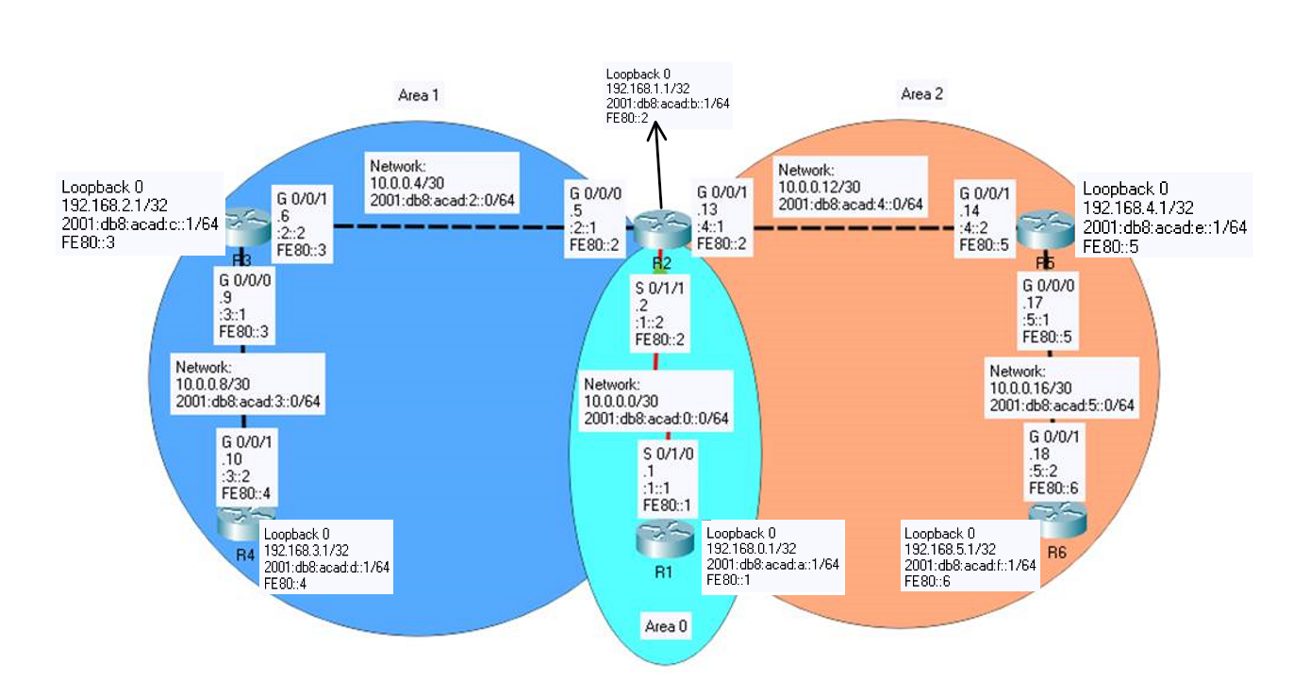

|  |  |  |  |  |  |
| --- | --- | --- | --- | --- | --- |
| Device | Interface | IP Address | IPv6 Address | Area | Link-Local Addresses |
| R1 | S 0/1/0 | 10.0.0.1/30 | 2001:db8:acad:1::1/64 | 0 | fe80::1 |
| Loopback 0 | 192.168.0.1/32 | 2001:db8:acad:a::1/64 | 0 | fe80::1 |
| R2 | S 0/1/1 | 10.0.0.2/30 | 2001:db8:acad:1::2/64 | 0 | fe80::2 |
| G 0/0/0 | 10.0.0.5/30 | 2001:db8:acad:2::1/64 | 1 | fe80::2 |
| G 0/0/1 | 10.0.0.13/30 | 2001:db8:acad:4::1/64 | 2 | fe80::2 |
| Loopback 0 | 192.168.1.1/32 | 2001:db8:acad:b::1/64 | 0 | fe80::2 |
| R3 | G 0/0/0 | 10.0.0.9/30 | 2001:db8:acad:3::1/64 | 1 | fe80::3 |
| G 0/0/1 | 10.0.0.6/30 | 2001:db8:acad:2::2/64 | 1 | fe80::3 |
| Loopback 0 | 192.168.2.1/32 | 2001:db8:acad:c::1/64 | 1 | fe80::3 |
| R4 | G 0/0/1 | 10.0.0.10/30 | 2001:db8:acad:3::2/64 | 1 | fe80::4 |
| Loopback 0 | 192.168.3.1/32 | 2001:db8:acad:d::1/64 | 1 | fe80::4 |
| R5 | G 0/0/0 | 10.0.0.17/30 | 2001:db8:acad:5::1/64 | 2 | fe80::5 |
| G 0/0/1 | 10.0.0.14/30 | 2001:db8:acad:4::2/64 | 2 | fe80::5 |
| Loopback 0 | 192.168.4.1/32 | 2001:db8:acad:e::1/64 | 2 | fe80::5 |
| R6 | G 0/0/1 | 10.0.0.18/32 | 2001:db8:acad:5::2/64 | 2 | fe80::6 |
| Loopback 0 | 192.168.5.1/32 | 2001:db8:acad:f::1/64 | 2 | fe80::6 |

**Pings to Routers and Loopbacks for IPv4**

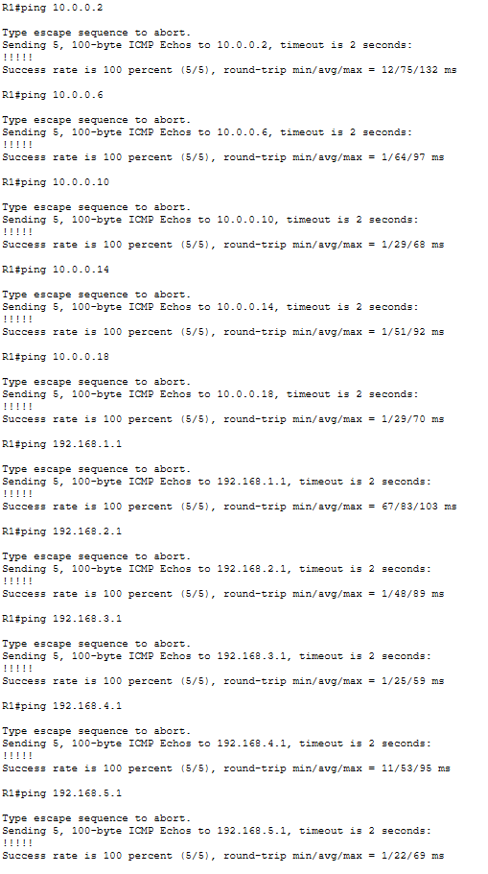

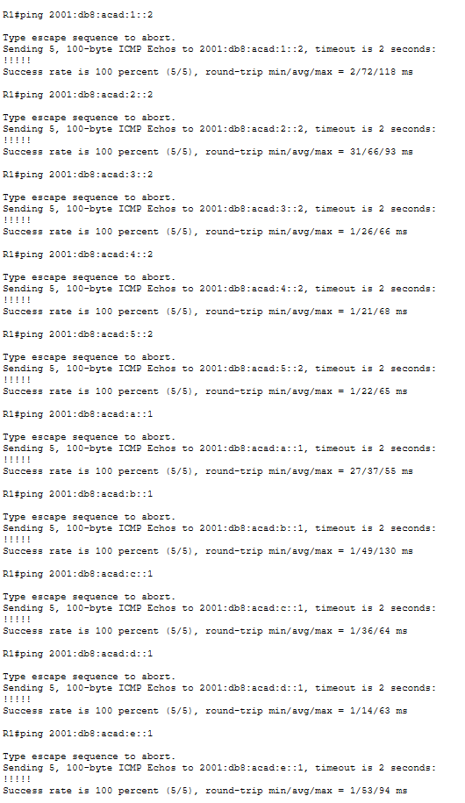

**Router 1 Config:**

**show run:**

R1#show run

Building configuration...

Current configuration : 1268 bytes

!

version 15.4

no service timestamps log datetime msec

no service timestamps debug datetime msec

no service password-encryption

!

hostname R1

!

no ip cef

ipv6 unicast-routing

!

no ipv6 cef

!

spanning-tree mode pvst

!

interface Loopback0

ip address 192.168.0.1 255.255.255.255

ipv6 address FE80::1 link-local

ipv6 address 2001:DB8:ACAD:A::1/64

ipv6 ospf 1 area 0

!

interface GigabitEthernet0/0/0

no ip address

duplex auto

speed auto

shutdown

!

interface GigabitEthernet0/0/1

no ip address

duplex auto

speed auto

shutdown

!

interface Serial0/1/0

ip address 10.0.0.1 255.255.255.252

ip ospf hello-interval 1

ip ospf dead-interval 3

ipv6 address FE80::1 link-local

ipv6 address 2001:DB8:ACAD:1::1/64

ipv6 ospf 1 area 0

!

interface Serial0/1/1

no ip address

clock rate 2000000

shutdown

!

interface Vlan1

no ip address

shutdown

!

router ospf 10

router-id 1.1.1.1

log-adjacency-changes

passive-interface Loopback0

network 10.0.0.0 0.0.0.3 area 0

network 192.168.0.1 0.0.0.0 area 0

!

ipv6 router ospf 1

router-id 1.1.1.1

log-adjacency-changes

passive-interface Loopback0

!

ip classless

!

ip flow-export version 9

!

no cdp run

!

line con 0

!

line aux 0

!

line vty 0 4

login

!

end

**show ip route:**

R1#show ip route

Codes: L - local, C - connected, S - static, R - RIP, M - mobile, B - BGP

D - EIGRP, EX - EIGRP external, O - OSPF, IA - OSPF inter area

N1 - OSPF NSSA external type 1, N2 - OSPF NSSA external type 2

E1 - OSPF external type 1, E2 - OSPF external type 2, E - EGP

i - IS-IS, L1 - IS-IS level-1, L2 - IS-IS level-2, ia - IS-IS inter area

* - candidate default, U - per-user static route, o - ODR

P - periodic downloaded static route

Gateway of last resort is not set

10.0.0.0/8 is variably subnetted, 6 subnets, 2 masks

C 10.0.0.0/30 is directly connected, Serial0/1/0

L 10.0.0.1/32 is directly connected, Serial0/1/0

O IA 10.0.0.4/30 [110/65] via 10.0.0.2, 00:07:40, Serial0/1/0

O IA 10.0.0.8/30 [110/66] via 10.0.0.2, 00:02:51, Serial0/1/0

O IA 10.0.0.12/30 [110/65] via 10.0.0.2, 00:07:40, Serial0/1/0

O IA 10.0.0.16/30 [110/66] via 10.0.0.2, 00:03:22, Serial0/1/0

192.168.0.0/32 is subnetted, 1 subnets

C 192.168.0.1/32 is directly connected, Loopback0

192.168.1.0/32 is subnetted, 1 subnets

O 192.168.1.1/32 [110/65] via 10.0.0.2, 00:07:40, Serial0/1/0

192.168.2.0/32 is subnetted, 1 subnets

O IA 192.168.2.1/32 [110/66] via 10.0.0.2, 00:02:51, Serial0/1/0

192.168.3.0/32 is subnetted, 1 subnets

O IA 192.168.3.1/32 [110/67] via 10.0.0.2, 00:02:51, Serial0/1/0

192.168.4.0/32 is subnetted, 1 subnets

O IA 192.168.4.1/32 [110/66] via 10.0.0.2, 00:03:22, Serial0/1/0

192.168.5.0/32 is subnetted, 1 subnets

O IA 192.168.5.1/32 [110/67] via 10.0.0.2, 00:03:22, Serial0/1/0

**show ipv6 route:**

R1#show ipv6 route

IPv6 Routing Table - 14 entries

Codes: C - Connected, L - Local, S - Static, R - RIP, B - BGP

U - Per-user Static route, M - MIPv6

I1 - ISIS L1, I2 - ISIS L2, IA - ISIS interarea, IS - ISIS summary

ND - ND Default, NDp - ND Prefix, DCE - Destination, NDr - Redirect

O - OSPF intra, OI - OSPF inter, OE1 - OSPF ext 1, OE2 - OSPF ext 2

ON1 - OSPF NSSA ext 1, ON2 - OSPF NSSA ext 2

D - EIGRP, EX - EIGRP external

C 2001:DB8:ACAD:1::/64 [0/0]

via Serial0/1/0, directly connected

L 2001:DB8:ACAD:1::1/128 [0/0]

via Serial0/1/0, receive

OI 2001:DB8:ACAD:2::/64 [110/65]

via FE80::2, Serial0/1/0

OI 2001:DB8:ACAD:3::/64 [110/66]

via FE80::2, Serial0/1/0

OI 2001:DB8:ACAD:4::/64 [110/65]

via FE80::2, Serial0/1/0

OI 2001:DB8:ACAD:5::/64 [110/66]

via FE80::2, Serial0/1/0

C 2001:DB8:ACAD:A::/64 [0/0]

via Loopback0, directly connected

L 2001:DB8:ACAD:A::1/128 [0/0]

via Loopback0, receive

O 2001:DB8:ACAD:B::1/128 [110/64]

via FE80::2, Serial0/1/0

OI 2001:DB8:ACAD:C::1/128 [110/65]

via FE80::2, Serial0/1/0

OI 2001:DB8:ACAD:D::1/128 [110/66]

via FE80::2, Serial0/1/0

OI 2001:DB8:ACAD:E::1/128 [110/65]

via FE80::2, Serial0/1/0

OI 2001:DB8:ACAD:F::1/128 [110/66]

via FE80::2, Serial0/1/0

L FF00::/8 [0/0]

via Null0, receive

**show ip ospf interface:**

R1#show ip ospf interface

Loopback0 is up, line protocol is up

Internet address is 192.168.0.1/32, Area 0

Process ID 10, Router ID 1.1.1.1, Network Type LOOPBACK, Cost: 1

Loopback interface is treated as a stub Host

Serial0/1/0 is up, line protocol is up

Internet address is 10.0.0.1/30, Area 0

Process ID 10, Router ID 1.1.1.1, Network Type POINT-TO-POINT, Cost: 64

Transmit Delay is 1 sec, State POINT-TO-POINT,

Timer intervals configured, Hello 1, Dead 3, Wait 3, Retransmit 5

Hello due in 00:00:00

Index 2/2, flood queue length 0

Next 0x0(0)/0x0(0)

Last flood scan length is 1, maximum is 1

Last flood scan time is 0 msec, maximum is 0 msec

Neighbor Count is 1 , Adjacent neighbor count is 1

Adjacent with neighbor 2.2.2.2

Suppress hello for 0 neighbor(s)

**show ipv6 ospf interface:**

R1#show ipv6 ospf interface

Loopback0 is up, line protocol is up

Link Local Address FE80::1, Interface ID 5

Area 0, Process ID 1, Instance ID 0, Router ID 1.1.1.1

Network Type LOOPBACK, Cost: 1

Loopback interface is treated as a stub Host

Serial0/1/0 is up, line protocol is up

Link Local Address FE80::1, Interface ID 3

Area 0, Process ID 1, Instance ID 0, Router ID 1.1.1.1

Network Type POINT-TO-POINT, Cost: 64

Transmit Delay is 1 sec, State POINT-TO-POINT,

Timer intervals configured, Hello 10, Dead 40, Wait 40, Retransmit 5

Hello due in 00:00:06

Index 2/2, flood queue length 0

Next 0x0(0)/0x0(0)

Last flood scan length is 1, maximum is 1

Last flood scan time is 0 msec, maximum is 0 msec

Neighbor Count is 1 , Adjacent neighbor count is 1

Adjacent with neighbor 2.2.2.2

Suppress hello for 0 neighbor(s)

**show ip ospf neighbor:**

R1#show ip ospf neighbor

Neighbor ID Pri State Dead Time Address Interface

2.2.2.2 0 FULL/ - 00:00:02 10.0.0.2 Serial0/1/0

**show ip protocol:**

R1#show ip protocol

Routing Protocol is "ospf 10"

Outgoing update filter list for all interfaces is not set

Incoming update filter list for all interfaces is not set

Router ID 1.1.1.1

Number of areas in this router is 1. 1 normal 0 stub 0 nssa

Maximum path: 4

Routing for Networks:

10.0.0.0 0.0.0.3 area 0

192.168.0.1 0.0.0.0 area 0

Passive Interface(s):

Loopback0

Routing Information Sources:

Gateway Distance Last Update

1.1.1.1 110 00:09:31

2.2.2.2 110 00:09:31

Distance: (default is 110)

**show ipv6 protocol:**

R1#show ipv6 protocol

IPv6 Routing Protocol is "connected"

IPv6 Routing Protocol is "ND"

IPv6 Routing Protocol is "ospf 1"

Interfaces (Area 0)

Loopback0

Serial0/1/0

Redistribution:

None

**show ip ospf border-router:**

R1#show ip ospf border-router

OSPF Process 10 internal Routing Table

Codes: i - Intra-area route, I - Inter-area route

i 2.2.2.2 [64] via 10.0.0.2, Serial0/1/0, ABR, Area 0, SPF 64

**show ipv6 ospf border-router:**

R1#show ipv6 ospf border-router

OSPFv3 Process 1 internal Routing Table

Codes: i - Intra-area route, I - Inter-area route

i 2.2.2.2 [64] via FE80::2, Serial0/1/0, ABR, Area 0, SPF 2

**Router 2 Config:**

**show run:**

R2# show run

Building configuration...

Current configuration : 1660 bytes

!

version 15.4

no service timestamps log datetime msec

no service timestamps debug datetime msec

no service password-encryption

!

hostname R2

!

no ip cef

ipv6 unicast-routing

!

no ipv6 cef

!

spanning-tree mode pvst

!

interface Loopback0

ip address 192.168.1.1 255.255.255.255

ipv6 address FE80::2 link-local

ipv6 address 2001:DB8:ACAD:B::1/64

ipv6 ospf 1 area 0

!

interface GigabitEthernet0/0/0

ip address 10.0.0.5 255.255.255.252

ip ospf hello-interval 1

ip ospf dead-interval 3

duplex auto

speed auto

ipv6 address FE80::2 link-local

ipv6 address 2001:DB8:ACAD:2::1/64

ipv6 ospf 1 area 1

!

interface GigabitEthernet0/0/1

ip address 10.0.0.13 255.255.255.252

ip ospf hello-interval 1

ip ospf dead-interval 3

duplex auto

speed auto

ipv6 address FE80::2 link-local

ipv6 address 2001:DB8:ACAD:4::1/64

ipv6 ospf 1 area 2

!

interface Serial0/1/0

no ip address

clock rate 2000000

shutdown

!

interface Serial0/1/1

ip address 10.0.0.2 255.255.255.252

ip ospf hello-interval 1

ip ospf dead-interval 3

ipv6 address FE80::2 link-local

ipv6 address 2001:DB8:ACAD:1::2/64

ipv6 ospf 1 area 0

clock rate 2000000

!

interface Vlan1

no ip address

shutdown

!

router ospf 10

router-id 2.2.2.2

log-adjacency-changes

passive-interface Loopback0

network 10.0.0.4 0.0.0.3 area 1

network 10.0.0.0 0.0.0.3 area 0

network 192.168.1.1 0.0.0.0 area 0

network 10.0.0.12 0.0.0.3 area 2

!

ipv6 router ospf 1

router-id 2.2.2.2

log-adjacency-changes

passive-interface Loopback0

!

ip classless

!

ip flow-export version 9

!

no cdp run

!

line con 0

!

line aux 0

!

line vty 0 4

login

!

end

**show ip route:**

R2#show ip route

Codes: L - local, C - connected, S - static, R - RIP, M - mobile, B - BGP

D - EIGRP, EX - EIGRP external, O - OSPF, IA - OSPF inter area

N1 - OSPF NSSA external type 1, N2 - OSPF NSSA external type 2

E1 - OSPF external type 1, E2 - OSPF external type 2, E - EGP

i - IS-IS, L1 - IS-IS level-1, L2 - IS-IS level-2, ia - IS-IS inter area

* - candidate default, U - per-user static route, o - ODR

P - periodic downloaded static route

Gateway of last resort is not set

10.0.0.0/8 is variably subnetted, 8 subnets, 2 masks

C 10.0.0.0/30 is directly connected, Serial0/1/1

L 10.0.0.2/32 is directly connected, Serial0/1/1

C 10.0.0.4/30 is directly connected, GigabitEthernet0/0/0

L 10.0.0.5/32 is directly connected, GigabitEthernet0/0/0

O 10.0.0.8/30 [110/2] via 10.0.0.6, 4294967273:4294967247:4294967295, GigabitEthernet0/0/0

C 10.0.0.12/30 is directly connected, GigabitEthernet0/0/1

L 10.0.0.13/32 is directly connected, GigabitEthernet0/0/1

O 10.0.0.16/30 [110/2] via 10.0.0.14, 4294967273:4294967248:4294967265, GigabitEthernet0/0/1

192.168.0.0/32 is subnetted, 1 subnets

O 192.168.0.1/32 [110/65] via 10.0.0.1, 4294967273:4294967252:4294967275, Serial0/1/1

192.168.1.0/32 is subnetted, 1 subnets

C 192.168.1.1/32 is directly connected, Loopback0

192.168.2.0/32 is subnetted, 1 subnets

O 192.168.2.1/32 [110/2] via 10.0.0.6, 4294967273:4294967247:4294967295, GigabitEthernet0/0/0

192.168.3.0/32 is subnetted, 1 subnets

O 192.168.3.1/32 [110/3] via 10.0.0.6, 4294967273:4294967247:4294967295, GigabitEthernet0/0/0

192.168.4.0/32 is subnetted, 1 subnets

O 192.168.4.1/32 [110/2] via 10.0.0.14, 4294967273:4294967248:4294967265, GigabitEthernet0/0/1

192.168.5.0/32 is subnetted, 1 subnets

O 192.168.5.1/32 [110/3] via 10.0.0.14, 4294967273:4294967248:4294967265, GigabitEthernet0/0/1

**show ipv6 route:**

R2#show ipv6 route

IPv6 Routing Table - 16 entries

Codes: C - Connected, L - Local, S - Static, R - RIP, B - BGP

U - Per-user Static route, M - MIPv6

I1 - ISIS L1, I2 - ISIS L2, IA - ISIS interarea, IS - ISIS summary

ND - ND Default, NDp - ND Prefix, DCE - Destination, NDr - Redirect

O - OSPF intra, OI - OSPF inter, OE1 - OSPF ext 1, OE2 - OSPF ext 2

ON1 - OSPF NSSA ext 1, ON2 - OSPF NSSA ext 2

D - EIGRP, EX - EIGRP external

C 2001:DB8:ACAD:1::/64 [0/0]

via Serial0/1/1, directly connected

L 2001:DB8:ACAD:1::2/128 [0/0]

via Serial0/1/1, receive

C 2001:DB8:ACAD:2::/64 [0/0]

via GigabitEthernet0/0/0, directly connected

L 2001:DB8:ACAD:2::1/128 [0/0]

via GigabitEthernet0/0/0, receive

O 2001:DB8:ACAD:3::/64 [110/2]

via FE80::3, GigabitEthernet0/0/0

C 2001:DB8:ACAD:4::/64 [0/0]

via GigabitEthernet0/0/1, directly connected

L 2001:DB8:ACAD:4::1/128 [0/0]

via GigabitEthernet0/0/1, receive

O 2001:DB8:ACAD:5::/64 [110/2]

via FE80::5, GigabitEthernet0/0/1

O 2001:DB8:ACAD:A::1/128 [110/64]

via FE80::1, Serial0/1/1

C 2001:DB8:ACAD:B::/64 [0/0]

via Loopback0, directly connected

L 2001:DB8:ACAD:B::1/128 [0/0]

via Loopback0, receive

O 2001:DB8:ACAD:C::1/128 [110/1]

via FE80::3, GigabitEthernet0/0/0

O 2001:DB8:ACAD:D::1/128 [110/2]

via FE80::3, GigabitEthernet0/0/0

O 2001:DB8:ACAD:E::1/128 [110/1]

via FE80::5, GigabitEthernet0/0/1

O 2001:DB8:ACAD:F::1/128 [110/2]

via FE80::5, GigabitEthernet0/0/1

L FF00::/8 [0/0]

via Null0, receive

**show ip ospf interface:**

R2#show ip ospf interface

GigabitEthernet0/0/0 is up, line protocol is up

Internet address is 10.0.0.5/30, Area 1

Process ID 10, Router ID 2.2.2.2, Network Type BROADCAST, Cost: 1

Transmit Delay is 1 sec, State BDR, Priority 1

Designated Router (ID) 3.3.3.3, Interface address 10.0.0.6

Backup Designated Router (ID) 2.2.2.2, Interface address 10.0.0.5

Timer intervals configured, Hello 1, Dead 3, Wait 3, Retransmit 5

Hello due in 00:00:00

Index 1/1, flood queue length 0

Next 0x0(0)/0x0(0)

Last flood scan length is 1, maximum is 1

Last flood scan time is 0 msec, maximum is 0 msec

Neighbor Count is 1, Adjacent neighbor count is 1

Adjacent with neighbor 3.3.3.3 (Designated Router)

Suppress hello for 0 neighbor(s)

Loopback0 is up, line protocol is up

Internet address is 192.168.1.1/32, Area 0

Process ID 10, Router ID 2.2.2.2, Network Type LOOPBACK, Cost: 1

Loopback interface is treated as a stub Host

Serial0/1/1 is up, line protocol is up

Internet address is 10.0.0.2/30, Area 0

Process ID 10, Router ID 2.2.2.2, Network Type POINT-TO-POINT, Cost: 64

Transmit Delay is 1 sec, State POINT-TO-POINT,

Timer intervals configured, Hello 1, Dead 3, Wait 3, Retransmit 5

Hello due in 00:00:00

Index 3/3, flood queue length 0

Next 0x0(0)/0x0(0)

Last flood scan length is 1, maximum is 1

Last flood scan time is 0 msec, maximum is 0 msec

Neighbor Count is 1 , Adjacent neighbor count is 1

Adjacent with neighbor 1.1.1.1

Suppress hello for 0 neighbor(s)

GigabitEthernet0/0/1 is up, line protocol is up

Internet address is 10.0.0.13/30, Area 2

Process ID 10, Router ID 2.2.2.2, Network Type BROADCAST, Cost: 1

Transmit Delay is 1 sec, State BDR, Priority 1

Designated Router (ID) 5.5.5.5, Interface address 10.0.0.14

Backup Designated Router (ID) 2.2.2.2, Interface address 10.0.0.13

Timer intervals configured, Hello 1, Dead 3, Wait 3, Retransmit 5

Hello due in 00:00:00

Index 4/4, flood queue length 0

Next 0x0(0)/0x0(0)

Last flood scan length is 1, maximum is 1

Last flood scan time is 0 msec, maximum is 0 msec

Neighbor Count is 1, Adjacent neighbor count is 1

Adjacent with neighbor 5.5.5.5 (Designated Router)

Suppress hello for 0 neighbor(s)

**show ipv6 ospf interface:**

R2#show ipv6 ospf interface

Loopback0 is up, line protocol is up

Link Local Address FE80::2, Interface ID 5

Area 0, Process ID 1, Instance ID 0, Router ID 2.2.2.2

Network Type LOOPBACK, Cost: 1

Loopback interface is treated as a stub Host

Serial0/1/1 is up, line protocol is up

Link Local Address FE80::2, Interface ID 4

Area 0, Process ID 1, Instance ID 0, Router ID 2.2.2.2

Network Type POINT-TO-POINT, Cost: 64

Transmit Delay is 1 sec, State POINT-TO-POINT,

Timer intervals configured, Hello 10, Dead 40, Wait 40, Retransmit 5

Hello due in 00:00:09

Index 2/2, flood queue length 0

Next 0x0(0)/0x0(0)

Last flood scan length is 1, maximum is 1

Last flood scan time is 0 msec, maximum is 0 msec

Neighbor Count is 1 , Adjacent neighbor count is 1

Adjacent with neighbor 1.1.1.1

Suppress hello for 0 neighbor(s)

GigabitEthernet0/0/0 is up, line protocol is up

Link Local Address FE80::2, Interface ID 1

Area 1, Process ID 1, Instance ID 0, Router ID 2.2.2.2

Network Type BROADCAST, Cost: 1

Transmit Delay is 1 sec, State BDR, Priority 1

Designated Router (ID) 3.3.3.3, local address FE80::2

Backup Designated Router (ID) 2.2.2.2, local address FE80::2

Timer intervals configured, Hello 10, Dead 40, Wait 40, Retransmit 5

Hello due in 00:00:09

Index 3/3, flood queue length 0

Next 0x0(0)/0x0(0)

Last flood scan length is 1, maximum is 1

Last flood scan time is 0 msec, maximum is 0 msec

Neighbor Count is 1, Adjacent neighbor count is 1

Adjacent with neighbor 3.3.3.3 (Designated Router)

Suppress hello for 0 neighbor(s)

GigabitEthernet0/0/1 is up, line protocol is up

Link Local Address FE80::2, Interface ID 2

Area 2, Process ID 1, Instance ID 0, Router ID 2.2.2.2

Network Type BROADCAST, Cost: 1

Transmit Delay is 1 sec, State BDR, Priority 1

Designated Router (ID) 5.5.5.5, local address FE80::2

Backup Designated Router (ID) 2.2.2.2, local address FE80::2

Timer intervals configured, Hello 10, Dead 40, Wait 40, Retransmit 5

Hello due in 00:00:00

Index 4/4, flood queue length 0

Next 0x0(0)/0x0(0)

Last flood scan length is 1, maximum is 1

Last flood scan time is 0 msec, maximum is 0 msec

Neighbor Count is 1, Adjacent neighbor count is 1

Adjacent with neighbor 5.5.5.5 (Designated Router)

Suppress hello for 0 neighbor(s)

**show ip ospf neighbor:**

R2#show ip ospf neighbor

Neighbor ID Pri State Dead Time Address Interface

3.3.3.3 1 FULL/DR 00:00:02 10.0.0.6 GigabitEthernet0/0/0

1.1.1.1 0 FULL/ - 00:00:02 10.0.0.1 Serial0/1/1

5.5.5.5 1 FULL/DR 00:00:02 10.0.0.14 GigabitEthernet0/0/1

**show ip protocol:**

R2#show ip protocol

Routing Protocol is "ospf 10"

Outgoing update filter list for all interfaces is not set

Incoming update filter list for all interfaces is not set

Router ID 2.2.2.2

Number of areas in this router is 3. 3 normal 0 stub 0 nssa

Maximum path: 4

Routing for Networks:

10.0.0.4 0.0.0.3 area 1

10.0.0.0 0.0.0.3 area 0

192.168.1.1 0.0.0.0 area 0

10.0.0.12 0.0.0.3 area 2

Passive Interface(s):

Loopback0

Routing Information Sources:

Gateway Distance Last Update

1.1.1.1 110 00:03:12

2.2.2.2 110 00:03:12

3.3.3.3 110 00:03:12

4.4.4.4 110 00:11:49

5.5.5.5 110 00:03:12

6.6.6.6 110 00:11:53

Distance: (default is 110)

**show ipv6 protocol:**

R2#show ipv6 protocol

IPv6 Routing Protocol is "connected"

IPv6 Routing Protocol is "ND"

IPv6 Routing Protocol is "ospf 1"

Interfaces (Area 0)

Loopback0

Serial0/1/1

Interfaces (Area 1)

GigabitEthernet0/0/0

Interfaces (Area 2)

GigabitEthernet0/0/1

Redistribution:

None

**show ip ospf border-router:**

R2#show ip ospf border-router

OSPF Process 10 internal Routing Table

Codes: i - Intra-area route, I - Inter-area route

**show ipv6 ospf border-router:**

R2#show ipv6 ospf border-router

OSPFv3 Process 1 internal Routing Table

Codes: i - Intra-area route, I - Inter-area route

**Router 3 Config:**

**show run:**

R3#show run

Building configuration...

Current configuration : 1281 bytes

!

version 15.4

no service timestamps log datetime msec

no service timestamps debug datetime msec

no service password-encryption

!

hostname R3

!

ip cef

ipv6 unicast-routing

!

no ipv6 cef

!

spanning-tree mode pvst

!

interface Loopback0

ip address 192.168.2.1 255.255.255.255

ipv6 address FE80::3 link-local

ipv6 address 2001:DB8:ACAD:C::1/64

ipv6 ospf 1 area 1

!

interface GigabitEthernet0/0/0

ip address 10.0.0.9 255.255.255.252

duplex auto

speed auto

ipv6 address FE80::3 link-local

ipv6 address 2001:DB8:ACAD:3::1/64

ipv6 ospf 1 area 1

!

interface GigabitEthernet0/0/1

ip address 10.0.0.6 255.255.255.252

ip ospf hello-interval 1

ip ospf dead-interval 3

duplex auto

speed auto

ipv6 address FE80::3 link-local

ipv6 address 2001:DB8:ACAD:2::2/64

ipv6 ospf 1 area 1

!

interface Vlan1

no ip address

shutdown

!

router ospf 10

router-id 3.3.3.3

log-adjacency-changes

passive-interface Loopback0

network 192.168.2.1 0.0.0.0 area 1

network 10.0.0.4 0.0.0.3 area 1

network 10.0.0.8 0.0.0.3 area 1

!

ipv6 router ospf 1

router-id 3.3.3.3

log-adjacency-changes

passive-interface Loopback0

!

ip classless

!

ip flow-export version 9

!

no cdp run

!

line con 0

!

line aux 0

!

line vty 0 4

login

!

end

**show ip route:**

R3#show ip route

Codes: L - local, C - connected, S - static, R - RIP, M - mobile, B - BGP

D - EIGRP, EX - EIGRP external, O - OSPF, IA - OSPF inter area

N1 - OSPF NSSA external type 1, N2 - OSPF NSSA external type 2

E1 - OSPF external type 1, E2 - OSPF external type 2, E - EGP

i - IS-IS, L1 - IS-IS level-1, L2 - IS-IS level-2, ia - IS-IS inter area

* - candidate default, U - per-user static route, o - ODR

P - periodic downloaded static route

Gateway of last resort is not set

10.0.0.0/8 is variably subnetted, 7 subnets, 2 masks

O IA 10.0.0.0/30 [110/65] via 10.0.0.5, 01:48:40, GigabitEthernet0/0/1

C 10.0.0.4/30 is directly connected, GigabitEthernet0/0/1

L 10.0.0.6/32 is directly connected, GigabitEthernet0/0/1

C 10.0.0.8/30 is directly connected, GigabitEthernet0/0/0

L 10.0.0.9/32 is directly connected, GigabitEthernet0/0/0

O IA 10.0.0.12/30 [110/2] via 10.0.0.5, 01:48:40, GigabitEthernet0/0/1

O IA 10.0.0.16/30 [110/3] via 10.0.0.5, 01:48:40, GigabitEthernet0/0/1

192.168.0.0/32 is subnetted, 1 subnets

O IA 192.168.0.1/32 [110/66] via 10.0.0.5, 01:48:40, GigabitEthernet0/0/1

192.168.1.0/32 is subnetted, 1 subnets

O IA 192.168.1.1/32 [110/2] via 10.0.0.5, 01:48:40, GigabitEthernet0/0/1

192.168.2.0/32 is subnetted, 1 subnets

C 192.168.2.1/32 is directly connected, Loopback0

192.168.3.0/32 is subnetted, 1 subnets

O 192.168.3.1/32 [110/2] via 10.0.0.10, 01:48:13, GigabitEthernet0/0/0

192.168.4.0/32 is subnetted, 1 subnets

O IA 192.168.4.1/32 [110/3] via 10.0.0.5, 01:48:40, GigabitEthernet0/0/1

192.168.5.0/32 is subnetted, 1 subnets

O IA 192.168.5.1/32 [110/4] via 10.0.0.5, 01:47:58, GigabitEthernet0/0/1

**show ipv6 route:**

R3#show ipv6 route

IPv6 Routing Table - 15 entries

Codes: C - Connected, L - Local, S - Static, R - RIP, B - BGP

U - Per-user Static route, M - MIPv6

I1 - ISIS L1, I2 - ISIS L2, IA - ISIS interarea, IS - ISIS summary

ND - ND Default, NDp - ND Prefix, DCE - Destination, NDr - Redirect

O - OSPF intra, OI - OSPF inter, OE1 - OSPF ext 1, OE2 - OSPF ext 2

ON1 - OSPF NSSA ext 1, ON2 - OSPF NSSA ext 2

D - EIGRP, EX - EIGRP external

OI 2001:DB8:ACAD:1::/64 [110/65]

via FE80::2, GigabitEthernet0/0/1

C 2001:DB8:ACAD:2::/64 [0/0]

via GigabitEthernet0/0/1, directly connected

L 2001:DB8:ACAD:2::2/128 [0/0]

via GigabitEthernet0/0/1, receive

C 2001:DB8:ACAD:3::/64 [0/0]

via GigabitEthernet0/0/0, directly connected

L 2001:DB8:ACAD:3::1/128 [0/0]

via GigabitEthernet0/0/0, receive

OI 2001:DB8:ACAD:4::/64 [110/2]

via FE80::2, GigabitEthernet0/0/1

OI 2001:DB8:ACAD:5::/64 [110/3]

via FE80::2, GigabitEthernet0/0/1

OI 2001:DB8:ACAD:A::1/128 [110/65]

via FE80::2, GigabitEthernet0/0/1

OI 2001:DB8:ACAD:B::1/128 [110/1]

via FE80::2, GigabitEthernet0/0/1

C 2001:DB8:ACAD:C::/64 [0/0]

via Loopback0, directly connected

L 2001:DB8:ACAD:C::1/128 [0/0]

via Loopback0, receive

O 2001:DB8:ACAD:D::1/128 [110/1]

via FE80::4, GigabitEthernet0/0/0

OI 2001:DB8:ACAD:E::1/128 [110/2]

via FE80::2, GigabitEthernet0/0/1

OI 2001:DB8:ACAD:F::1/128 [110/3]

via FE80::2, GigabitEthernet0/0/1

L FF00::/8 [0/0]

via Null0, receive

**show ip ospf interface:**

R3#show ip ospf interface

Loopback0 is up, line protocol is up

Internet address is 192.168.2.1/32, Area 1

Process ID 10, Router ID 3.3.3.3, Network Type LOOPBACK, Cost: 1

Loopback interface is treated as a stub Host

GigabitEthernet0/0/0 is up, line protocol is up

Internet address is 10.0.0.9/30, Area 1

Process ID 10, Router ID 3.3.3.3, Network Type BROADCAST, Cost: 1

Transmit Delay is 1 sec, State BDR, Priority 1

Designated Router (ID) 4.4.4.4, Interface address 10.0.0.10

Backup Designated Router (ID) 3.3.3.3, Interface address 10.0.0.9

Timer intervals configured, Hello 10, Dead 40, Wait 40, Retransmit 5

Hello due in 00:00:05

Index 2/2, flood queue length 0

Next 0x0(0)/0x0(0)

Last flood scan length is 1, maximum is 1

Last flood scan time is 0 msec, maximum is 0 msec

Neighbor Count is 1, Adjacent neighbor count is 1

Adjacent with neighbor 4.4.4.4 (Designated Router)

Suppress hello for 0 neighbor(s)

GigabitEthernet0/0/1 is up, line protocol is up

Internet address is 10.0.0.6/30, Area 1

Process ID 10, Router ID 3.3.3.3, Network Type BROADCAST, Cost: 1

Transmit Delay is 1 sec, State DR, Priority 1

Designated Router (ID) 3.3.3.3, Interface address 10.0.0.6

Backup Designated Router (ID) 2.2.2.2, Interface address 10.0.0.5

Timer intervals configured, Hello 1, Dead 3, Wait 3, Retransmit 5

Hello due in 00:00:00

Index 3/3, flood queue length 0

Next 0x0(0)/0x0(0)

Last flood scan length is 1, maximum is 1

Last flood scan time is 0 msec, maximum is 0 msec

Neighbor Count is 1, Adjacent neighbor count is 1

Adjacent with neighbor 2.2.2.2 (Backup Designated Router)

Suppress hello for 0 neighbor(s)

**show ipv6 ospf interface:**

R3#show ipv6 ospf interface

Loopback0 is up, line protocol is up

Link Local Address FE80::3, Interface ID 3

Area 1, Process ID 1, Instance ID 0, Router ID 3.3.3.3

Network Type LOOPBACK, Cost: 1

Loopback interface is treated as a stub Host

GigabitEthernet0/0/0 is up, line protocol is up

Link Local Address FE80::3, Interface ID 1

Area 1, Process ID 1, Instance ID 0, Router ID 3.3.3.3

Network Type BROADCAST, Cost: 1

Transmit Delay is 1 sec, State BDR, Priority 1

Designated Router (ID) 4.4.4.4, local address FE80::3

Backup Designated Router (ID) 3.3.3.3, local address FE80::3

Timer intervals configured, Hello 10, Dead 40, Wait 40, Retransmit 5

Hello due in 00:00:02

Index 2/2, flood queue length 0

Next 0x0(0)/0x0(0)

Last flood scan length is 1, maximum is 1

Last flood scan time is 0 msec, maximum is 0 msec

Neighbor Count is 1, Adjacent neighbor count is 1

Adjacent with neighbor 4.4.4.4 (Designated Router)

Suppress hello for 0 neighbor(s)

GigabitEthernet0/0/1 is up, line protocol is up

Link Local Address FE80::3, Interface ID 2

Area 1, Process ID 1, Instance ID 0, Router ID 3.3.3.3

Network Type BROADCAST, Cost: 1

Transmit Delay is 1 sec, State DR, Priority 1

Designated Router (ID) 3.3.3.3, local address FE80::3

Backup Designated Router (ID) 2.2.2.2, local address FE80::3

Timer intervals configured, Hello 10, Dead 40, Wait 40, Retransmit 5

Hello due in 00:00:07

Index 3/3, flood queue length 0

Next 0x0(0)/0x0(0)

Last flood scan length is 1, maximum is 1

Last flood scan time is 0 msec, maximum is 0 msec

Neighbor Count is 1, Adjacent neighbor count is 1

Adjacent with neighbor 2.2.2.2 (Backup Designated Router)

Suppress hello for 0 neighbor(s)

**show ip ospf neighbor:**

R3#show ip ospf neighbor

Neighbor ID Pri State Dead Time Address Interface

4.4.4.4 1 FULL/DR 00:00:38 10.0.0.10 GigabitEthernet0/0/0

2.2.2.2 1 FULL/BDR 00:00:02 10.0.0.5 GigabitEthernet0/0/1

**show ip protocol:**

R3# show ip protocol

Routing Protocol is "ospf 10"

Outgoing update filter list for all interfaces is not set

Incoming update filter list for all interfaces is not set

Router ID 3.3.3.3

Number of areas in this router is 1. 1 normal 0 stub 0 nssa

Maximum path: 4

Routing for Networks:

192.168.2.1 0.0.0.0 area 1

10.0.0.4 0.0.0.3 area 1

10.0.0.8 0.0.0.3 area 1

Passive Interface(s):

Loopback0

Routing Information Sources:

Gateway Distance Last Update

2.2.2.2 110 00:10:21

3.3.3.3 110 00:10:21

4.4.4.4 110 00:19:00

Distance: (default is 110)

**show ipv6 protocol:**

R3#show ipv6 protocol

IPv6 Routing Protocol is "connected"

IPv6 Routing Protocol is "ND"

IPv6 Routing Protocol is "ospf 1"

Interfaces (Area 1)

Loopback0

GigabitEthernet0/0/0

GigabitEthernet0/0/1

Redistribution:

None

**show ip ospf border-router:**

R3#show ip ospf border-router

OSPF Process 10 internal Routing Table

Codes: i - Intra-area route, I - Inter-area route

i 2.2.2.2 [1] via 10.0.0.5, GigabitEthernet0/0/1, ABR, Area 1, SPF 1

**show ipv6 ospf border-router:**

R3#show ipv6 ospf border-router

OSPFv3 Process 1 internal Routing Table

Codes: i - Intra-area route, I - Inter-area route

i 2.2.2.2 [1] via FE80::2, GigabitEthernet0/0/1, ABR, Area 1, SPF 2

**Router 4 Config:**

**show run:**

R4#show run

Building configuration...

Current configuration : 1068 bytes

!

version 15.4

no service timestamps log datetime msec

no service timestamps debug datetime msec

no service password-encryption

!

hostname R4

!

ip cef

ipv6 unicast-routing

!

no ipv6 cef

!

spanning-tree mode pvst

!

interface Loopback0

ip address 192.168.3.1 255.255.255.255

ipv6 address FE80::4 link-local

ipv6 address 2001:DB8:ACAD:D::1/64

ipv6 ospf 1 area 1

!

interface GigabitEthernet0/0/0

no ip address

duplex auto

speed auto

shutdown

!

interface GigabitEthernet0/0/1

ip address 10.0.0.10 255.255.255.252

duplex auto

speed auto

ipv6 address FE80::4 link-local

ipv6 address 2001:DB8:ACAD:3::2/64

ipv6 ospf 1 area 1

!

interface Vlan1

no ip address

shutdown

!

router ospf 10

router-id 4.4.4.4

log-adjacency-changes

passive-interface Loopback0

network 10.0.0.8 0.0.0.3 area 1

network 192.168.3.1 0.0.0.0 area 1

!

ipv6 router ospf 1

router-id 4.4.4.4

log-adjacency-changes

!

ip classless

!

ip flow-export version 9

!

no cdp run

!

line con 0

!

line aux 0

!

line vty 0 4

login

!

end

**show ip route:**

R4#show ip route

Codes: L - local, C - connected, S - static, R - RIP, M - mobile, B - BGP

D - EIGRP, EX - EIGRP external, O - OSPF, IA - OSPF inter area

N1 - OSPF NSSA external type 1, N2 - OSPF NSSA external type 2

E1 - OSPF external type 1, E2 - OSPF external type 2, E - EGP

i - IS-IS, L1 - IS-IS level-1, L2 - IS-IS level-2, ia - IS-IS inter area

* - candidate default, U - per-user static route, o - ODR

P - periodic downloaded static route

Gateway of last resort is not set

10.0.0.0/8 is variably subnetted, 6 subnets, 2 masks

O IA 10.0.0.0/30 [110/66] via 10.0.0.9, 00:13:56, GigabitEthernet0/0/1

O 10.0.0.4/30 [110/2] via 10.0.0.9, 00:13:56, GigabitEthernet0/0/1

C 10.0.0.8/30 is directly connected, GigabitEthernet0/0/1

L 10.0.0.10/32 is directly connected, GigabitEthernet0/0/1

O IA 10.0.0.12/30 [110/3] via 10.0.0.9, 00:13:56, GigabitEthernet0/0/1

O IA 10.0.0.16/30 [110/4] via 10.0.0.9, 00:13:56, GigabitEthernet0/0/1

192.168.0.0/32 is subnetted, 1 subnets

O IA 192.168.0.1/32 [110/67] via 10.0.0.9, 00:13:56, GigabitEthernet0/0/1

192.168.1.0/32 is subnetted, 1 subnets

O IA 192.168.1.1/32 [110/3] via 10.0.0.9, 00:13:56, GigabitEthernet0/0/1

192.168.2.0/32 is subnetted, 1 subnets

O 192.168.2.1/32 [110/2] via 10.0.0.9, 01:54:56, GigabitEthernet0/0/1

192.168.3.0/32 is subnetted, 1 subnets

C 192.168.3.1/32 is directly connected, Loopback0

192.168.4.0/32 is subnetted, 1 subnets

O IA 192.168.4.1/32 [110/4] via 10.0.0.9, 00:13:56, GigabitEthernet0/0/1

192.168.5.0/32 is subnetted, 1 subnets

O IA 192.168.5.1/32 [110/5] via 10.0.0.9, 00:13:56, GigabitEthernet0/0/1

**show ipv6 route:**

R4#show ipv6 route

IPv6 Routing Table - 14 entries

Codes: C - Connected, L - Local, S - Static, R - RIP, B - BGP

U - Per-user Static route, M - MIPv6

I1 - ISIS L1, I2 - ISIS L2, IA - ISIS interarea, IS - ISIS summary

ND - ND Default, NDp - ND Prefix, DCE - Destination, NDr - Redirect

O - OSPF intra, OI - OSPF inter, OE1 - OSPF ext 1, OE2 - OSPF ext 2

ON1 - OSPF NSSA ext 1, ON2 - OSPF NSSA ext 2

D - EIGRP, EX - EIGRP external

OI 2001:DB8:ACAD:1::/64 [110/66]

via FE80::3, GigabitEthernet0/0/1

O 2001:DB8:ACAD:2::/64 [110/2]

via FE80::3, GigabitEthernet0/0/1

C 2001:DB8:ACAD:3::/64 [0/0]

via GigabitEthernet0/0/1, directly connected

L 2001:DB8:ACAD:3::2/128 [0/0]

via GigabitEthernet0/0/1, receive

OI 2001:DB8:ACAD:4::/64 [110/3]

via FE80::3, GigabitEthernet0/0/1

OI 2001:DB8:ACAD:5::/64 [110/4]

via FE80::3, GigabitEthernet0/0/1

OI 2001:DB8:ACAD:A::1/128 [110/66]

via FE80::3, GigabitEthernet0/0/1

OI 2001:DB8:ACAD:B::1/128 [110/2]

via FE80::3, GigabitEthernet0/0/1

O 2001:DB8:ACAD:C::1/128 [110/1]

via FE80::3, GigabitEthernet0/0/1

C 2001:DB8:ACAD:D::/64 [0/0]

via Loopback0, directly connected

L 2001:DB8:ACAD:D::1/128 [0/0]

via Loopback0, receive

OI 2001:DB8:ACAD:E::1/128 [110/3]

via FE80::3, GigabitEthernet0/0/1

OI 2001:DB8:ACAD:F::1/128 [110/4]

via FE80::3, GigabitEthernet0/0/1

L FF00::/8 [0/0]

via Null0, receive

**show ip ospf interface:**

R4#show ip ospf interface

Loopback0 is up, line protocol is up

Internet address is 192.168.3.1/32, Area 1

Process ID 10, Router ID 4.4.4.4, Network Type LOOPBACK, Cost: 1

Loopback interface is treated as a stub Host

GigabitEthernet0/0/1 is up, line protocol is up

Internet address is 10.0.0.10/30, Area 1

Process ID 10, Router ID 4.4.4.4, Network Type BROADCAST, Cost: 1

Transmit Delay is 1 sec, State DR, Priority 1

Designated Router (ID) 4.4.4.4, Interface address 10.0.0.10

Backup Designated Router (ID) 3.3.3.3, Interface address 10.0.0.9

Timer intervals configured, Hello 10, Dead 40, Wait 40, Retransmit 5

Hello due in 00:00:07

Index 2/2, flood queue length 0

Next 0x0(0)/0x0(0)

Last flood scan length is 1, maximum is 1

Last flood scan time is 0 msec, maximum is 0 msec

Neighbor Count is 1, Adjacent neighbor count is 1

Adjacent with neighbor 3.3.3.3 (Backup Designated Router)

Suppress hello for 0 neighbor(s)

**show ipv6 ospf interface:**

R4#show ipv6 ospf interface

Loopback0 is up, line protocol is up

Link Local Address FE80::4, Interface ID 3

Area 1, Process ID 1, Instance ID 0, Router ID 4.4.4.4

Network Type LOOPBACK, Cost: 1

Loopback interface is treated as a stub Host

GigabitEthernet0/0/1 is up, line protocol is up

Link Local Address FE80::4, Interface ID 2

Area 1, Process ID 1, Instance ID 0, Router ID 4.4.4.4

Network Type BROADCAST, Cost: 1

Transmit Delay is 1 sec, State DR, Priority 1

Designated Router (ID) 4.4.4.4, local address FE80::4

Backup Designated Router (ID) 3.3.3.3, local address FE80::4

Timer intervals configured, Hello 10, Dead 40, Wait 40, Retransmit 5

Hello due in 00:00:03

Index 2/2, flood queue length 0

Next 0x0(0)/0x0(0)

Last flood scan length is 1, maximum is 1

Last flood scan time is 0 msec, maximum is 0 msec

Neighbor Count is 1, Adjacent neighbor count is 1

Adjacent with neighbor 3.3.3.3 (Backup Designated Router)

Suppress hello for 0 neighbor(s)

**show ip ospf neighbor:**

R4#show ip ospf neighbor

Neighbor ID Pri State Dead Time Address Interface

3.3.3.3 1 FULL/BDR 00:00:34 10.0.0.9 GigabitEthernet0/0/1

**show ip protocol:**

R4#show ip protocol

Routing Protocol is "ospf 10"

Outgoing update filter list for all interfaces is not set

Incoming update filter list for all interfaces is not set

Router ID 4.4.4.4

Number of areas in this router is 1. 1 normal 0 stub 0 nssa

Maximum path: 4

Routing for Networks:

10.0.0.8 0.0.0.3 area 1

192.168.3.1 0.0.0.0 area 1

Passive Interface(s):

Loopback0

Routing Information Sources:

Gateway Distance Last Update

2.2.2.2 110 00:16:05

3.3.3.3 110 00:16:06

4.4.4.4 110 00:24:46

Distance: (default is 110)

**show ipv6 protocol:**

R4#show ipv6 protocol

IPv6 Routing Protocol is "connected"

IPv6 Routing Protocol is "ND"

IPv6 Routing Protocol is "ospf 1"

Interfaces (Area 1)

Loopback0

GigabitEthernet0/0/1

Redistribution:

None

**show ip ospf border-router:**

R4#show ip ospf border-router

OSPF Process 10 internal Routing Table

Codes: i - Intra-area route, I - Inter-area route

i 2.2.2.2 [2] via 10.0.0.9, GigabitEthernet0/0/1, ABR, Area 1, SPF 2

**show ipv6 ospf border-router:**

R4#show ipv6 ospf border-router

OSPFv3 Process 1 internal Routing Table

Codes: i - Intra-area route, I - Inter-area route

i 2.2.2.2 [2] via FE80::3, GigabitEthernet0/0/1, ABR, Area 1, SPF 2

**Router 5 Config:**

**show run:**

R5#show run

Building configuration...

Current configuration : 1256 bytes

!

version 15.4

no service timestamps log datetime msec

no service timestamps debug datetime msec

no service password-encryption

!

hostname R5

!

ip cef

ipv6 unicast-routing

!

no ipv6 cef

!

spanning-tree mode pvst

!

interface Loopback0

ip address 192.168.4.1 255.255.255.255

ipv6 address FE80::5 link-local

ipv6 address 2001:DB8:ACAD:E::1/64

ipv6 ospf 1 area 2

!

interface GigabitEthernet0/0/0

ip address 10.0.0.17 255.255.255.252

duplex auto

speed auto

ipv6 address FE80::5 link-local

ipv6 address 2001:DB8:ACAD:5::1/64

ipv6 ospf 1 area 2

!

interface GigabitEthernet0/0/1

ip address 10.0.0.14 255.255.255.252

ip ospf hello-interval 1

ip ospf dead-interval 3

duplex auto

speed auto

ipv6 address FE80::5 link-local

ipv6 address 2001:DB8:ACAD:4::2/64

ipv6 ospf 1 area 2

!

interface Vlan1

no ip address

shutdown

!

router ospf 10

router-id 5.5.5.5

log-adjacency-changes

passive-interface Loopback0

network 10.0.0.12 0.0.0.3 area 2

network 192.168.4.1 0.0.0.0 area 2

network 10.0.0.16 0.0.0.3 area 2

!

ipv6 router ospf 1

router-id 5.5.5.5

log-adjacency-changes

!

ip classless

!

ip flow-export version 9

!

no cdp run

!

line con 0

!

line aux 0

!

line vty 0 4

login

!

end

**show ip route:**

R5#show ip route

Codes: L - local, C - connected, S - static, R - RIP, M - mobile, B - BGP

D - EIGRP, EX - EIGRP external, O - OSPF, IA - OSPF inter area

N1 - OSPF NSSA external type 1, N2 - OSPF NSSA external type 2

E1 - OSPF external type 1, E2 - OSPF external type 2, E - EGP

i - IS-IS, L1 - IS-IS level-1, L2 - IS-IS level-2, ia - IS-IS inter area

* - candidate default, U - per-user static route, o - ODR

P - periodic downloaded static route

Gateway of last resort is not set

10.0.0.0/8 is variably subnetted, 7 subnets, 2 masks

O IA 10.0.0.0/30 [110/65] via 10.0.0.13, 02:08:39, GigabitEthernet0/0/1

O IA 10.0.0.4/30 [110/2] via 10.0.0.13, 02:08:49, GigabitEthernet0/0/1

O IA 10.0.0.8/30 [110/3] via 10.0.0.13, 02:08:39, GigabitEthernet0/0/1

C 10.0.0.12/30 is directly connected, GigabitEthernet0/0/1

L 10.0.0.14/32 is directly connected, GigabitEthernet0/0/1

C 10.0.0.16/30 is directly connected, GigabitEthernet0/0/0

L 10.0.0.17/32 is directly connected, GigabitEthernet0/0/0

192.168.0.0/32 is subnetted, 1 subnets

O IA 192.168.0.1/32 [110/66] via 10.0.0.13, 02:08:39, GigabitEthernet0/0/1

192.168.1.0/32 is subnetted, 1 subnets

O IA 192.168.1.1/32 [110/2] via 10.0.0.13, 02:08:39, GigabitEthernet0/0/1

192.168.2.0/32 is subnetted, 1 subnets

O IA 192.168.2.1/32 [110/3] via 10.0.0.13, 02:08:39, GigabitEthernet0/0/1

192.168.3.0/32 is subnetted, 1 subnets

O IA 192.168.3.1/32 [110/4] via 10.0.0.13, 02:07:59, GigabitEthernet0/0/1

192.168.4.0/32 is subnetted, 1 subnets

C 192.168.4.1/32 is directly connected, Loopback0

192.168.5.0/32 is subnetted, 1 subnets

O 192.168.5.1/32 [110/2] via 10.0.0.18, 02:08:14, GigabitEthernet0/0/0

**show ipv6 route:**

R5#show ipv6 route

IPv6 Routing Table - 15 entries

Codes: C - Connected, L - Local, S - Static, R - RIP, B - BGP

U - Per-user Static route, M - MIPv6

I1 - ISIS L1, I2 - ISIS L2, IA - ISIS interarea, IS - ISIS summary

ND - ND Default, NDp - ND Prefix, DCE - Destination, NDr - Redirect

O - OSPF intra, OI - OSPF inter, OE1 - OSPF ext 1, OE2 - OSPF ext 2

ON1 - OSPF NSSA ext 1, ON2 - OSPF NSSA ext 2

D - EIGRP, EX - EIGRP external

OI 2001:DB8:ACAD:1::/64 [110/65]

via FE80::2, GigabitEthernet0/0/1

OI 2001:DB8:ACAD:2::/64 [110/2]

via FE80::2, GigabitEthernet0/0/1

OI 2001:DB8:ACAD:3::/64 [110/3]

via FE80::2, GigabitEthernet0/0/1

C 2001:DB8:ACAD:4::/64 [0/0]

via GigabitEthernet0/0/1, directly connected

L 2001:DB8:ACAD:4::2/128 [0/0]

via GigabitEthernet0/0/1, receive

C 2001:DB8:ACAD:5::/64 [0/0]

via GigabitEthernet0/0/0, directly connected

L 2001:DB8:ACAD:5::1/128 [0/0]

via GigabitEthernet0/0/0, receive

OI 2001:DB8:ACAD:A::1/128 [110/65]

via FE80::2, GigabitEthernet0/0/1

OI 2001:DB8:ACAD:B::1/128 [110/1]

via FE80::2, GigabitEthernet0/0/1

OI 2001:DB8:ACAD:C::1/128 [110/2]

via FE80::2, GigabitEthernet0/0/1

OI 2001:DB8:ACAD:D::1/128 [110/3]

via FE80::2, GigabitEthernet0/0/1

C 2001:DB8:ACAD:E::/64 [0/0]

via Loopback0, directly connected

L 2001:DB8:ACAD:E::1/128 [0/0]

via Loopback0, receive

O 2001:DB8:ACAD:F::1/128 [110/1]

via FE80::6, GigabitEthernet0/0/0

L FF00::/8 [0/0]

via Null0, receive

**show ip ospf interface:**

R5#show ip ospf interface

Loopback0 is up, line protocol is up

Internet address is 192.168.4.1/32, Area 2

Process ID 10, Router ID 5.5.5.5, Network Type LOOPBACK, Cost: 1

Loopback interface is treated as a stub Host

GigabitEthernet0/0/0 is up, line protocol is up

Internet address is 10.0.0.17/30, Area 2

Process ID 10, Router ID 5.5.5.5, Network Type BROADCAST, Cost: 1

Transmit Delay is 1 sec, State BDR, Priority 1

Designated Router (ID) 6.6.6.6, Interface address 10.0.0.18

Backup Designated Router (ID) 5.5.5.5, Interface address 10.0.0.17

Timer intervals configured, Hello 10, Dead 40, Wait 40, Retransmit 5

Hello due in 00:00:07

Index 2/2, flood queue length 0

Next 0x0(0)/0x0(0)

Last flood scan length is 1, maximum is 1

Last flood scan time is 0 msec, maximum is 0 msec

Neighbor Count is 1, Adjacent neighbor count is 1

Adjacent with neighbor 6.6.6.6 (Designated Router)

Suppress hello for 0 neighbor(s)

GigabitEthernet0/0/1 is up, line protocol is up

Internet address is 10.0.0.14/30, Area 2

Process ID 10, Router ID 5.5.5.5, Network Type BROADCAST, Cost: 1

Transmit Delay is 1 sec, State DR, Priority 1

Designated Router (ID) 5.5.5.5, Interface address 10.0.0.14

Backup Designated Router (ID) 2.2.2.2, Interface address 10.0.0.13

Timer intervals configured, Hello 1, Dead 3, Wait 3, Retransmit 5

Hello due in 00:00:00

Index 3/3, flood queue length 0

Next 0x0(0)/0x0(0)

Last flood scan length is 1, maximum is 1

Last flood scan time is 0 msec, maximum is 0 msec

Neighbor Count is 1, Adjacent neighbor count is 1

Adjacent with neighbor 2.2.2.2 (Backup Designated Router)

Suppress hello for 0 neighbor(s)

**show ipv6 ospf interface:**

R5#show ipv6 ospf interface

Loopback0 is up, line protocol is up

Link Local Address FE80::5, Interface ID 3

Area 2, Process ID 1, Instance ID 0, Router ID 5.5.5.5

Network Type LOOPBACK, Cost: 1

Loopback interface is treated as a stub Host

GigabitEthernet0/0/0 is up, line protocol is up

Link Local Address FE80::5, Interface ID 1

Area 2, Process ID 1, Instance ID 0, Router ID 5.5.5.5

Network Type BROADCAST, Cost: 1

Transmit Delay is 1 sec, State BDR, Priority 1

Designated Router (ID) 6.6.6.6, local address FE80::5

Backup Designated Router (ID) 5.5.5.5, local address FE80::5

Timer intervals configured, Hello 10, Dead 40, Wait 40, Retransmit 5

Hello due in 00:00:07

Index 2/2, flood queue length 0

Next 0x0(0)/0x0(0)

Last flood scan length is 1, maximum is 1

Last flood scan time is 0 msec, maximum is 0 msec

Neighbor Count is 1, Adjacent neighbor count is 1

Adjacent with neighbor 6.6.6.6 (Designated Router)

Suppress hello for 0 neighbor(s)

GigabitEthernet0/0/1 is up, line protocol is up

Link Local Address FE80::5, Interface ID 2

Area 2, Process ID 1, Instance ID 0, Router ID 5.5.5.5

Network Type BROADCAST, Cost: 1

Transmit Delay is 1 sec, State DR, Priority 1

Designated Router (ID) 5.5.5.5, local address FE80::5

Backup Designated Router (ID) 2.2.2.2, local address FE80::5

Timer intervals configured, Hello 10, Dead 40, Wait 40, Retransmit 5

Hello due in 00:00:03

Index 3/3, flood queue length 0

Next 0x0(0)/0x0(0)

Last flood scan length is 1, maximum is 1

Last flood scan time is 0 msec, maximum is 0 msec

Neighbor Count is 1, Adjacent neighbor count is 1

Adjacent with neighbor 2.2.2.2 (Backup Designated Router)

Suppress hello for 0 neighbor(s)

**show ip ospf neighbor:**

R5#show ip ospf neighbor

Neighbor ID Pri State Dead Time Address Interface

6.6.6.6 1 FULL/DR 00:00:34 10.0.0.18 GigabitEthernet0/0/0

2.2.2.2 1 FULL/BDR 00:00:02 10.0.0.13 GigabitEthernet0/0/1

**show ip protocol:**

R5#show ip protocol

Routing Protocol is "ospf 10"

Outgoing update filter list for all interfaces is not set

Incoming update filter list for all interfaces is not set

Router ID 5.5.5.5

Number of areas in this router is 1. 1 normal 0 stub 0 nssa

Maximum path: 4

Routing for Networks:

10.0.0.12 0.0.0.3 area 2

192.168.4.1 0.0.0.0 area 2

10.0.0.16 0.0.0.3 area 2

Passive Interface(s):

Loopback0

Routing Information Sources:

Gateway Distance Last Update

2.2.2.2 110 00:00:56

5.5.5.5 110 00:00:56

6.6.6.6 110 00:09:39

Distance: (default is 110)

**show ipv6 protocol:**

R5#show ipv6 protocol

IPv6 Routing Protocol is "connected"

IPv6 Routing Protocol is "ND"

IPv6 Routing Protocol is "ospf 1"

Interfaces (Area 2)

Loopback0

GigabitEthernet0/0/0

GigabitEthernet0/0/1

Redistribution:

None

**show ip ospf border-router:**

R5#show ip ospf border-router

OSPF Process 10 internal Routing Table

Codes: i - Intra-area route, I - Inter-area route

i 2.2.2.2 [1] via 10.0.0.13, GigabitEthernet0/0/1, ABR, Area 2, SPF 1

**show ipv6 ospf border-router:**

R5#show ipv6 ospf border-router

OSPFv3 Process 1 internal Routing Table

Codes: i - Intra-area route, I - Inter-area route

i 2.2.2.2 [1] via FE80::2, GigabitEthernet0/0/1, ABR, Area 2, SPF 2

**Router 6 Config:**

**show run:**

R6#show run

Building configuration...

Current configuration : 1098 bytes

!

version 15.4

no service timestamps log datetime msec

no service timestamps debug datetime msec

no service password-encryption

!

hostname R6

!

ip cef

ipv6 unicast-routing

!

no ipv6 cef

!

spanning-tree mode pvst

!

interface Loopback0

ip address 192.168.5.1 255.255.255.255

ipv6 address FE80::6 link-local

ipv6 address 2001:DB8:ACAD:F::1/64

ipv6 ospf 1 area 2

!

interface GigabitEthernet0/0/0

no ip address

duplex auto

speed auto

shutdown

!

interface GigabitEthernet0/0/1

ip address 10.0.0.18 255.255.255.252

duplex auto

speed auto

ipv6 address FE80::6 link-local

ipv6 address 2001:DB8:ACAD:5::2/64

ipv6 ospf 1 area 2

!

interface Vlan1

no ip address

shutdown

!

router ospf 10

router-id 6.6.6.6

log-adjacency-changes

passive-interface Loopback0

network 10.0.0.16 0.0.0.3 area 2

network 192.168.5.1 0.0.0.0 area 2

!

ipv6 router ospf 1

router-id 6.6.6.6

log-adjacency-changes

passive-interface Loopback0

!

ip classless

!

ip flow-export version 9

!

no cdp run

!

line con 0

!

line aux 0

!

line vty 0 4

login

!

end

**show ip route:**

R6#show ip route

Codes: L - local, C - connected, S - static, R - RIP, M - mobile, B - BGP

D - EIGRP, EX - EIGRP external, O - OSPF, IA - OSPF inter area

N1 - OSPF NSSA external type 1, N2 - OSPF NSSA external type 2

E1 - OSPF external type 1, E2 - OSPF external type 2, E - EGP

i - IS-IS, L1 - IS-IS level-1, L2 - IS-IS level-2, ia - IS-IS inter area

* - candidate default, U - per-user static route, o - ODR

P - periodic downloaded static route

Gateway of last resort is not set

10.0.0.0/8 is variably subnetted, 6 subnets, 2 masks

O IA 10.0.0.0/30 [110/66] via 10.0.0.17, 02:15:52, GigabitEthernet0/0/1

O IA 10.0.0.4/30 [110/3] via 10.0.0.17, 02:15:52, GigabitEthernet0/0/1

O IA 10.0.0.8/30 [110/4] via 10.0.0.17, 02:15:52, GigabitEthernet0/0/1

O 10.0.0.12/30 [110/2] via 10.0.0.17, 02:15:52, GigabitEthernet0/0/1

C 10.0.0.16/30 is directly connected, GigabitEthernet0/0/1

L 10.0.0.18/32 is directly connected, GigabitEthernet0/0/1

192.168.0.0/32 is subnetted, 1 subnets

O IA 192.168.0.1/32 [110/67] via 10.0.0.17, 02:15:52, GigabitEthernet0/0/1

192.168.1.0/32 is subnetted, 1 subnets

O IA 192.168.1.1/32 [110/3] via 10.0.0.17, 02:15:52, GigabitEthernet0/0/1

192.168.2.0/32 is subnetted, 1 subnets

O IA 192.168.2.1/32 [110/4] via 10.0.0.17, 02:15:52, GigabitEthernet0/0/1

192.168.3.0/32 is subnetted, 1 subnets

O IA 192.168.3.1/32 [110/5] via 10.0.0.17, 02:15:37, GigabitEthernet0/0/1

192.168.4.0/32 is subnetted, 1 subnets

O 192.168.4.1/32 [110/2] via 10.0.0.17, 02:15:52, GigabitEthernet0/0/1

192.168.5.0/32 is subnetted, 1 subnets

C 192.168.5.1/32 is directly connected, Loopback0

**show ipv6 route:**

R6#show ipv6 route

IPv6 Routing Table - 14 entries

Codes: C - Connected, L - Local, S - Static, R - RIP, B - BGP

U - Per-user Static route, M - MIPv6

I1 - ISIS L1, I2 - ISIS L2, IA - ISIS interarea, IS - ISIS summary

ND - ND Default, NDp - ND Prefix, DCE - Destination, NDr - Redirect

O - OSPF intra, OI - OSPF inter, OE1 - OSPF ext 1, OE2 - OSPF ext 2

ON1 - OSPF NSSA ext 1, ON2 - OSPF NSSA ext 2

D - EIGRP, EX - EIGRP external

OI 2001:DB8:ACAD:1::/64 [110/66]

via FE80::5, GigabitEthernet0/0/1

OI 2001:DB8:ACAD:2::/64 [110/3]

via FE80::5, GigabitEthernet0/0/1

OI 2001:DB8:ACAD:3::/64 [110/4]

via FE80::5, GigabitEthernet0/0/1

O 2001:DB8:ACAD:4::/64 [110/2]

via FE80::5, GigabitEthernet0/0/1

C 2001:DB8:ACAD:5::/64 [0/0]

via GigabitEthernet0/0/1, directly connected

L 2001:DB8:ACAD:5::2/128 [0/0]

via GigabitEthernet0/0/1, receive

OI 2001:DB8:ACAD:A::1/128 [110/66]

via FE80::5, GigabitEthernet0/0/1

OI 2001:DB8:ACAD:B::1/128 [110/2]

via FE80::5, GigabitEthernet0/0/1

OI 2001:DB8:ACAD:C::1/128 [110/3]

via FE80::5, GigabitEthernet0/0/1

OI 2001:DB8:ACAD:D::1/128 [110/4]

via FE80::5, GigabitEthernet0/0/1

O 2001:DB8:ACAD:E::1/128 [110/1]

via FE80::5, GigabitEthernet0/0/1

C 2001:DB8:ACAD:F::/64 [0/0]

via Loopback0, directly connected

L 2001:DB8:ACAD:F::1/128 [0/0]

via Loopback0, receive

L FF00::/8 [0/0]

via Null0, receive

**show ip ospf interface:**

R6#show ip ospf interface

Loopback0 is up, line protocol is up

Internet address is 192.168.5.1/32, Area 2

Process ID 10, Router ID 6.6.6.6, Network Type LOOPBACK, Cost: 1

Loopback interface is treated as a stub Host

GigabitEthernet0/0/1 is up, line protocol is up

Internet address is 10.0.0.18/30, Area 2

Process ID 10, Router ID 6.6.6.6, Network Type BROADCAST, Cost: 1

Transmit Delay is 1 sec, State DR, Priority 1

Designated Router (ID) 6.6.6.6, Interface address 10.0.0.18

Backup Designated Router (ID) 5.5.5.5, Interface address 10.0.0.17

Timer intervals configured, Hello 10, Dead 40, Wait 40, Retransmit 5

Hello due in 00:00:00

Index 2/2, flood queue length 0

Next 0x0(0)/0x0(0)

Last flood scan length is 1, maximum is 1

Last flood scan time is 0 msec, maximum is 0 msec

Neighbor Count is 1, Adjacent neighbor count is 1

Adjacent with neighbor 5.5.5.5 (Backup Designated Router)

Suppress hello for 0 neighbor(s)

**show ipv6 ospf interface:**

R6#show ipv6 ospf interface

Loopback0 is up, line protocol is up

Link Local Address FE80::6, Interface ID 3

Area 2, Process ID 1, Instance ID 0, Router ID 6.6.6.6

Network Type LOOPBACK, Cost: 1

Loopback interface is treated as a stub Host

GigabitEthernet0/0/1 is up, line protocol is up

Link Local Address FE80::6, Interface ID 2

Area 2, Process ID 1, Instance ID 0, Router ID 6.6.6.6

Network Type BROADCAST, Cost: 1

Transmit Delay is 1 sec, State DR, Priority 1

Designated Router (ID) 6.6.6.6, local address FE80::6

Backup Designated Router (ID) 5.5.5.5, local address FE80::6

Timer intervals configured, Hello 10, Dead 40, Wait 40, Retransmit 5

Hello due in 00:00:02

Index 2/2, flood queue length 0

Next 0x0(0)/0x0(0)

Last flood scan length is 1, maximum is 1

Last flood scan time is 0 msec, maximum is 0 msec

Neighbor Count is 1, Adjacent neighbor count is 1

Adjacent with neighbor 5.5.5.5 (Backup Designated Router)

Suppress hello for 0 neighbor(s)

**show ip ospf neighbor:**

R6#show ip ospf neighbor

Neighbor ID Pri State Dead Time Address Interface

5.5.5.5 1 FULL/BDR 00:00:37 10.0.0.17 GigabitEthernet0/0/1

**show ip protocol:**

R6#show ip protocol

Routing Protocol is "ospf 10"

Outgoing update filter list for all interfaces is not set

Incoming update filter list for all interfaces is not set

Router ID 6.6.6.6

Number of areas in this router is 1. 1 normal 0 stub 0 nssa

Maximum path: 4

Routing for Networks:

10.0.0.16 0.0.0.3 area 2

192.168.5.1 0.0.0.0 area 2

Passive Interface(s):

Loopback0

Routing Information Sources:

Gateway Distance Last Update

2.2.2.2 110 00:09:44

5.5.5.5 110 00:09:45

6.6.6.6 110 00:18:27

Distance: (default is 110)

**show ipv6 protocol:**

R6#show ipv6 protocol

IPv6 Routing Protocol is "connected"

IPv6 Routing Protocol is "ND"

IPv6 Routing Protocol is "ospf 1"

Interfaces (Area 2)

Loopback0

GigabitEthernet0/0/1

Redistribution:

None

**show ip ospf border-router:**

R6#show ip ospf border-router

OSPF Process 10 internal Routing Table

Codes: i - Intra-area route, I - Inter-area route

i 2.2.2.2 [2] via 10.0.0.17, GigabitEthernet0/0/1, ABR, Area 2, SPF 2

**show ipv6 ospf border-router:**

R6#show ipv6 ospf border-router

OSPFv3 Process 1 internal Routing Table

Codes: i - Intra-area route, I - Inter-area route

i 2.2.2.2 [2] via FE80::5, GigabitEthernet0/0/1, ABR, Area 2, SPF 2

**Problems and Troubleshooting:**

I encountered several problems when completing this lab. First. When configuring the routers for OSPF, I discovered that the previous configuration was not wiped by the people who used the router beforehand and had been copied to the startup-config. I then entered the config register 0x2102, clear the startup-config and reloaded the router. Another problem occurred when all six routers were set up with loopbacks and we looked at the OSPFv3 routing table. None of the Loopbacks other then the directly connected one had advertised routes. I pinged and tracerouted the addresses but had no luck. I then clear the ospf process through the command clear ipv6 ospf process and checked neighbor adjacencies to make sure the OSPF process was working properly. Since we could ping to the IPv4 and IPv6 addresses on routers in other areas, I knew it had to be a problem with the Loopback interfaces themselves. I first entered a show ip interface brief to check if the interface had somehow shut off. I then checked the addressing scheme for the Loopbacks to see if they had been entered incorrectly. What I realized is that the Loopback addresses were not specific enough and that was causing OSPF to not advertise them. The addresses were in the 2000::1/64 range which is nowhere near specific enough. After I changed the addressing scheme to the 2001:db8:acad:0::0/64 network the loopbacks worked. While going through the show runs of the routers, I realized that I had another problem. I had copied over my old config from OSPFv2 single-area, and all the routers were in the same OSPFv2 area 0. I then went through each router changing the interface areas to their respective multiarea’ s. The final problem I encountered was that interface Gig0/0/1 on R3 was not establishing a neighbor adjacency with R2. I issued a show run command and compared the configurations of R2 and R3. I discovered that G0/0/1 had no IPv6 OSPF 1 Area 1 command. When I entered that command, the adjacency was reestablished.

**Conclusion**

OSPFv3 and multiarea OSPF are useful in reducing network overhead especially in large and complicated networks. ABRs and ASBRs help manage traffic in between areas and outside networks. OSPFv3 allows for efficient IPv6 routing. I learned a lot about how to set up OSPFv3 and multiarea OSPF. There are many advantages and few disadvantages to using OSPF. However, OSPF is not the only routing protocol out there and is not the best in certain situation. In our next labs we will learn about BGP, EIGRP and stubby and not so stubby areas (NSSAs).

CCNP ROUTING AND SWITCHING



Configuring Single

Area OSPF

Brennen Tse

9/13/2021

##### Configuring Single-Area OSPF

Go Back

**Purpose:**

The purpose of this lab is to configure single-area OSPFv2 on five routers, allowing them to share routing information and networks without the need for the configuration of static routes. Students will also learn terms like wildcard masks, router-id, process-ids, and area-ids and OSPF specific commands.

**Background Information**

Open Shortest Path First (OSPF) is a routing protocol that is an alternative of Routing Information Protocol (RIP). Advantages of using OSPF includes faster convergence, easier scalability, and minimized overhead. OSPF serves as a good alternative to configuring RIP and static routes.

Static routes are routes configured by network administrators manually determining routes through the network. Configuring static routes has many benefits including increased network security, less use of network resources and bandwidth and easier troubleshooting. However static routes do have many drawbacks, including the complex documentation needed to keep track of all static routes in large networks and limited scalability.

Routing Information Protocol (RIP) is a routing protocol that uses distance or hop count to determine the fastest route to a destination. RIP preferred in some cases over than static routes due to ease of configuration and automatic updates if topology changes. The major limitations of RIP are the hop count limit of 15, restricting RIP’s use to small networks and making it unsuitable for scalability over larger networks. Convergence is also slow due to timers, so if a link goes down, significant network resources can be wasted finding alternate paths. It also broadcasts its complete routing table to neighboring routers every 30 seconds, consuming more network resources and bandwidth of needed links.

Open Shortest Path First (OSPF) is a routing protocol that uses a link-state routing protocol. It analyzes different sources like speed, path congestion, and cost to identify the shortest path. OSPF generates link-state packets containing local information for each router. OSPF routers exchange messages like hello, database description, link-state request, update and acknowledgement packets which are used to create and maintain the neighbor and topology table. Hello packets are sent to discover neighbors and establish adjacencies with those neighbors. It also advertises parameters, elects the DR and BDR in multiaccess networks.

OSPF has seven operational states while building adjacencies with neighboring routers. Those include the down, init, two-way, exstart, exchange, loading and full state. When the routers has not received any hello packets it is in the down state. Once hello packets have been received from the neighbor, down transitions to the init state. When bidirectional communication is established between the two routers, the two-way state is entered. In this state, routers elect a DR and a BDR. They then transition to the ExStart state, where routers decide which one will initiate the DBD packet exchange and the sequence number. In the Exchange state, routers exchange DBD packets. Database Description Packets (DBD) are packets with descriptions of the link-state databases of other neighboring routers. After DBD packets are exchanged, the Loading state is entered where LSRs and LSUs are used to gain additional information, Link State Acknowledgements (LSAs) acknowledge delivery of said packets, and routes are processed using the SPF algorithm. Link state requests (LSRs) are requests sent by other OSPF routers for specific link-state records. Link state updates (LSUs) are used to forward routing updates and can contain 11 different types of OSPF Link-state advertisements (LSAs). These include summary, router and multicast OSPF LSAs as well as updates that check database synchronization. The routing table is built using the calculations of the Dijkstra shortest-past first algorithm. The SPF algorithm is based on the cumulative cost to reach a destination. The SPF tree is created by placing each router at the root of the tree and calculating the shortest path to each node. The tree is then used to calculate the best routes and those best routes are put into the forwarding database, later used to make the routing table. After the routes are all processed and the link-state database is fully synchronized, the full state is entered, with full adjacency achieved between the two routers.

OSPF and RIP solve the limitations of static routes. Being a dynamic routing protocol, routing tables are automatically created, maintained and updated, removing the need for administrators to manually configure routes and making scalability much easier. These routing protocols also allow for fault tolerance as different paths can be chosen to a destination if a link goes down. RIP does have limitations that OSPF can solve. Unlike RIP, OSPF has no hop limit as it does not use distance as it’s metric, meaning scalability to large networks is easy. Convergence is fast as route changes are transmitted to all OSPF routers through link-state updates and the relevant tables are updated. Routers only send updates during link-state changes and not at predetermined intervals, meaning that OSPF is less bandwidth intensive than RIP. OSPF also does not use broadcast, instead using multicast addresses only used by OSPF routers, reducing traffic on unneeded links.

**Lab Summary**

When configuring OSPFv2, I set up five PCs, five 4321 Cisco Routers with one NIM-2T WAN Interface Card. I connected five cooper straight-through cables from the GigabitEthernet 0/0/0 to the FastEthernet 0/0 interface of the PCs. I connected the serial interfaces of the routers with DCE cables. I then set the IPv4 addresses and default gateways for the PC’s in their respective networks. The routers used the 10.0.0.0 network with a /30 subnet, from 10.0.0.0-10.0.0.15. The host ip addresses and the router interface connected to them are part of the 192.168.0.0-192.168.40.0 network with a /24 subnet. I also configured OSPFv2 on all five routers using the commands listed below and set the Gig0/0/0 interface which connects to the LAN networks as a passive-interface to ensure network security and efficiency. Finally, I pinged all addresses in the OSPF area to ensure all routes and OSPF was working.

**Lab Commands**

Router(config)#**router ospf** *process-id*

Definition: This command enables OSPFv2 on a router. The process-id is a value between 1 and 65,535 and is locally significant but its best practice to use the same ID on all OSPF routers. I used the ID of 10 for my network.

Router(config-router)#**router-id** *router-id*

Definition: This command configures the router-id on a router. The router ID is used to identify an OSPF router and is included in all packets sent by that router.

Router(config-router)#**network** *network-address* *wild-card mask* **area** *area-id*

Definition: The network command specifies the interfaces that belong to an OSPF point-to-point network. The area-id refers to the OSPF area. In single-area OSPFv2 all routers in that area should be configured with the same area-id, preferably 0. Any interfaces on a router that match the network address in the network command can send and receive OSPF packets.

Router(config-router)#**passive-interface** *interface*

Definition: Configuring an interface as a passive-interface prevents the transmission of OSPF routing messages through that interface but still allows the network to be advertised to other routers. This helps prevent unauthorized access to routers.

Router#**show ip ospf interface**

Description: This command lists information’s about the OSPF process running on the router including OSPF router ID, area IDs, and the number of interfaces.

Router#**show ip route**

Definition: This command displays the current state of the routing table. This includes static, dynamically assigned or learned routes.

Router#**show ip ospf neighbor**

Definition: This command shows neighboring OSPFv2 routers. The router-id, priority, state, hello and dead timers, ip address and interfaces of the neighbors are also shown.

**Diagram of Network Topology**

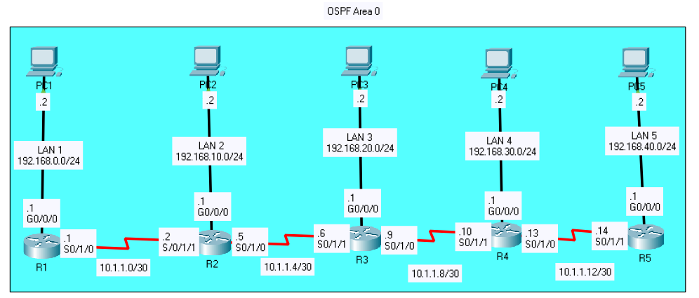

|  |  |  |  |
| --- | --- | --- | --- |
| Device | Interface | IP Address | Default Gateway |
| Router 1 | G 0/0/0 | **192.168.0.1**/24 | N/A |
| S 0/1/0 | **10.0.0.1**/30 |
| Router 2 | G 0/0/0 | **192.168.10.1**/24 | N/A |
| S 0/1/0 | **10.0.0.5**/30 |
| S 0/1/1 | **10.0.0.2**/30 |
| Router 3 | G 0/0/0 | **192.168.20.1**/24 | N/A |
| S 0/1/0 | **10.0.0.9**/30 |
| S 0/1/1 | **10.0.0.6**/30 |
| Router 4 | G 0/0/0 | **192.168.30.1**/24 | N/A |
| S 0/0/0 | **10.0.0.13**/30 |
| S 0/1/1 | **10.0.0.10**/30 |
| Router 5 | G 0/0/0 | **192.168.40.1**/24 | N/A |
| S 0/1/1 | **10.0.0.14**/30 |
| PC 1 | NIC | **192.168.0.2**/24 | 192.168.0.1 |
| PC 2 | NIC | **192.168.10.2**/24 | 192.168.10.1 |
| PC 3 | NIC | **192.168.20.2**/24 | 192.168.20.1 |
| PC 4 | NIC | **192.168.30.2**/24 | 192.168.30.1 |
| PC 5 | NIC | **192.168.40.2/**24 | 192.168.40.1 |

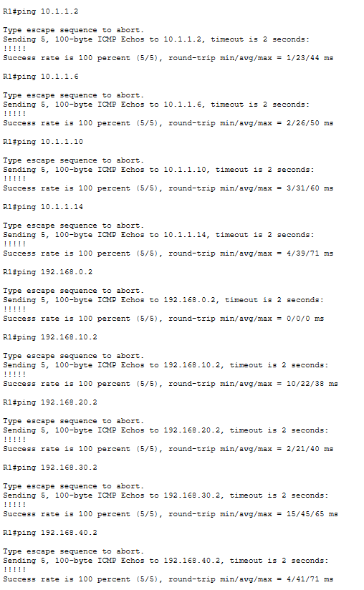

**Pings between all networks:**

**Router 1 Config:**

**show run:**

R1#show run

Building configuration...

Current configuration : 875 bytes

!

version 15.4

no service timestamps log datetime msec

no service timestamps debug datetime msec

no service password-encryption

!

hostname R1

!

!

no ip cef

no ipv6 cef

!

!

spanning-tree mode pvst

!

interface GigabitEthernet0/0/0

ip address 192.168.0.1 255.255.255.0

duplex auto

speed auto

!

interface GigabitEthernet0/0/1

no ip address

duplex auto

speed auto

shutdown

!

interface Serial0/1/0

ip address 10.1.1.1 255.255.255.252

!

interface Serial0/1/1

no ip address

clock rate 2000000

shutdown

!

interface Vlan1

no ip address

shutdown

!

router ospf 10

router-id 1.1.1.1

log-adjacency-changes

passive-interface GigabitEthernet0/0/0

network 10.1.1.0 0.0.0.3 area 0

network 192.168.0.0 0.0.0.255 area 0

!

ip classless

!

ip flow-export version 9

!

!

line con 0

!

line aux 0

!

line vty 0 4

login

!

!

end

**show ip route:**

R1#show ip route

Codes: L - local, C - connected, S - static, R - RIP, M - mobile, B - BGP

D - EIGRP, EX - EIGRP external, O - OSPF, IA - OSPF inter area

N1 - OSPF NSSA external type 1, N2 - OSPF NSSA external type 2

E1 - OSPF external type 1, E2 - OSPF external type 2, E - EGP

i - IS-IS, L1 - IS-IS level-1, L2 - IS-IS level-2, ia - IS-IS inter area

* - candidate default, U - per-user static route, o - ODR

P - periodic downloaded static route

Gateway of last resort is not set

10.0.0.0/8 is variably subnetted, 5 subnets, 2 masks

C 10.1.1.0/30 is directly connected, Serial0/1/0

L 10.1.1.1/32 is directly connected, Serial0/1/0

O 10.1.1.4/30 [110/128] via 10.1.1.2, 00:06:00, Serial0/1/0

O 10.1.1.8/30 [110/192] via 10.1.1.2, 00:06:00, Serial0/1/0

O 10.1.1.12/30 [110/256] via 10.1.1.2, 00:06:00, Serial0/1/0

192.168.0.0/24 is variably subnetted, 2 subnets, 2 masks

C 192.168.0.0/24 is directly connected, GigabitEthernet0/0/0

L 192.168.0.1/32 is directly connected, GigabitEthernet0/0/0

O 192.168.10.0/24 [110/65] via 10.1.1.2, 00:06:00, Serial0/1/0

O 192.168.20.0/24 [110/129] via 10.1.1.2, 00:06:00, Serial0/1/0

O 192.168.30.0/24 [110/193] via 10.1.1.2, 00:06:00, Serial0/1/0

O 192.168.40.0/24 [110/257] via 10.1.1.2, 00:06:00, Serial0/1/0

**show ip ospf interface:**

R1#show ip ospf interface

GigabitEthernet0/0/0 is up, line protocol is up

Internet address is 192.168.0.1/24, Area 0

Process ID 10, Router ID 1.1.1.1, Network Type BROADCAST, Cost: 1

Transmit Delay is 1 sec, State DR, Priority 1

Designated Router (ID) 1.1.1.1, Interface address 192.168.0.1

No backup designated router on this network

Timer intervals configured, Hello 10, Dead 40, Wait 40, Retransmit 5

No Hellos (Passive interface)

Index 1/1, flood queue length 0

Next 0x0(0)/0x0(0)

Last flood scan length is 1, maximum is 1

Last flood scan time is 0 msec, maximum is 0 msec

Neighbor Count is 0, Adjacent neighbor count is 0

Suppress hello for 0 neighbor(s)

Serial0/1/0 is up, line protocol is up

Internet address is 10.1.1.1/30, Area 0

Process ID 10, Router ID 1.1.1.1, Network Type POINT-TO-POINT, Cost: 64

Transmit Delay is 1 sec, State POINT-TO-POINT,

Timer intervals configured, Hello 10, Dead 40, Wait 40, Retransmit 5

Hello due in 00:00:00

Index 2/2, flood queue length 0

Next 0x0(0)/0x0(0)

Last flood scan length is 1, maximum is 1

Last flood scan time is 0 msec, maximum is 0 msec

Neighbor Count is 1 , Adjacent neighbor count is 1

Adjacent with neighbor 2.2.2.2

Suppress hello for 0 neighbor(s)

**show ip ospf neighbor:**

R1#show ip ospf neighbor

Neighbor ID Pri State Dead Time Address Interface

2.2.2.2 0 FULL/ - 00:00:36 10.1.1.2 Serial0/1/0

**Router 2 Config:**

**show run:**

R2#show run

Building configuration...

Current configuration : 922 bytes

!

version 15.4

no service timestamps log datetime msec

no service timestamps debug datetime msec

no service password-encryption

!

hostname R2

!

!

no ip cef

no ipv6 cef

!

!

spanning-tree mode pvst

!

!

interface GigabitEthernet0/0/0

ip address 192.168.10.1 255.255.255.0

duplex auto

speed auto

!

interface GigabitEthernet0/0/1

no ip address

duplex auto

speed auto

shutdown

!

interface Serial0/1/0

ip address 10.1.1.5 255.255.255.252

!

interface Serial0/1/1

ip address 10.1.1.2 255.255.255.252

clock rate 2000000

!

interface Vlan1

no ip address

shutdown

!

router ospf 10

router-id 2.2.2.2

log-adjacency-changes

passive-interface GigabitEthernet0/0/0

network 10.1.1.0 0.0.0.3 area 0

network 10.1.1.4 0.0.0.3 area 0

network 192.168.10.0 0.0.0.255 area 0

!

ip classless

!

ip flow-export version 9

!

!

line con 0

!

line aux 0

!

line vty 0 4

login

!

!

end

**show ip route:**

R2#show ip route

Codes: L - local, C - connected, S - static, R - RIP, M - mobile, B - BGP

D - EIGRP, EX - EIGRP external, O - OSPF, IA - OSPF inter area

N1 - OSPF NSSA external type 1, N2 - OSPF NSSA external type 2

E1 - OSPF external type 1, E2 - OSPF external type 2, E - EGP

i - IS-IS, L1 - IS-IS level-1, L2 - IS-IS level-2, ia - IS-IS inter area

* - candidate default, U - per-user static route, o - ODR

P - periodic downloaded static route

Gateway of last resort is not set

10.0.0.0/8 is variably subnetted, 6 subnets, 2 masks

C 10.1.1.0/30 is directly connected, Serial0/1/1

L 10.1.1.2/32 is directly connected, Serial0/1/1

C 10.1.1.4/30 is directly connected, Serial0/1/0

L 10.1.1.5/32 is directly connected, Serial0/1/0

O 10.1.1.8/30 [110/128] via 10.1.1.6, 00:11:15, Serial0/1/0

O 10.1.1.12/30 [110/192] via 10.1.1.6, 00:11:15, Serial0/1/0

O 192.168.0.0/24 [110/65] via 10.1.1.1, 00:11:15, Serial0/1/1

192.168.10.0/24 is variably subnetted, 2 subnets, 2 masks

C 192.168.10.0/24 is directly connected, GigabitEthernet0/0/0

L 192.168.10.1/32 is directly connected, GigabitEthernet0/0/0

O 192.168.20.0/24 [110/65] via 10.1.1.6, 00:11:15, Serial0/1/0

O 192.168.30.0/24 [110/129] via 10.1.1.6, 00:11:15, Serial0/1/0

O 192.168.40.0/24 [110/193] via 10.1.1.6, 00:11:15, Serial0/1/0

**show ip ospf interface**

R2#show ip ospf interface

GigabitEthernet0/0/0 is up, line protocol is up

Internet address is 192.168.10.1/24, Area 0

Process ID 10, Router ID 2.2.2.2, Network Type BROADCAST, Cost: 1

Transmit Delay is 1 sec, State DR, Priority 1

Designated Router (ID) 2.2.2.2, Interface address 192.168.10.1

No backup designated router on this network

Timer intervals configured, Hello 10, Dead 40, Wait 40, Retransmit 5

No Hellos (Passive interface)

Index 1/1, flood queue length 0

Next 0x0(0)/0x0(0)

Last flood scan length is 1, maximum is 1

Last flood scan time is 0 msec, maximum is 0 msec

Neighbor Count is 0, Adjacent neighbor count is 0

Suppress hello for 0 neighbor(s)

Serial0/1/0 is up, line protocol is up

Internet address is 10.1.1.5/30, Area 0

Process ID 10, Router ID 2.2.2.2, Network Type POINT-TO-POINT, Cost: 64

Transmit Delay is 1 sec, State POINT-TO-POINT,

Timer intervals configured, Hello 10, Dead 40, Wait 40, Retransmit 5

Hello due in 00:00:08

Index 2/2, flood queue length 0

Next 0x0(0)/0x0(0)

Last flood scan length is 1, maximum is 1

Last flood scan time is 0 msec, maximum is 0 msec

Neighbor Count is 1 , Adjacent neighbor count is 1

Adjacent with neighbor 3.3.3.3

Suppress hello for 0 neighbor(s)

Serial0/1/1 is up, line protocol is up

Internet address is 10.1.1.2/30, Area 0

Process ID 10, Router ID 2.2.2.2, Network Type POINT-TO-POINT, Cost: 64

Transmit Delay is 1 sec, State POINT-TO-POINT,

Timer intervals configured, Hello 10, Dead 40, Wait 40, Retransmit 5

Hello due in 00:00:09

Index 3/3, flood queue length 0

Next 0x0(0)/0x0(0)

Last flood scan length is 1, maximum is 1

Last flood scan time is 0 msec, maximum is 0 msec

Neighbor Count is 1 , Adjacent neighbor count is 1

Adjacent with neighbor 1.1.1.1

Suppress hello for 0 neighbor(s)

**show ip ospf neighbor**

R2#show ip ospf neighbor

Neighbor ID Pri State Dead Time Address Interface

3.3.3.3 0 FULL/ - 00:00:31 10.1.1.6 Serial0/1/0

1.1.1.1 0 FULL/ - 00:00:31 10.1.1.1 Serial0/1/1

**Router 3:**

**show run:**

R3#show run

Building configuration...

Current configuration : 922 bytes

!

version 15.4

no service timestamps log datetime msec

no service timestamps debug datetime msec

no service password-encryption

!

hostname R3

!

!

no ip cef

no ipv6 cef

!

!

spanning-tree mode pvst

!

!

interface GigabitEthernet0/0/0

ip address 192.168.20.1 255.255.255.0

duplex auto

speed auto

!

interface GigabitEthernet0/0/1

no ip address

duplex auto

speed auto

shutdown

!

interface Serial0/1/0

ip address 10.1.1.9 255.255.255.252

!

interface Serial0/1/1

ip address 10.1.1.6 255.255.255.252

clock rate 2000000

!

interface Vlan1

no ip address

shutdown

!

router ospf 10

router-id 3.3.3.3

log-adjacency-changes

passive-interface GigabitEthernet0/0/0

network 10.1.1.4 0.0.0.3 area 0

network 10.1.1.8 0.0.0.3 area 0

network 192.168.20.0 0.0.0.255 area 0

!

ip classless

!

ip flow-export version 9

!

!

line con 0

!

line aux 0

!

line vty 0 4

login

!

!

end

**show ip route:**

R3#show ip route

Codes: L - local, C - connected, S - static, R - RIP, M - mobile, B - BGP

D - EIGRP, EX - EIGRP external, O - OSPF, IA - OSPF inter area

N1 - OSPF NSSA external type 1, N2 - OSPF NSSA external type 2

E1 - OSPF external type 1, E2 - OSPF external type 2, E - EGP

i - IS-IS, L1 - IS-IS level-1, L2 - IS-IS level-2, ia - IS-IS inter area

* - candidate default, U - per-user static route, o - ODR

P - periodic downloaded static route

Gateway of last resort is not set

10.0.0.0/8 is variably subnetted, 6 subnets, 2 masks

O 10.1.1.0/30 [110/128] via 10.1.1.5, 00:16:52, Serial0/1/1

C 10.1.1.4/30 is directly connected, Serial0/1/1

L 10.1.1.6/32 is directly connected, Serial0/1/1

C 10.1.1.8/30 is directly connected, Serial0/1/0

L 10.1.1.9/32 is directly connected, Serial0/1/0

O 10.1.1.12/30 [110/128] via 10.1.1.10, 00:16:52, Serial0/1/0

O 192.168.0.0/24 [110/129] via 10.1.1.5, 00:16:42, Serial0/1/1

O 192.168.10.0/24 [110/65] via 10.1.1.5, 00:16:52, Serial0/1/1

192.168.20.0/24 is variably subnetted, 2 subnets, 2 masks

C 192.168.20.0/24 is directly connected, GigabitEthernet0/0/0

L 192.168.20.1/32 is directly connected, GigabitEthernet0/0/0

O 192.168.30.0/24 [110/65] via 10.1.1.10, 00:16:52, Serial0/1/0

O 192.168.40.0/24 [110/129] via 10.1.1.10, 00:16:42, Serial0/1/0

**show ip ospf interface**

R3#show ip ospf interface

GigabitEthernet0/0/0 is up, line protocol is up

Internet address is 192.168.20.1/24, Area 0

Process ID 10, Router ID 3.3.3.3, Network Type BROADCAST, Cost: 1

Transmit Delay is 1 sec, State DR, Priority 1

Designated Router (ID) 3.3.3.3, Interface address 192.168.20.1

No backup designated router on this network

Timer intervals configured, Hello 10, Dead 40, Wait 40, Retransmit 5

No Hellos (Passive interface)

Index 1/1, flood queue length 0

Next 0x0(0)/0x0(0)

Last flood scan length is 1, maximum is 1

Last flood scan time is 0 msec, maximum is 0 msec

Neighbor Count is 0, Adjacent neighbor count is 0

Suppress hello for 0 neighbor(s)

Serial0/1/1 is up, line protocol is up

Internet address is 10.1.1.6/30, Area 0

Process ID 10, Router ID 3.3.3.3, Network Type POINT-TO-POINT, Cost: 64

Transmit Delay is 1 sec, State POINT-TO-POINT,

Timer intervals configured, Hello 10, Dead 40, Wait 40, Retransmit 5

Hello due in 00:00:06

Index 2/2, flood queue length 0

Next 0x0(0)/0x0(0)

Last flood scan length is 1, maximum is 1

Last flood scan time is 0 msec, maximum is 0 msec

Neighbor Count is 1 , Adjacent neighbor count is 1

Adjacent with neighbor 2.2.2.2

Suppress hello for 0 neighbor(s)

Serial0/1/0 is up, line protocol is up

Internet address is 10.1.1.9/30, Area 0

Process ID 10, Router ID 3.3.3.3, Network Type POINT-TO-POINT, Cost: 64

Transmit Delay is 1 sec, State POINT-TO-POINT,

Timer intervals configured, Hello 10, Dead 40, Wait 40, Retransmit 5

Hello due in 00:00:06

Index 3/3, flood queue length 0

Next 0x0(0)/0x0(0)

Last flood scan length is 1, maximum is 1

Last flood scan time is 0 msec, maximum is 0 msec

Neighbor Count is 1 , Adjacent neighbor count is 1

Adjacent with neighbor 4.4.4.4

Suppress hello for 0 neighbor(s)

show ip ospf neighbor

R3#show ip ospf neighbor

Neighbor ID Pri State Dead Time Address Interface

4.4.4.4 0 FULL/ - 00:00:31 10.1.1.10 Serial0/1/0

2.2.2.2 0 FULL/ - 00:00:32 10.1.1.5 Serial0/1/1

**Router 4 Config:**

**show run:**

R4#show run

Building configuration...

Current configuration : 925 bytes

!

version 15.4

no service timestamps log datetime msec

no service timestamps debug datetime msec

no service password-encryption

!

hostname R4

!

!

no ip cef

no ipv6 cef

!

!

spanning-tree mode pvst

!

!

interface GigabitEthernet0/0/0

ip address 192.168.30.1 255.255.255.0

duplex auto

speed auto

!

interface GigabitEthernet0/0/1

no ip address

duplex auto

speed auto

shutdown

!

interface Serial0/1/0

ip address 10.1.1.13 255.255.255.252

!

interface Serial0/1/1

ip address 10.1.1.10 255.255.255.252

clock rate 2000000

!

interface Vlan1

no ip address

shutdown

!

router ospf 10

router-id 4.4.4.4

log-adjacency-changes

passive-interface GigabitEthernet0/0/0

network 10.1.1.12 0.0.0.3 area 0

network 10.1.1.8 0.0.0.3 area 0

network 192.168.30.0 0.0.0.255 area 0

!

ip classless

!

ip flow-export version 9

!

!

line con 0

!

line aux 0

!

line vty 0 4

login

!

!

end

**show ip route:**

R4#show ip route

Codes: L - local, C - connected, S - static, R - RIP, M - mobile, B - BGP

D - EIGRP, EX - EIGRP external, O - OSPF, IA - OSPF inter area

N1 - OSPF NSSA external type 1, N2 - OSPF NSSA external type 2

E1 - OSPF external type 1, E2 - OSPF external type 2, E - EGP

i - IS-IS, L1 - IS-IS level-1, L2 - IS-IS level-2, ia - IS-IS inter area

* - candidate default, U - per-user static route, o - ODR

P - periodic downloaded static route

Gateway of last resort is not set

10.0.0.0/8 is variably subnetted, 6 subnets, 2 masks

O 10.1.1.0/30 [110/192] via 10.1.1.9, 00:20:49, Serial0/1/1

O 10.1.1.4/30 [110/128] via 10.1.1.9, 00:20:59, Serial0/1/1

C 10.1.1.8/30 is directly connected, Serial0/1/1

L 10.1.1.10/32 is directly connected, Serial0/1/1

C 10.1.1.12/30 is directly connected, Serial0/1/0

L 10.1.1.13/32 is directly connected, Serial0/1/0

O 192.168.0.0/24 [110/193] via 10.1.1.9, 00:20:49, Serial0/1/1

O 192.168.10.0/24 [110/129] via 10.1.1.9, 00:20:49, Serial0/1/1

O 192.168.20.0/24 [110/65] via 10.1.1.9, 00:20:59, Serial0/1/1

192.168.30.0/24 is variably subnetted, 2 subnets, 2 masks

C 192.168.30.0/24 is directly connected, GigabitEthernet0/0/0

L 192.168.30.1/32 is directly connected, GigabitEthernet0/0/0

O 192.168.40.0/24 [110/65] via 10.1.1.14, 00:20:59, Serial0/1/0

**show ip ospf interface:**

R4#show ip ospf interface

GigabitEthernet0/0/0 is up, line protocol is up

Internet address is 192.168.30.1/24, Area 0

Process ID 10, Router ID 4.4.4.4, Network Type BROADCAST, Cost: 1

Transmit Delay is 1 sec, State DR, Priority 1

Designated Router (ID) 4.4.4.4, Interface address 192.168.30.1

No backup designated router on this network

Timer intervals configured, Hello 10, Dead 40, Wait 40, Retransmit 5

No Hellos (Passive interface)

Index 1/1, flood queue length 0

Next 0x0(0)/0x0(0)

Last flood scan length is 1, maximum is 1

Last flood scan time is 0 msec, maximum is 0 msec

Neighbor Count is 0, Adjacent neighbor count is 0

Suppress hello for 0 neighbor(s)

Serial0/1/1 is up, line protocol is up

Internet address is 10.1.1.10/30, Area 0

Process ID 10, Router ID 4.4.4.4, Network Type POINT-TO-POINT, Cost: 64

Transmit Delay is 1 sec, State POINT-TO-POINT,

Timer intervals configured, Hello 10, Dead 40, Wait 40, Retransmit 5

Hello due in 00:00:01

Index 2/2, flood queue length 0

Next 0x0(0)/0x0(0)

Last flood scan length is 1, maximum is 1

Last flood scan time is 0 msec, maximum is 0 msec

Neighbor Count is 1 , Adjacent neighbor count is 1

Adjacent with neighbor 3.3.3.3

Suppress hello for 0 neighbor(s)

Serial0/1/0 is up, line protocol is up

Internet address is 10.1.1.13/30, Area 0

Process ID 10, Router ID 4.4.4.4, Network Type POINT-TO-POINT, Cost: 64

Transmit Delay is 1 sec, State POINT-TO-POINT,

Timer intervals configured, Hello 10, Dead 40, Wait 40, Retransmit 5

Hello due in 00:00:05

Index 3/3, flood queue length 0

Next 0x0(0)/0x0(0)

Last flood scan length is 1, maximum is 1

Last flood scan time is 0 msec, maximum is 0 msec

Neighbor Count is 1 , Adjacent neighbor count is 1

Adjacent with neighbor 5.5.5.5

Suppress hello for 0 neighbor(s)

**show ip ospf neighbor:**

R4#show ip ospf neighbor

Neighbor ID Pri State Dead Time Address Interface

5.5.5.5 0 FULL/ - 00:00:33 10.1.1.14 Serial0/1/0

3.3.3.3 0 FULL/ - 00:00:33 10.1.1.9 Serial0/1/1

**Router 5 Config:**

**show run:**

R5#show run

Building configuration...

Current configuration : 921 bytes

!

version 15.4

no service timestamps log datetime msec

no service timestamps debug datetime msec

no service password-encryption

!

hostname R5

!

!

no ip cef

no ipv6 cef

!

!

spanning-tree mode pvst

!

!

interface GigabitEthernet0/0/0

ip address 192.168.40.1 255.255.255.0

duplex auto

speed auto

!

interface GigabitEthernet0/0/1

no ip address

duplex auto

speed auto

shutdown

!

interface Serial0/1/0

no ip address

ip ospf priority 255

clock rate 2000000

shutdown

!

interface Serial0/1/1

ip address 10.1.1.14 255.255.255.252

clock rate 2000000

!

interface Vlan1

no ip address

shutdown

!

router ospf 10

router-id 5.5.5.5

log-adjacency-changes

passive-interface GigabitEthernet0/0/0

network 10.1.1.12 0.0.0.3 area 0

network 192.168.40.0 0.0.0.255 area 0

!

ip classless

!

ip flow-export version 9

!

!

line con 0

!

line aux 0

!

line vty 0 4

login

!

!

end

**show ip route:**

R5#show ip route

Codes: L - local, C - connected, S - static, R - RIP, M - mobile, B - BGP

D - EIGRP, EX - EIGRP external, O - OSPF, IA - OSPF inter area

N1 - OSPF NSSA external type 1, N2 - OSPF NSSA external type 2

E1 - OSPF external type 1, E2 - OSPF external type 2, E - EGP

i - IS-IS, L1 - IS-IS level-1, L2 - IS-IS level-2, ia - IS-IS inter area

* - candidate default, U - per-user static route, o - ODR

P - periodic downloaded static route

Gateway of last resort is not set

10.0.0.0/8 is variably subnetted, 5 subnets, 2 masks

O 10.1.1.0/30 [110/256] via 10.1.1.13, 00:24:30, Serial0/1/1

O 10.1.1.4/30 [110/192] via 10.1.1.13, 00:24:30, Serial0/1/1

O 10.1.1.8/30 [110/128] via 10.1.1.13, 00:24:40, Serial0/1/1

C 10.1.1.12/30 is directly connected, Serial0/1/1

L 10.1.1.14/32 is directly connected, Serial0/1/1

O 192.168.0.0/24 [110/257] via 10.1.1.13, 00:24:30, Serial0/1/1

O 192.168.10.0/24 [110/193] via 10.1.1.13, 00:24:30, Serial0/1/1

O 192.168.20.0/24 [110/129] via 10.1.1.13, 00:24:30, Serial0/1/1

O 192.168.30.0/24 [110/65] via 10.1.1.13, 00:24:40, Serial0/1/1

192.168.40.0/24 is variably subnetted, 2 subnets, 2 masks

C 192.168.40.0/24 is directly connected, GigabitEthernet0/0/0

L 192.168.40.1/32 is directly connected, GigabitEthernet0/0/0

**show ip ospf interface:**

R5#show ip ospf interface

GigabitEthernet0/0/0 is up, line protocol is up

Internet address is 192.168.40.1/24, Area 0

Process ID 10, Router ID 5.5.5.5, Network Type BROADCAST, Cost: 1

Transmit Delay is 1 sec, State DR, Priority 1

Designated Router (ID) 5.5.5.5, Interface address 192.168.40.1

No backup designated router on this network

Timer intervals configured, Hello 10, Dead 40, Wait 40, Retransmit 5

No Hellos (Passive interface)

Index 1/1, flood queue length 0

Next 0x0(0)/0x0(0)

Last flood scan length is 1, maximum is 1

Last flood scan time is 0 msec, maximum is 0 msec

Neighbor Count is 0, Adjacent neighbor count is 0

Suppress hello for 0 neighbor(s)

Serial0/1/1 is up, line protocol is up

Internet address is 10.1.1.14/30, Area 0

Process ID 10, Router ID 5.5.5.5, Network Type POINT-TO-POINT, Cost: 64

Transmit Delay is 1 sec, State POINT-TO-POINT,

Timer intervals configured, Hello 10, Dead 40, Wait 40, Retransmit 5

Hello due in 00:00:07

Index 2/2, flood queue length 0

Next 0x0(0)/0x0(0)

Last flood scan length is 1, maximum is 1

Last flood scan time is 0 msec, maximum is 0 msec

Neighbor Count is 1 , Adjacent neighbor count is 1

Adjacent with neighbor 4.4.4.4

Suppress hello for 0 neighbor(s)e

**show ip ospf neighbor:**

R5#show ip ospf neighbor

Neighbor ID Pri State Dead Time Address Interface

4.4.4.4 0 FULL/ - 00:00:37 10.1.1.13 Serial0/1/1

**Problems and Troubleshooting:**

I encountered two problems when completing this lab. First, after configuring OSPFv2 on routers 1-4, I noticed 4 and 5 were not showing a neighbor adjacency. I issued a show ip ospf command and there was no adjacency there either. I then checked the interface states through the show ip interface brief command I noticed that S0/1/1 was in the down. State. This indicated to me that this was a Layer 1 problem, and I checked the cabling. Sure enough, one of the cables was pinched and did not work. After replacing it the interface came online and I was able to continue setting up OSPF. Another problem I encountered was one of the LAN networks not showing up when I did the show ip route command on R5. LAN 4 (192.168.40.0) did not have a route to it so I performed a show ip route on R4. I noticed that instead of the 192.168.30.0 network route, it had the route of 192.168.39.0. I checked the interface and saw that I had incorrectly entered the ip address. After correcting the mistake and after waiting for the exchange of link state updates, the 192.168.30.0 network was once again in the routing table of neighboring routers.

**Conclusion**

OSPF is a very useful routing protocol especially in large and complicated networks. Single area networks can be very efficient in distributing routes. I learned a lot about how to set up OSPFv2, how it works and what its advantages and disadvantages are. However, there is still a lot of unnecessary traffic and OSPF messages taking up bandwidth on links. In our next lab, we will go more in depth into OSPFv3 and multiarea networks, passive interfaces, hello/dead timers and designated routers.

CCNP ROUTING AND SWITCHING



AWS EBS

Instance

B Brennen Tse . 5/27/2022

##### AWS EBS INSTANCE

Go Back

Task 1: Create a New EBS Volume

1. In the **AWS Management Console** on the top left of the screen, click the **Services** menu then **EC2**.
2. Choose **Instances** in the left navigation pane. (You should see a Lab Instance already launched)
3. Choose **Volumes** in the left navigation pane.
4. Choose Create Volume then configure:
5. 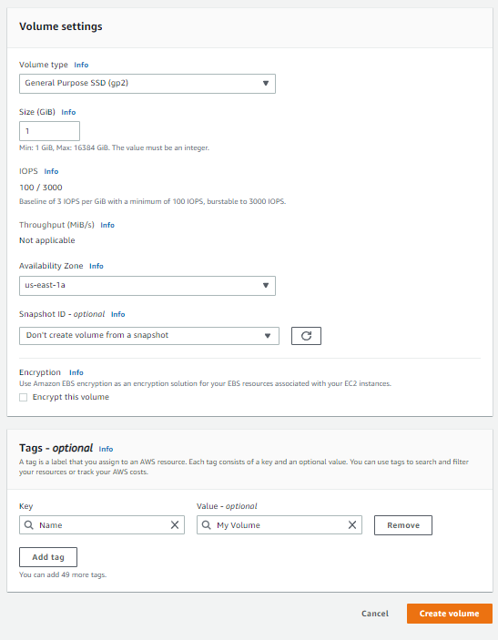

Task 2: Attach the Volume to an Instance

1. Select **My Volume**
2. In the **Actions** menu, choose **Attach volume**
3. Choose the **Instance** field, then select the Lab instance that appears
4. 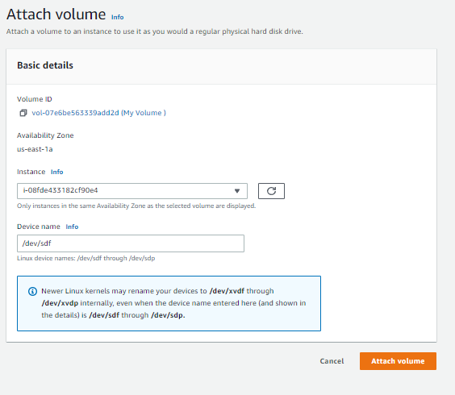

Task 3: Connect to Your Amazon EC2 Instance

Read through the three bullet points in this step before you start to complete the actions, because you will not be able see these instructions when the Details panel is open.

* Choose the Details drop down menu above these instructions you are currently reading, and then choose Show. A Credentials window will open.
* Choose the **Download PPK** button and save the **labsuser.ppk** file. Typically your browser will save it to the Downloads directory.
* Then exit the Details panel by choosing the **X**.

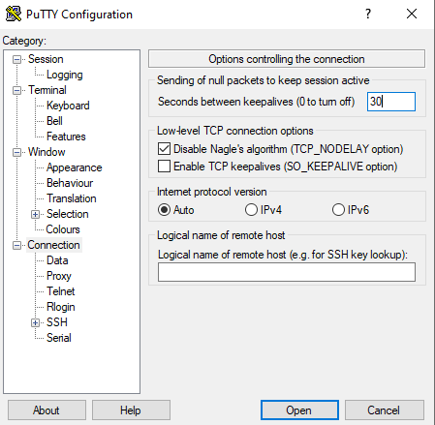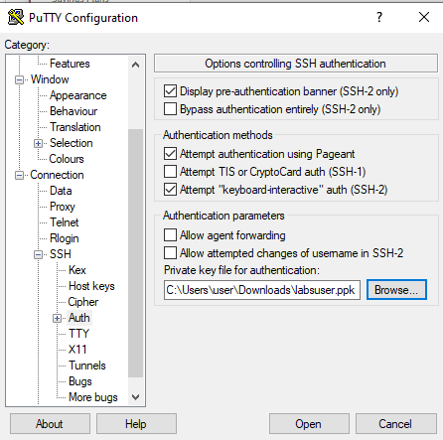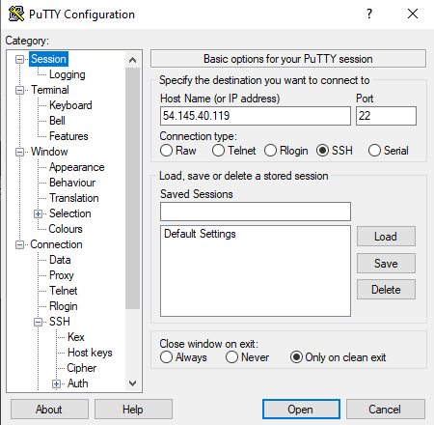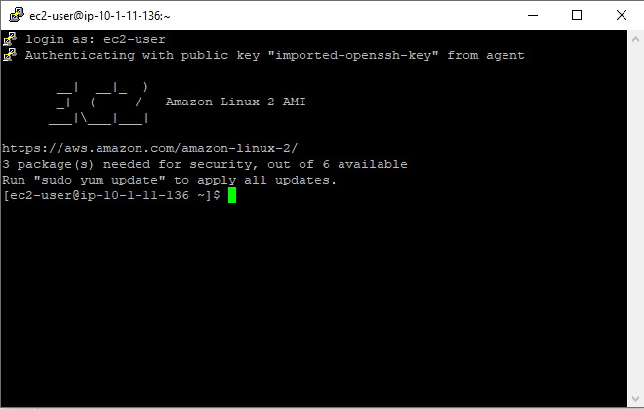

Task 4: Create and Configure Your File System

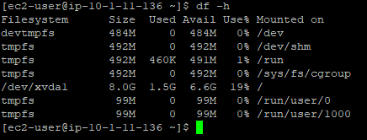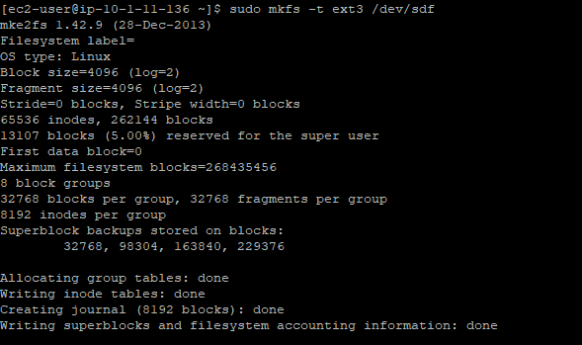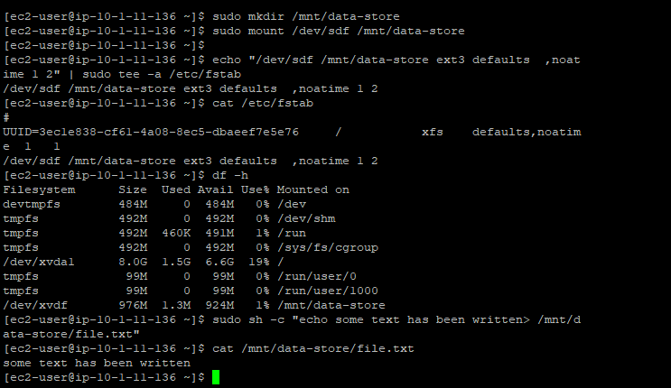

Task 5: Create an Amazon EBS Snapshot

1. In the AWS Management Console, choose Volumes and select My Volume
2. In the Actions menu, select Create snapshot
3. Choose Add tag then

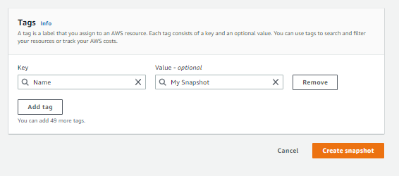

1. Left navigation pane choose Snapshots
2. 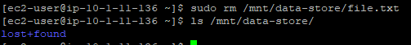

Task 6: Restore the Amazon EBS Snapshot

Create a Volume Using Your Snapshot

1. Select My Snapshot from the AWS Management Console
2. Select Create volume from snapshot in the Actions menu
3. Select Availability Zone
4. 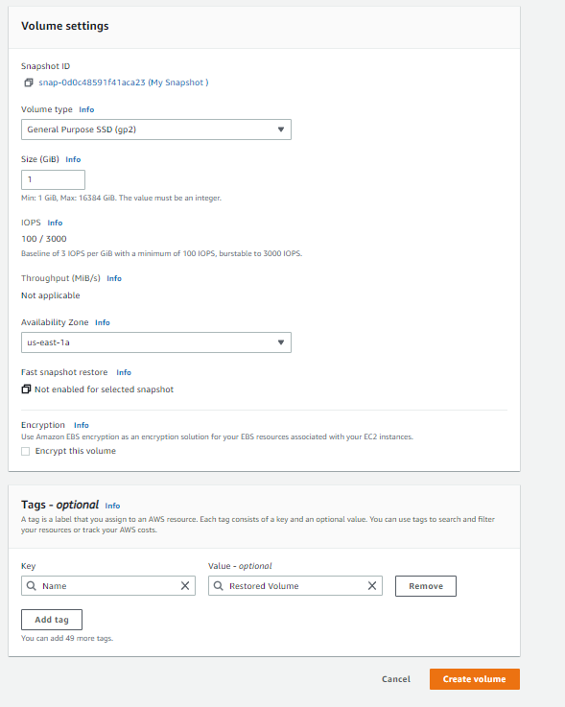
5. Choose Volumes from the left navigation pane
6. Select restored volume
7. 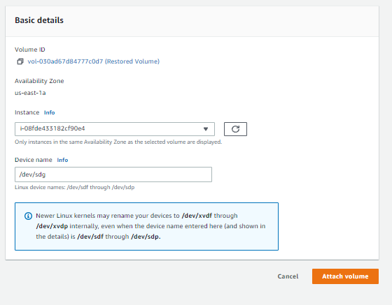

CCNP ROUTING AND SWITCHING



AWS EC2

Instance

B Brennen Tse . 2/21/2022

##### AWS EC2 Instance

Go Back

Task 1: Launch Your Amazon EC2 Instance

1. Choose EC2 from the AWS Management Console on the Services menu
2. Launch Instance from the Instance button in the top left
3. Choose the Amazon Linux 2 AMI and Select it.
4. Choose a t2.micro instance and choose next: configure instance details in the bottom right
5. Select Lab VPC and protect against accidental termination

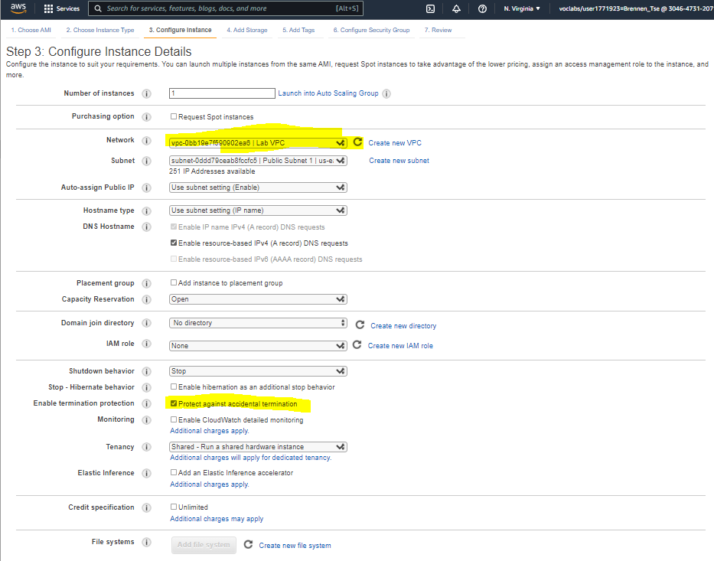

1. Expand advance details on the bottom and paste the command into the user data field:

#!/bin/bash

yum -y install httpd

systemctl enable httpd

systemctl start httpd

echo '<html><h1>Hello From Your Web Server!</h1></html>' > /var/www/html/index.html

This command installs a web server, configures it, activates and creates a web page.

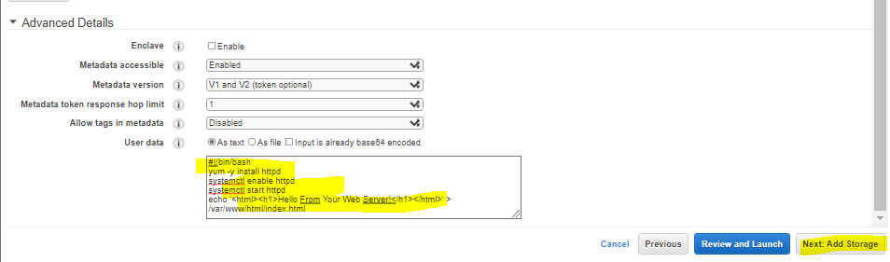

1. You do not have to worry about adding storage, choose next: add tags
2. Select Add Tag and configure a key of Name and Value of Web Server, then click next.

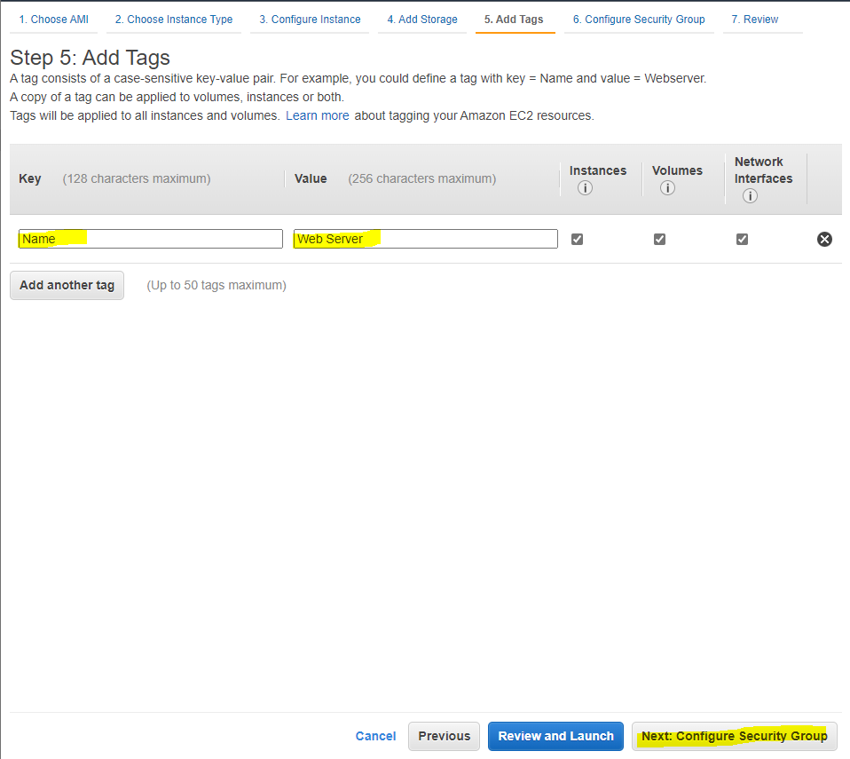

1. Configure the security group with a name of Web Server security group and a description of Security group for my web server. Remove SSH access for security. Then click review and launch

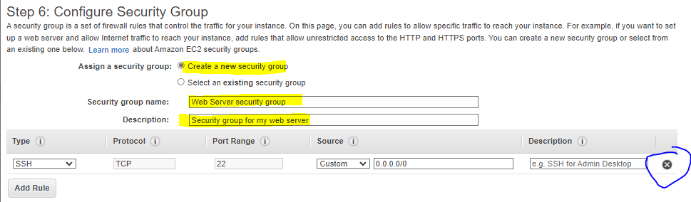

1. Select Launch, choose proceed without a key pair. Click the necessary popups and launch the instance, then view it.

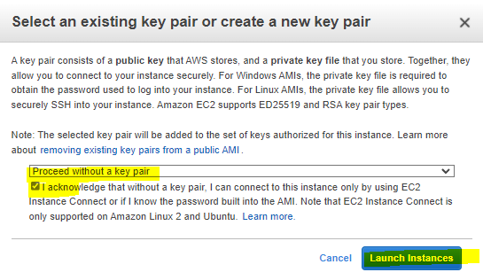

1. The instance will initially be pending but once the state changes to running, you know the EC2 instance is working.

Task 2: Monitor Your Instance

1. Choose the Status Checks Tab by clicking on the instance and selecting the 5th tab that appears, then the 6th Monitoring tab then in the actions menu select Monitor and troubleshoot, retrieve the system log. 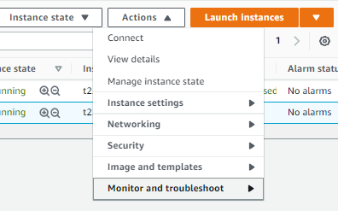
2. Look at the output and choose cancel

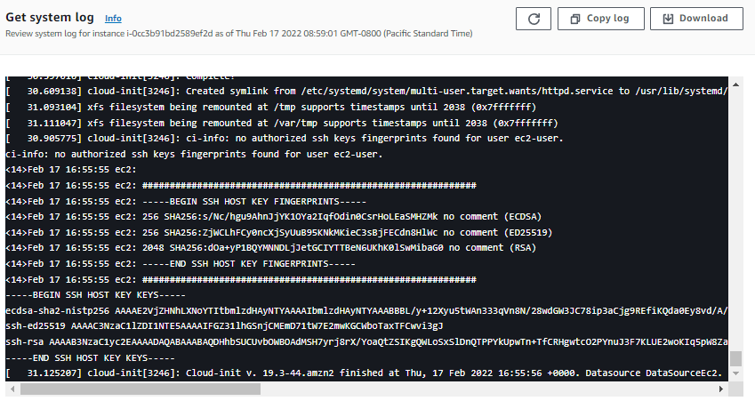

1. In the Actions menu select Monitor and troubleshoot then get a screenshot. Then click cancel.

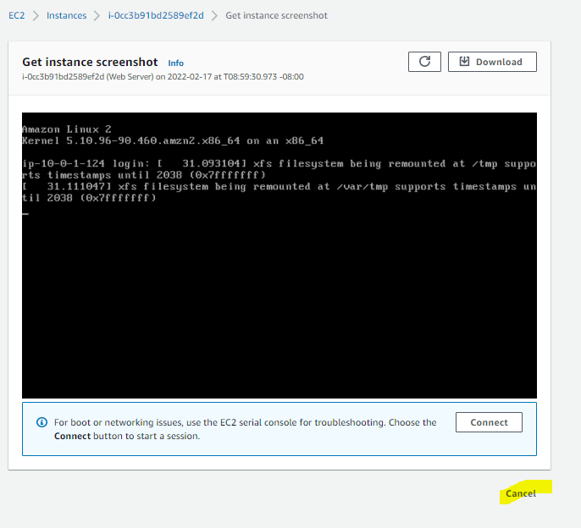

Task 3: Update Your Security Group and Access the Web Server

1. Choose the Details tab after clicking the instance
2. Copy the IPV4 Public IP of the instance
3. Open a new tab and paste the ip address
4. You won’t be able to access the web server so return to the EC2 Management Console.
5. On the left, choose security groups
6. Choose Inbound rules, edit inbound rules and configure:

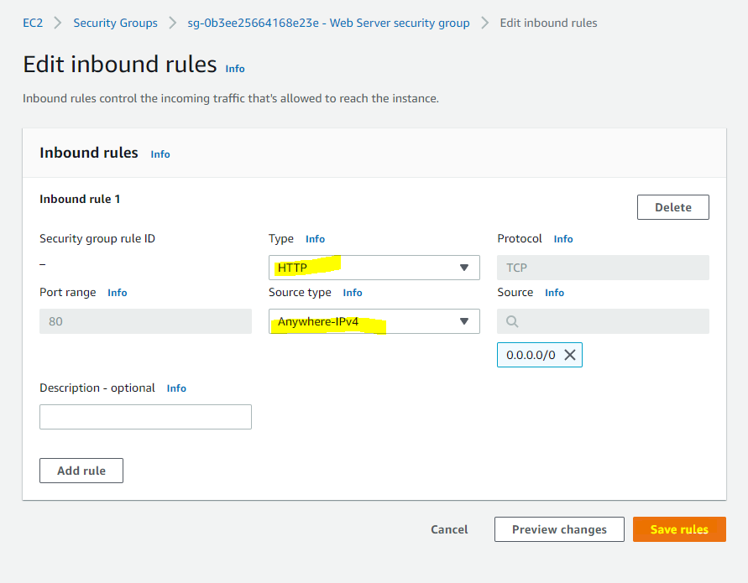

1. The webpage should now display: 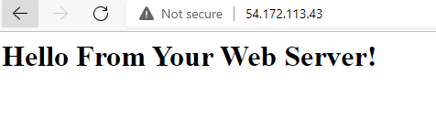

Task 4: Resize Your Instance: Instance Type and EBS Volume

1. Stop the instance to resize it. Select Instances from the left and in the Instance State menu Stop instance.

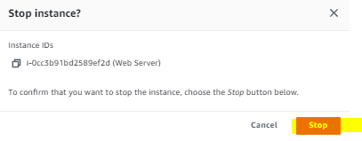

1. Change the instance type by going to the actions menu, selecting instance settings, changing the type, then configuring: 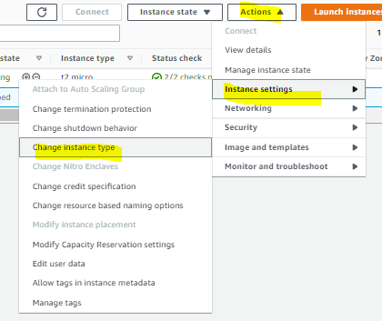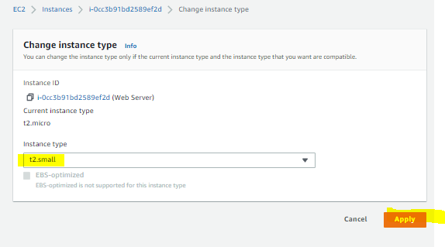
2. Resize the volume from the left volumes tab.

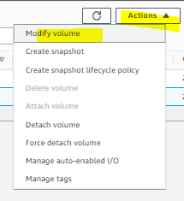

1. Change disk volume to 10 GiB and choose modify and yes.

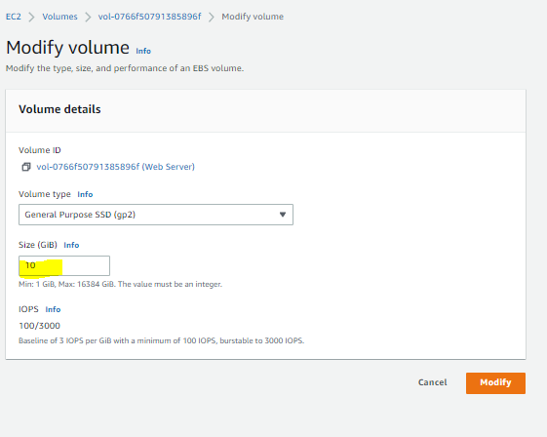

1. Restart the Instance by clicking on Instances, Start Instance from the instance menu and start.

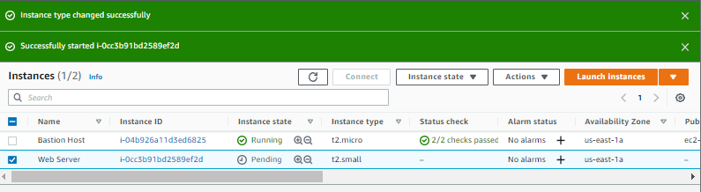

Task 5: Explore EC2 Limits

1. Choose limits from the left and select running instances from the drop down list.

Task 6: Test Termination Protection

1. DO this by selecting Instances again, and from the instance state menu try to terminate the instance. It should fail and give this message: 
2. In the actions menu select instance setting and turn off termination protection, save it and try to terminate it again, it should work this time.

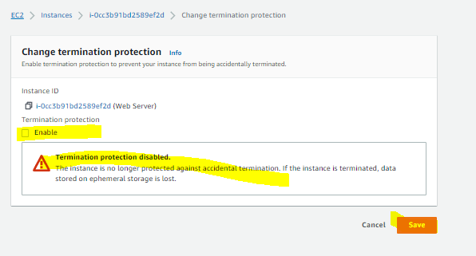

CCNP ROUTING AND SWITCHING



AWS Load Balancing

B Brennen Tse . 3/1/2022

##### AWS Load Balancing

Go Back

Creating an AMI for Web Server 1

Navigate to E2 in the services menu

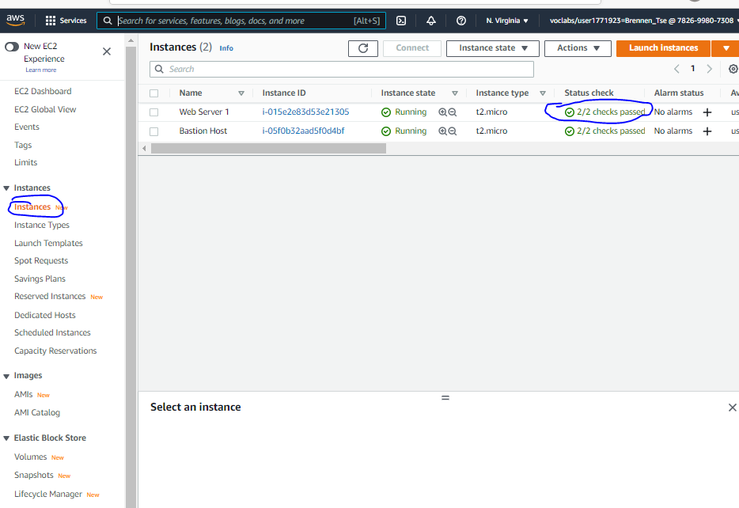

Confirm instance is running by clicking Instances in the left navigation pane, and checking that the 2/2 checks passed is seen in the status check area.

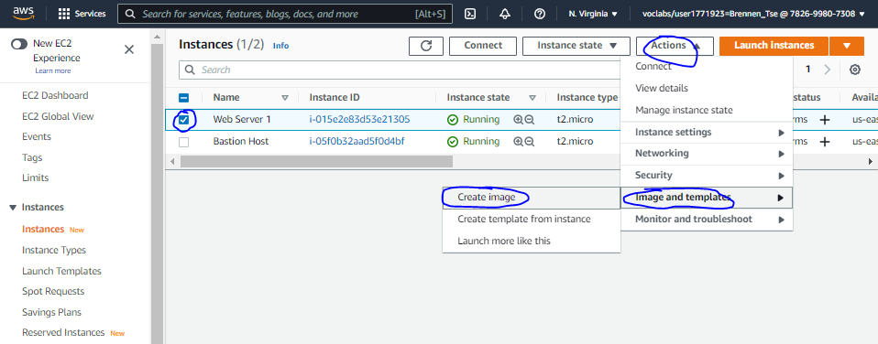1, check the box for webserver, then in the actions dropdown menu, select image and templates and create an image.

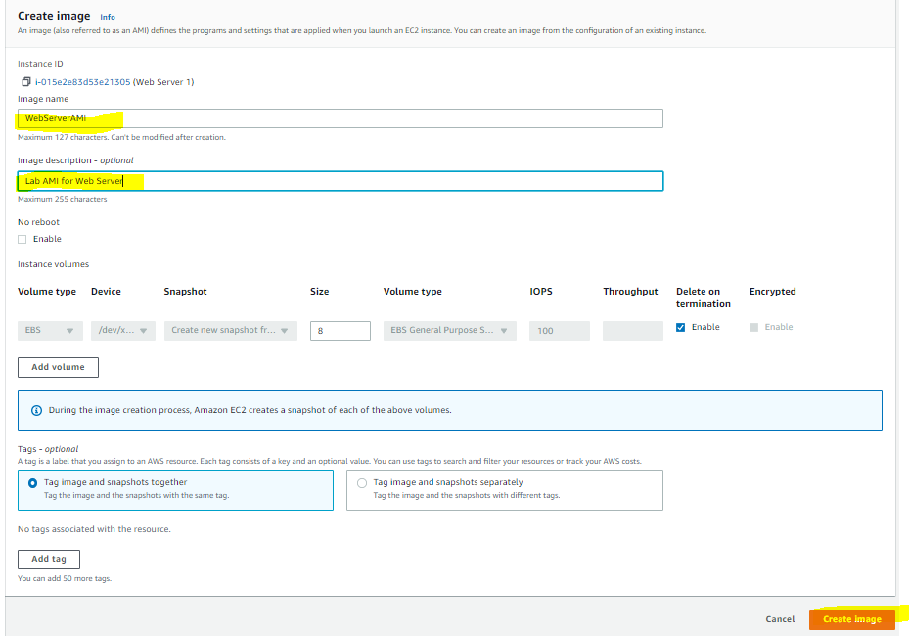

Name the image WebServerAMI, describe it as LAB AMI for webserver and create image.

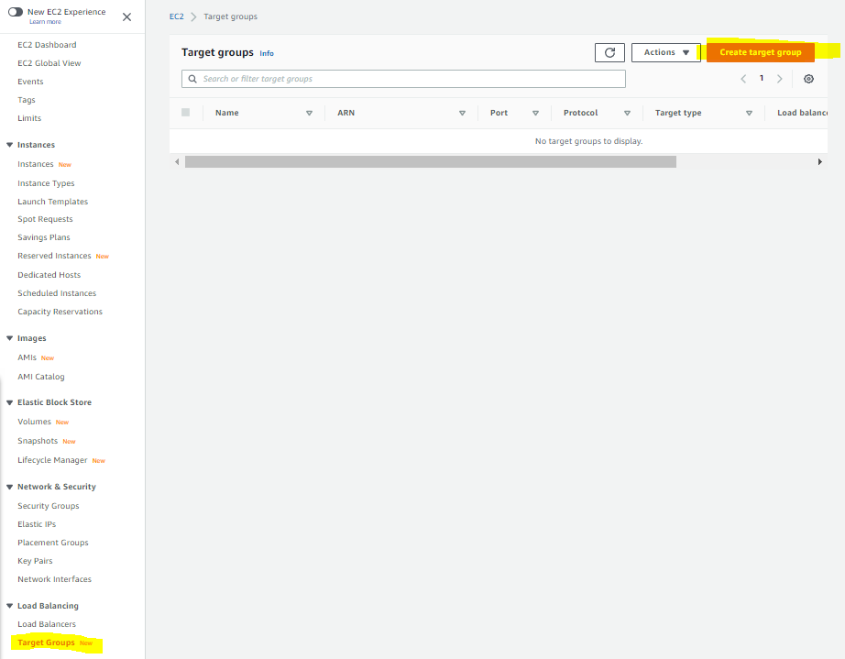

Select Target Groups  and Create a target group

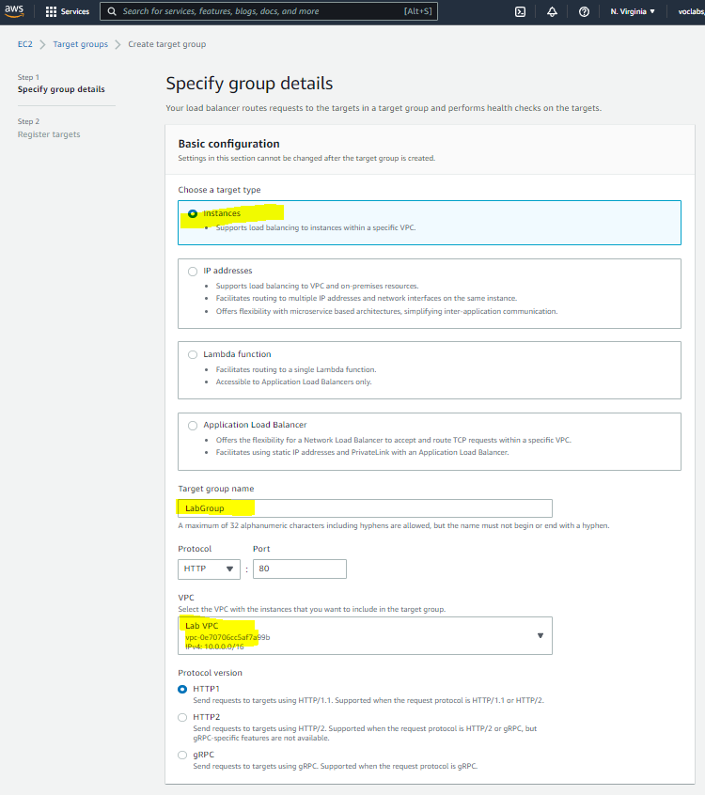 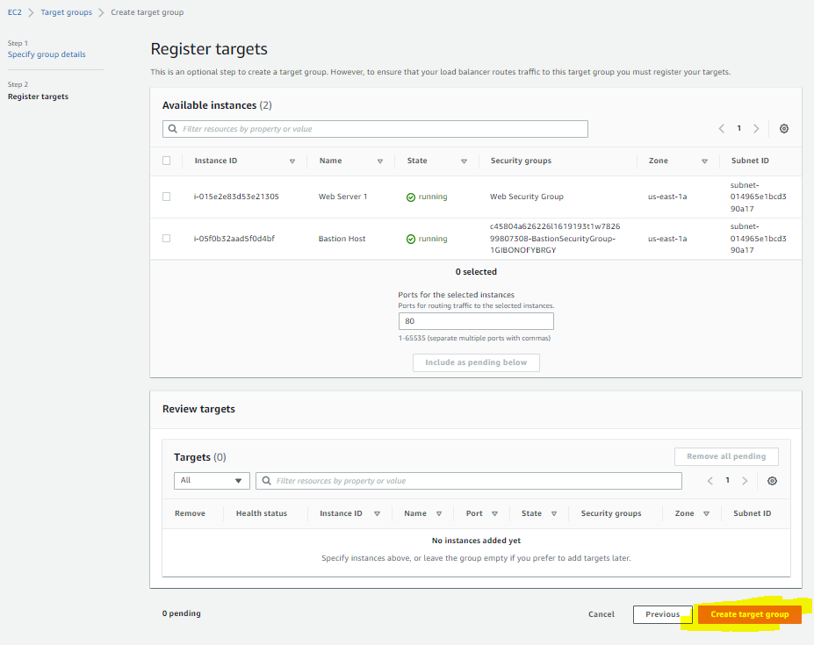

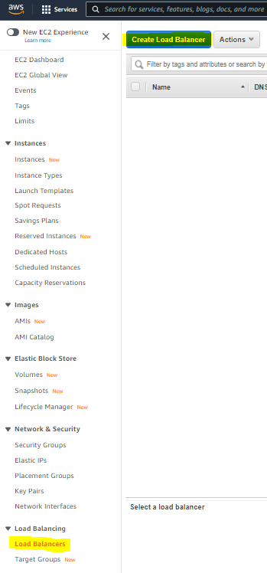

Select Load Balancer and Create Load Balancer

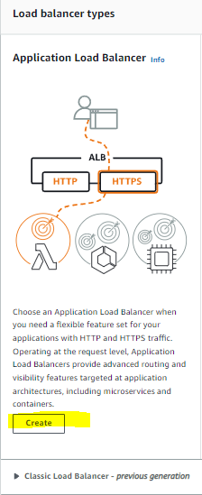

Choose Create under Application Load Balancer

For the name of the Load Balancer, use LabELB

Scroll down to the Network mapping section then

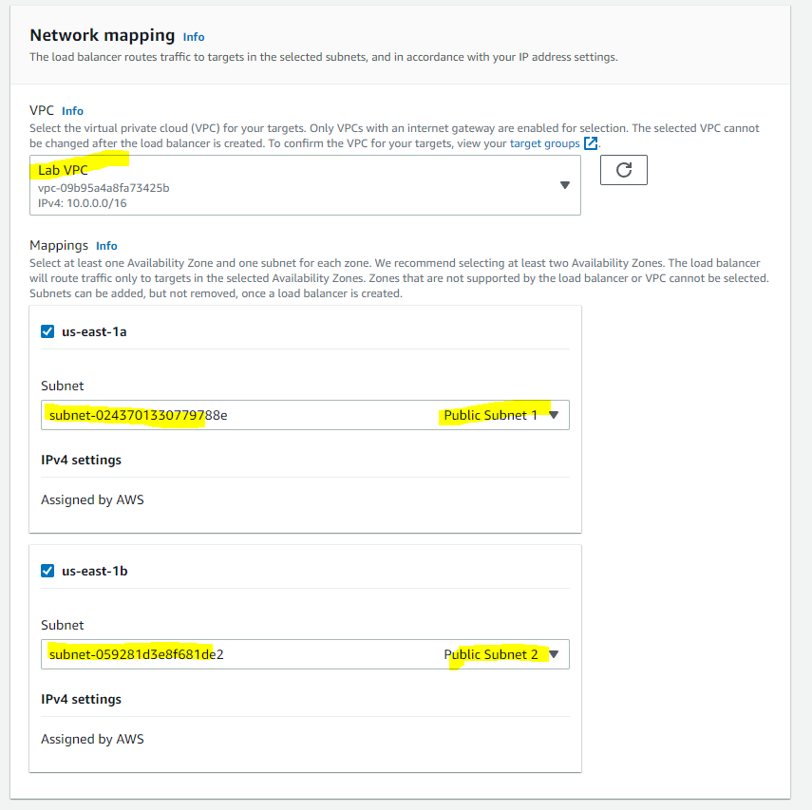

In the group of Security Groups,

Select Web Security Group, remove the default security group, leaving only Web Security Group.

Set default action of HTTP:80 row to forward to Lab Group

Create load balancer and view it.

TASK 3: Create a Launch Configuration and an Auto Scaling Group

1. Click Launch Configurations from the left navigation pane
2. Then create that Launch configuration
3. Configure:

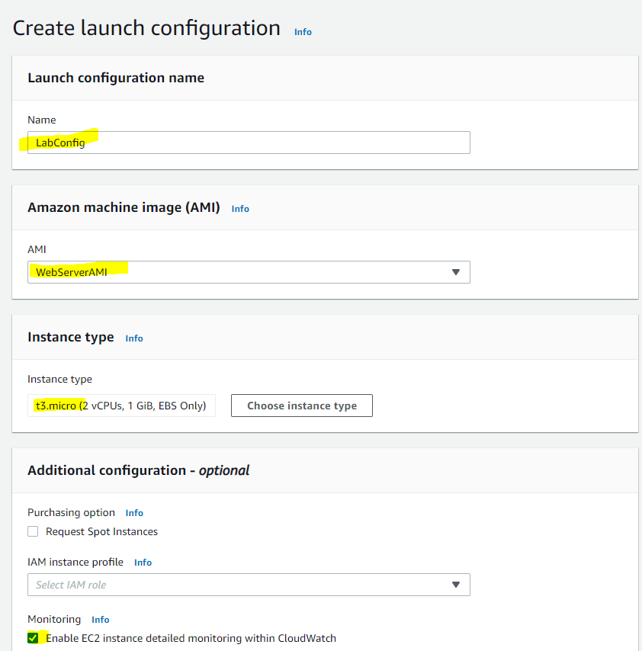

1. In the security groups, select the web security group from the existing groups.
2. Under Key Pair:

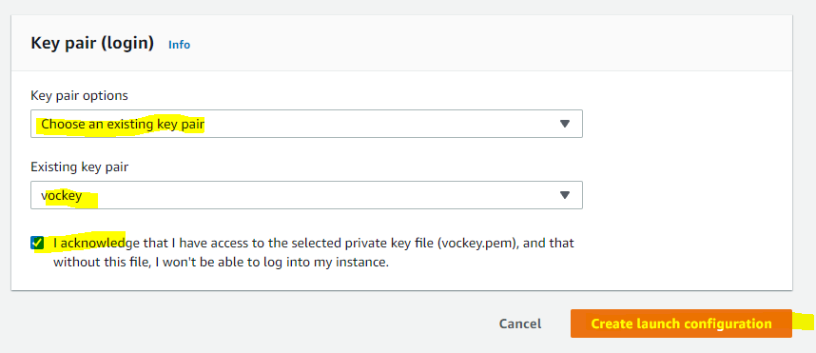

1. Select the LabConfig Launch Config checkbox
2. Create auto Scaling group from the actions menu
3. Name this group Lab Auto Scaling Group
4. Choose Next and configure on the network page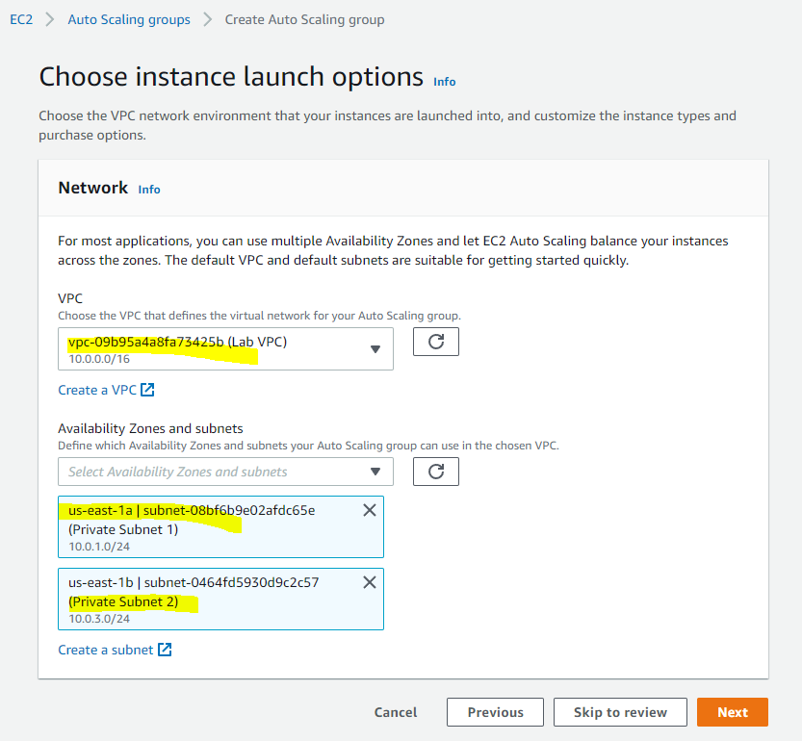
5. Choose next
6. Attach to an existing load balancer from the load balancing optional pane and select lab group after attaching.
7. In additional settings optional pane, check the enable group metrics collection...
8. Choose next, then under group size configure:

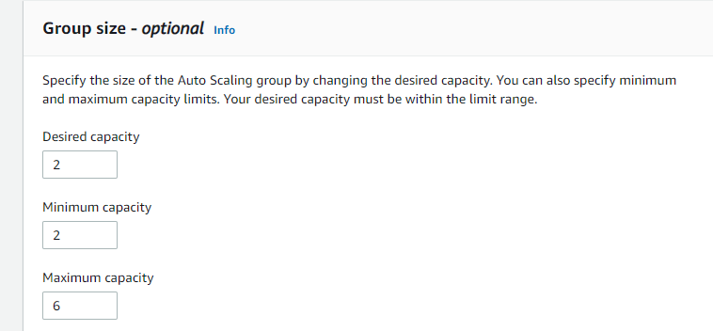

1. Under **Scaling policies**, choose *Target tracking scaling policy* and configure:

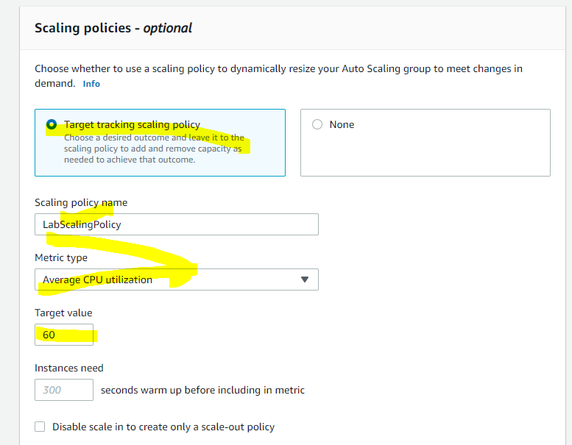

 Choose next, then next, then add tag, configure

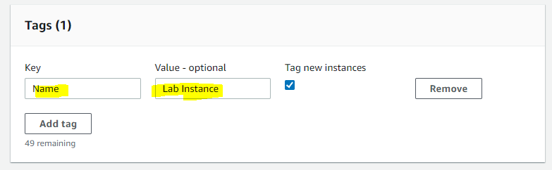

TASK 4: Verify that Load Balancing is Working

1. Click Instances and confirm that Lab Instance have passed the health check.
2. Select Target Groups from the Load Balancing Section, and Choose LabGroup. See if these instances are healthy and refresh to update.
3. Select Load Balancers, copy the DNS name and paste the name into a web browser.

TASK 5: Test Auto Scaling

1. From the Services menu, select CloudWatch
2. Select all alarms
3. Choose the OK alarm which is the AlarmHigh. Return to the browser, click load test, and refresh. When the useage crosses 60%, the scaling should kick in.

TASK 6: Terminate Web Server 1

1. Select the web server, choose instance state and terminate it.

##### Certifications:

Go Back





